Supplementary Material
Supplementary Figure 1. Research flow chart

Supplementary Figure 2. Mind map visualisation of the themes following a thematic framework for staff stakeholders
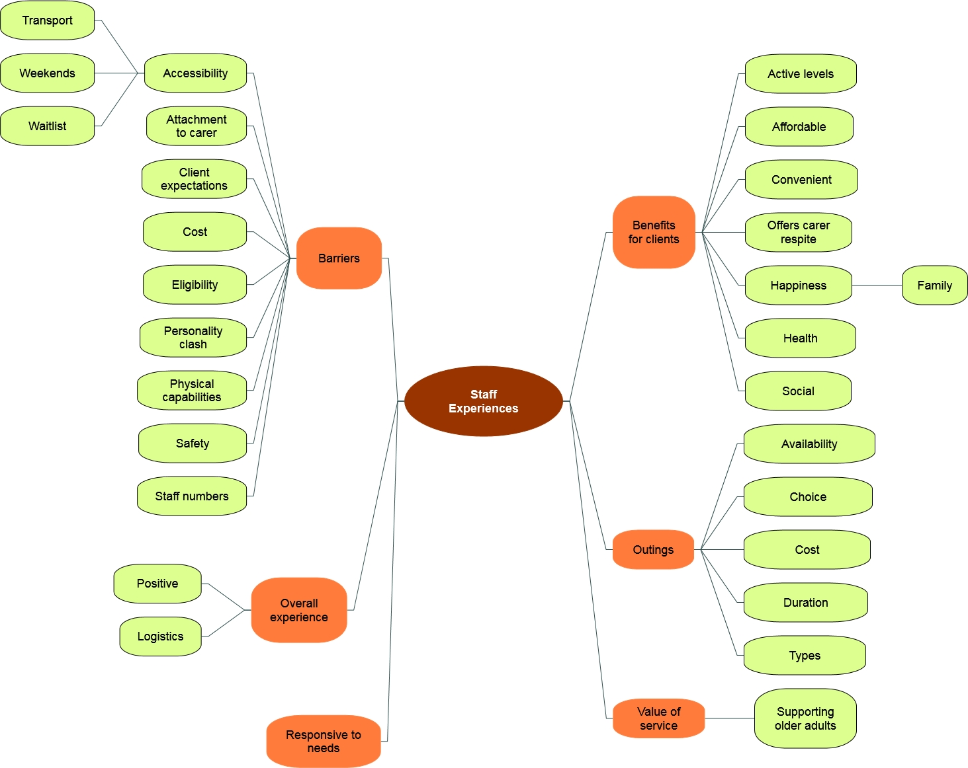

Supplementary Table 1. Characteristics of participants engaged in the social program involved in the qualitative interviews.
Age Range | Gender | Range of use of Enrich Services | Number of outings (/month) | Types of outings completed
68-91 | 63.6% female | 2 months – 12 years | 2 – 12 | Whale watching  Helicopter ride  Harley Davidson ride  Pubs  Restaurants  Zoo  Railway launch  Yacht club  National park  Cinema  Concert  Boat ride  Camel ride  Vineyards  Art gallery  Cinema

Supplementary Table 2. Interview schedule with different stakeholders.
Stakeholder groups | Questions
Clients | - What was your experience of the Community Connections Program?  - Was it acceptable to you?  - Can you discuss the availability of the outings and the choice of outings?  - Did you feel that Community Connections was responsive to your needs?  - What are the perceived benefits for you?  - What do you think the advantages or disadvantages were by attending Community Connections?  - What was the value of the service for you?  - What could be improved with the current program?
Staff | - What was your experience of the Community Connections Program?  - How feasible was it to set up Community Connections?  - Was it acceptable to your clients?  - Can you discuss the availability of the outings and the choice of outings?  - Did you feel that Community Connections was responsive to your client needs?  - What are the perceived benefits for your clients?  - What do you think the advantages or disadvantages were for clients who attended Community Connections?  - What was the value of the service for you?  - Were there any barriers in implementing Community Connections?
Family caregivers | - What was your experience of the Community Connections Program?  - Did you feel that Community Connections was responsive to your client needs?  - What are the perceived benefits for your cared one?  - What are the perceived benefits for you?  - What do you think the advantages or disadvantages were for your cared one?  - What was the value of the service for you?  - How can Community Connections be improved to address both your cared one and your needs?

Supplementary Table 3. Initial thematic framework.
Role | Major theme | Sub-themes
Client | Overall perception | Acceptability  Gratefulness  Cost
Client | Strength of program | Transport  Carers/Enrich staff – care, take suggestions on board  Outing quality and type  Organisation of outings
Client | Suggested improvements | Length of outing  Targeting all client needs  Frequency and booking  Car/transport
Client | Change/Benefit | Physical  Social – established friendships  Psychological – smiling all the time now
Client | Feasibility | Awareness  Booking  Attending
Client | Needs | Physical – got to get out of the house  Social – don’t have anyone to talk to
Staff | Feasibility | Establishing program  Organising schedule  Informing clients
Staff | Advantages | Social  Physical
Staff | Disadvantages | Mobility
Staff | Personal value | Contributing to client’s wellbeing
Staff | Barriers to implementation | Welfare  Safety  Location  Timing  Staff
Staff | A powerful experience | Making a difference matters  Emotional involvement  Learning?
Carer | Advantage | Cared for appropriately (transport and staff)  Time off/respite  Adding value to their cared one’s life
Carer | Limitations | Cost – limiting outing frequency
Carer | Initial approach | Scepticism  Collaborative approach
Carer | Change in cared one | Positive; psychological
Carer | Suggestions | Online booking

