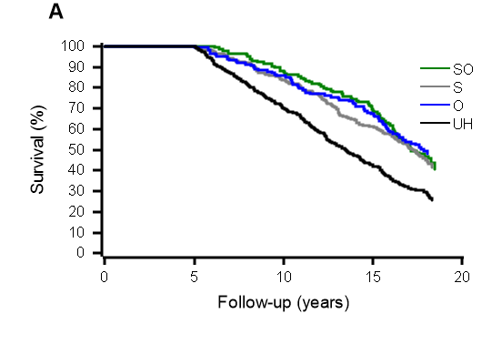
Additional file 3. Rates of survival by combined health information (self-reported [subjective] health and registered illnesses [objective health]) for participants followed-up for more than 5 years, during the 18-year follow-up. SO = good subjective and objective health, S = good subjective and poor objective health, O = poor subjective and good objective health and UH = unhealthy, poor subjective and objective health.

