Supplementary figure 1

Overview of the reliability testing process

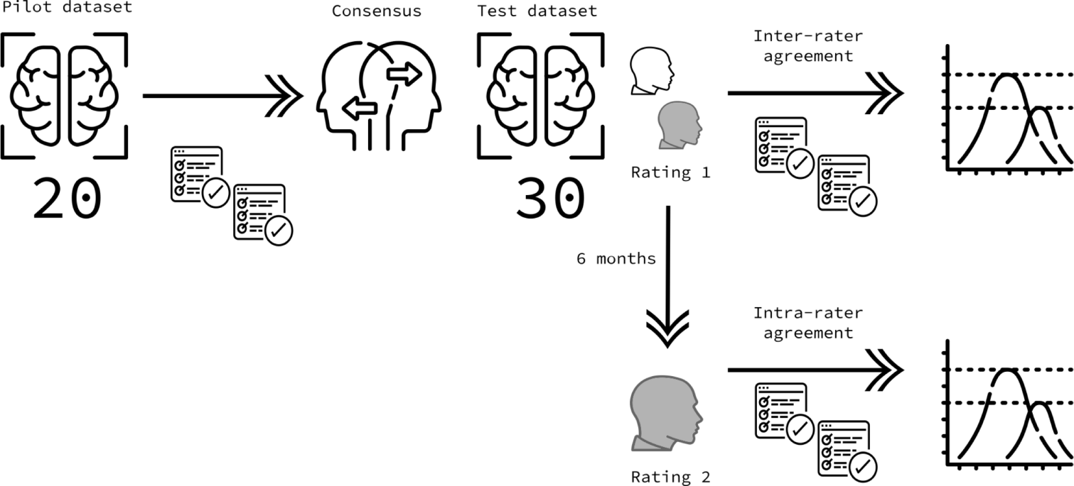
Supplementary figure 1: Overview of the reliability testing process.

