Additional file 6 Calibration plots
Supplementary Figure 6 Calibration plots of DIVERT per country for outcome ED visits

Supplementary Figure 7 Calibration plots of CARS per country for outcome hospital admissions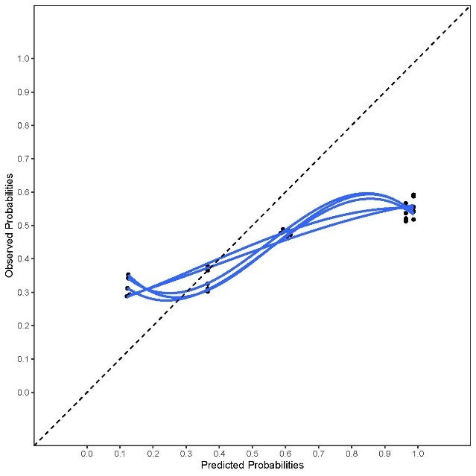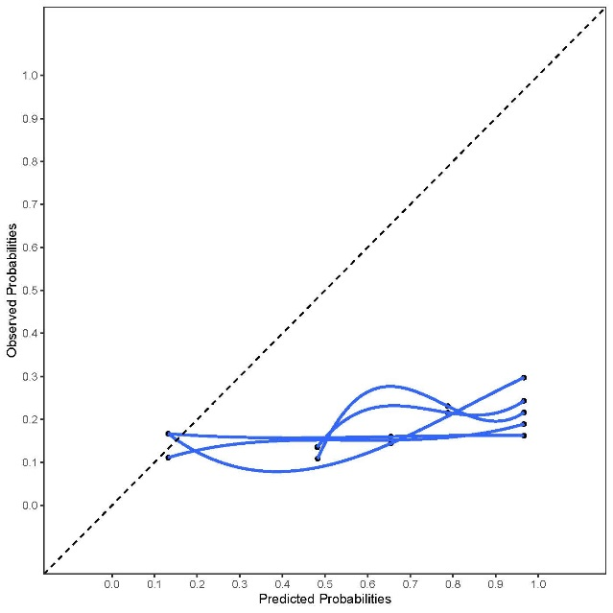
Italy
Iceland
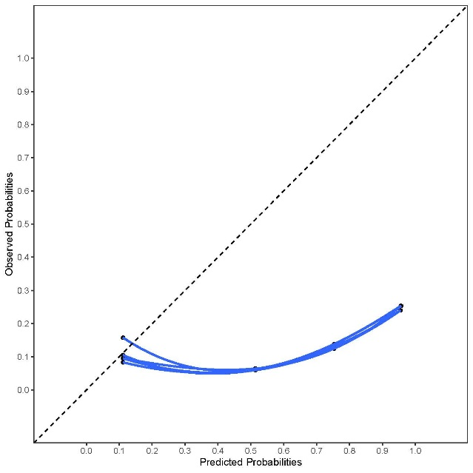
Germany

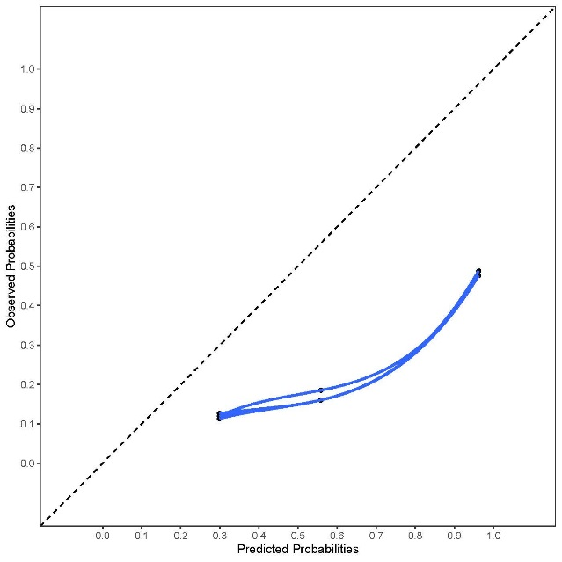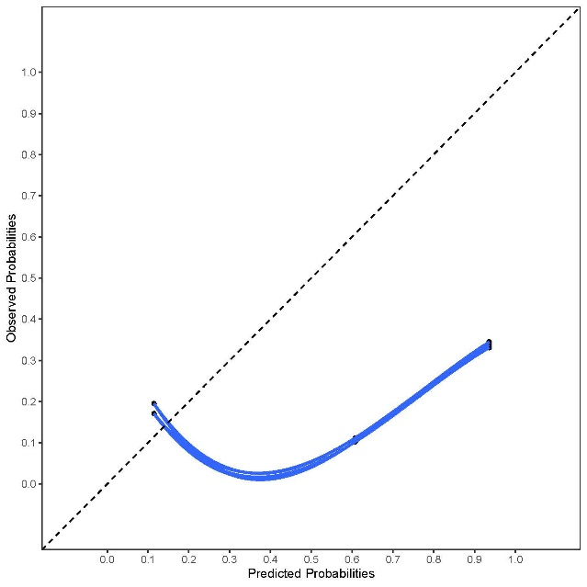
Finland
Netherlands

Supplementary Figure 8 Calibration plots of CARS per country for outcome ED visits

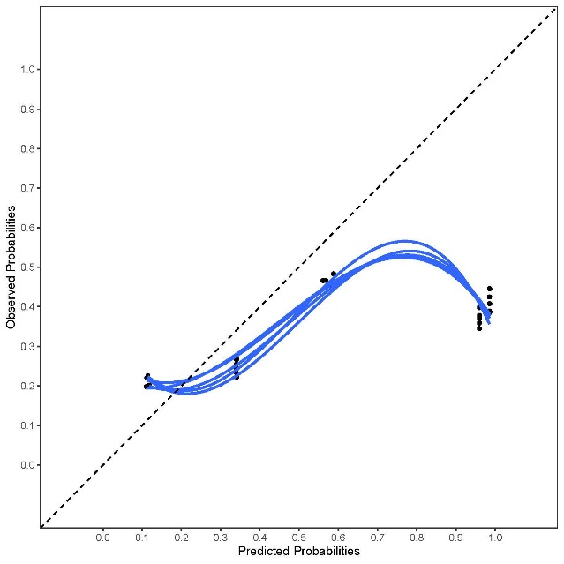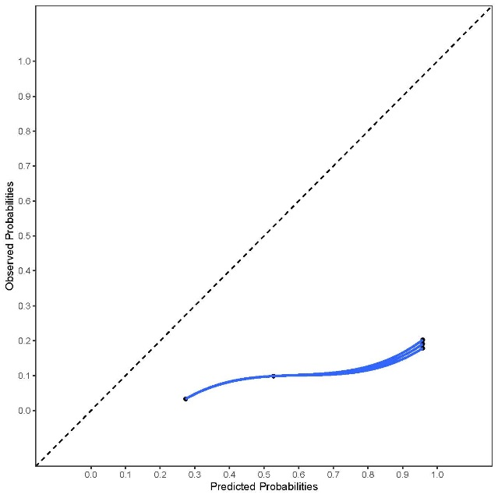
Iceland
Italy

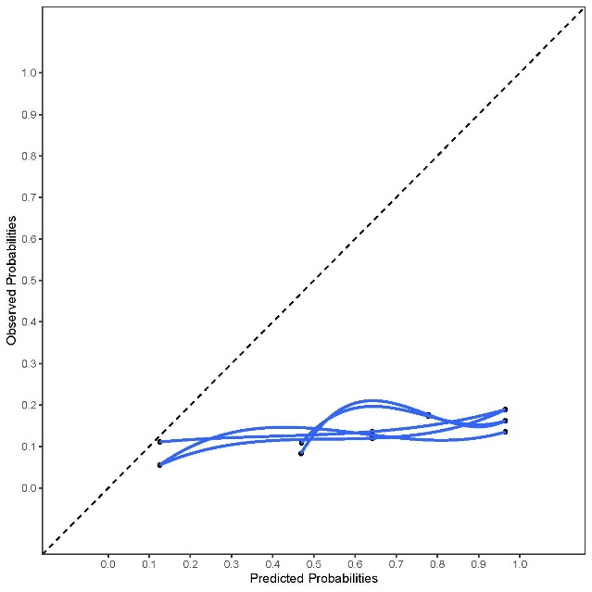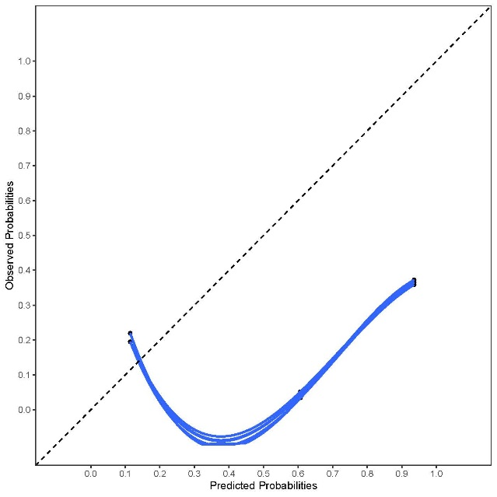
Finland
Netherlands
Supplementary Figure 9 Calibration plots of CARS per country for outcome any unplanned hospital visit
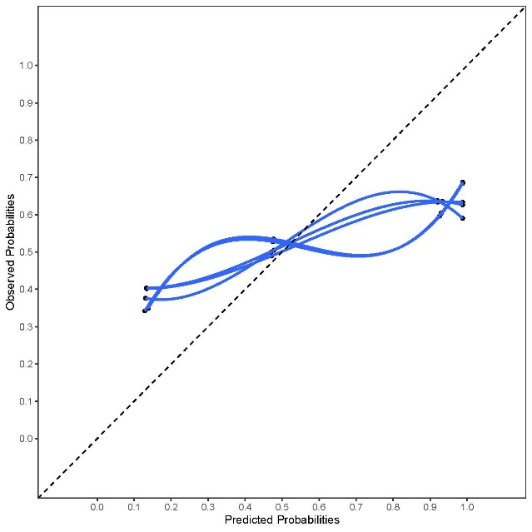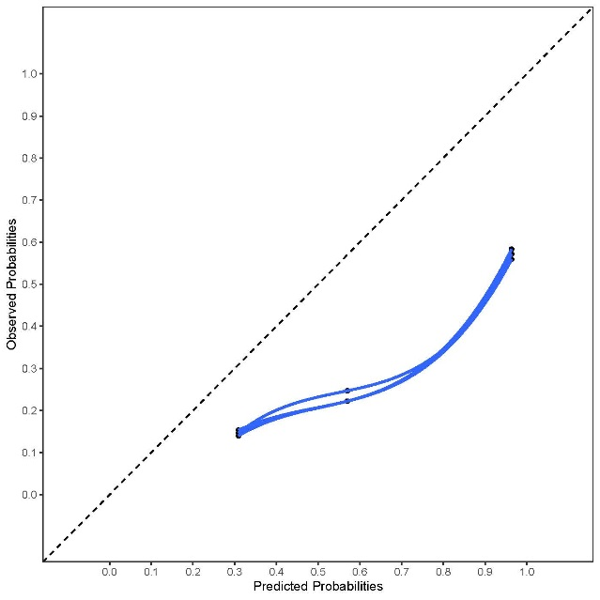
Finland
Iceland
Italy

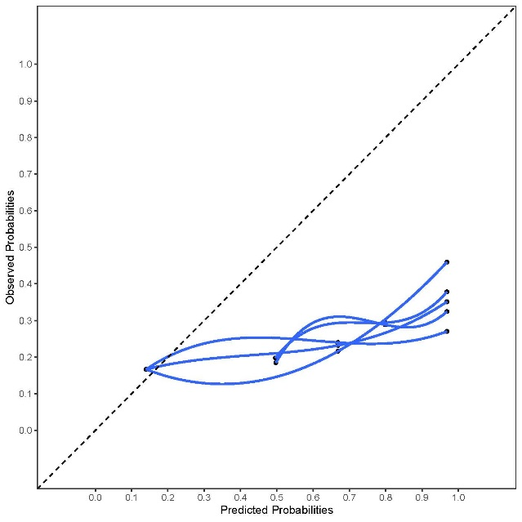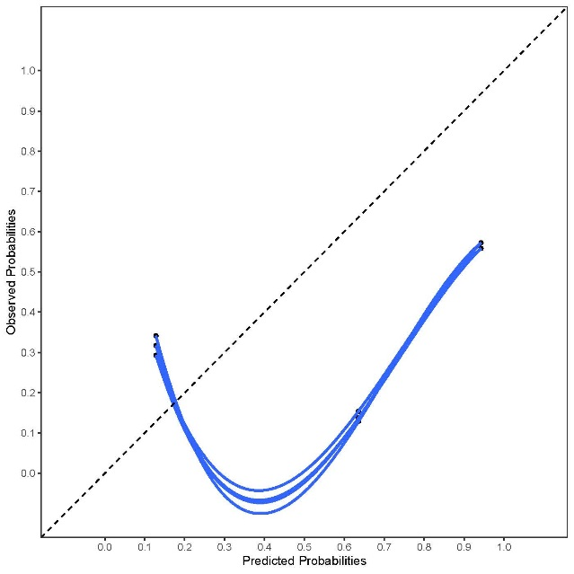
Netherlands
Supplementary Figure 10 Calibration plots of EARLI per country for outcome hospital admissions
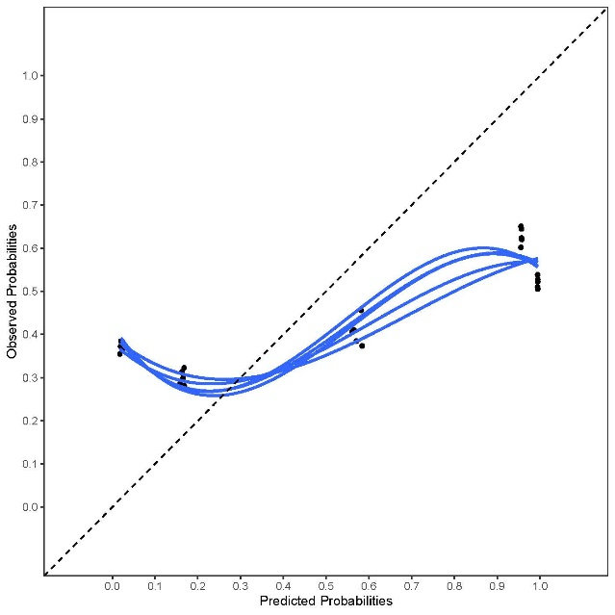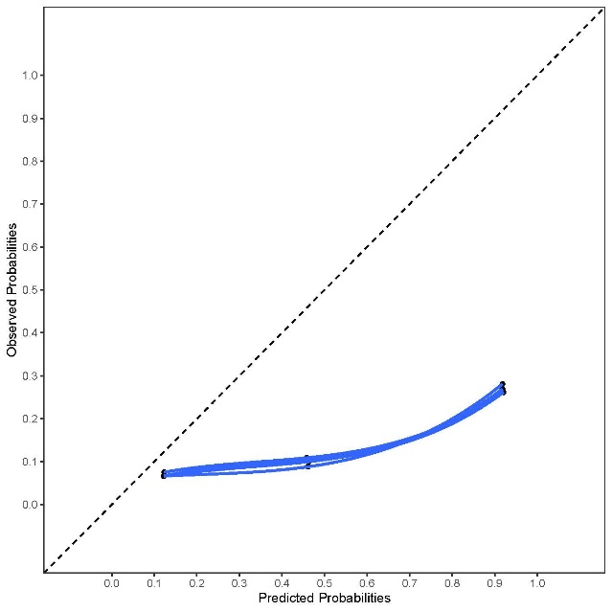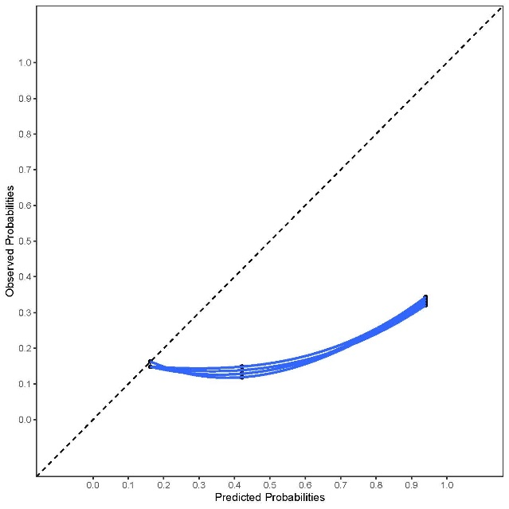
Finland
Iceland
Belgium
Netherlands
Italy

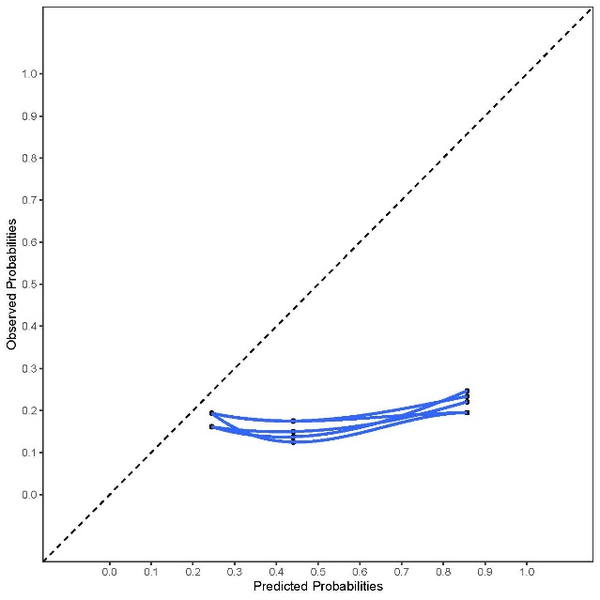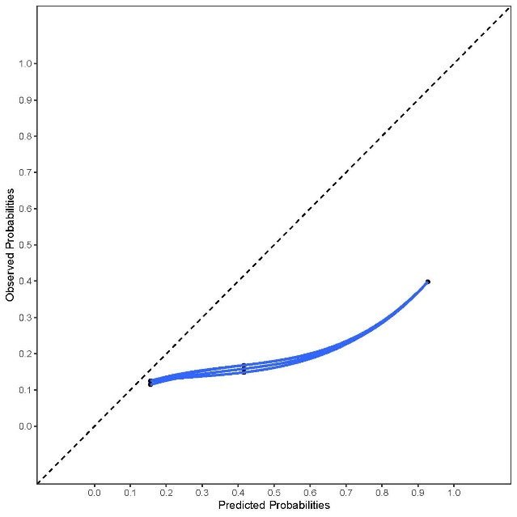
Supplementary Figure 11 Calibration plots of EARLI per country for outcome ED visits
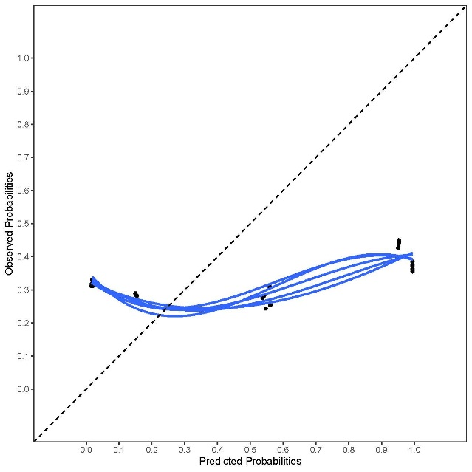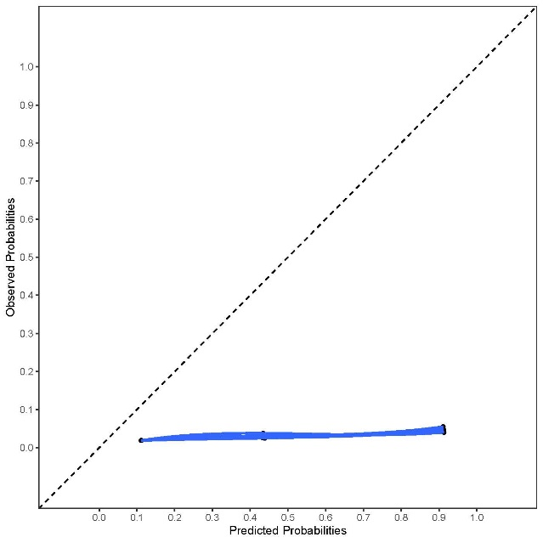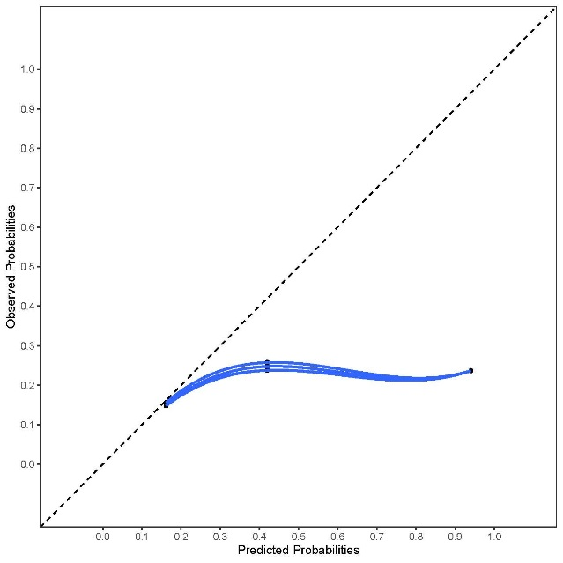
Finland
Iceland
Belgium
Netherlands
Italy

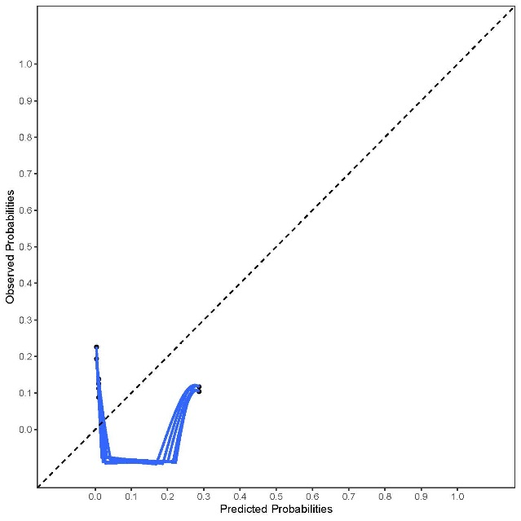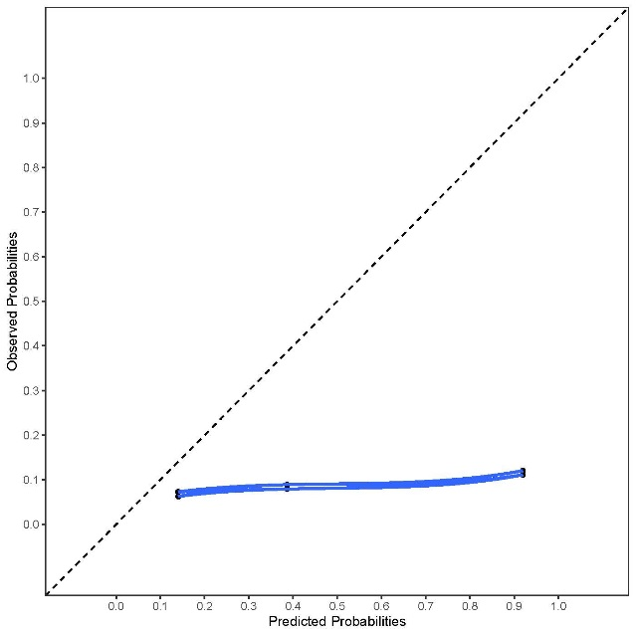
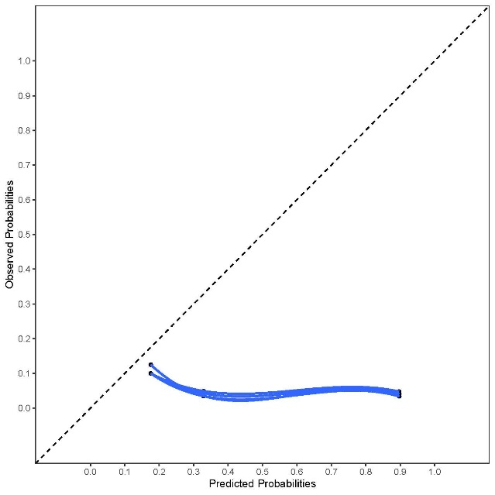
Germany
Supplementary Figure 12 Calibration plots of EARLI per country for outcome any hospital visit 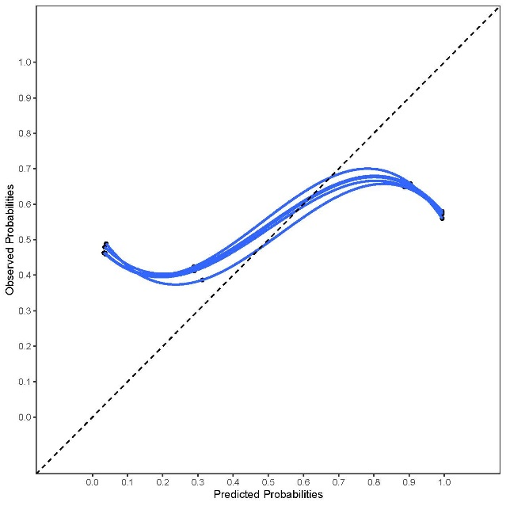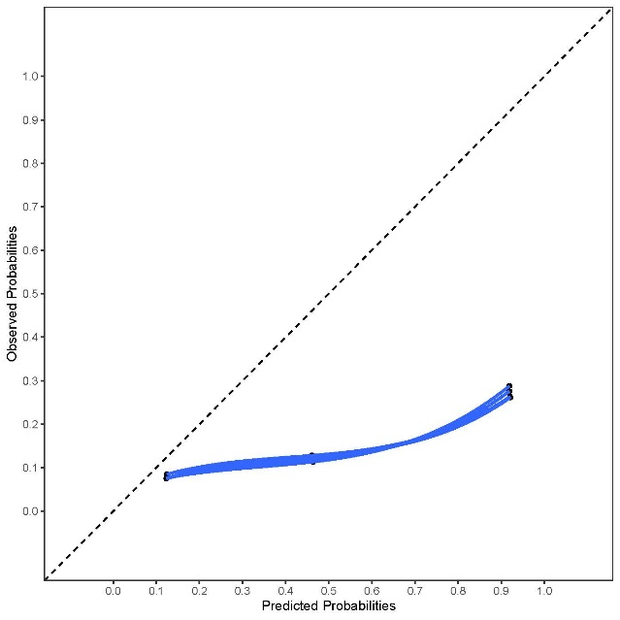
Italy
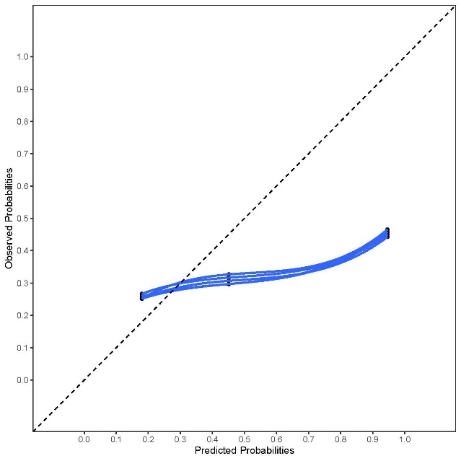
Finland

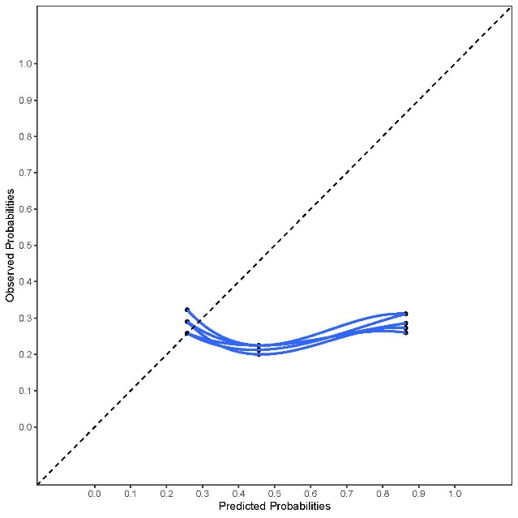
Belgium
Netherlands
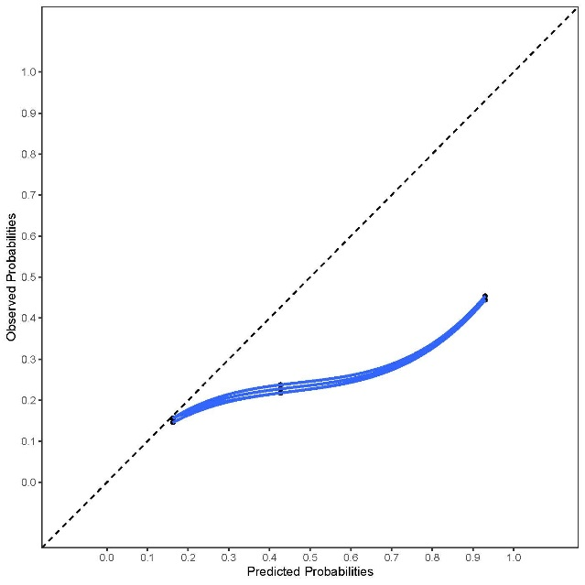
Iceland
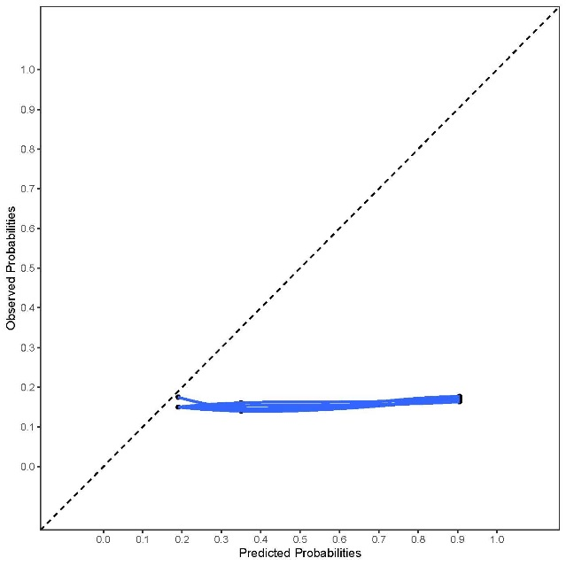
Germany
Supplementary Figure 13 Calibration plots of PAA per country for all outcomes

Supplementary Figure 14 Calibration plots of CHESS per country for outcome hospital admissions

