Supplementary Figure S1. Selection of Study Sample

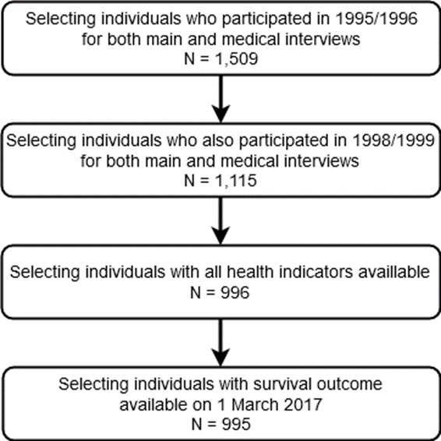

Supplementary Table S2. Items Included in the Frailty Index
ADLs/IADLs | SELF-RATED HEALTH & SYMPTOMS
- Dressing | - Self-rated health
- Cut toenails | - Self-rated health compared to others
- Walking outside of the house | - Low physical activity
- Getting up from chair | - Slow gait speed
- Climb one flight of stairs | PSYCHOLOGICAL SYMPTOMS
- Use public transport | - Felt depressed
CHRONIC CONDITIONS | - Felt everything was effort
- Heart disease | - Happy (reverse-coded)
- Peripheral arterial disease | - Lonely
- High blood pressure | - Could not get going
- Stroke | - Enjoyed life (reverse-coded)
- Diabetes | COGNITION
- Chronic lung disease | - Delayed word recall
- Arthritis | - Self-rated memory
- Cancer | - Orientation regarding time
- Incontinence | - Orientation regarding place
- Other chronic disease 1 | - Attention
- Other chronic disease 2 | TOTAL NUMBER OF ITEMS: 32

Additional information on items and cut-points can be found here: Hoogendijk, E.O., Theou, O., Rockwood, K. et al. Development and validation of a frailty index in the Longitudinal Aging Study Amsterdam. Aging Clin Exp Res 2017;29;927–933. https://doi.org/10.1007/s40520-016-0689-0

Supplementary Figure S3. Study Design Scheme

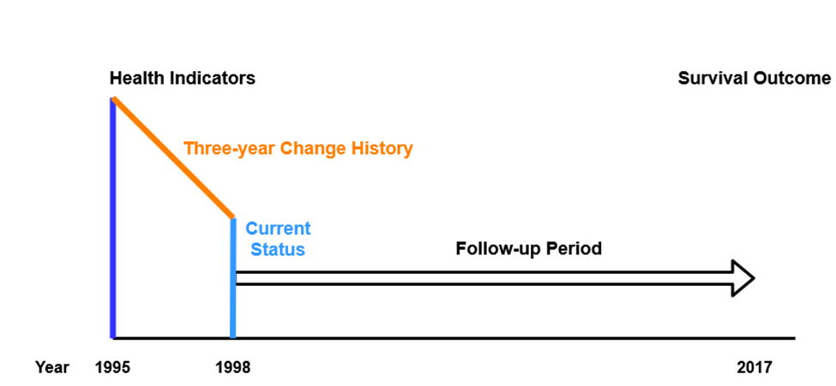

Supplementary Figure S4. Distribution of Current Status and Three-year Change in Health Indicators Stratified for Sex
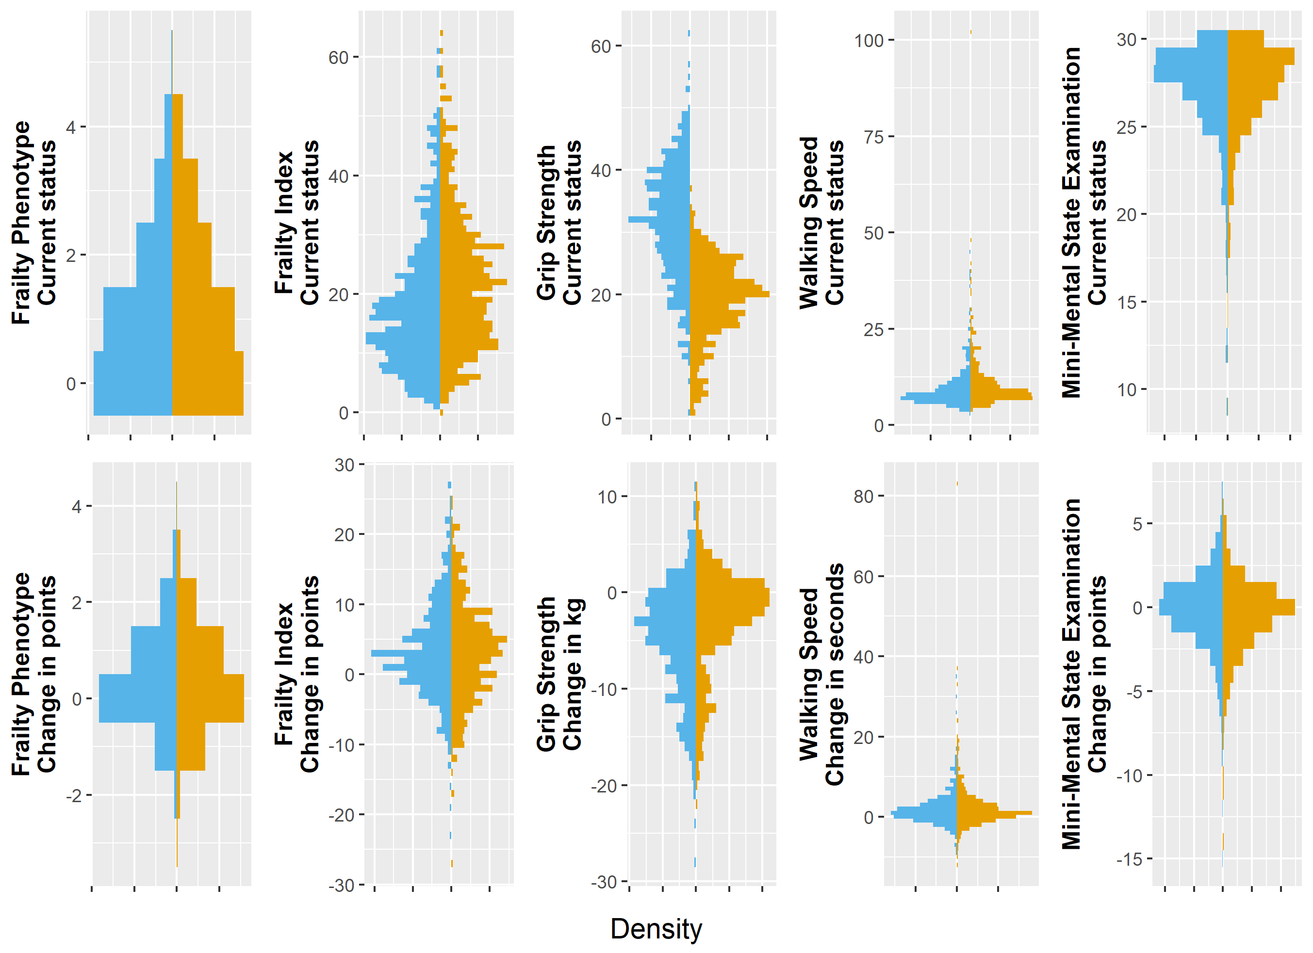
Males are displayed in blue and females are displayed in orange.

Supplementary Table S5. Added Value of Health Indicators to Mortality Prediction Stratified for Sex

Strata | Health Indicator | Current Status |  |  | Three-year Change
Strata | Health Indicator | Average Score  (min - max) | Five-year AUC¹ |  | Average Score  (min - max) | Five-year AUC¹
Males | Age |  | 71.3 (66.0 – 76.7) |  |  | 71.3 (66.0 – 76.7)
(472 at risk, 124 died) | + Frailty Phenotype | 1.1 (0.0 – 5.0) | + 2.7 (1.0 – 4.4) |  | 0.4 (-2.0 – 4.0) | + 0.2 (-0.2 – 0.7)
 | + Frailty Index | 0.18 (0.01 – 0.61) | + 4.4 (1.8 – 7.0) |  | 0.03 (-0.23 – 0.27) | + 2.6 (0.6 – 4.5)
 | + Grip strength | 32.0 (1.0 – 62.5) | + 1.2 (0.1 – 2.3) |  | -4.7 (-28.0 – 11.0) | + 0.8 (0.1 – 1.5)
 | + Walking speed | 9.5 (3.0 – 45.0) | + 1.5 (0.3 – 2.7) |  | 2.0 (-9.0 – 35.0) | + 1.2 (0.4 – 2.1)
 | + Mini-Mental State Examination | 27.0 (9.0 -30.0) | + 0.3 (-0.9 – 1.4) |  | -0.2 (-15.0 – 7.0) | + 0.0 (-0.5 – 0.6)
Females | Age |  | 73.7 (68.4 – 79.1) |  |  | 73.7 (68.4 – 79.1)
(523 at risk, 96 died) | + Frailty Phenotype | 1.2 (0.0 – 5.0) | + 0.8 (-0.4 – 1.9) |  | 0.4 (-3.0 – 4.0) | ̶ 0.2 (-0.4 – 0.0)
 | + Frailty Index | 0.22 (0.00 – 0.64) | + 2.3 (0.2 – 4.5) |  | 0.03 (-0.27 – 0.25) | ̶+ 0.2 (-0.7 – 1.0)
 | + Grip strength | 19.1 (1.0 – 37.0) | + 1.0 (0.0 – 2.0) |  | -2.6 (-21.5 – 11.5) | ̶ 0.1 (-0.6 – 0.4)
 | + Walking speed | 11.0 (4.0 – 102.0) | - 0.2 (-0.6 – 1.1) |  | 2.3 (-12.0 – 83.0) | + 0.0 (-0.4 – 0.5)
 | + Mini-Mental State Examination | 26.9 (9.0 – 30.0) | + 2.3 (0.4 – 4.2) |  | -0.5 (-14.0 – 6.0) | + 0.1 (-0.7 – 0.9)

¹ AUC: Discrimination ability as measured using Area Under the Curve in percentages

Supplementary Table S6. Added Value of Health Indicators to Mortality Prediction Based on Age and Sex Stratified for Number of Chronic Diseases

Strata | Health Indicator | Current Status |  |  | Three-year Change
Strata | Health Indicator | Average Score  (min - max) | Five-year AUC¹ |  | Average Score  (min - max) | Five-year AUC¹
With ≤ 1 Chronic Disease | Age and sex |  | 71.4 (64.1 – 78.6) |  |  | 71.4 (64.1 – 78.6)
(388 at risk, 59 died) | + Frailty Phenotype | 0.9 (0.0 – 5.0) | + 1.6 (-0.2 – 3.4) |  | 0.3 (-2.0 – 3.0) | ̶ 0.2 (-0.4 – 0.0)
 | + Frailty Index | 0.13 (0.00 – 0.57) | + 2.0 (-0.6 - 4.6) |  | 0.01 (-0.27 – 0.24) | + 0.1 (-0.4 – 0.5)
 | + Grip strength | 26.7 (1.0 – 55.5) | + 0.6 (-0.7 – 1.9) |  | -3.2 (-21.5 – 11.0) | + 0.1 (-0.6 – 0.9)
 | + Walking speed | 9.0 (4.0 – 40.0) | + 1.2 (-0.1 – 2.6) |  | 1.5 (-9.0 – 30.0) | + 0.4 (-0.1 – 1.0)
 | + Mini-Mental State Examination | 26.9 (9.0 – 30.0) | + 2.3 (-0.3 – 4.9) |  | -0.4 (-12.0 – 6.0) | + 0.6 (-0.6 – 1.9)
With 2 Chronic Diseases | Age and sex |  | 75.2 (68.8 – 81.6) |  |  | 75.2 (68.8 – 81.6)
(298 at risk, 67 died) | + Frailty Phenotype | 1.1 (0.0 – 5.0) | + 0.2 (-0.7 – 1.0) |  | 0.4 (-3.0 – 4.0) | ̶ 0.3 (-0.6 – 0.0)
 | + Frailty Index | 0.20 (0.06 – 0.51) | + 1.2 (-0.5 – 2.9) |  | 0.04 (-0.19 – 0.27) | + 1.5 (-0.3 – 3.3)
 | + Grip strength | 25.4 (1.0 – 62.5) | + 0.0 (-0.4 – 0.5) |  | -3.8 (-23.5 – 10.0) | + 0.0 (-0.6 – 0.6)
 | + Walking speed | 10.6 (3.0 – 102.0) | + 0.1 (-0.9 – 1.1) |  | 2.5 (-8.0 – 83.0) | ̶ 0.1 (-0.8 – 0.6)
 | + Mini-Mental State Examination | 27.1 (12.0 – 30.0) | + 2.0 (0.3 – 3.8) |  | -0.3 (-15.0 – 6.0) | + 0.0 (-1.4 – 1.4)
With > 2 Chronic Diseases | Age and sex |  | 70.0 (63.6 – 76.3) |  |  | 70.0 (63.6 – 76.3)
(309 at risk, 94 died) | + Frailty Phenotype | 1.6 (0.0 – 4.0) | + 1.6 (-0.3 – 3.5) |  | 0.5 (-3.0 – 3.0) | - 0.3 (-0.6 – 0.1)
 | + Frailty Index | 0.30 (0.11 – 0.64) | + 2.6 (-0.1 – 5.2) |  | 0.06 (-0.17 – 0.27) | + 0.3 (-1.2 – 1.8)
 | + Grip strength | 23.2 (1.0 – 57.5) | + 2.0 (-0.0 – 4.0) |  | -3.9 (-28.0 – 11.5) | + 0.4 (-0.3 – 1.1)
 | + Walking speed | 11.7 (4.0 – 48.0) | + 0.1 (-0.9 – 1.2) |  | 2.6 (-12.0 – 37.0) | + 0.3 (-0.6 – 1.1)
 | + Mini-Mental State Examination | 26.8 (9.0 – 30.0) | + 0.2 (-1.2 - 1.6) |  | -0.4 (-14.0 – 7.0) | - 0.1 (-0.3 – 0.1)

¹ AUC: Discrimination ability as measured using Area Under the Curve in percentages

