Supplemental Figure 1 Diagrammatic interpretation of the relationship between potential confounders, exposure and outcome
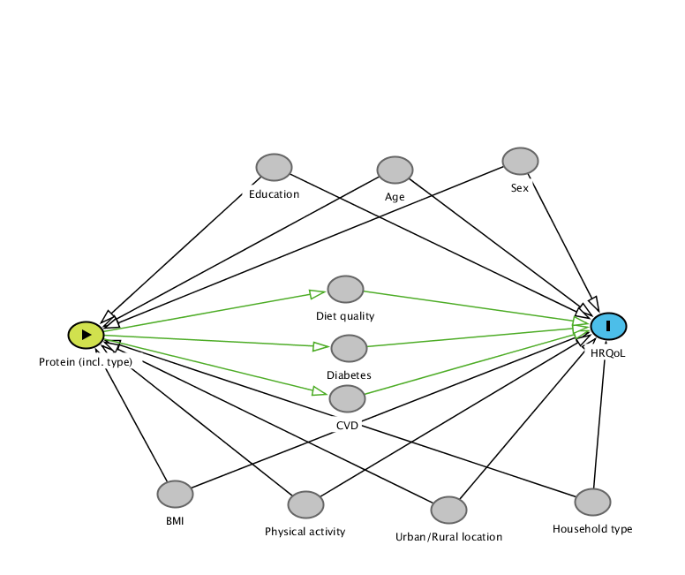

Supplemental Table 1 Baseline characteristics of participants included versus excluded
 | Included | Excluded^{c}
 | (n= 752) | (n= 2546) | P-value*
Age (years), mean (SD) | 66.1 ± 5.0 | 70.8 ± 6.9 | <0.001
Sex (female) n (%) | 386 (51.3%) | 1390 (54.6%) | 0.124
BMI (kg/m²), mean (SD) | 27.0 ± 4.1 | 27.4 ± 4.7 | 0.015
Education
- Secondary n, (%) | 326 (43.4%) | 1431 (57.1%) | <0.001
- Diploma n, (%) | 334 (44.4%) | 923 (36.9%) | <0.001
- Degree n, (%) | 92 (12.2%) | 151 (6.0%) | <0.001
Smoking statusª
- Current daily smokers n, (%) | 40 (5.4%) | 231 (9.3%) | 0.001
- Ex-smokers n, (%) | 257 (34.5%) | 882 (35.5%) | 0.001
- Never smoked daily n, (%) | 447 (60.1%) | 1369 (55.2%) | 0.001
Urban/Rural classification
- Urban n, (%) | 474 (63.0%) | 1388 (54.5%) | <0.001
- Rural n, (%) | 278 (37.0%) | 1158 (45.5%) | <0.001
Physical activity
- None n, (%) | 118 (15.7%) | 526 (20.8%) | <0.001
- Insufficient (1-149 minutes/week) n, (%) | 197 (26.2%) | 786 (31.2%) | <0.001
- Sufficient (≥150 minutes/week) n, (%) | 437 (58.1%) | 1209 (48.0%) | <0.001
Prevalence of Cardiovascular diseaseª, n (%) | 94 (12.7%) | 616 (24.7%) | <0.001
Prevalence of Diabetesª ,n (%) | 89 (11.9%) | 542 (21.6%) | <0.001
Household type^{b}
- Person living alone, n (%) | 227 (30.2%) | 13 (26.0%) | 0.569
- Married or de facto couple only, n (%) | 469 (62.3%) | 32 (64.0%) | 0.569
- Married or de facto couple living with children, n (%) | 22 (2.9%) | 2 (4.0%) | 0.569
- One person living with children, n (%) | 14 (1.9%) | 0 (0%) | 0.569
- Shared household, n (%) | 18 (2.4%) | 3 (6.0%) | 0.569
- All other households, n (%) | 2 (0.3%) | 0 (0%) | 0.569
Health-related quality of life
SF-36 Physical component summary (PCS) score, mean (SD) | 47.8 ± 8.6 | 42.9 ± 10.9 | <0.001
SF-36 Mental component summary (MCS) score, mean (SD) | 52.2 ± 8.5 | 50.2 ± 9.7 | <0.001
SD - Standard deviation; BMI - body mass index; ª Data not complete (variable included for information only, not treated as a covariate); ^{b} Data collected at 12-year follow-up; ^{c} figures based on participants who provided valid data; * p-values based on assessments of differences between included and excluded participants using independent sample t–tests for continuous variables and chi-squared test for categorical variables

Supplemental Table 2 Sensitivity analysis: Associations between baseline protein intake by source in grams per day and 12-year changes in health-related quality of life
 | Sensitivity 1* |  | Sensitivity 2** |  | Sensitivity 3***
 | (n=602) |  | (n=752) |  | (n=752)
 | β (CI) | P-value | β (CI) | P-value | β (CI) | P-value
Change in PCS score
Animal protein | -0.08 (-0.13, -0.04) | 0.001 | -0.04 (-0.06, -0.01) | 0.014 | -0.05 (-0.08, -0.02) | 0.002
Red meat protein | -0.09 (-0.15, -0.03) | 0.003 | -0.04 (-0.07, 0.00) | 0.027 | -0.05 (-0.09. -0.01) | 0.014
Processed animal protein | -0.35 (-0.61, -0.10) | 0.007 | -0.11 (-0.24, 0.03) | 0.123 | -0.15 (-0.30, 0.0) | 0.050
Other animal protein | -0.09 (-0.40, 0.23) | 0.593 | -0.11 (-0.36, 0.13) | 0.365 | -0.04 (-0.32, 0.23) | 0.759
Dairy protein | -0.07 (-0.17, 0.03) | 0.151 | -0.07 (-0.15, 0.01) | 0.073 | -0.10 (-0.19, -0.01) | 0.039
Full-fat dairy protein | -0.14 (-0.28, -0.01) | 0.036 | -0.10 (-0.20, 0.01) | 0.080 | -0.11 (-0.22, 0.01) | 0.080
Low-fat dairy protein | 0.00 (-0.09, 0.09) | 0.947 | -0.02 (-0.09, 0.05) | 0.634 | -0.03 (-0.11, 0.06) | 0.504
Plant protein | 0.16 (-0.07, 0.39) | 0.180 | 0.10 (-0.10, 0.29) | 0.325 | 0.13 (-0.09, 0.35) | 0.234
Soy protein | 0.05 (-0.23, 0.34) | 0.724 | 0.06 (-0.19, 0.31) | 0.630 | 0.06 (-0.23, 0.34) | 0.698
Vegetable protein | 0.50 (0.04, 0.97) | 0.034 | 0.21 (-0.15, 0.57) | 0.254 | 0.33 (-0.07, 0.73) | 0.104
Change in MCS score
Animal protein | -0.02 (-0.06, 0.02) | 0.364 | -0.02 (-0.04, 0.01) | 0.161 | -0.31 (-0.06, 0.00) | 0.036
Red meat protein | -0.03 (-0.08, 0.03) | 0.330 | -0.04 (-0.07, -0.01) | 0.021 | -0.04 (-0.08, -0.01) | 0.011
Processed animal protein | -0.10 (-0.34, 0.13) | 0.382 | -0.06 (-0.18, 0.06) | 0.343 | -0.08 (-0.22, 0.06) | 0.265
Other animal protein | 0.25 (-0.04, 0.53) | 0.091 | 0.17 (-0.06, 0.39) | 0.143 | 0.26 (0.01, 0.51) | 0.042
Dairy protein | -0.04 (-0.13, 0.05) | 0.348 | 0.04 (-0.03, 0.11) | 0.300 | -0.01 (-0.09, 0.07) | 0.844
Full-fat dairy protein | -0.05 (-0.17, 0.08) | 0.455 | -0.02 (-0.11, 0.08) | 0.753 | -0.01 (-0.11, 0.10) | 0.922
Low-fat dairy protein | -0.02 (-0.09, 0.07) | 0.713 | 0.04 (-0.03, 0.10) | 0.243 | 0.00 (-0.08, 0.07) | 0.909
Plant protein | -0.03 (0.24, 018) | 0.179 | -0.04 (-0.22, 0.13) | 0.627 | -0.05 (-0.25, 0.16) | 0.648
Soy protein | 0.03 (-0.23, 0.29) | 0.833 | 0.03 (-0.19, 0.25) | 0.800 | 0.04 (-0.22, 0.30) | 0.759
Vegetable protein | -0.20 (-0.62, 0.22) | 0.351 | -0.21 (-0.53, 0.11) | 0.201 | -0.24 (-0.61, 0.13) | 0.202
* Sensitivity 1: Excluding energy intake misreporters (defined as outside the range mean energy expenditure: energy intake ratio ±1 standard deviation) model adjusted for age, sex, BMI, education, physical activity, urban/rural classification, household type and energy misreporting ratio ** Sensitivity 2: Baseline HRQoL added to the model – Model adjusted for age, sex, BMI, education, physical activity, urban/rural classification, household type, energy misreporting ratio and baseline HRQoL (baseline PCS for change in PCS, baseline MCS for change in MCS); Sensitivity 3: Diet quality, prevalence of cardiovascular disease, prevalence of diabetes added to the model – Model adjusted for age, sex, BMI, education, physical activity, urban/rural classification, household type, energy misreporting ratio, diet quality, prevalence of cardiovascular disease, prevalence of diabetes β represents the expected change in HRQoL with 1 additional gram of protein. CI - 95% confidence interval; PCS - Physical component summary; MCS - Mental component summary

