Prevalence of dysphagia and risk of pneumonia and mortality in acute stroke patients: a meta-analysis

Authors: Kondwani Joseph Banda, MSN, RNM^{1,2}, Hsin Chu, MD, PhD^{3,4}, Xiao Linda Kang, PhD, RN^{1,5}, Doresses Liu, PhD, RN^{1,6,7}, Li-Chung Pien, PhD, RN^{8,11}, Hsiu-Ju Jen, MS, RN^{1,9}, Shu-Tai H. Shen, MSN, RN^{1,10}, Kuei-Ru Chou, PhD, RN, FAAN^{1,7,9,11}

¹ School of Nursing, College of Nursing, Taipei Medical University, Taipei, Taiwan
² Endoscopy Unit, Surgery Department, Kamuzu Central Hospital, Lilongwe, Malawi
³ Institute of Aerospace and Undersea Medicine, School of Medicine, National Defense Medical Center, Taipei, Taiwan
⁴ Department of Neurology, Tri-Service General Hospital, National Defense Medical Center, Taipei, Taiwan
⁵ School of Nursing, University of Pennsylvania, USA
⁶ Department of Nursing, Wan Fang Hospital, Taipei Medical University, Taipei, Taiwan
⁷ Center for Nursing and Healthcare Research in Clinical Practice Application, Wan Fang Hospital, Taipei Medical University, Taipei, Taiwan
⁸ Post-Baccalaureate Program in Nursing, College of Nursing, Taipei Medical University, Taipei, Taiwan
⁹ Department of Nursing, Taipei Medical University-Shuang Ho Hospital, New Taipei, Taiwan
¹⁰ Department of Nursing, Taipei Medical University Hospital, Taipei, Taiwan
¹¹ Psychiatric Research Center, Taipei Medical University Hospital, Taipei, Taiwan
Supplementary material
Supplemental Table 1: Search strategy
Supplemental Table 2: Study characteristics
Supplemental Table 3: Risk of bias assessment
Supplemental Table 4: Moderator analysis
Supplemental Figure 1: Funnel plot for publication bias
Supplemental Figure 2: Gender – female
Supplemental Figure 3: Gender – male
Supplemental Figure 4: Haemorrhagic stroke
Supplemental Figure 5: Ischaemic stroke
Supplemental Figure 6: Previous stroke
Supplemental Figure 7: Stroke severity
Supplemental Figure 8: Diabetes mellitus
Supplemental Figure 9: Hypertension
Supplemental Figure 10: Atrial fibrillation
Supplemental Figure 11: Hyperlipidaemia
Supplemental Figure 12: Right hemisphere
Supplemental Figure 13: Left hemisphere
Supplemental Figure 14: Total anterior circulation syndrome (TACS)
Supplemental Figure 15: Partial anterior circulation syndrome PACS
Supplemental Figure 16: Posterior circulation syndrome (POCS)
Supplemental Figure 17: Lacunar syndrome (LACS)
Supplemental References

Supplemental Table 1: Search strategy
Database | Keywords | Number of studies
Cochrane Library | prevalence of dysphagia in Title Abstract Keyword AND stroke in Title Abstract Keyword - (Word variations have been searched) (10 studies)  incidence of dysphagia in Title Abstract Keyword AND stroke in Title Abstract Keyword - (Word variations have been searched) (48 studies)  epidemiology of dysphagia in Title Abstract Keyword AND stroke in Title Abstract Keyword - (Word variations have been searched) (30 studies) | 88
Embase | prevalence of dysphagia AND stroke (401 studies)  incidence of dysphagia AND stroke (542 studies)  epidemiology of dysphagia AND stroke (1521 studies) | 2464
Medline | prevalence of dysphagia AND stroke.mp. [mp=title, abstract, original title, name of substance word, subject heading word, floating sub-heading word, keyword heading word, organism supplementary concept word, protocol supplementary concept word, rare disease supplementary concept word, unique identifier, synonyms] (23 studies)  incidence of dysphagia AND stroke. mp. [mp=title, abstract, original title, name of substance word, subject heading word, floating sub-heading word, keyword heading word, organism supplementary concept word, protocol supplementary concept word, rare disease supplementary concept word, unique identifier, synonyms] (19 studies)  epidemiology of dysphagia AND stroke. mp. [mp=title, abstract, original title, name of substance word, subject heading word, floating sub-heading word, keyword heading word, organism supplementary concept word, protocol supplementary concept word, rare disease supplementary concept word, unique identifier, synonyms] (2 studies) | 44
PubMed | prevalence of dysphagia AND stroke (483 studies)  incidence of dysphagia AND stroke (503 studies)  epidemiology of dysphagia AND stroke (394 studies) | 1380
Web of Science | prevalence of dysphagia AND stroke Timespan: All years. Indexes: SCI-EXPANDED, SSCI. (267 studies)  incidence of dysphagia AND stroke Timespan: All years. Indexes: SCI-EXPANDED, SSCI. (216 studies)  epidemiology of dysphagia AND stroke Timespan: All years. Indexes: SCI-EXPANDED, SSCI. (36 studies) | 519

Supplemental Table 2: Study characteristics

Author (Year) | Age  Sample size | Type and Phase of Stroke | Design  Country & Continent | Diagnostic Method | Prevalence | Prognostic Factors | Outcomes
Abubakar & Jamoh, 2017  [1] | Age  55.5 (15.7)  Sample size  Total: 94  Male: 53  Female: 41 | Type  Ischaemic  Haemorrhagic  Phase  Acute | Design  Prospective study  Nigeria, Africa | WST  Baseline Test  < 72 hours | Dysphagia  (n = 32)  No dysphagia  (n = 62) | Diabetes mellitus  Hypertension | Pneumonia  Mortality
Al-Khaled et al., 2016 [2] | Age  73 (13)  Sample size  Total: 12276  Male: 6261  Female: 6015 | Type  Ischaemic  Phase  Acute | Design  Prospective study  Germany, Europe | WST  Baseline Test  < 3 hours | Dysphagia  (n = 3083)  No dysphagia  (n = 9193) | Previous stroke  Diabetes mellitus  Hypertension | Pneumonia  Mortality
Barer 1989 [3] | Age  70  Sample size  Total: 357  Male: 189  Female: 168 | Type  Ischemic  Hemorrhagic  Phase  Acute | Design  Prospective study  Britain, Europe | WST  Baseline Test  < 48 hours | Dysphagia  (n = 105)  No dysphagia  (n = 252) | NA | NA
Braun et al., 2019 [4] | Age  73 (61.3-81)  Sample size  Total: 152  Male: 94  Female: 58 | Type  Ischaemic  Haemorrhagic  Phase  Acute | Design  Prospective study  Germany, Europe | FEES  Baseline Test  NA | Dysphagia  (n = 110)  No dysphagia  (n = 42) | NA | Pneumonia  Mortality
Broadley et al., 2003 [5] | Age  72  Sample size  Total: 149  Male: 88  Female: 61 | Type  Ischaemic  Phase  Acute | Design  Prospective study  Australia, Oceania | WST  Baseline Test  < 72 hours | Dysphagia  (n = 74)  No dysphagia  (n = 75) | NA | NA
Carnaby, Sia & Crary, 2019  [6] | Age  62.5 (14.1)  Sample size  Total: 96  Male: 58  Female: 38 | Type  Ischaemic  Haemorrhagic  Phase  Acute | Design  Prospective study  USA, North America | MASA  Baseline Test  < 24 hours | Dysphagia  (n = 41)  No dysphagia  (n = 55) | Stroke severity | NA
Cong et al.,2012 [7] | Age  65 (12)  Sample size  Total: 496  Male: 251  Female: 245 | Type  Ischaemic  Phase  Acute | Design  Retrospective study  China, Asia | WST  Baseline Test  < 72 hours | Dysphagia  (n = 103)  No dysphagia  (n = 393) | Diabetes mellitus  Hypertension | NA
Crary et al., 2006 [8] | Age  66.2 (11.8)  Sample size  Total: 76  Male: 36  Female: 40 | Type  Ischaemic  Phase  Acute | Design  Prospective study  USA, North America | MASA  Baseline Test  < 72 hours | Dysphagia  (n = 40)  No dysphagia  (n = 36) | Stroke severity  Previous stroke  Hyperlipidaemia  LACS  POCS  TACS | NA
Crary et al., 2013 [9] | Age  65.7  Sample size  Total: 67  Male: 29  Female: 38 | Type  Ischaemic  Phase  Acute | Design  Prospective study  USA, North America | MASA  Baseline Test  < 48 hours | Dysphagia  (n = 25)  No dysphagia  (n = 42) | Stroke severity  Diabetes mellitus  Hypertension  Hyperlipidaemia  LACS  PACS  POCS  TACS | NA
De Cock et al., 2020 [10] | Age  67 (14)  Sample size  Total: 151  Male: 84  Female: 67 | Type  Ischaemic  Haemorrhagic  Phase  Acute | Design  Prospective study  Belgium, Europe | WST  Baseline Test  < 72 hours | Dysphagia  (n = 35)  No dysphagia  (n = 116) | Stroke severity  Left hemisphere  Right hemisphere | NA
Diendere et al., 2018 [11] | Age  60.5 (14.2)  Sample size  Total: 222  Male: 121  Female: 101 | Type  Ischaemic  Haemorrhagic  Phase  Acute | Design  Prospective study  Burkina Faso, Africa | WST  Baseline Test  < 24 hours | Dysphagia  (n = 83)  No dysphagia  (n = 139) | NA | NA
Ding et al., 2019 [12] | Age  71.5 (50-89)  Sample size  Total: 414  Male: 264  Female: 150 | Type  Ischaemic  Haemorrhagic  Phase  Acute | Design  Retrospective study  China, Asia | WST  Baseline Test  < 48 hours | Dysphagia  (n = 72)  No dysphagia  (n = 342) | NA | NA
Fernandez-Pombo et al., 2019 [13] | Age  72.1 (13.5)  Sample size  Total: 106  Male: 58  Female: 48 | Type  Ischaemic  Haemorrhagic  Phase  Acute | Design  Prospective study  Spain, Europe | V-VST  Baseline Test  < 72 hours | Dysphagia  (n = 60)  No dysphagia  (n = 46) | Left hemisphere  Right hemisphere | Mortality
Gandolfo et al., 2019 [14] | Age  74  Sample size  Total: 249  Male: 126  Female: 123 | Type  Ischaemic  Haemorrhagic  Phase  Acute | Design  Prospective study  Italy, Europe | WST  Baseline Test  < 7 days | Dysphagia  (n = 94)  No dysphagia  (n = 155) | NA | NA
Gordon, Hewer & Wade, 1987  [15] | Age  70  Sample size  Total: 91  Male: 38  Female: 53 | Type  Ischaemic  Haemorrhagic  Phase  Acute | Design  Prospective study  Italy, Europe | WST  Baseline Test  < 48 hours | Dysphagia  (n = 41)  No dysphagia  (n = 50) | Previous stroke  Diabetes mellitus  Hypertension | Mortality
Gottlieb et al., 1996 [16] | Age  74 (8)  Sample size  Total: 180  Male: 86  Female: 94 | Type  Ischaemic  Haemorrhagic  Phase  Acute | Design  Prospective study  Israel, Middle East | WST  Baseline Test  < 48 hours | Dysphagia  (n = 51)  No dysphagia  (n = 129) | NA | NA
Guyomard et al., 2009 [17] | Age  78 (17-105)  Sample size  Total: 2983  Male: 1333  Female: 1650 | Type  Ischaemic  Haemorrhagic  Phase  Acute | Design  Retrospective study  United Kingdom, Europe | WST  Baseline Test  < 48 hours | Dysphagia  (n = 1506)  No dysphagia  (n = 1477) | Previous stroke  LACS  PACS  POCS  TACS | Mortality
Hamidon, Nabil & Raymond, 2006 [18] | Age  64.4 (10.9)  Sample size  Total: 134  Male: 67  Female: 67 | Type  Ischaemic  Phase  Acute | Design  Prospective study  Malaysia, Asia | WST  Baseline Test  < 7 days | Dysphagia  (n = 55)  No dysphagia  (n = 79) | Diabetes mellitus  Hypertension | Mortality
Hasan et al., 2010 [19] | Age  60.6 (30-82)  Sample size  Total: 72  Male: 40  Female: 32 | Type  Ischaemic  Haemorrhagic  Phase  Acute | Design  Prospective study  Iraq, Asia | MASA  Baseline Test  < 7 days | Dysphagia  (n = 41)  No dysphagia  (n = 31) | Left hemisphere  Right hemisphere  PACS  TACS | NA
Henke, Foerch & Lapa, 2017  [20] | Age  70 (14)  Sample size  Total: 1646  Male: 914  Female: 732 | Type  Ischaemic  Phase  Acute | Design  Prospective cohort study  Germany, Europe | WST  Baseline Test  < 7 days | Dysphagia  (n = 413)  No dysphagia  (n = 1029) | NA | Pneumonia
Hernandez-Bello, Castellot-Perales & Tomas-Aznar, 2018 [21] | Age  72.8 (12.5)  Sample size  Total: 81  Male: 53  Female: 28 | Type  Ischemic  Haemorrhagic  Phase  Acute | Design  Prospective study  Spain, Europe | V-VST  Baseline Test  < 24 hours | Dysphagia  (n = 10)  No dysphagia  (n = 71) | Previous stroke | Mortality
Khedr et al., 2021a [22] | Age  62.8 (12.1)  Sample size  Total: 180  Male: 84  Female: 96 | Type  Ischaemic  Phase  Acute | Design  Cross-sectional study  Egypt, Africa | WST  Baseline Test  < 72 hours | Dysphagia  (n = 57)  No dysphagia  (n = 123) | Diabetes mellitus  Hypertension  Hyperlipidaemia  Left hemisphere  Right hemisphere | NA
Khedr et al., 2021b [22] | Age  50.4 (13.3)  Sample size  Total: 70  Male: 32  Female: 38 | Type  Haemorrhagic  Phase  Acute | Design  Cross-sectional study  Egypt, Africa | WST  Baseline Test  < 72 hours | Dysphagia  (n = 41)  No dysphagia  (n = 70) | Diabetes mellitus  Hypertension  Hyperlipidaemia  Left hemisphere  Right hemisphere | NA
Kwon et al., 2006 [23] | Age  62.8 (12.1)  Sample size  Total: 286  Male: 192  Female: 94 | Type  Ischaemic  Haemorrhagic  Phase  Acute | Design  Prospective study  Korea, Asia | WST  Baseline Test  < 5 days | Dysphagia  (n = 96)  No dysphagia  (n = 190) | NA | NA
Lendinez-Mesa et al., 2016 [24] | Age  56.5 (12.4)  Sample size  Total: 124  Male: 88  Female: 36 | Type  Ischaemic  Haemorrhagic  Phase  Acute | Design  Cross-sectional study  Spain, Europe | V-VST  Baseline Test  < 24 hours | Dysphagia  (n = 58)  No dysphagia  (n = 66) | NA | NA
Li et al., 2019  [25] | Age  63.5 (13.7)  Sample size  Total: 1211  Male: 801  Female: 410 | Type  Ischaemic  Phase  Acute | Design  Retrospective study  China, Asia | WST  Baseline Test  < 24 hours | Dysphagia  (n = 209)  No dysphagia  (n = 1002) | NA | NA
Mann, Hankey & Cameron, 2001 [26] | Age  71 (12.1)  Sample size  Total: 128  Male: 81  Female: 47 | Type  Ischemic  Haemorrhagic  Phase  Acute | Design  Prospective study  Australia, Oceania | WST  Baseline Test  < 72 hours | Dysphagia  (n = 82)  No dysphagia  (n = 46) | Left hemisphere  Right hemisphere  LACS  PACS  POCS  TACS | NA
Nam et al., 2017 [27] | Age  68  Sample size  Total: 308  Male: 192  Female: 66 | Type  Ischaemic  Phase  Acute | Design  Retrospective study  South Korea, Asia | WST  Baseline Test  < 48 hours | Dysphagia  (n = 58)  No dysphagia  (n = 250) | NA | NA
Odderson et al., 1995 [28] | Age  75.3  Sample size  Total: 124  Male: 49  Female: 75 | Type  Ischaemic  Phase  Acute | Design  Prospective study  USA, North America | WST  Baseline Test  < 24 hours | Dysphagia  (n = 48)  No dysphagia  (n = 76) | NA | Mortality
Paciaroni et al., 2004 [29] | Age  73.2 (11.4)  Sample size  Total: 406  Male: 222  Female: 184 | Type  Ischaemic  Haemorrhagic  Phase  Acute | Design  Prospective study  Italy, Europe | WST  Baseline Test  < 24 hours | Dysphagia  (n = 141)  No dysphagia  (n = 265) | Diabetes mellitus  Hypertension  Hyperlipidaemia  Left hemisphere  Right hemisphere | NA
Rofes et al., 2017 [30] | Age  73.2 (13.1)  Sample size  Total: 395  Male: 211  Female: 184 | Type  Ischaemic  Haemorrhagic  Phase  Acute | Design  Prospective study  Brazil, South America | V-VST  Baseline Test  < 24 hours | Dysphagia  (n = 178)  No dysphagia  (n = 217) | Stroke severity  Previous stroke  Diabetes mellitus  Hypertension  Hyperlipidaemia  Left hemisphere  Right hemisphere | Mortality
Schelp et al., 2004 [31] | Age  62.2 (32-92)  Sample size  Total: 102  Male: 66  Female: 36 | Type  Ischaemic  Haemorrhagic  Phase  Acute | Design  Prospective study  Brazil, South America | WST  Baseline Test  < 72 hours | Dysphagia  (n = 78)  No dysphagia  (n = 24) | NA | NA
Shibazaki et al., 2014 [32] | Age  68.1  Sample size  Total: 97  Male: 55  Female: 42 | Type  Haemorrhagic  Phase  Acute | Design  Prospective study  Japan, Asia | V-VST  Baseline Test  < 24 hours | Dysphagia  (n = 57)  No dysphagia  (n = 40) | NA | NA
Smithard, Smeeton & Wolfe, 2007  [33] | Age  69.6  Sample size  Total: 1188  Male: 567  Female: 621 | Type  Ischaemic  Haemorrhagic  Phase  Acute | Design  Prospective study  United Kingdom, Europe | WST  Baseline Test  < 7 days | Dysphagia  (n = 567)  No dysphagia  (n = 621) | Diabetes mellitus  Hypertension  LACS  PACS  POCS  TACS | Mortality
Sundar et al., 2008 [34] | Age  65  Sample size  Total: 50  Male: 63  Female: 27 | Type  Ischaemic  Phase  Acute | Design  Prospective study  India, Asia | SSA  Baseline Test  < 48 hours | Dysphagia  (n = 21)  No dysphagia  (n = 29) | NA | NA
Suntrup et al., 2011 [35] | Age  71.1 (10.0)  Sample size  Total: 30  Male: 16  Female: 14 | Type  Haemorrhagic  Phase  Acute | Design  Prospective study  Germany, Europe | FEES  Baseline Test  < 72 hours | Dysphagia  (n = 23)  No dysphagia  (n = 7) | NA | NA
Suntrup et al., 2015 [36] | Age  73.7 (30-96)  Sample size  Total: 200  Male: 101  Female: 99 | Type  Ischaemic  Haemorrhagic  Phase  Acute | Design  Prospective study  Germany, Europe | FEES  Baseline Test  < 96 hours | Dysphagia  (n = 165)  No dysphagia  (n = 35) | NA | NA
Szu et al., 2017  [37] | Age  62.8  Sample size  Total: 130  Male: 79  Female: 51 | Type  Ischaemic  Haemorrhagic  Phase  Acute | Design  Prospective study  China, Asia | SSA  Baseline Test  < 48 hours | Dysphagia  (n = 83)  No dysphagia  (n = 47) | NA | NA
Teasell et al., 2001 [38] | Age  56  Sample size  Total: 20  Male: 15  Female: 5 | Type  Ischaemic  Haemorrhagic  Phase  Acute | Design  Retrospective study  Canada, North America | VFSS  Baseline Test  < 48 hours | Dysphagia  (n = 11)  No dysphagia  (n = 9) | NA | Pneumonia
Toscano et al., 2015 [39] | Age  73 (11.6)  Sample size  Total: 275  Male: 138  Female: 137 | Type  Ischaemic  Haemorrhagic  Phase  Acute | Design  Prospective study  Italy, Europe | WST  Baseline Test  < 48 hours | Dysphagia  (n = 121)  No dysphagia  (n = 154) | Stroke severity | NA
Turner-Lawrence et al., 2009 [40] | Age  62 (16.2)  Sample size  Total: 84  Male: 47  Female: 37 | Type  Ischaemic  Haemorrhagic  Phase  Acute | Design  Prospective study  USA, North America | WST  Baseline Test  < 24 hours | Dysphagia  (n = 48)  No dysphagia  (n = 36) | NA | NA
Zhang et al., 2012 [41] | Age  71.3  Sample size  Total: 106  Male: NA  Female: NA | Type  Ischaemic  Phase  Acute | Design  Prospective study  China, Asia | WST  Baseline Test  < 48 hours | Dysphagia  (n = 20)  No dysphagia  (n = 86) | NA | Pneumonia
Zhang et al., 2015 [42] | Age  65  Sample size  Total: 760  Male: 394  Female: 366 | Type  Ischaemic  Haemorrhagic  Phase  Acute | Design  Prospective study  China, Asia | WST  Baseline Test  < 48 hours | Dysphagia  (n = 482)  No dysphagia  (n = 278) | NA | NA

FEES: Fiberoptic Endoscopic Evaluation of Swallowing, LACS (lacunar syndrome), MASA: Mann Assessment of Swallowing Ability, NA: not available, PACS (partial anterior circulation syndrome), POCS (posterior circulation syndrome), SSA: Standardized Swallowing Assessment, TACS (total anterior circulation syndrome), USA: United States of America, VFSS: Videofluoroscopic Swallowing Study, V-VST: volume-viscosity swallow test, WST: Water Swallow Test

Supplemental Table 3: Risk of bias assessment

Author | External validity |  |  |  | Internal validity
Author | Representativeness | Sampling frame | Random selection | Non-response | Data collection | Case definition | Valid Instrument | Same mode | Numerator / denominator | Overall risk of bias
Abubakar 2017 | 0 | 1 | 1 | 0 | 0 | 0 | 0 | 0 | 0 | 2 – Low
Al-Khaled 2016 | 0 | 0 | 1 | 0 | 0 | 0 | 0 | 0 | 0 | 1 – Low
Barer 1989 | 0 | 0 | 1 | 0 | 0 | 0 | 0 | 0 | 0 | 1 – Low
Braun 2019 | 0 | 0 | 1 | 0 | 1 | 0 | 0 | 0 | 0 | 2 – Low
Broadley 2003 | 1 | 1 | 1 | 0 | 0 | 0 | 0 | 0 | 0 | 3 – Low
Carnaby 2019 | 0 | 0 | 1 | 0 | 0 | 0 | 0 | 0 | 0 | 1 – Low
Cong 2012 | 1 | 0 | 1 | 0 | 1 | 1 | 0 | 0 | 0 | 4 – Moderate
Crary 2006 | 1 | 1 | 1 | 0 | 0 | 0 | 0 | 0 | 0 | 3 – Low
Crary 2013 | 1 | 1 | 1 | 0 | 0 | 0 | 0 | 0 | 0 | 3 – Low
De Cock 2020 | 0 | 0 | 1 | 0 | 0 | 0 | 0 | 0 | 0 | 1 – Low
Diendere 2018 | 1 | 1 | 1 | 0 | 0 | 0 | 0 | 0 | 0 | 3 – Low
Ding 2019 | 1 | 1 | 1 | 0 | 1 | 0 | 1 | 0 | 0 | 5 – Moderate
Fenarndez-Pombo 2019 | 0 | 1 | 1 | 0 | 0 | 0 | 0 | 0 | 0 | 2 – Low
Gandolfo 2019 | 0 | 0 | 1 | 0 | 0 | 0 | 0 | 0 | 0 | 1 – Low
Gordon 1987 | 1 | 1 | 1 | 0 | 0 | 0 | 0 | 0 | 0 | 3 – Low
Gottlieb 1996 | 1 | 1 | 1 | 0 | 0 | 0 | 0 | 0 | 0 | 3 – Low
Guyomard 2009 | 1 | 1 | 1 | 0 | 0 | 0 | 0 | 0 | 0 | 3 – Low
Hamidon 2006 | 1 | 1 | 1 | 0 | 0 | 0 | 0 | 0 | 0 | 3 – Low
Hasan 2010 | 1 | 1 | 1 | 0 | 0 | 0 | 0 | 0 | 0 | 3 – Low
Henke 2017 | 1 | 1 | 1 | 0 | 1 | 0 | 0 | 0 | 0 | 4 – Moderate
Hernandez-Bello 2018 | 1 | 1 | 1 | 0 | 0 | 0 | 0 | 0 | 0 | 3 – Low
Khedr 2021 | 0 | 0 | 1 | 0 | 0 | 0 | 0 | 0 | 0 | 1 – Low
Kwon 2006 | 1 | 1 | 1 | 0 | 0 | 0 | 0 | 1 | 0 | 4 – Moderate
Lendinez-Mesa 2017 | 1 | 1 | 1 | 0 | 1 | 0 | 0 | 0 | 0 | 4 – Moderate
Li 2020 | 1 | 1 | 1 | 0 | 1 | 0 | 0 | 0 | 0 | 4 – Moderate
Mann 2001 | 1 | 1 | 1 | 0 | 0 | 0 | 0 | 0 | 0 | 3 – Low
Nam 2017 | 1 | 1 | 1 | 0 | 1 | 0 | 0 | 0 | 0 | 4 – Moderate
Odderson 1995 | 1 | 1 | 1 | 0 | 0 | 0 | 0 | 0 | 0 | 3 – Low
Paciaroni 2004 | 0 | 1 | 1 | 0 | 0 | 0 | 0 | 0 | 0 | 2 – Low
Rofes 2018 | 1 | 1 | 0 | 0 | 0 | 0 | 0 | 0 | 0 | 2 – Low
Schelp 2014 | 1 | 1 | 1 | 0 | 0 | 0 | 0 | 0 | 0 | 3 – Low
Shibakazi 2014 | 1 | 1 | 1 | 0 | 0 | 1 | 0 | 0 | 0 | 4 – Moderate
Smithard 2007 | 0 | 0 | 1 | 0 | 0 | 0 | 0 | 0 | 0 | 1 – Low
Sundar 2008 | 1 | 1 | 1 | 0 | 0 | 0 | 0 | 0 | 0 | 3 – Low
Suntrup 2011 | 1 | 1 | 1 | 0 | 0 | 0 | 0 | 0 | 0 | 3 – Low
Suntrup 2015 | 1 | 0 | 0 | 0 | 0 | 0 | 0 | 0 | 0 | 1 – Low
Szu 2017 | 0 | 0 | 1 | 0 | 0 | 0 | 0 | 1 | 0 | 2 – Low
Teasel 2011 | 1 | 1 | 1 | 0 | 1 | 0 | 0 | 0 | 0 | 4 – Moderate
Toscano 2015 | 1 | 1 | 1 | 0 | 0 | 0 | 0 | 0 | 0 | 3 – Low
Turner-Lawrence 2009 | 1 | 1 | 1 | 0 | 0 | 0 | 0 | 0 | 0 | 3 – Low
Zhang 2012 | 1 | 1 | 1 | 0 | 0 | 1 | 1 | 1 | 0 | 6 – Moderate
Zhang 2016 | 0 | 1 | 1 | 0 | 0 | 0 | 0 | 0 | 0 | 2 – Low

Note: Score for each item is 0 for low risk and 1 for high risk. 0-3: low risk study, 4-6: moderate risk study, 7-9: high risk study

Supplemetal Table 4: Moderator analysis

Variables | p-value | n | Prevalence (95% CI)
Age | 0.615 | 43 | -0.01 (-0.05-0.03)
Continent | 0.263 | 43
South America |  | 2 | 0.61 (0.38 – 0.81)
North America |  | 6 | 0.46 (0.40 – 0.53)
Europe |  | 17 | 0.44 (0.35 – 0.54)
Africa |  | 4 | 0.39 (0.30 – 0.49)
Asia |  | 14 | 0.37 (0.27 – 0.47)
Stroke type | 0.0001 | 43
Haemorrhagic |  | 3 | 0.61 (0.54 – 0.68)
Combined |  | 26 | 0.49 (0.42 – 0.55)
Ischaemic |  | 14 | 0.28 (0.23 – 0.33)
Assessment method | 0.0001 | 43
Instrumental assessment |  | 4 | 0.75 (0.66 – 0.82)
Clinical subjective assessment |  | 6 | 0.50 (0.42 – 0.58)
Clinical objective assessment |  | 33 | 0.38 (0.32 – 0.44)
Study Quality | 0.002 | 43
High quality |  | 33 | 0.47 (0.41 – 0.53)
Moderate quality |  | 10 | 0.29 (0.21 – 0.38)
Study design | 0.237 | 43
Prospective |  | 30 | 0.46 (0.40 – 0.52)
Cross-sectional |  | 5 | 0.41 (0.24 – 0.60)
Retrospective |  | 8 | 0.32 (0.20 – 0.47)

CI: confidence interval, n: number of studies.

Supplemental Figure 1: Funnel plot for publication bias
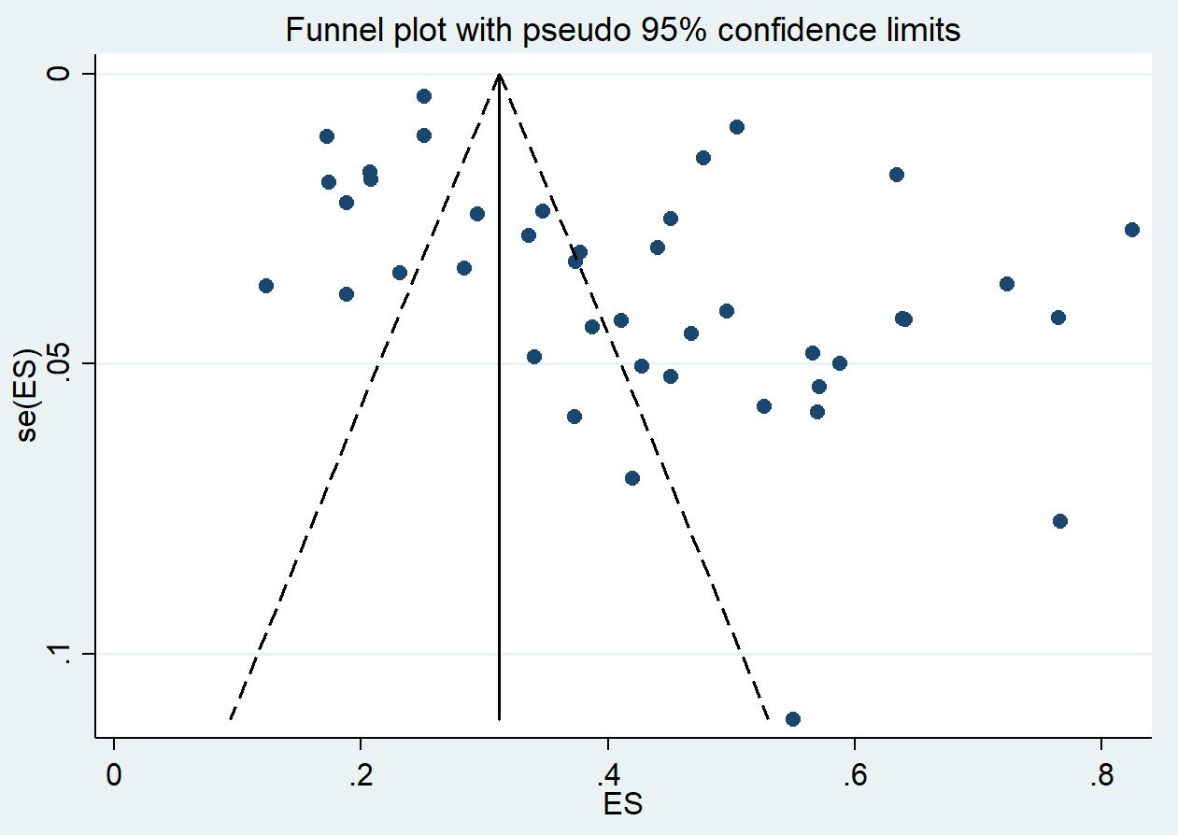

Supplemental Figure 2: Gender - female
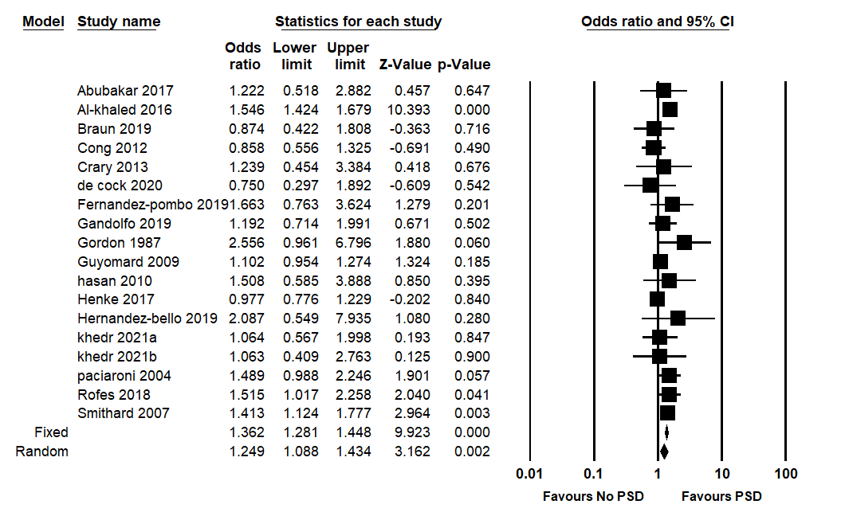

Supplemental Figure 3: Gender - male
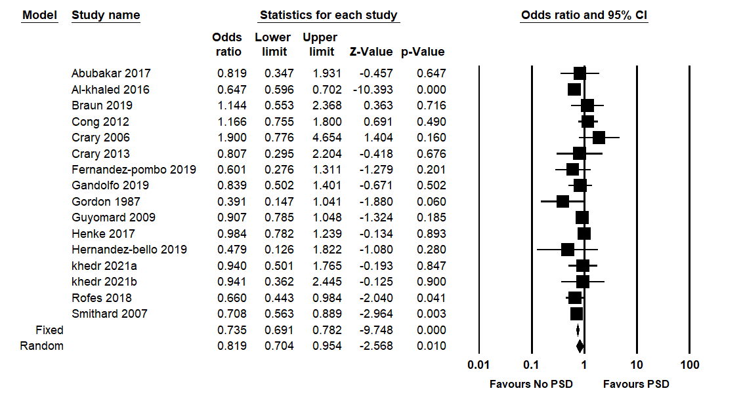

Supplemental Figure 4: Haemorrhagic stroke
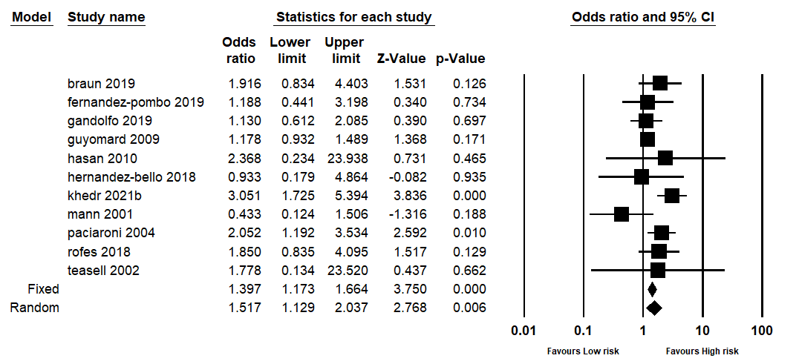

Supplemental Figure 5: Ischaemic stroke
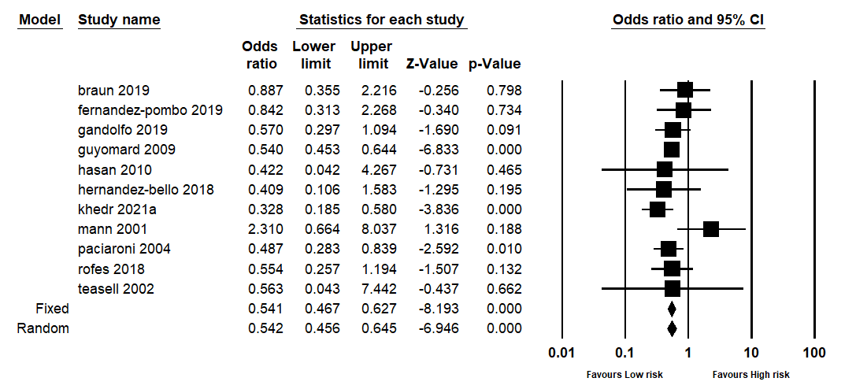

Supplemental Figure 6: Previous stroke
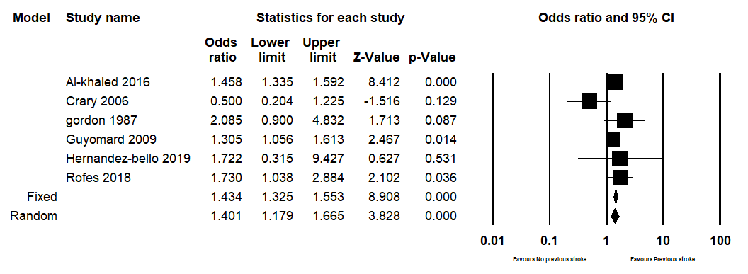

Supplemental Figure 7: Stroke severity
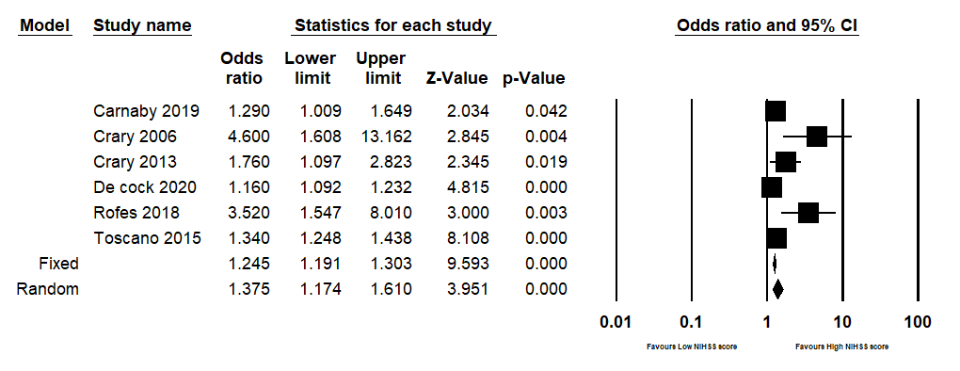

Supplemental Figure 8: Diabetes mellitus
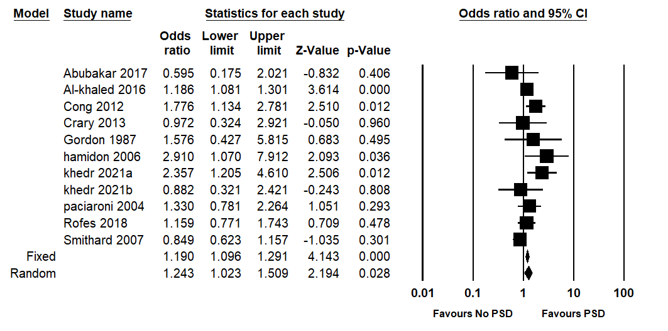

Supplemental Figure 9: Hypertension
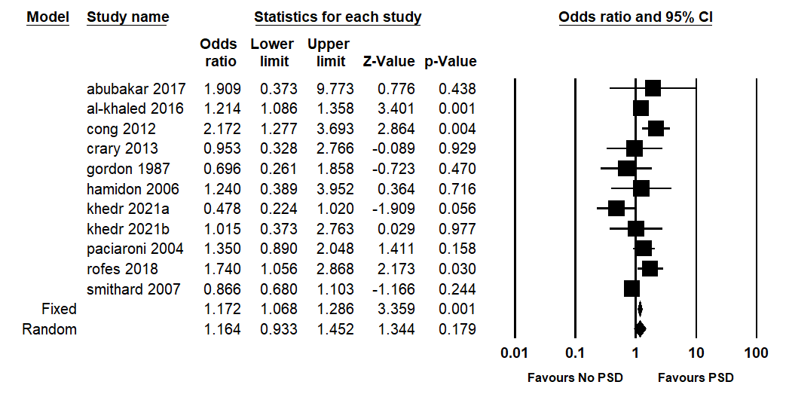

Supplemental Figure 10: Atrial fibrillation
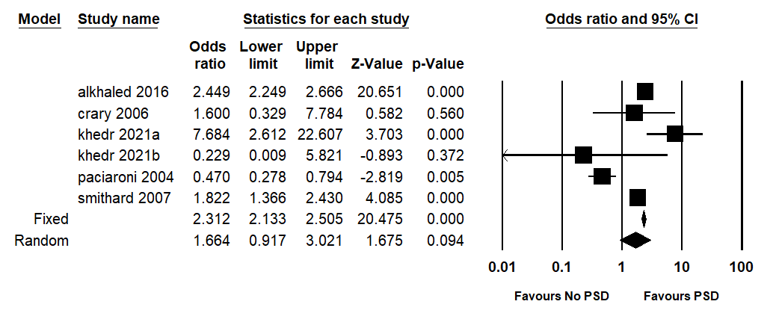

Supplemental Figure 11: Hyperlipidaemia
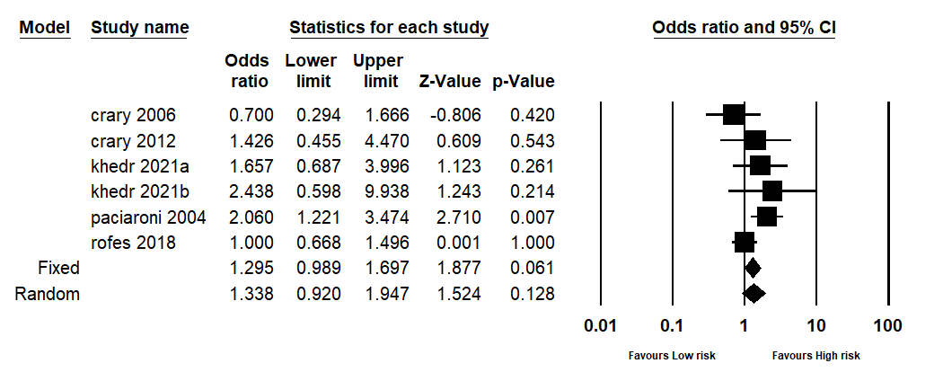
Supplemental Figure 12: Right hemisphere
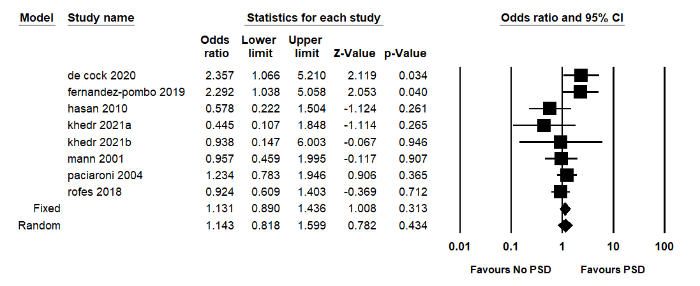

Supplemental Figure 13: Left hemisphere
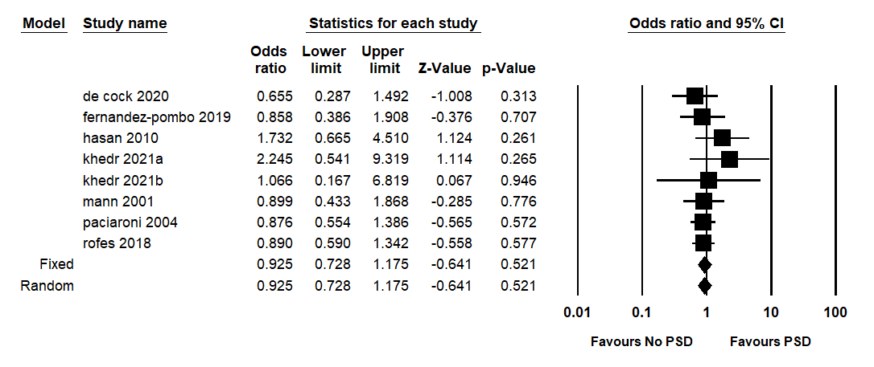

Supplemental Figure 14: TACS
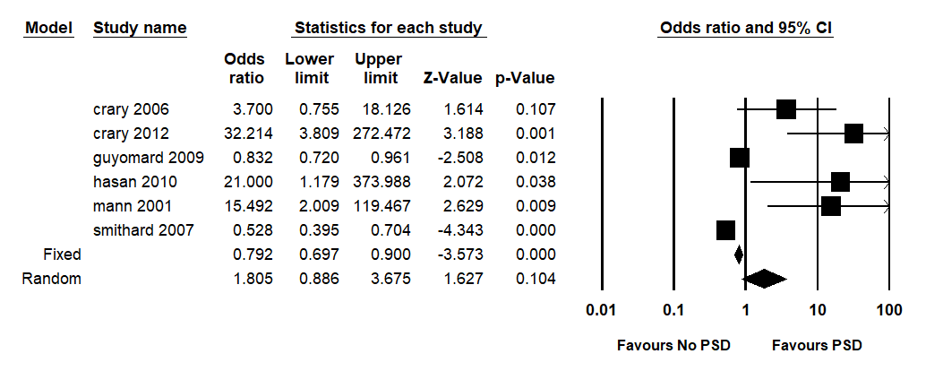
Supplemental Figure 15: Partial anterior circulation syndrome (PACS)
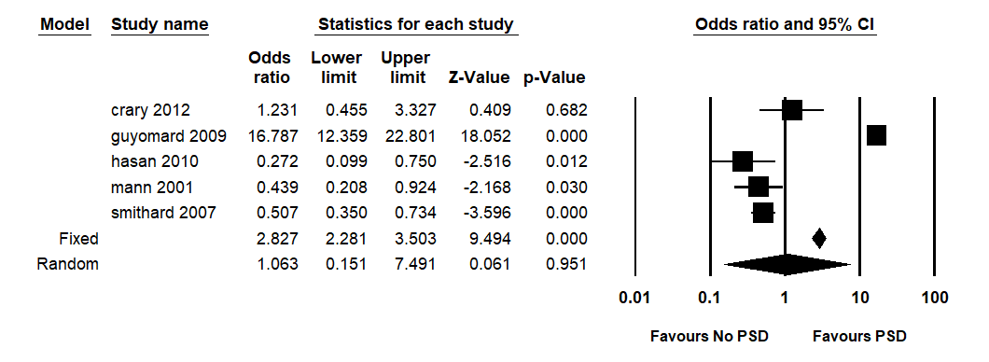

Supplemental Figure 16: Posterior circulation syndrome (POCS)
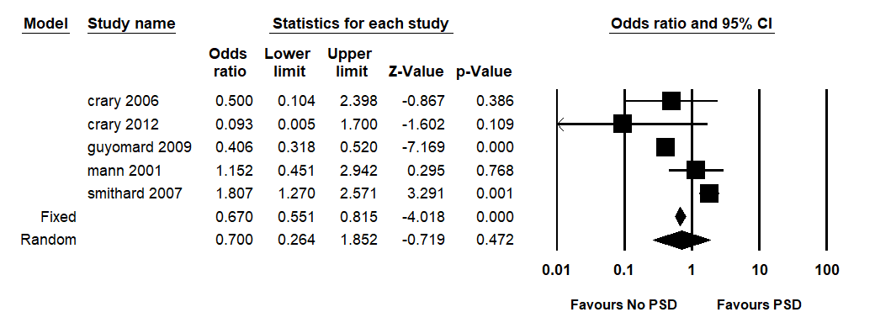

Supplemental Figure 17: Lacunar syndrome (LACS)
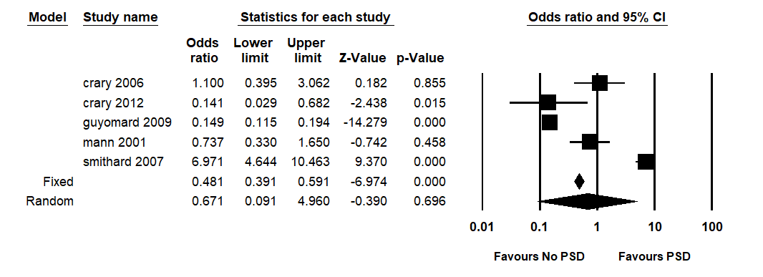
Supplemental references
1. Abubakar SA, Jamoh BY. Dysphagia following acute stroke and its effect on short-term outcome. Niger Postgrad Med J 2017; 24 (3): 182-186.
2. Al-Khaled M, Matthis C, Binder A et al. Dysphagia in Patients with Acute Ischemic Stroke: Early Dysphagia Screening May Reduce Stroke-Related Pneumonia and Improve Stroke Outcomes. Cerebrovasc Dis 2016; 42 (1-2): 81-89.
3. Barer DH. The natural history and functional consequences of dysphagia after hemispheric stroke. Journal of Neurology Neurosurgery and Psychiatry 1989; 52 (2): 236-241.
4. Braun T, Juenemann M, Viard M et al. Adjustment of oral diet based on flexible endoscopic evaluation of swallowing (FEES) in acute stroke patients: A cross-sectional hospital-based registry study. BMC Neurology 2019; 19 (1): 1-10.
5. Broadley S, Croser D, Cottrell M et al., Predictors of prolonged dysphagia following acute stroke. Journal of Clinical Neuroscience 2003; 10 (3): 300-305.
6. Carnaby G, Sia I, Crary M. Associations between spontaneous swallowing frequency at admission, dysphagia, and stroke-related outcomes in acute care. Archives of Physical Medicine & Rehabilitation 2019; 100 (7): 1283-1288.
7. Cong L, Jiang HT. Analysis of the risk factors associated with swallowing dysfunction in patients with ischemic stroke. Chinese Journal of Cerebrovascular Diseases 2012; 9 (8): 408-411.
8. Crary MA, Carnaby-Mann GD, Miller L, Antonios N, Silliman S. Dysphagia and nutritional status at the time of hospital admission for ischemic stroke. J Stroke Cerebrovasc Dis 2006; 15 (4): 164-71.
9. Crary MA, Humphrey JL, Carnaby-Mann G, Sambandam R, Miller L, Silliman S. Dysphagia, Nutrition, and Hydration in Ischemic Stroke Patients at Admission and Discharge from Acute Care. Dysphagia 2013; 28 (1): 69-76.
10. De Cock E, Batens K, Hemelsoet D, Boon P, Oostra K, De Herdt V. Dysphagia, dysarthria and aphasia following a first acute ischaemic stroke: incidence and associated factors. European Journal of Neurology, 2020; 27 (10): 2014-2021.
11. Diendéré J, Millogo A, Philippe F et al. Post-stroke complications and mortality in burkinabè hospitals: relationships with deglutition disorders and nutritional status. Dysphagia 2021; 36 (1):85-95.
12. Ding Y, Yan Y, Niu J et al. Braden scale for assessing pneumonia after acute ischaemic stroke. BMC Geriatrics 2019; 19 (1):1-7.
13. Fernández-Pombo A, Seijo-Raposo IM, López-Osorio N et al. Lesion location and other predictive factors of dysphagia and its complications in acute stroke. Clinical Nutrition ESPEN 2019; 1 (33): 178-182.
14. Gandolfo C, Sukkar S, Ceravolo MG et al. The predictive dysphagia score (PreDyScore) in the short- and medium-term post-stroke: a putative tool in PEG indication. Neurological Sciences 2019; 40 (8): 1619-1626.
15. Gordon C, Hewer RL, Wade DT. Dysphagia in acute stroke. British Medical Journal Clinical Research Ed 1987; 295 (6595): 411-414.
16. Gottlieb D, Kipnis M, Sister E, Vardi Y, Brill S. Validation of the 50 ml3 drinking test for evaluation of post-stroke dysphagia. Disability & Rehabilitation 1996. 18 (10): 529-532.
17. Guyomard V, Fulcher RA, Redmayne O, Metcalf AK, Potter JF, Myint PK. Effect of dysphasia and dysphagia on inpatient mortality and hospital length of stay: a database study. J Am Geriatr Soc 2009; 57 (11): 2101-2106.
18. Hamidon BB, Nabil I, Raymond AA. Risk factors and outcome of dysphagia after an acute ischaemic stroke. Med J Malaysia 2006; 61 (5): 553-557.
19. Hasan ZN, Al-Shimmery EK, Taha MA. Evaluation of neurogenic dysphagia in Iraqi patients with acute stroke. Neurosciences (Riyadh) 2010; 15 (2): 90-96.
20. Henke C, Foerch C, Lapa S. Early Screening Parameters for Dysphagia in Acute Ischemic Stroke. Cerebrovasc Dis 2017; 44 (5-6): 285-290.
21. Hernández-Bello E, Castellot-Perales L, Tomás-Aznar C. Assessment of dysphagia with the V-VST in patients hospitalised after a stroke. Revista Cientifica de la Sociedad Espanola de Enfermeria Neurologica 2019 (49): 8-15.
22. Khedr EM, Abbass MA, Soliman RK, Zaki AF, Gamea A. Post-stroke dysphagia: frequency, risk factors, and topographic representation: hospital-based study. The Egyptian Journal of Neurology, Psychiatry and Neurosurgery 2021; 57 (1): 1-8.
23. Kwon HM, Jeong SW, Lee SH, Yoon BW. The pneumonia score: a simple grading scale for prediction of pneumonia after acute stroke. American journal of infection control 2006; 34 (2): 64-68.
24. Lendinez-Mesa A, del Carmen Díaz-García M, Casero-Alcázar M, Grantham SJ, de la Torre-Montero JC, Fernandes-Ribeiro AS. Prevalence of oropharyngeal dysphagia inpatients related with cerebrovascular disease at a neurorehabilitation unit. Revista Cientifica de la Sociedad Espanola de Enfermeria Neurologica 2017; 45: 3-8.
25. Li J, Wang Y, Sun X et al. AND score: a simple tool for predicting infection in acute ischemic stroke patients without a ventilator in the Chinese population. Journal of International Medical Research 2020; 48 (3): 0300060519888303.
26. Mann G, Hankey GJ. Initial clinical and demographic predictors of swallowing impairment following acute stroke. Dysphagia 2001; 16 (3): 208-215.
27. Nam KW, Kwon HM, Lim JS, Lee YS. Leukoaraiosis is associated with pneumonia after acute ischemic stroke. BMC Neurology 2017; 17 (1): 1-5.
28. Odderson IR, Keaton JC, McKenna BS. Swallow management in patients on an acute stroke pathway: quality is cost effective. Archives of physical medicine and rehabilitation 1995; 76 (12): 1130-1133.
29. Paciaroni M, Mazzotta G, Corea F et al. Dysphagia following stroke. European Neurology 2004; 51 (3): 162-167.
30. Rofes L, Muriana D, Palomeras E et al. Prevalence, risk factors and complications of oropharyngeal dysphagia in stroke patients: a cohort study. Neurogastroenterology & Motility 2018; 30 (8): e13338.
31. Schelp AO, Cola PC, Gatto AR, Silva RG, Carvalho LR. Incidence of oropharyngeal dysphagia associated with stroke in a regional hospital in São Paulo State - Brazil. Arquivos de Neuro-Psiquiatria 2004; 62 (2 B): 503-506.
32. Shibazaki K, Kimura K, Aoki J, Uemura J, Fujii S, Sakai K. Dysarthria plus dysphagia is associated with severe sleep-disordered breathing in patients with acute intracerebral hemorrhage. European Journal of Neurology 2014; 21 (2): 344-348.
33. Smithard DG, Smeeton NC, Wolfe CD. Long-term outcome after stroke: does dysphagia matter? Age Ageing 2007; 36 (1): 90-94.
34. Sundar U, Pahuja V, Dwivedi N, Yeolekar ME. Dysphagia in acute stroke: Correlation with stroke subtype, vascular territory and in-hospital respiratory morbidity and mortality. Neurology India 2008; 56 (4): 463-470.
35. Suntrup S, Warnecke T, Kemmling A et al. Dysphagia in patients with acute striatocapsular hemorrhage. Journal of Neurology 2012; 259 (1): 93-99.
36. Suntrup S, Kemmling A, Warnecke T et al. The impact of lesion location on dysphagia incidence, pattern and complications in acute stroke. Part 1: Dysphagia incidence, severity and aspiration. European Journal of Neurology 2015; 22 (5): 832-838.
37. Szu LY, Hsieh SI, Tseng SM, Huang TH. The determinants of dysphagia in patients with stroke during hospitalized rehabilitation. Hu Li Za Zhi The Journal of Nursing 2017; 64 (3): 43-55.
38. Teasell R, Foley N, Fisher J, Finestone H. The incidence, management, and complications of dysphagia in patients with medullary strokes admitted to a rehabilitation unit. Dysphagia 2002; 17 (2): 115-120.
39. Toscano M, Cecconi E, Capiluppi E et al. Neuroanatomical, clinical and cognitive correlates of post-stroke dysphagia. European Neurology 2015; 74 (3-4): 171-177.
40. Turner-Lawrence DE, Peebles M, Price MF, Singh SJ, Asimos AW. A feasibility study of the sensitivity of emergency physician Dysphagia screening in acute stroke patients. Annals of Emergency Medicine 2009; 54 (i3): 344-348.
41. Zhang X, Wang F, Zhang Y, Ge Z. Risk factors for developing pneumonia in patients with diabetes mellitus following acute ischaemic stroke. J Int Med Res 2012; 40 (5): 1860-1865.
42. Zhang J, Zhao X, Wang A et al. Emerging malnutrition during hospitalisation independently predicts poor 3-month outcomes after acute stroke: data from a Chinese cohort. Asia Pacific Journal of Clinical Nutrition 2015; 24 (3): 379-386.

