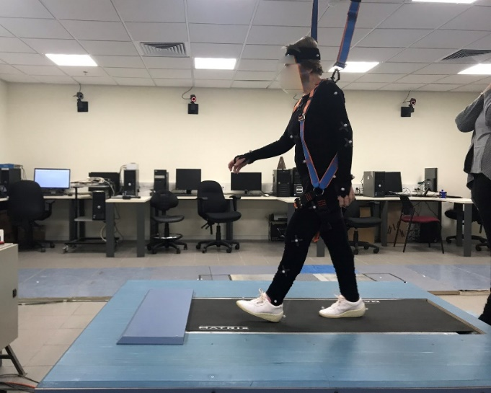
Fig 1 (supplementary). Experimental setup.

