Additional file 3. Combined Cognitive and Physical Training-CCPT (BIGMAP) [15]
BIGMAP  Intervention Characteristics | 16 wk, 2 d/wk, 60 min/session  Participants will be assigned into 3 groups and practice a task for 15 min.
BIGMAP Characteristics | 10 “Think and Act” tasks with various levels of difficulties involving  low to high intensities of mental and physical activities.
Sample Task | Square Walking consists of 12 different levels.
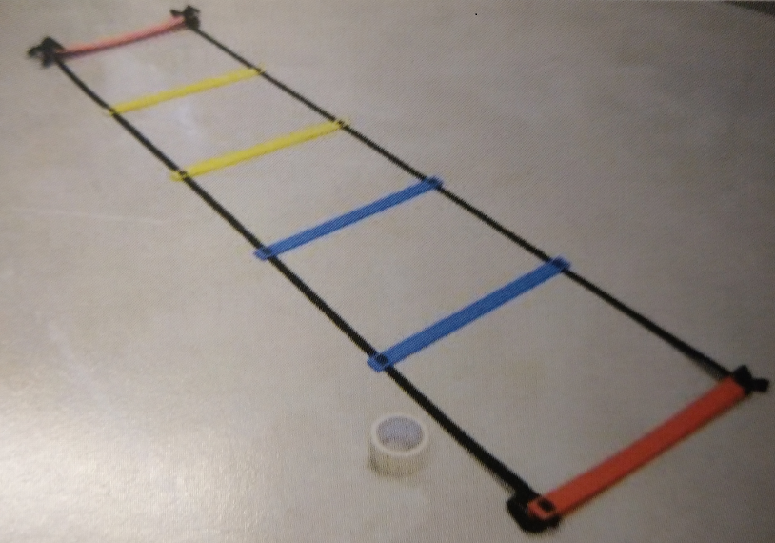  Red=Left foot  Blue=Right foot  1…20 Step sequence | Level 1 Walk Forward | Level 4 Side Stepping | Level 12 Cross Stepping
 | 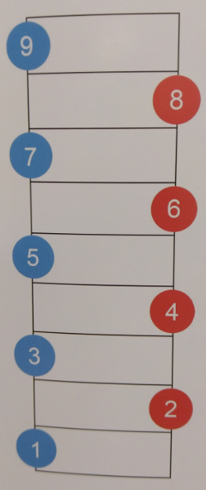 | 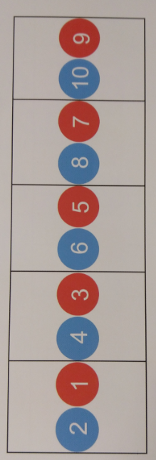 | 