Supplemental Figure 1. Kaplan–Meier curve for all-cause death based on the excluded and included patients.

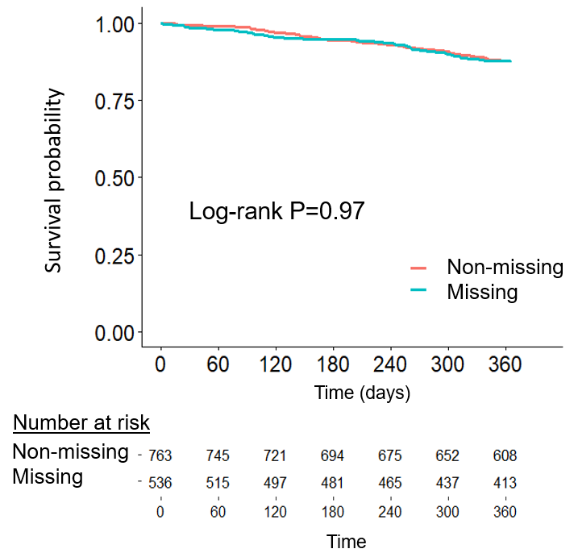

Supplemental Figure 2. Kaplan–Meier curve for cardiovascular death (A) and non-cardiovascular death (B) according to the excluded patients and the study patients.

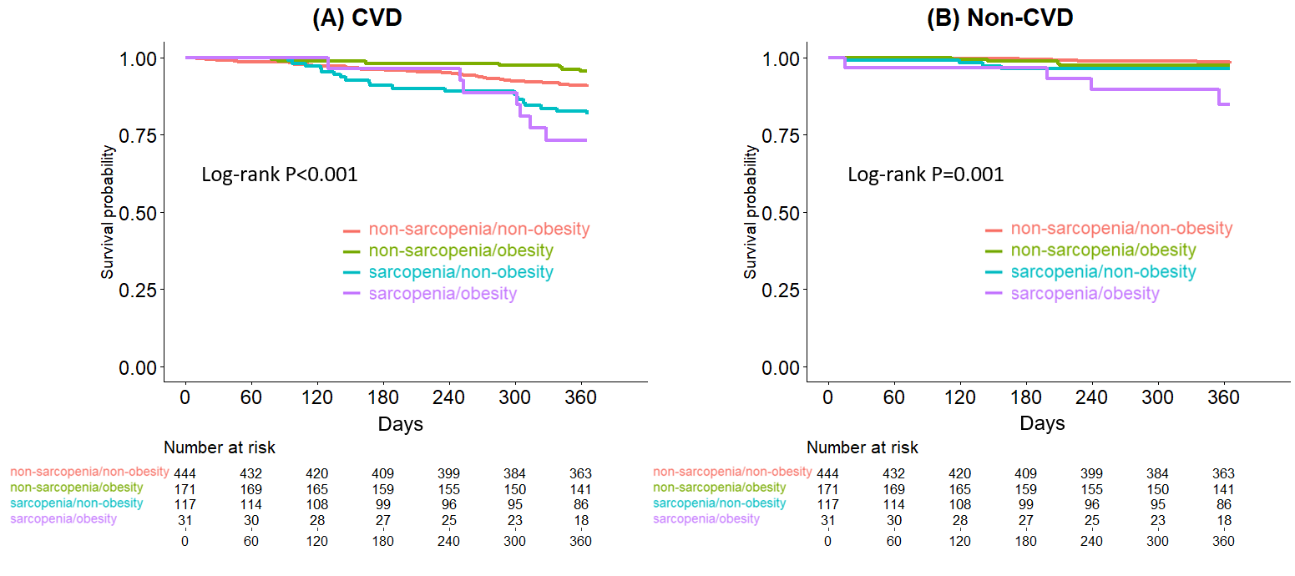

CVD; cardiovascular death

