Appendix
Appendix 1: Visual Representation of Table 2
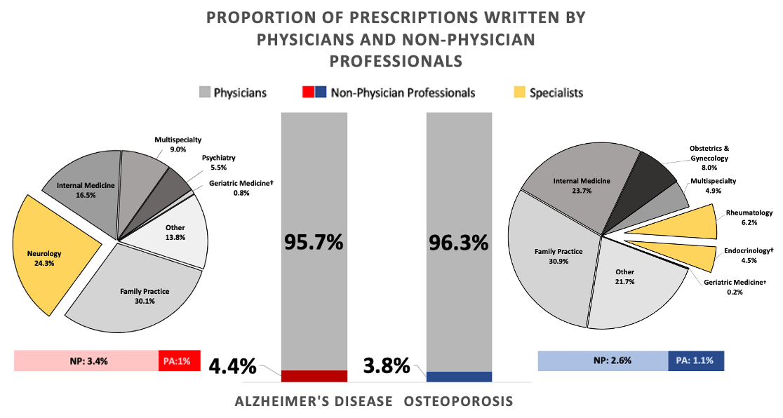
Abbreviations: NPs = Nurse Practitioners, PAs = Physician Assistants

Appendix 2: Data for Figure 2
Osteoporosis
 | Alendronate | Ibandronate | Raloxifene | Risedronate | Denosumab | Teriparatide | Abaloparatide | Zoledronic Acid | Alendronate & Cholecalciferol
PA | 63.38% | 13.86% | 9.99% | 8.02% | 2.79% | 1.70% | 0.14% | 0 | 0.14%
NP | 64.53% | 14.66% | 12.01% | 5.77% | 1.76% | 0.95% | 0.23% | 0.03% | 0.06%
MD | 61% | 14.09% | 12.73% | 8.24% | 2.51% | 1.03% | 0.17% | 0.15% | 0.09%

Alzheimer’s Disease
 | Donepezil | Memantine | Rivastigmine | Galantamine | Donepezil & Memantine
PA | 50.90% | 40.22% | 7.29% | 1.60% | 0.00%
NP | 52.14% | 39.09% | 8.02% | 1.38% | 1.41%
MD | 57.47% | 33.34% | 7.74% | 1.42% | 0.03%

Abbreviations: NP = Nurse Practitioner, PA = Physician Assistants, MD = Medical Doctor

Appendix 3: Data for Figure 3
Rurality  (NCHS) | Alzheimer’s Disease |  |  |  | Osteoporosis
Rurality  (NCHS) | Total | Specialists | NP | PA | Total | Specialists | NP | PA
MSA = 0 | 19638 | 4292 | 858 | 289 | 18554 | 1290 | 1026 | 411
1 | 8906 | 2038 | 221 | 96 | 25093 | 959 | 205 | 120
2 | 33402 | 7986 | 910 | 236 | 49351 | 6217 | 907 | 395
3 | 20064 | 4318 | 776 | 237 | 25093 | 2278 | 764 | 311
4 | 8643 | 1804 | 359 | 67 | 10363 | 830 | 370 | 120
5 | 4 | 1 | 1 | 0 | 11 | 4 | 1 | 0
6 | 0 | 0 | 0 | 0 | 0 | 0 | 0 | 0
Excluded* | 12410 |  |  |  | 16442
*MSA not listed in the Census Bureau Crosswalk
National Center for Health Statistics (NCHS) Rurality Classification: (1: Large central metro, 2: Large fringe metro, 3: Medium Metro, 4: Small Metro, 5: Micropolitan, 6: Non-Core)
Abbreviations: NCHS = National Center for Health Statistics, NP = Nurse Practitioner, PA = Physician Assistant

Appendix 4: Regional Top and Bottom Analysis
 | AD Top 5% |  | AD Bottom 5%
 | Mean | SD | Mean | SD
Percent NP/PA | 17.30% | 2.41 | 0.9% | 0.04
County Population | 135,103 | 173,109 | 680,809 | 1,923,149
Median Household Income | $62,642 | 8,909 | $67,509 | 15716
Unemployment | 3.57% | 0.76 | 3.37% | 0.51
% High School | 9.4% | 4.1 | 12.86% | 4.33
% College | 30.20% | 11.6 | 27.91% | 12.67

Abbreviations: AD = Alzheimer’s Disease, SD = Standard Deviation, NP = Nurse Practitioner, PA = Physician Assistant

Appendix 5: Results of the 2-sample independent z-tests
Test | Coefficient | Result (p-value and 95% CI)
Provider type proportions: AD compared to OP
Specialists* | 0.188 | p-value < 0.001 | (0.185, 0.191)
Nurse Practitioners* | 0.007 | p-value < 0.001 | (0.006, 0.008)
Physician Assistants* | -0.004 | p-value < 0.001 | (-0.002, -0.0006)
NPs/PAs* | -0.0013 | p-value < 0.001 | (0.004, 0.008)
Medicines prescribed: physicians compared to NPs/PAs
Donepezil* | 0.056 | p-value < 0.001 | (0.041, 0.071)
Memantine* | -0.0445 | p-value < 0.001 | (-0.059, -0.030)
Rivastigmine | -0.001 | p-value = 0.815 | (-0.009, 0.007)
Galantamine | 0 | p-value = 1 | (-0.004, 0.004)
Donepezil & Memantine* | -0.011 | p-value < 0.001 | (-0.014, -0.008)
Medicines prescribed: physicians compared to NPs/PAs
Alendronate* | 0.032 | p-value < 0.001 | (0.018, 0.046)
Ibandronate | 0.003 | p-value = 0.527 | (-0.007, 0.013)
Raloxifene* | -0.013 | p-value = 0.007 | (-0.022, -0.004)
Risedronate* | -0.018 | p-value < 0.001 | (-0.025, -0.011)
Denosumab | -0.0046 | p-value =0.058 | (-0.009, -0.0002)
Teriparatide | 0.011 | p-value = 0.3534| (0.012, 0.010)
Abaloparatide | 0.0005 | p-value = 0.738 | (-0.001, 0.002)
Zoledronic Acid | -0.0005 | p-value = 0.035 | (-0.002, -0.001)
Alendronate & Cholecalciferol | 0.001 | p-value = 1 | (0.001, 0.001)
Rural vs. Large Fringe Metro
AD Non-Physician PCPs* | 0.023 | p-value < 0.001 | (0.018,0.028)
AD Nurse Practitioners* | 0.0175 | p-value < 0.001 | (0.014, 0.023)
AD Physician Assistants* | 0.004 | p-value = 0.009 | (0.001, 0.007)
AD Specialists | -0.0104 | p-value = 0.055 | (-0.021, 0.0002)
OP Non-Physician PCPs* | 0.0665 | p-value < 0.001 | (0.064, 0.069)
OP Nurse Practitioners* | 0.0472 | p-value < 0.001 | (0.0434, 0.051)
OP Physician Assistants* | 0.0035 | p-value = 0.009 | (0.002,0.005)
OP Specialists* | 0.0315 | p-value = 0.001 | (0.027, 0.036)
*: Significant at alpha=0.05

Abbreviations: CI = Confidence Interval, AD = Alzheimer’s Disease, OP = Osteoporosis, NP = Nurse Practitioner, PA = Physician Assistant

