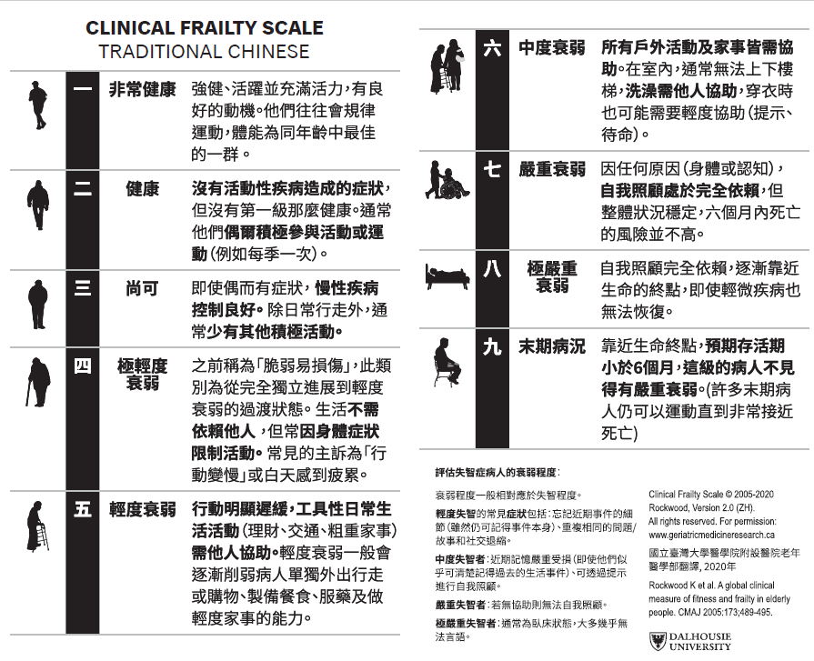
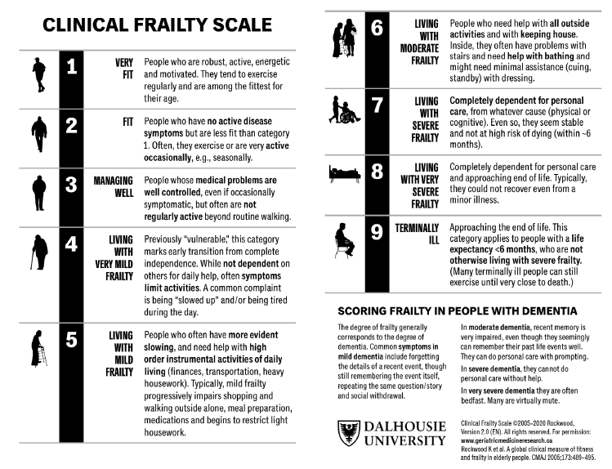
Additional file 3. The Clinical Frailty Scale 2.0 in English (left) and the Chinese translation (right)

