Interpretable classifiers for prediction of disability trajectories using a nationwide longitudinal database

Wave 2002 (n=16,064)
Wave 2005 (n=15,638)
Wave 2008 (n=16,540)
Wave 2011(n=9,765)
Wave 2014 (n=7,192)
Wave 2018 (n=15,874)
7,889 lost to follow up
7,463 newly recruited
8,166 lost to follow up
9,068 newly recruited
8,307 lost to follow up
1,532 newly recruited
3,698 lost to follow up
1,125 newly recruited
3,729 lost to follow up
12,411 newly recruited
n=16,064
n=4,149
Selected 2002 as baseline
11,915 excluded according to following criteria:
- aged< 65 years;
- Completed < 3 waves of ADL between 2000-2018.

Supplementary Fig. 1 | Flow chart of CLHLS-HF survey and sample selection in current analysis.

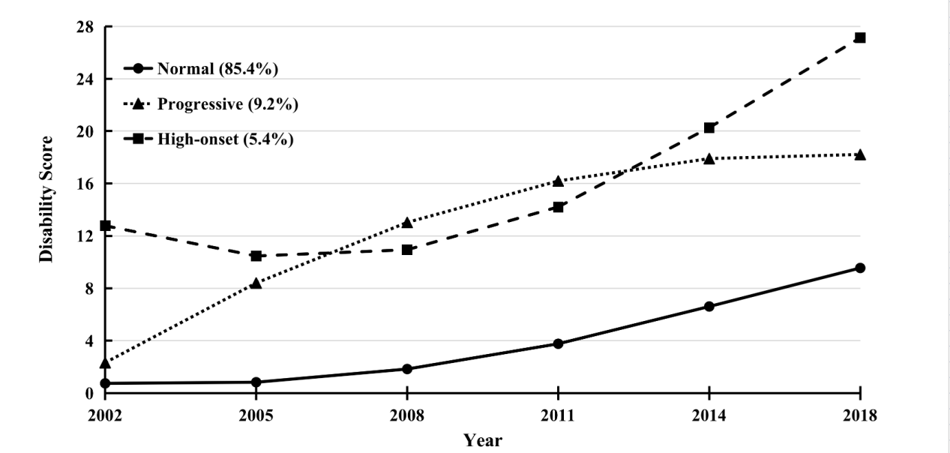
Supplementary Fig. 2 | Heterogenous disability trajectory classes of older adults with complete information for at least four waves (n= 2,457). Disability score (0-28) was measured by the sum score of BADL (0-12) and IADL (0-16). The three-class GMM was selected as final model (Bayesian information criteria= 68,354.452; entropy= 0.959; Vuong-Lo-Mendell-Rubin Likelihood Ratio Test p=0.003), including “Normal” class (intercept= 0.743, p<0.001; linear slope= -0.373, p<0.001; quadratic slope= 0.460, p<0.001), “Progressive” class (intercept= 2.325, p<0.001; linear slope= 6.814, p<0.001; quadratic slope= -0.730, p<0.001), and “High-onset” class (intercept= 12.780, p<0.001; linear slope= -3.707, p<0.001; quadratic slope= 1.395, p<0.001). It showed similar pattern of disability trajectory classes with our analytic sample (n= 4,149).

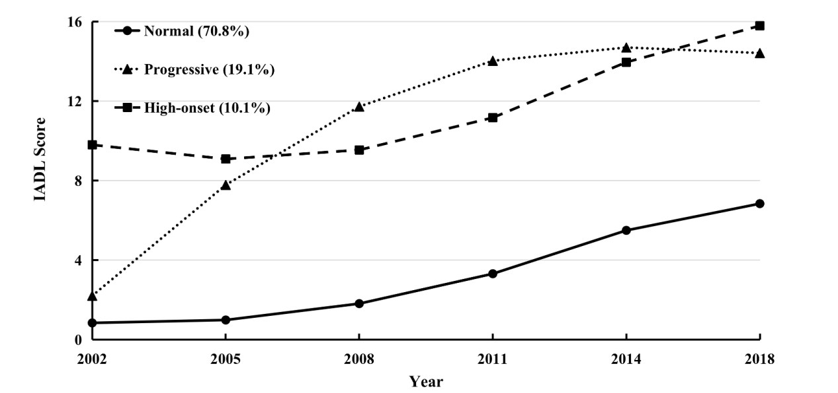
Supplementary Fig. 3 | Heterogenous IADL (0-16) trajectory classes of older adults with complete information for at least three waves (n= 4,149). The three-class GMM was selected as final model (Bayesian information criteria= 94,589.351; entropy= 0.927; Vuong-Lo-Mendell-Rubin Likelihood Ratio Test p<0.001), including “Normal” class (intercept= 0.838, p<0.001; linear slope= -0.193, p<0.001; quadratic slope= 0.339, p<0.001), “Progressive” class (intercept= 2.204, p<0.001; linear slope= 6.395, p<0.001; quadratic slope= -0.818, p<0.001), and “High-onset” class (intercept= 9.795, p<0.001; linear slope= -1.296, p<0.001; quadratic slope= 0.584, p<0.001). It showed similar pattern of disability trajectory classes with our analytic sample (n= 4,149).

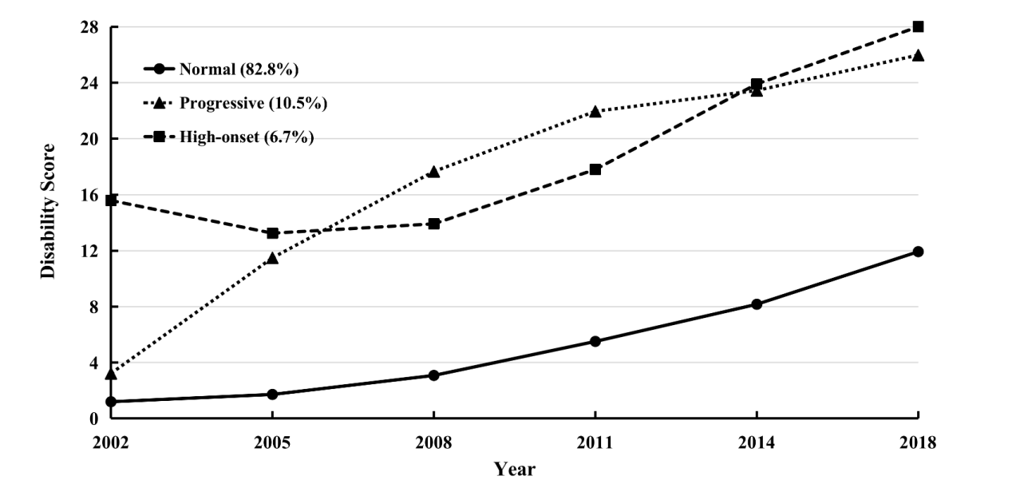
Supplementary Fig. 4 | Heterogenous disability trajectory classes of older adults with adjusting time-varying covariates (age) and time invariant covariates (sex, and education) for at least three waves (n= 4,149). Disability score (0-28) was measured by the sum score of BADL (0-12) and IADL (0-16). Three-class GMM was selected as final model (Bayesian information criteria= 97,625.671; entropy= 0.942; Vuong-Lo-Mendell-Rubin Likelihood Ratio Test p<0.001), including “Normal” class, “Progressive” class, and “High-onset” class. It showed similar pattern of disability trajectory classes with our analytic sample (n= 4,149).

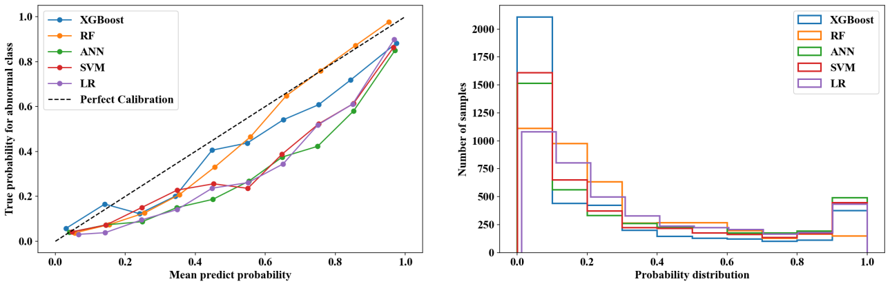
Supplementary Fig. 5 | Reliability curve and histogram of prediction probability of the models based on nested cross-validation.

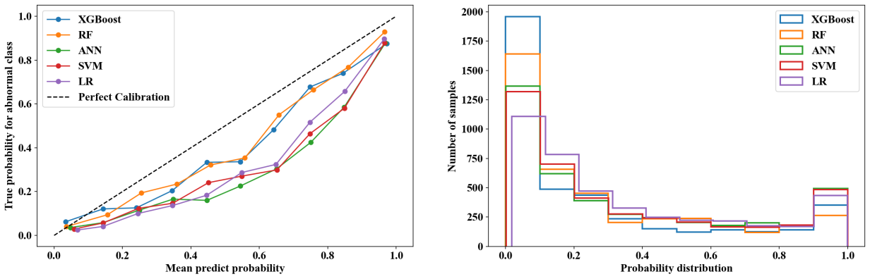
Supplementary Fig. 6 | Reliability curve and histogram of prediction probability of the models based on nested cross-validation when LASSO feature selection is performed.

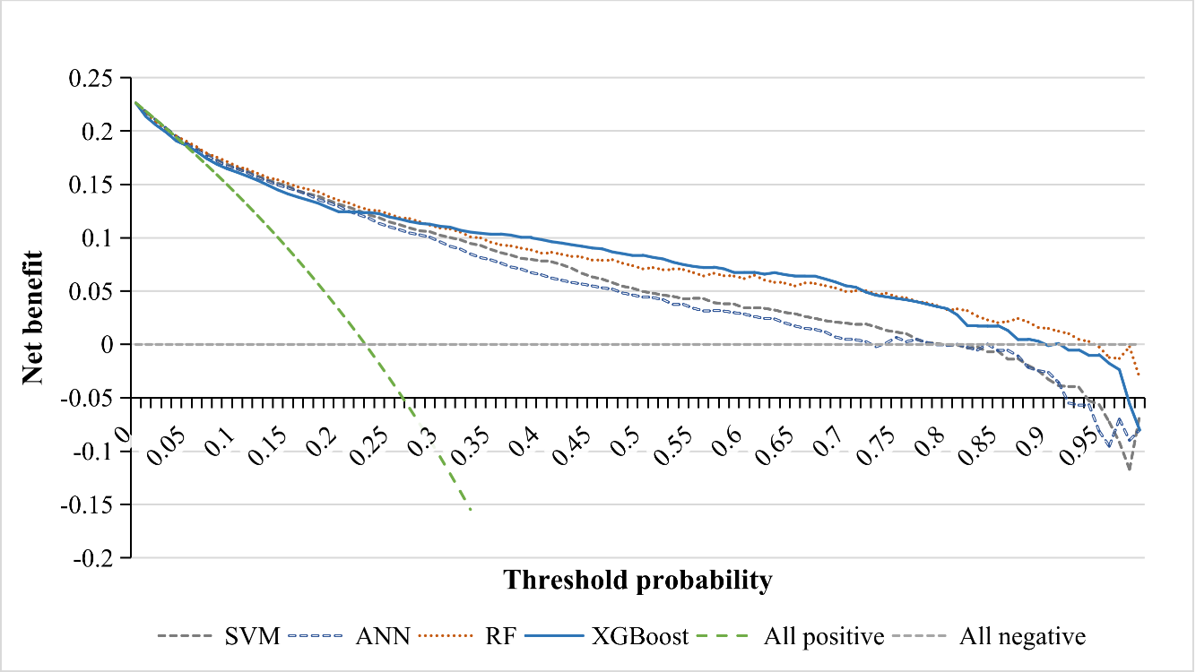

Supplementary Fig. 7 | Decision curve analysis for the prediction models when LASSO feature selection is performed.

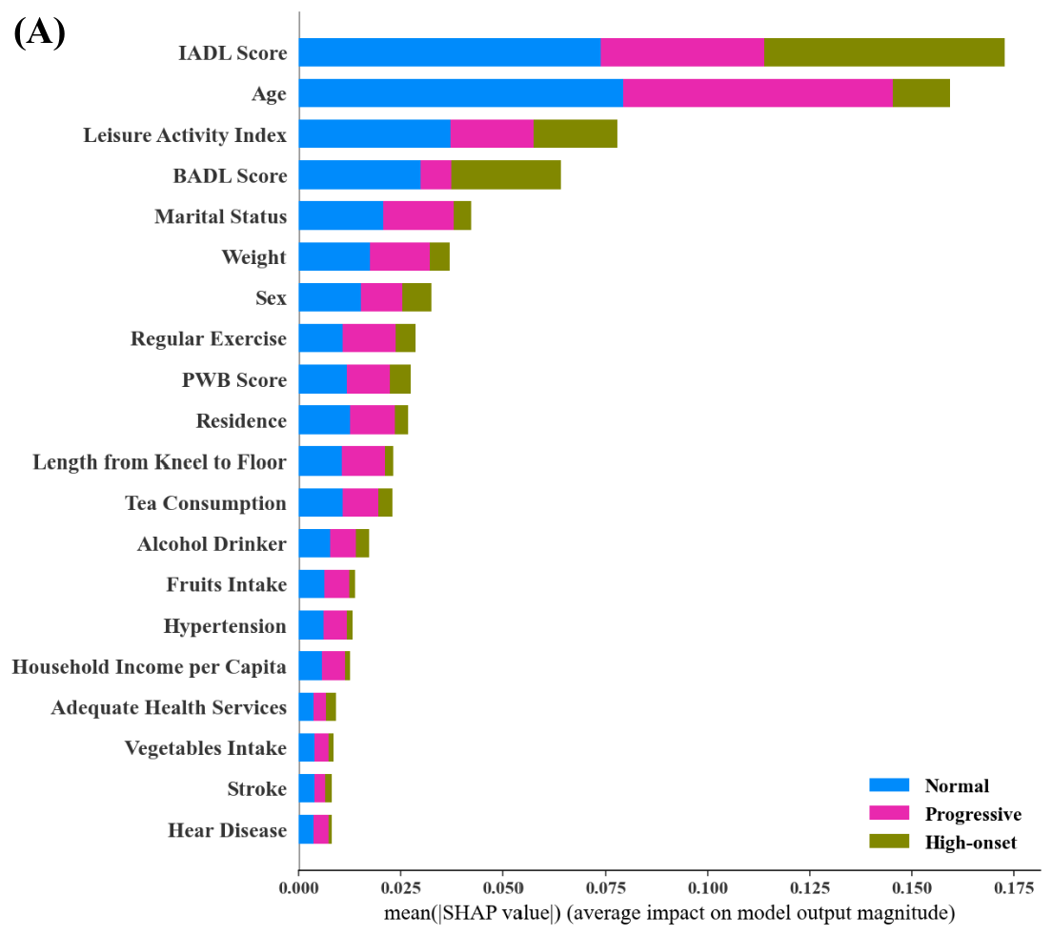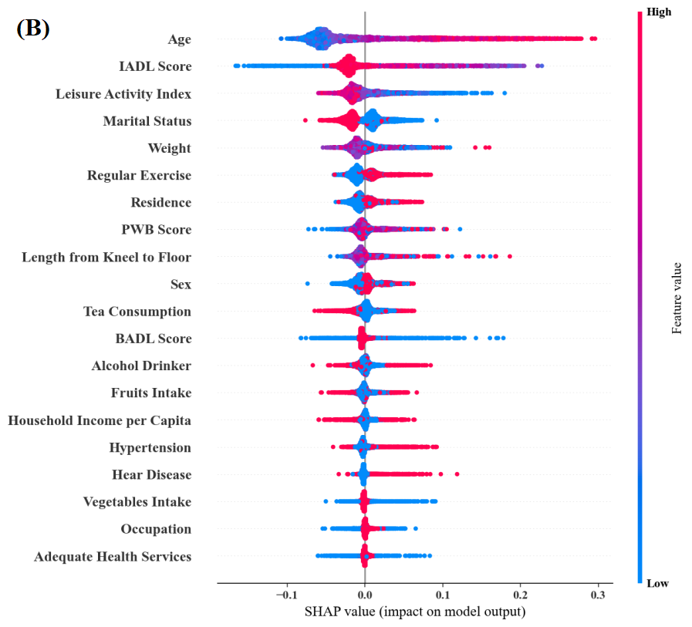

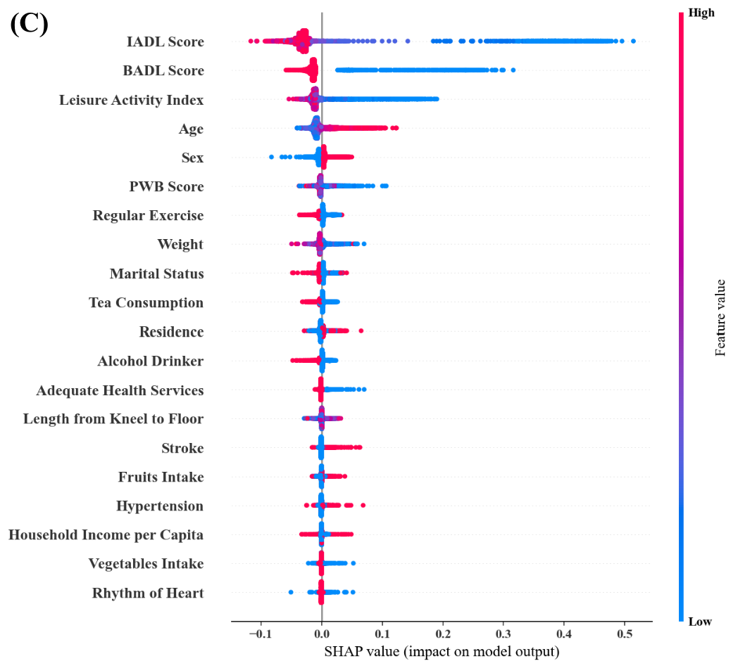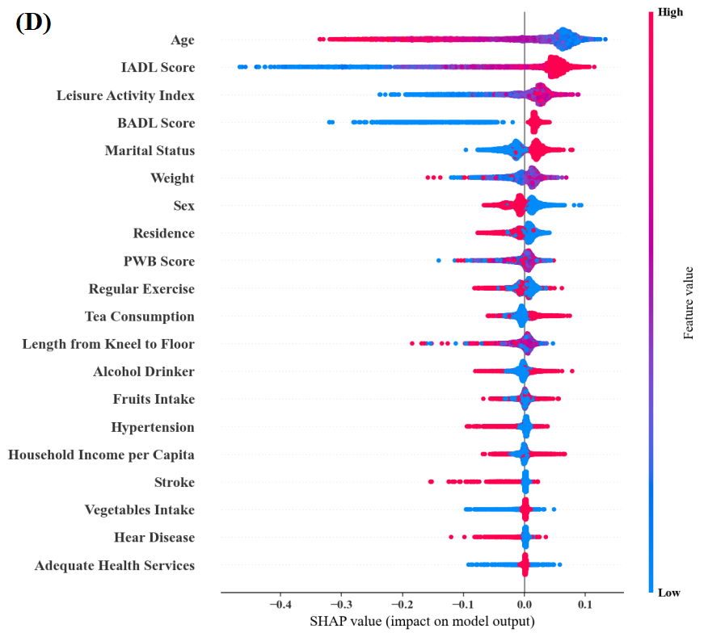

Supplementary Fig. 8 | The relative feature importance (top 20) of RF in three-class prediction when LASSO feature selection is performed. A: overall feature importance; B: SHAP summary plot when the expected trajectory is Progressive; C: SHAP summary plot when the expected trajectory is High-onset; D: SHAP summary plot when the expected trajectory is Normal.

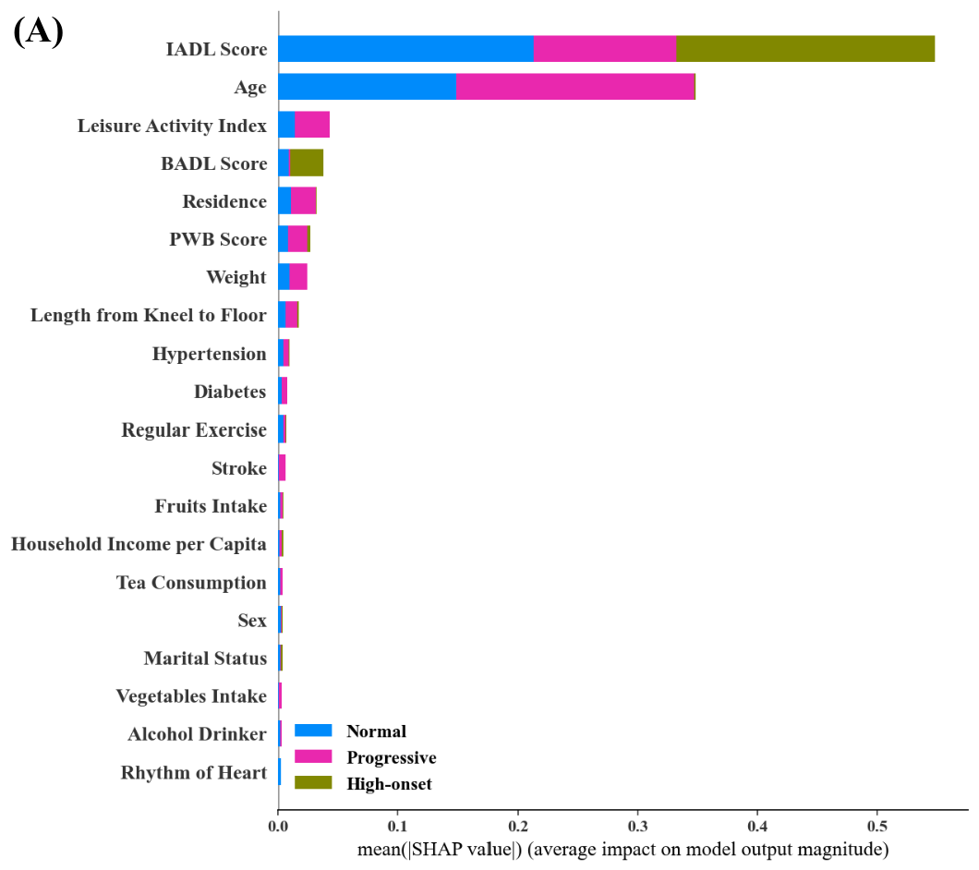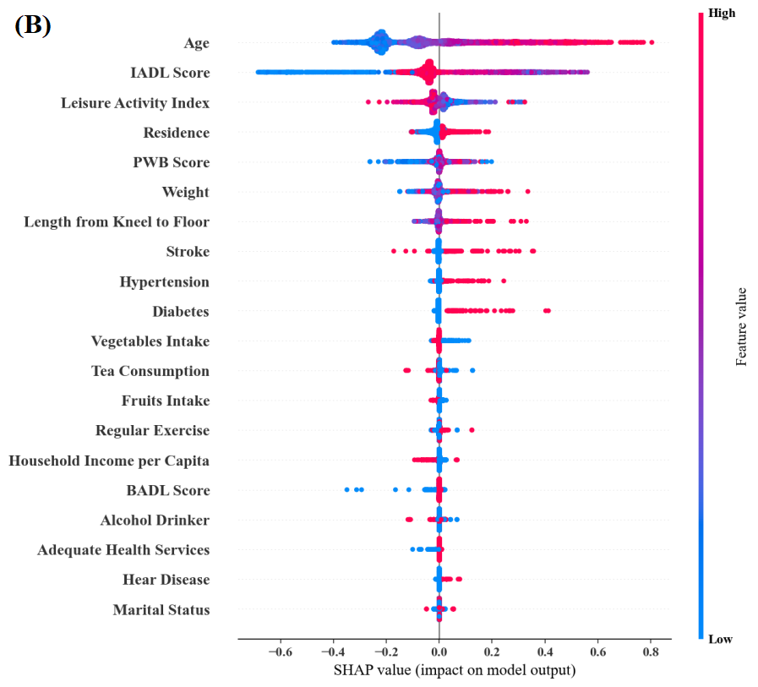

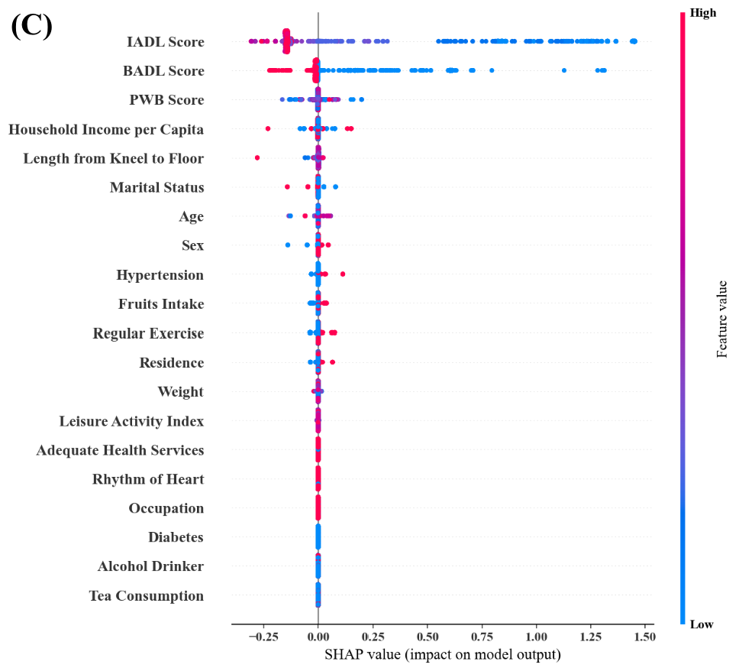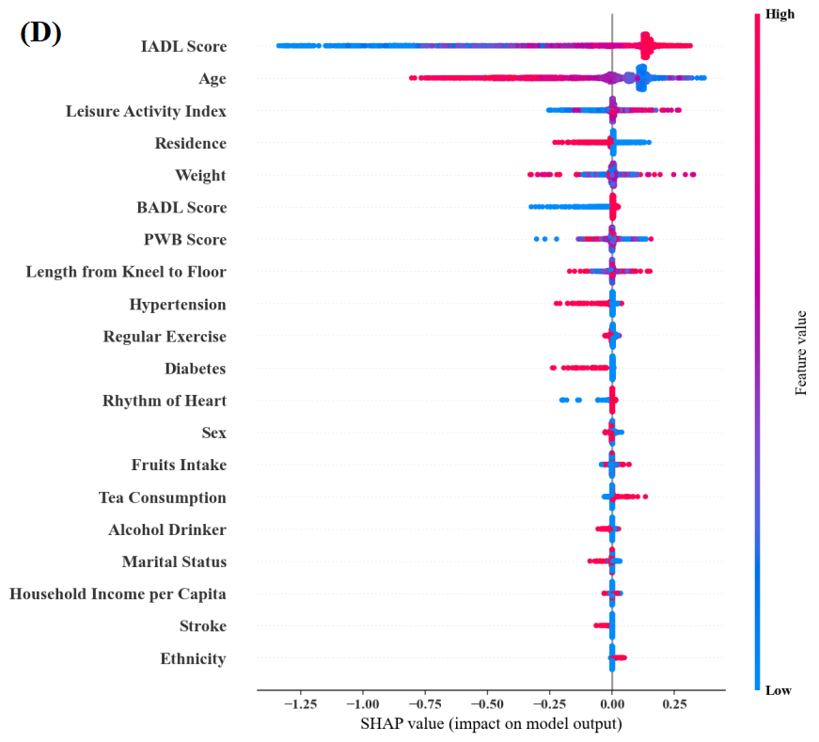

Supplementary Fig. 9 | The relative feature importance (top 20) of XGBoost in three-class prediction when LASSO feature selection is performed. A: overall feature importance; B: SHAP summary plot when the expected trajectory is Progressive; C: SHAP summary plot when the expected trajectory is High-onset; D: SHAP summary plot when the expected trajectory is Normal.

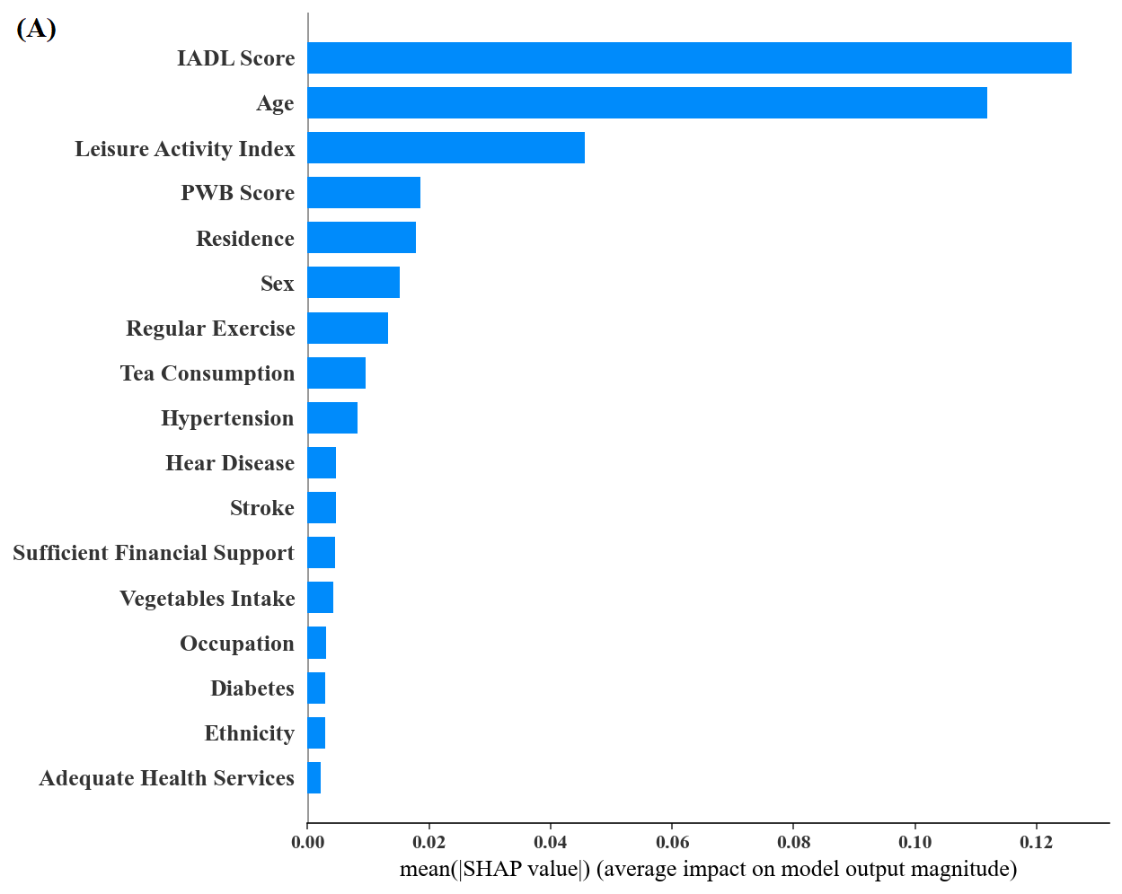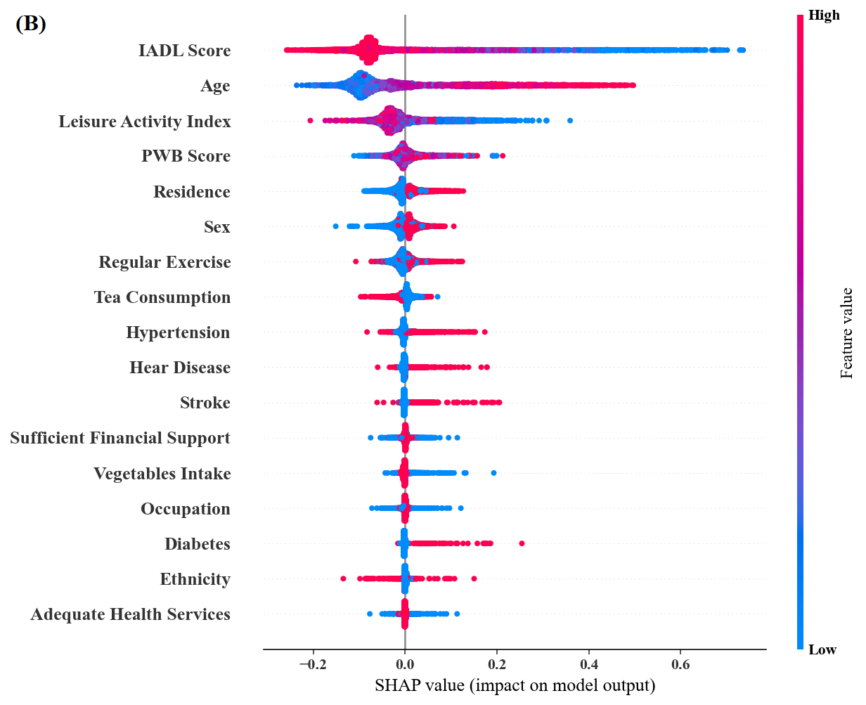
Supplementary Fig. 10 | The relative feature importance of RF in two-class prediction when LASSO feature selection is performed. A: overall feature importance; B: SHAP summary plot when the expected outcome is Abnormal.

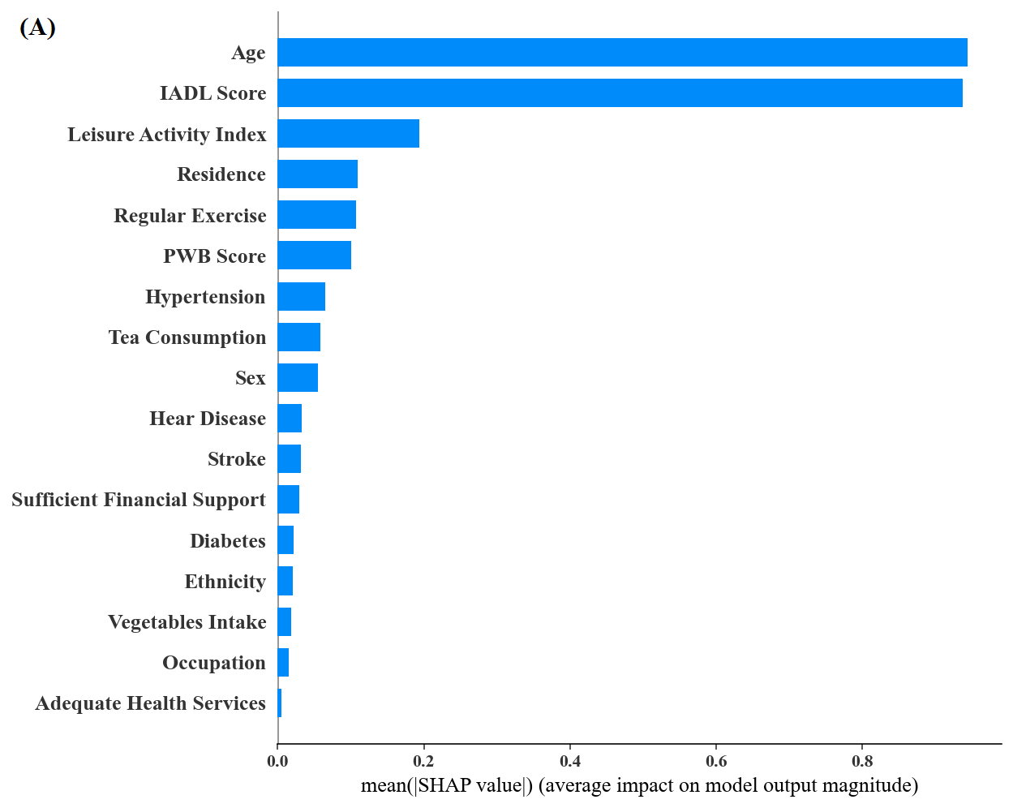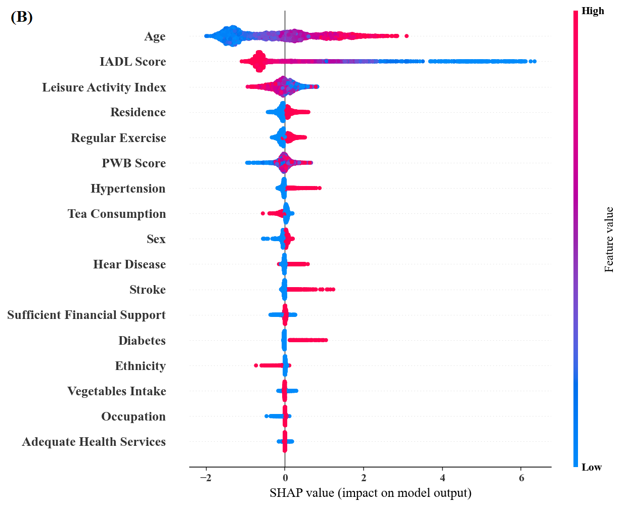
Supplementary Fig. 11 | The relative feature importance of XGBoost in two-class prediction when LASSO feature selection is performed. A: overall feature importance; B: SHAP summary plot when the expected outcome is Abnormal.

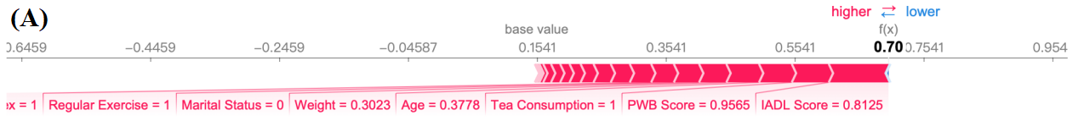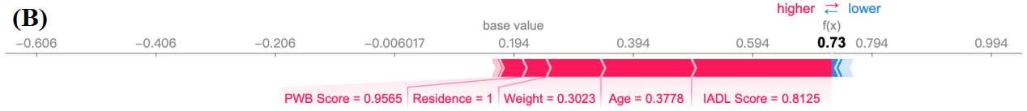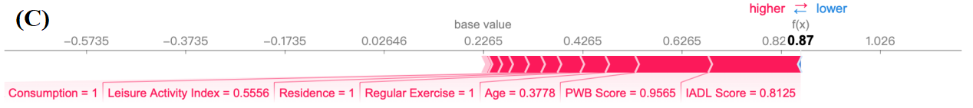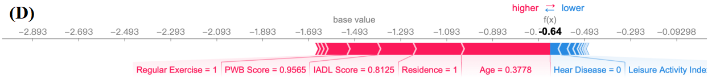
Supplementary Fig. 12 | Local interpretation of samples based on RF (A, C) and XGBoost (B, D) in LASSO selection data set. A: RF explanation when the expected trajectory is progressive; B: XGBoost explanation when the expected trajectory is progressive; C: RF explanation when the expected trajectory is abnormal; D: XGBoost explanation when the expected trajectory is abnormal.

Supplementary Table 1 | Measurement of variables in 2002.
Variables | Measurement
Sociodemographic Characteristics
Age | Continuous Variable
Sex | 0=Male, 1=Female
Ethnicity | 0=Han Ancestry, 1=Minority
Education | 0=Illiterate, 1=Literate
Occupation | 0=Low level, 1=High level
Marital Status | 0=Unmarried/Separated/Divorced/Widowed;  1=Married
Residence | 0=Rural, 1=Urban
Co-residence | 0=Living alone, 1=With family
Lifestyles
Fruits Intake | 0=Low frequency, 1=High frequency
Vegetables Intake | 0=Low frequency, 1=High frequency
Tea Consumption | 0=Low frequency, 1=High frequency
Smoker | 0=No, 1=Yes
Alcohol Drinker | 0=No, 1=Yes
Regular Exercise | 0=No, 1=Yes
Leisure Activity Index | Continuous Variable
Objective Examination
Weight | Continuous Variable
Systolic Pressure | Continuous Variable
Diastolic Pressure | Continuous Variable
Rhythm of Heart | 0=Irregular, 1=Regular
Heart Rate | Continuous Variable
Length from Wrist to Shoulder | Continuous Variable
Length from Kneel to Floor | Continuous Variable
Mental & Cognitive &Physical State
PWB Score* | Continuous Variable
MMSE Score* | Continuous Variable
BADL Score* | Continuous Variable
IADL Score* | Continuous Variable
Chronic Condition | Continuous Variable
Hypertension | 0=No, 1=Yes
Diabetes | 0=No, 1=Yes
Stroke | 0=No, 1=Yes
Hear Disease | 0=No, 1=Yes
Family Socioeconomic factors
Household Income per Capita | 0=Low level, 1=High level
Adequate Health Services | 0=No, 1=Yes
Sufficient Financial Support | 0=No, 1=Yes
Abbreviations: PWB, psychological well-being; BADL, basic activity of daily living; IADL, instrumental activity of daily living; MMSE, Mini-Mental State Examination.
Supplementary Table 2 | The parameters of disability trajectories with consideration of covariates (Age, Sex, Education).
 |  | Coefficients | P value
Sex | Intercept | 0.584 | <0.001
 | Linear slope | 0.027 | 0.836
 | Quadratic slope | 0.014 | 0.732
Education | Intercept | -0.328 | <0.001
 | Linear slope | 0.064 | 0.622
 | Quadratic slope | -0.046 | 0.243
Age2002ª | — | 0.121 | <0.001
Age2005 | — | 0.169 | <0.001
Age2008 | — | 0.256 | <0.001
Age2011 | — | 0.381 | <0.001
Age2014 | — | 0.531 | <0.001
Age2018 | — | 0.721 | <0.001
ª Age2002 represents the participants’ age in wave 2002, the others were in similar coding ways.

Supplementary Table 3 | Comparison of sample characteristics between analytical sample and drop-out sample
 | Multivariate Logistic
 | OR | P-value
Age | 0.94 (0.93-0.95) | 0.000
Sex (Ref: Male)
Female | 1.18 (1.00-1.39) | 0.044
Ethnicity (Ref: Han Ancestry)
Minority | 1.23 (0.94-1.62) | 0.135
Education (Ref: Illiterate)
Literate | 0.96 (0.83-1.11) | 0.575
Occupation (Ref: Low level)
High level | 1.10 (0.93-1.31) | 0.282
Marital Status
(Ref:Unmarried/Separated/Divorced/Widowed)
Married | 0.99 (0.86-1.15) | 0.907
Residence (Ref: Rural)
Urban | 0.65 (0.57-0.74) | 0.000
Co-residence (Ref: Living alone)
With family | 1.37 (1.13-1.65) | 0.001
Fruit Intake (Ref: Low frequency)
High frequency | 0.86 (0.75-0.98) | 0.022
Vegetables Intake
(Ref: Low frequency)
High frequency | 1.04 (0.84-1.28) | 0.750
Tea Consumption (Ref: Low frequency)
High frequency | 0.90 (0.79-1.03) | 0.115
Smoker (Ref: No)
Yes | 1.01 (0.88-1.17) | 0.854
Alcohol Drinker (Ref: No)
Yes | 1.07 (0.93-1.24) | 0.347
Regular Exercise (Ref: No)
Yes | 1.04 (0.91-1.18) | 0.611
Leisure Activity Index | 2.07 (1.17-3.64) | 0.012
Weight | 1.00 (0.99-1.01) | 0.888
Systolic Pressure | 1.00 (0.99-1.00) | 0.106
Diastolic Pressure | 1.00 (0.99-1.00) | 0.296
Rhythm of Heart (Ref: Irregular)
Regular | 1.16 (0.90-1.49) | 0.255
Heart Rate | 0.99 (0.98-0.99) | 0.000
Length from Wrist to Shoulder | 0.99 (0.97-1.00) | 0.067
Length from Kneel to Floor | 1.01 (0.99-1.03) | 0.217
PWB Score* | 1.01 (0.99-1.03) | 0.292
BADL Score* | 1.03 (0.93-1.15) | 0.576
IADL Score* | 1.09 (1.07-1.13) | 0.000
MMSE score* | 1.02 (1.00-1.04) | 0.101
Chronic Condition | 0.90 (0.82-1.00) | 0.039
Hypertension (Ref: No)
Yes | 1.34 (1.08-1.65) | 0.007
Diabetes (Ref: No)
Yes | 0.78 (0.54-1.14) | 0.196
Stroke (Ref: No)
Yes | 0.98 (0.73-1.33) | 0.915
Hear Disease (Ref: No)
Yes | 1.21 (0.96-1.52) | 0.108
Household Income per Capita (Ref: Low leavel)
High level | 0.76 (0.66-0.88) | 0.000
Adequate Health Services (Ref: No)
Yes | 1.09 (0.84-1.42) | 0.497
Sufficient Financial Support (Ref: No)
Yes | 1.00 (0.84-1.20) | 0.972
The numbers of analytical sample and drop-out sample were 4,149 and 11,915 respectively. Multivariate logistic models were used, and the drop-out sample was set as the reference.
Abbreviations: OR, odds ratio; Ref, reference; PWB, psychological well-being; BADL, basic activity of daily living; IADL, instrumental activity of daily living; MMSE, Mini-Mental State Examination.

Supplementary Table 4 | Selected variables in each imputation data with LASSO for three-class prediction task.
variables | M1 | M2 | M3 | M4 | M5
Age | √ | √ | √ | √ | √
Sex | √ | √ | √ | √ | √
Ethnicity | √ | √ | √ | √ | √
Education | × | × | √ | × | √
Occupation | √ | √ | √ | √ | √
Marital Status | √ | √ | √ | √ | √
Residence | √ | √ | √ | √ | √
Co-residence | × | × | √ | √ | ×
Fruit Intake | √ | √ | √ | √ | √
Vegetables Intake | √ | √ | √ | √ | √
Tea Consumption | √ | √ | √ | √ | √
Smoker | × | × | × | × | ×
Alcohol Drinker | √ | √ | √ | √ | √
Regular Exercise | √ | √ | √ | √ | √
Leisure Activity Index | √ | √ | √ | √ | √
Weight | √ | √ | √ | √ | √
Systolic Pressure | × | × | × | × | ×
Diastolic Pressure | × | × | × | × | ×
Rhythm of Heart | √ | √ | √ | √ | √
Heart Rate | × | × | × | × | ×
Length from Wrist to Shoulder | × | × | × | × | ×
Length from Kneel to Floor | √ | √ | √ | √ | √
PWB Score* | √ | √ | √ | √ | √
BADL Score* | √ | √ | √ | √ | √
IADL Score* | √ | √ | √ | √ | √
MMSE score* | × | × | × | × | ×
Chronic Condition | × | × | × | × | ×
Hypertension | √ | √ | √ | √ | √
Diabetes | √ | √ | √ | √ | √
Stroke | √ | √ | √ | √ | √
Hear Disease | √ | √ | √ | √ | √
Household Income per Capita | √ | √ | √ | √ | ×
Adequate Health Services | √ | √ | √ | √ | √
Sufficient Financial Support | × | × | × | × | ×
Note: M1-M5 represent the five sets of data obtained by multiple imputation according to the original data. “√” means the variables selected by LASSO and “×” represents the variables not included by LASSO in every imputation data.

Supplementary Table 5 | Optimal hyper-parameters for a set of imputation data using nested cross-validation in three-class prediction task.
Fold | LR | SVM | RF | ANN | XGboost
1 | Penalty:“L2”  C= 0.1 | Kernel: “rbf  Gamma=0.1  C=100 | n_estimators=60  max_features=3 | hidden_layer_sizes:  [10, 10] | learning_rate=0.01  Gamma=0.001  max_depth=5
2 | Penalty:“L2”  C= 0.1 | Kernel: “rbf”  Gamma=0.1  C=10 | n_estimators=110  max_features=4 | hidden_layer_sizes:  [10] | learning_rate=0.01  Gamma=1  max_depth=5
3 | Penalty:“L2”  C= 0.1 | Kernel: “rbf”  Gamma=0.1  C=100 | n_estimators=70  max_features=7 | hidden_layer_sizes:  [10, 5, 10] | learning_rate=0.01  Gamma=0.01  max_depth=6
4 | Penalty:“L1”  C= 10 | Kernel: “rbf”  Gamma=0.1  C=1 | n_estimators=130  max_features=2 | hidden_layer_sizes:  [5, 5, 5] | learning_rate=0.05  Gamma=0.001  max_depth=6
5 | Penalty:“L2”  C= 1 | Kernel: “rbf”  Gamma=0.1  C=10 | n_estimators=80  max_features=6 | hidden_layer_sizes:  [10, 5] | learning_rate=0.1  Gamma=1  max_depth=4
6 | Penalty:“L2”  C= 1 | Kernel:“rbf”  Gamma=0.1  C=10 | n_estimators=100  max_features=2 | hidden_layer_sizes:  [5, 10] | learning_rate=0.01  Gamma=1  max_depth=10
7 | Penalty:“L2”  C= 10 | Kernel: “rbf”  Gamma=0.1  C=10 | n_estimators=110  max_features=2 | hidden_layer_sizes:  [10, 5,10] | learning_rate=1  Gamma=0.01  max_depth=8
8 | Penalty:“L1”  C= 0.1 | Kernel:“rbf”  Gamma=0.1  C=10 | n_estimators=60  max_features=7 | hidden_layer_sizes:  [10, 5, 10] | learning_rate=0.01  Gamma=1  max_depth=8
9 | Penalty:“L2”  C= 10 | Kernel: “rbf”  Gamma=0.1  C=10 | n_estimators=30  max_features=5 | hidden_layer_sizes:  [10, 5, 10] | learning_rate=0.01  Gamma=0.01  max_depth=8
10 | Penalty:“L2”  C= 0.1 | Kernel: “rbf”  Gamma=1  C=0.1 | n_estimators=40  max_features=2 | hidden_layer_sizes:  [5, 5, 5] | learning_rate=0.1  Gamma=0.001  max_depth=8
For LR, the “penalty” was tuned from “none”, “L1” and “L2”; the “C” parameter is selected from 0.001, 0.1, 1, 10, 100. For SVM, the “kernel” parameter is searching from “linear” and “rbf”; the “gamma” parameters include 0.001, 0.1, 1, 10, 100; the “C” parameter is selected from 0.001, 0.1, 1, 10, 100. For RF, the “n_estimators” parameter is from 10 to 150 by 10; the “max_features” parameter is from 1 to 12. For ANN, the “hidden_layer_sizes” parameter is selected from “[5,5]”, “[10,10]”, “[5,10]”, “[10,5]”, “[10,10,10]”, “[5,5,5]”, “[5,10,10]”, “[10,5,10]”, “[5,10,5]” “[10,10,5]”, “[5,5,10]”, “[10,5,5]”. For XGboost, the “learning_rate” parameters include 0.01, 0.05, 0.1, 0.5, 1; the “gamma” parameter is selected from 0.01, 0.1, 1, 10; the “max_depth” parameter is from 1 to 10. All models’ hyper-parameters except the above are set to default value.

Supplementary Table 6 | Performance of machine learning algorithms for trajectories predictionª.
 | Full variables |  |  |  |  | Selected variables with LASSO
 | LR | SVM | RF | ANN | XGBoost | LR | SVM | RF | ANN | XGBoost
Accuracy | 0.687 | 0.719 | 0.768 | 0.704 | 0.764 | 0.702 | 0.707 | 0.759 | 0.700 | 0.737
Recall | 0.774 | 0.860 | 0.896 | 0.775 | 0.874 | 0.783 | 0.839 | 0.891 | 0.774 | 0.879
Precision | 0.757 | 0.857 | 0.926 | 0.771 | 0.871 | 0.768 | 0.825 | 0.907 | 0.754 | 0.885
F1 Score | 0.735 | 0.857 | 0.909 | 0.744 | 0.868 | 0.745 | 0.827 | 0.898 | 0.734 | 0.880
Hamming | 0.226 | 0.140 | 0.104 | 0.225 | 0.126 | 0.217 | 0.161 | 0.109 | 0.226 | 0.121
Jaccard | 0.623 | 0.781 | 0.853 | 0.636 | 0.798 | 0.634 | 0.742 | 0.839 | 0.623 | 0.814
Kappa | 0.408 | 0.464 | 0.543 | 0.341 | 0.554 | 0.424 | 0.439 | 0.549 | 0.401 | 0.533
ª Trajectory classes were identified among older adults with complete information for at least four waves (n= 2,457).
Note: accuracy, recall, precision, F1 score were all calculated with weighted metrics. Hamming, Jaccard, and Kappa refer to Hamming distance, Jaccard similarity coefficient, and Cohen's kappa score.

Supplementary Table 7 | Performance of machine learning algorithms for trajectories predictionª.
 | Full variables |  |  |  |  | Selected variables with LASSO
 | LR | SVM | RF | ANN | XGBoost | LR | SVM | RF | ANN | XGBoost
Accuracy | 0.760 | 0.743 | 0.777 | 0.755 | 0.771 | 0.755 | 0.745 | 0.779 | 0.755 | 0.777
Recall | 0.779 | 0.782 | 0.815 | 0.776 | 0.810 | 0.775 | 0.781 | 0.816 | 0.776 | 0.817
Precision | 0.775 | 0.782 | 0.821 | 0.768 | 0.812 | 0.771 | 0.779 | 0.823 | 0.768 | 0.825
F1 Score | 0.765 | 0.780 | 0.818 | 0.763 | 0.810 | 0.761 | 0.778 | 0.819 | 0.763 | 0.820
Hamming | 0.221 | 0.218 | 0.185 | 0.224 | 0.190 | 0.225 | 0.219 | 0.184 | 0.224 | 0.183
Jaccard | 0.639 | 0.664 | 0.712 | 0.638 | 0.701 | 0.634 | 0.662 | 0.714 | 0.638 | 0.715
Kappa | 0.565 | 0.520 | 0.585 | 0.554 | 0.581 | 0.559 | 0.522 | 0.587 | 0.554 | 0.589
ªTrajectory classes were identified among older adults with complete information of IADL for at least three waves (n= 4,149).
Note: accuracy, recall, precision, F1 score were all calculated with weighted metrics. Hamming, Jaccard, and Kappa refer to Hamming distance, Jaccard similarity coefficient, and Cohen's kappa score.

Supplementary Table 8 | Performance of machine learning algorithms for trajectories predictionª.

 | Full variables |  |  |  |  | Selected variables with LASSO
 | LR | SVM | RF | ANN | XGBoost | LR | SVM | RF | ANN | XGBoost
Accuracy | 0.653 | 0.653 | 0.695 | 0.679 | 0.716 | 0.652 | 0.641 | 0.684 | 0.655 | 0.692
Recall | 0.729 | 0.836 | 0.870 | 0.742 | 0.853 | 0.742 | 0.805 | 0.862 | 0.743 | 0.863
Precision | 0.709 | 0.843 | 0.911 | 0.722 | 0.857 | 0.712 | 0.785 | 0.891 | 0.714 | 0.891
F1 Score | 0.685 | 0.838 | 0.888 | 0.705 | 0.852 | 0.701 | 0.791 | 0.875 | 0.703 | 0.875
Hamming | 0.271 | 0.164 | 0.130 | 0.258 | 0.147 | 0.258 | 0.195 | 0.138 | 0.257 | 0.137
Jaccard | 0.561 | 0.755 | 0.822 | 0.583 | 0.774 | 0.583 | 0.696 | 0.805 | 0.586 | 0.804
Kappa | 0.371 | 0.430 | 0.500 | 0.408 | 0.510 | 0.376 | 0.413 | 0.487 | 0.376 | 0.498
ªTrajectory classes were identified with consideration of covariates (age, sex, education) among older adults with complete information for at least three waves (n= 4,149).
Note: accuracy, recall, precision, F1 score were all calculated with weighted metrics. Hamming, Jaccard, and Kappa refer to Hamming distance, Jaccard similarity coefficient, and Cohen's kappa score.

Supplementary Table 9 | Performance of machine learning algorithms for trajectories predictionª.

 | Full variables |  |  |  |  | Selected variables with LASSO
 | LR | SVM | RF | ANN | XGBoost | LR | SVM | RF | ANN | XGBoost
Accuracy | 0.647 | 0.684 | 0.735 | 0.663 | 0.727 | 0.608 | 0.654 | 0.679 | 0.657 | 0.690
Recall | 0.759 | 0.820 | 0.855 | 0.756 | 0.837 | 0.753 | 0.804 | 0.840 | 0.744 | 0.832
Precision | 0.747 | 0.821 | 0.882 | 0.733 | 0.838 | 0.740 | 0.786 | 0.853 | 0.734 | 0.830
F1 Score | 0.728 | 0.819 | 0.866 | 0.724 | 0.833 | 0.720 | 0.792 | 0.845 | 0.708 | 0.827
Hamming | 0.241 | 0.180 | 0.145 | 0.244 | 0.163 | 0.247 | 0.196 | 0.160 | 0.256 | 0.168
Jaccard | 0.604 | 0.729 | 0.791 | 0.604 | 0.744 | 0.596 | 0.693 | 0.763 | 0.582 | 0.736
Kappa | 0.366 | 0.326 | 0.394 | 0.340 | 0.421 | 0.355 | 0.341 | 0.376 | 0.341 | 0.423
ªTrajectory classes were identified among older adults with complete information of ADL for at least three waves (n= 4,149), and predictions were made among older adults with complete information of MMSE at baseline (n= 2,469).
Note: accuracy, recall, precision, F1 score were all calculated with weighted metrics. Hamming, Jaccard, and Kappa refer to Hamming distance, Jaccard similarity coefficient, and Cohen's kappa score.

Supplementary Table 10 | Selected variables in each imputation data with LASSO for two-class prediction task.
Variables | M1 | M2 | M3 | M4 | M5
Age | √ | √ | √ | √ | √
Sex | √ | √ | √ | √ | √
Ethnicity | √ | √ | √ | √ | √
Education | × | × | × | × | ×
Occupation | √ | √ | √ | √ | √
Marital Status | × | × | × | × | ×
Residence | √ | √ | √ | √ | √
Co-residence | × | × | × | × | ×
Fruit Intake | × | × | × | × | ×
Vegetables Intake | √ | √ | √ | √ | √
Tea Consumption | √ | √ | √ | √ | √
Smoker | × | × | × | × | ×
Alcohol Drinker | × | × | × | × | ×
Regular Exercise | √ | √ | √ | √ | √
Leisure Activity Index | √ | √ | √ | √ | √
Weight | × | × | × | × | ×
Systolic Pressure | × | × | × | × | ×
Diastolic Pressure | × | × | × | × | ×
Rhythm of Heart | × | × | × | × | ×
Heart Rate | × | × | × | × | ×
Length from Wrist to Shoulder | × | × | × | × | ×
Length from Kneel to Floor | × | × | × | × | ×
PWB Score* | √ | √ | √ | √ | √
BADL Score* | × | √ | √ | √ | √
IADL Score* | √ | √ | √ | √ | √
MMSE score* | × | × | × | × | ×
Chronic Condition | × | × | × | × | ×
Hypertension | √ | √ | √ | √ | √
Diabetes | √ | √ | √ | √ | √
Stroke | √ | √ | √ | √ | √
Hear Disease | √ | √ | √ | √ | √
Household Income per Capita | × | × | × | × | ×
Adequate Health Services | √ | √ | √ | √ | √
Sufficient Financial Support | √ | √ | √ | √ | √
M1-M5 represent the five sets of data obtained by multiple imputation according to the original data. “√” means the variables selected by LASSO and “×” represents the variables not included by LASSO in every imputation data.

Supplementary Table 11 | Optimal hyper-parameters for a set of imputation data using nested cross-validation in two-class prediction task.
Fold | LR | SVM | RF | ANN | XGboost
1 | Penalty:“L2”  C= 1 | Kernel: “rbf  Gamma=0.1  C=1 | n_estimators=90  max_features=4 | hidden_layer_sizes:  [10, 10, 5] | learning_rate=0.5  Gamma=0.1  max_depth=7
2 | Penalty:“L1”  C= 0.1 | Kernel: “rbf”  Gamma=0.1  C=100 | n_estimators=60  max_features=2 | hidden_layer_sizes:  [10, 5] | learning_rate=0.05  Gamma=0.01  max_depth=9
3 | Penalty:“L2”  C= 0.1 | Kernel: “rbf”  Gamma=0.1  C=1 | n_estimators=70  max_features=3 | hidden_layer_sizes:  [5] | learning_rate=1  Gamma=10  max_depth=7
4 | Penalty:“L2”  C= 100 | Kernel: “rbf”  Gamma=0.1  C=0.1 | n_estimators=120  max_features=6 | hidden_layer_sizes:  [5] | learning_rate=0.5  Gamma=0.1  max_depth=9
5 | Penalty:“L2”  C= 100 | Kernel: “rbf”  Gamma=0.1  C=10 | n_estimators=30  max_features=6 | hidden_layer_sizes:  [5] | learning_rate=0.01  Gamma=1  max_depth=6
6 | Penalty:“L2”  C= 10 | Kernel:“rbf”  Gamma=0.1  C=10 | n_estimators=30  max_features=11 | hidden_layer_sizes:  [10, 5, 5] | learning_rate=0.05  Gamma=0.01  max_depth=10
7 | Penalty:“L2”  C= 0.1 | Kernel: “rbf”  Gamma=0.1  C=0.1 | n_estimators=110  max_features=3 | hidden_layer_sizes:  [10, 5, 5] | learning_rate=0.1  Gamma=0.01  max_depth=8
8 | Penalty:“L1”  C= 1 | Kernel:“rbf”  Gamma=0.1  C=0.1 | n_estimators=30  max_features=5 | hidden_layer_sizes:  [5, 5, 10] | learning_rate=0.05  Gamma=1  max_depth=7
9 | Penalty:“L1”  C= 0.1 | Kernel: “rbf”  Gamma=0.1  C=0.1 | n_estimators=80  max_features=4 | hidden_layer_sizes:  [10, 10, 10] | learning_rate=0.1  Gamma=0.01  max_depth=10
10 | Penalty:“L2”  C= 0.1 | Kernel: “rbf”  Gamma=1  C=0.1 | n_estimators=40  max_features=2 | hidden_layer_sizes:  [10, 10, 5] | learning_rate=0.05  Gamma=10  max_depth=5
For LR, the “penalty” was tuned from “none”, “L1” and “L2”; the “C” parameter is selected from 0.001, 0.1, 1, 10, 100. For SVM, the “kernel” parameter is searching from “linear” and “rbf”; the “gamma” parameters include 0.001, 0.1, 1, 10, 100; the “C” parameter is selected from 0.001, 0.1, 1, 10, 100. For RF, the “n_estimators” parameter is from 10 to 150 by 10; the “max_features” parameter is from 1 to 12. For ANN, the “hidden_layer_sizes” parameter is selected from “[5,5]”, “[10,10]”, “[5,10]”, “[10,5]”, “[10,10,10]”, “[5,5,5]”, “[5,10,10]”, “[10,5,10]”, “[5,10,5]” “[10,10,5]”, “[5,5,10]”, “[10,5,5]”. For XGboost, the “learning_rate” parameters include 0.01, 0.05, 0.1, 0.5, 1; the “gamma” parameter is selected from 0.01, 0.1, 1, 10; the “max_depth” parameter is from 1 to 10. All models’ hyper-parameters except the above are set to default values.

