Figure S1. Study Sample Flow Diagram
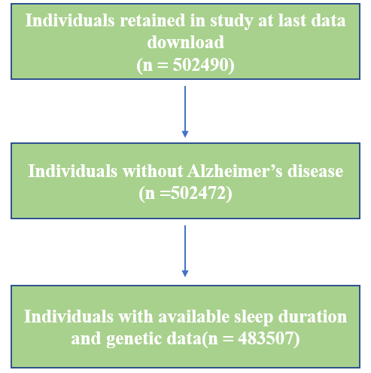

Figure S2. Visualization of Mendelian randomization results
- scatter diagram;
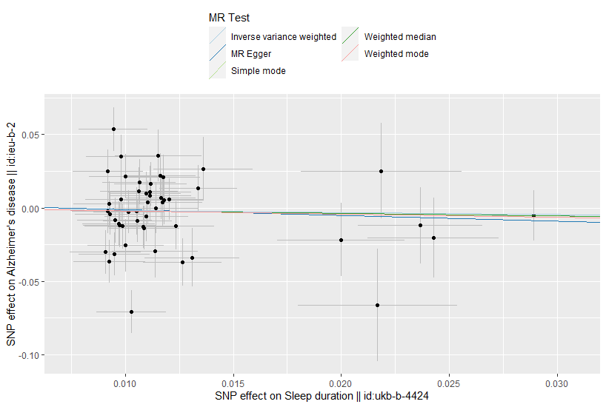

- Forest map
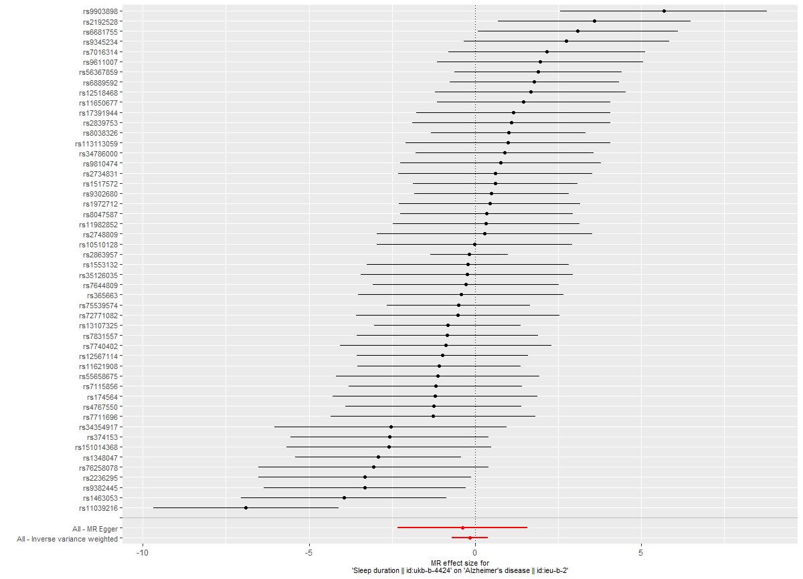

- Draw sensitivity analysis diagram

(4) Funnel plot
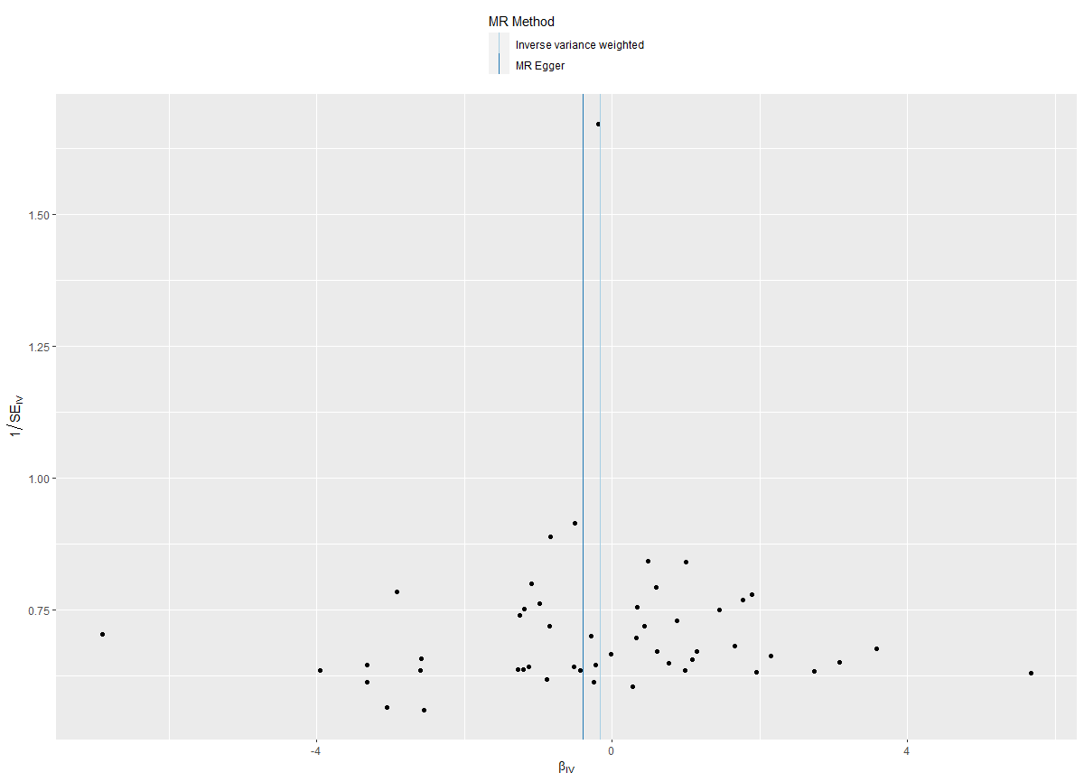

Figure S3. The direct acyclic graph (DAG) between sleep duration and AD
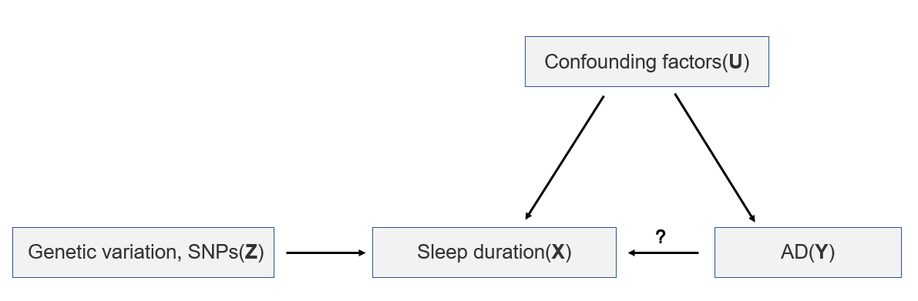
Z: SNPs of sleep duration
X: Expose (sleep duration)
U: Confounding factors
Y: Outcome (AD)
?: Possible paths

