Supplementary material
Table S1 Goodness of fit and mean posterior probability for four latent classes
# classes | log-likelihood | BIC | cAIC | AIC | Entropy | LMR
1 | -9953.45 | 20000.89 | 20011.89 | 19928.90
2 | -6154.01 | 12538.71 | 12565.71 | 12362.01 | 0.970 | 7313.56^{(*)}
3 | -5855.59 | 12078.59 | 12121.59 | 11797.18 | 0.953 | 574.42^{(*)}
4 | -5605.96 | 11716.05 | 11775.05 | 11329.93 | 0.916 | 480.51^{(*)}
5 | -5854.93 | 12350.70 | 12425.70 | 11859.86 | 0.970 | -479.24
Mean posterior probability conditional on class membership for four latent classes
Class | P(C=1 | C=j) | P(C=2 | C=j) | P(C=3 | C=j) | P(C=4 | C=j) | N | %
1 | 0.979 | 0.021 | <0.001 | <0.001 | 4441 | 86.43
2 | 0.059 | 0.848 | 0.093 | <0.001 | 380 | 7.40
3 | 0.001 | 0.093 | 0.883 | 0.022 | 221 | 4.30
4 | <0.001 | <0.001 | 0.066 | 0.934 | 96 | 1.87
Notes: # classes: Number of classes; P(Class=k | Class=j): is the mean probability of belonging to k-th class given that the individuals are classified in the j-th class; LMR: Lo–Mendell–Rubin statistic and ^{(*)} indicates p-value < 0.05.

Table S2 Associations of sociodemographic characteristics among the dependency classes
 | ‘IADL-dependent’ vs. ‘ND’ |  | ‘Dependent’ vs. ‘ND’ |  | ‘Impaired’ vs. ‘ND’
 | Sign | p | Sign | p | Sign | p
Age | + | <0.001 | + | <0.001 | + | 0.003
Sex | + | 0.008 | + | 0.333 | - | 0.007
Age*Sex | - | 0.038 | - | 0.603 | + | 0.005
>Primary | - | 0.035 | - | 0.200 | - | 0.031

Notes: sign and corresponding p-values of the effects of covariates on the probability of belonging to the latent classes ‘IADL-dependent’, ‘Dependent’ and ‘Impaired’ with respect to the probability of belonging to the ‘Non-dependent’ latent class.

Figure S1 Density of the BAREMO scale and its cut-off points for severity of dependency according to the classification into the four latent dependency classes.
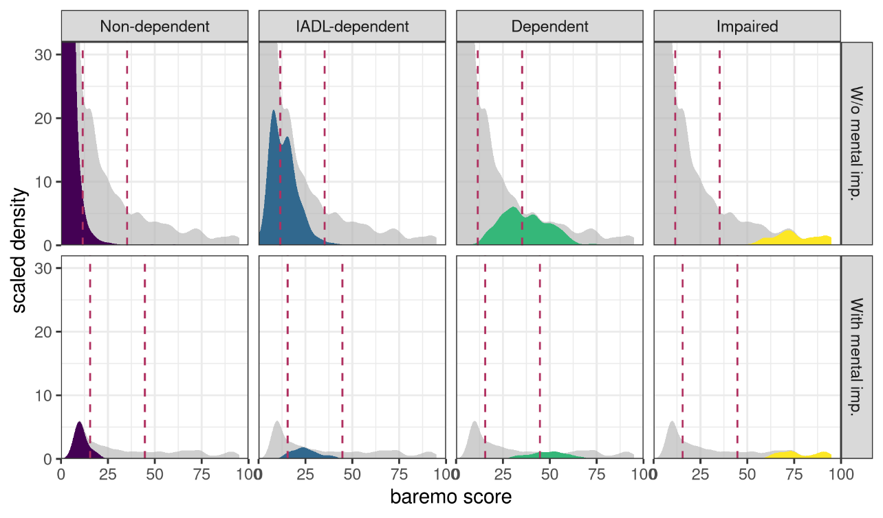
Notes: Only includes individuals with positive score in the BAREMO evaluation (~17 per cent of the sample). Red lines indicate the cut-off points between categories. A person with a score of zero on the scale is classified as non-dependent, with a positive score below 11.56 as mildly dependent, with a score between 11.56 and 35.24 as moderately dependent, and with a score above 35.24 as severely dependent. If the person declares to have a mental condition, the cut-off points differ slightly such that zero is still classified as non-dependent, a positive score below 15.51 as slightly dependent, a score between 15.51 and 44.72 as moderately dependent and a score above 44.72 as severely dependent (21).

Table S3 Goodness of fit of education in three categories: primary/secondary/tertiary
N. classes | log-likelihood | BIC | cAIC | AIC | Entropy | LMR
1 | -9953.45 | 20000.89 | 20011.89 | 19928.90
2 | -6151.61 | 12542.47 | 12570.47 | 12359.23 | 0.970 | 7318.2^{(*)}
3 | -5688.46 | 11761.41 | 11806.41 | 11466.91 | 0.954 | 891.53^{(*)}
4 | -5601.17 | 11732.10 | 11794.10 | 11326.35 | 0.913 | 168.01^{(*)}
5 | -5551.76 | 11778.54 | 11857.54 | 11261.53 | 0.921 | 95.11^{(*)}
Notes: LMR: Lo–Mendell–Rubin statistic and ^{(*)} indicates p-value < 0.05.

Table S4 Goodness of fit of tertiary education dummy
N. classes | log-likelihood | BIC | cAIC | AIC | Entropy | LMR
1 | -9953.45 | 20000.89 | 20011.89 | 19928.90
2 | -6151.91 | 12534.51 | 12561.51 | 12357.81 | 0.970 | 7317.6^{(*)}
3 | -5691.56 | 11750.53 | 11793.53 | 11469.12 | 0.954 | 886.12^{(*)}
4 | -5605.00 | 11714.13 | 11773.13 | 11328.00 | 0.915 | 166.61^{(*)}
5 | -5555.59 | 11752.01 | 11827.01 | 11261.18 | 0.923 | 95.12^{(*)}
Notes: LMR: Lo–Mendell–Rubin statistic and ^{(*)} indicates p-value < 0.05.

Table S5 Goodness of fit of model without covariates
N. classes | log-likelihood | BIC | cAIC | AIC | Entropy | LMR
1 | -9953.45 | 20000.89 | 20011.89 | 19928.9
2 | -6284.85 | 12766.22 | 12789.22 | 12615.7 | 0.968 | 7061.7^{(*)}
3 | -5861.21 | 12021.47 | 12056.47 | 11792.41 | 0.963 | 815.47^{(*)}
4 | -5808.56 | 12018.72 | 12065.72 | 11711.13 | 0.944 | 101.33^{(*)}
5 | -5767.15 | 12038.42 | 12097.42 | 11652.3 | 0.934 | 79.71^{(*)}
Notes: LMR: Lo–Mendell–Rubin statistic and ^{(*)} indicates p-value < 0.05.

