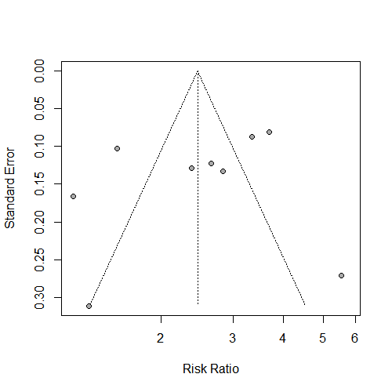
supplement Fig.2 Publication bias was reported using the funnel graph

