Supporting Information

Contents
1 Supplementary Methods: Study Design, Codes to Identify Psychosis and Dementia, and Operational Definitions of Baseline Characteristics and Events of Interest 3
1.1 Study Design 3
1.2 Codes to Identify Psychosis 5
1.3 Codes to Identify Dementia 7
1.4 Description of Comorbidities, Comedications and Healthcare Utilization 11
1.4.1 Comorbidities 11
1.4.2 Comedications 12
1.4.3 Healthcare Utilization 13
1.5 Operational Definition of Falls and Fractures 14
1.6 Operational Definition of Infections 16
1.6.1 Operational Definition of Aspiration Pneumonia 16
1.6.2 Operational Definition of Serious Hospitalized Infection 16
1.7 Operational Definition of Healthcare Utilization 16
1.7.1 Operational Definition of Skilled Nursing Facility Services 16
1.7.2 Operational Definition of Home Healthcare Episodes 16
1.7.3 Operational Definition of Hospitalizations 17
1.7.4 Operational Definition of Hospitalizations 17
1.7.5 Operational Definition of Parenteral Anti-infective Use 17
1.8 Operational Definition of Death 17
2 Results Tables and Figures 18
3 References 43

Tables
Table S-1. Diagnosis Codes for Identifying Psychosis: ICD-9-CM 5
Table S-2. Diagnosis Codes for Identifying Psychosis: ICD-10-CM 6
Table S-3. Diagnosis Codes for Identifying Dementia: ICD-9-CM 7
Table S-4. Diagnosis Codes for Identifying Dementia: ICD-10-CM 9
Table S-5. Comorbidities of Patients With Dementia-Related Psychosis 18
Table S-6. Comedication Use Among Patients With Dementia-Related Psychosis 20
Table S-7. Healthcare Utilization in Patients With Dementia-Related Psychosis Assessed in the Year Before and Not Including the Index Date 21
Table S-8. Incidence Rates of Events of Interest in Patients With Dementia-Related Psychosis 22
Table S-9. Characteristics of Initial Antipsychotic Treatment in Patients With Dementia-Related Psychosis 34

Figures
Figure S-1. Variable Assessment Windows Relative to the Study Index Date 3
Figure S-2. Mean Cumulative Counts for Each Event of Interest in Patients With Dementia-Related Psychosis 26
Figure S-3. Antipsychotic Treatment Status Over Follow-up in Patients With Dementia-Related Psychosis 36

Supplementary Methods: Study Design, Codes to Identify Psychosis and Dementia, and Operational Definitions of Baseline Characteristics and Events of Interest

Study Design
- Variable Assessment Windows Relative to the Study Index Date

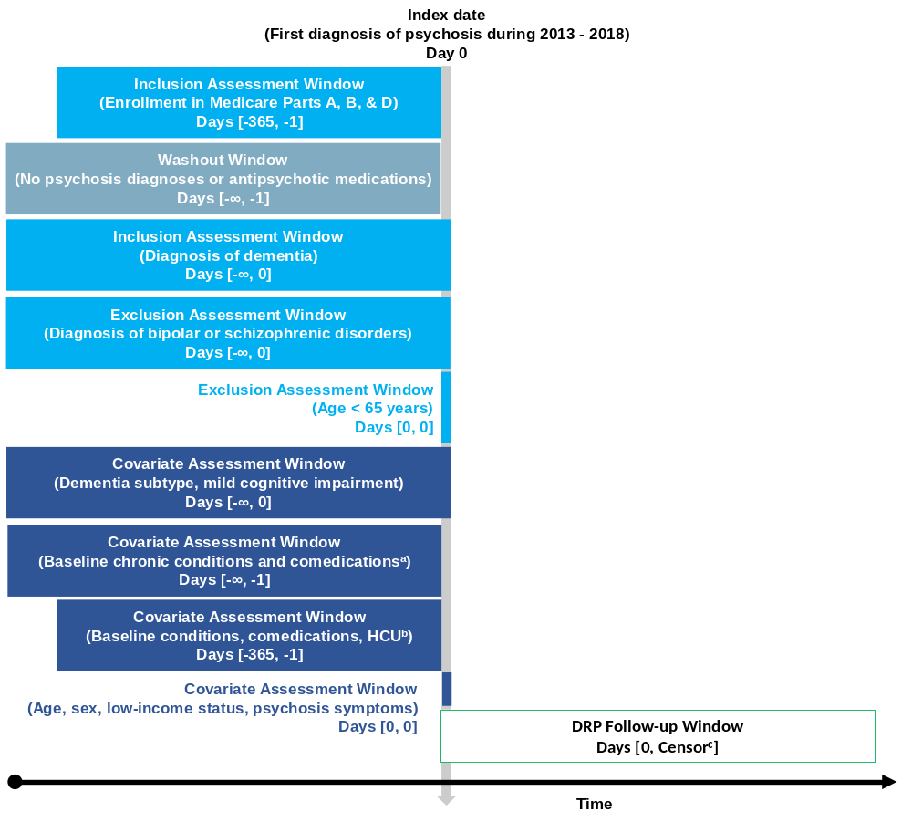
DRP = dementia-related psychosis; HCU = healthcare utilization.
Note: figure template available at www.repeatinitiative.org
ª Chronic cardiovascular disease, cerebrovascular diseases, hypertension, diabetes mellitus (type 1 or 2), hyperlipidemia, malignancies, chronic kidney disease and other renal disorders, liver disease, chronic obstructive pulmonary disease, osteoporosis, psychiatric disorders, Charlson Comorbidity Index score, acetylcholinesterase inhibitors, antidepressants, anxiolytics, sedatives, drugs used in opioid dependence.
^{b} Use of skilled nursing facility; use of home healthcare services; cardiovascular events; diseases of arteries, arterioles, and capillaries; falls and fractures; aspiration pneumonia; upper respiratory tract infections; lower respiratory tract infections; urinary tract infections; severe sepsis; serious hospitalized infections; overall frailty index; antihypertensives; cholesterol-lowering medications; anticoagulants; treatments for Parkinson’s disease; anti-inflammatory drugs; bronchodilators; osteoporosis treatments; oral anti-infectives; parenteral anti-infectives; hospitalizations; emergency department visits; clinic visits.
^{c} End of study (December 31, 2018); disenrollment from Medicare Part A, B, or D; diagnosis of a bipolar or schizophrenic condition; or death.

Codes to Identify Psychosis
- Diagnosis Codes for Identifying Psychosis: ICD-9-CM
Code | Description
Hallucinations
293.82 | Psychotic disorder with hallucinations in conditions classified elsewhere
368.16 | Psychophysical visual disturbances
780.1 | Hallucinations
Delusions
293.81 | Psychotic disorder with delusions in conditions classified elsewhere
297.1 | Delusional disorder
297.2 | Paraphrenia
Other
297.0 | Paranoid state, simple
297.3 | Shared psychotic disorder
297.8 | Other specified paranoid states
297.9 | Unspecified paranoid state
298.0 | Depressive type psychosis
298.1 | Excitative type psychosis
298.2 | Reactive confusion
298.3 | Acute paranoid reaction
298.4 | Psychogenic paranoid psychosis
298.8 | Other and unspecified reactive psychosis
298.9 | Unspecified psychosis
ICD-9-CM = International Classification of Diseases, Ninth Revision, Clinical Modification.

- Diagnosis Codes for Identifying Psychosis: ICD-10-CM
Code | Description
Hallucinations
F06.0 | Psychotic disorder with hallucinations due to known physiological condition
H53.16 | Psychophysical visual disturbances
R44.0 | Auditory hallucinations
R44.1 | Visual hallucinations
R44.2 | Other hallucinations
R44.3 | Hallucinations, unspecified
R48.3 | Visual agnosia
Delusions
F06.2 | Psychotic disorder with delusions due to known physiological condition
F22 | Delusional disorders
Other
F23 | Brief psychotic disorder
F24 | Shared psychotic disorder
F28 | Other psychotic disorder not due to a substance or known physiological condition
F29 | Unspecified psychosis not due to a substance or known physiological condition
F32.3 | Major depressive disorder, single episode, severe with psychotic features
F33.3 | Major depressive disorder, recurrent, severe with psychotic symptoms
F44.89 | Other dissociative and conversion disorders
ICD-10-CM = International Classification of Diseases, Tenth Revision, Clinical Modification.

Codes to Identify Dementia
- Diagnosis Codes for Identifying Dementia: ICD-9-CM
Code | Description
Alzheimer’s disease
331.0 | Alzheimer’s disease
Vascular dementia
290.40 | Vascular dementia, uncomplicated
290.41 | Vascular dementia, with delirium
290.42 | Vascular dementia, with delusions
290.43 | Vascular dementia, with depressed mood
Dementia with Lewy bodies
331.82 | Dementia with Lewy bodies
Frontotemporal dementia
331.11 | Pick’s disease
331.19 | Other frontotemporal dementia
Parkinson’s disease dementia
332.0 + Dementia code | Paralysis agitans
Dementia not otherwise specified
290.0 | Senile dementia, uncomplicated
290.10 | Presenile dementia, uncomplicated
290.11 | Presenile dementia with delirium
290.12 | Presenile dementia with delusional features
290.13 | Presenile dementia with depressive features
290.20 | Senile dementia with delusional features
290.21 | Senile dementia with depressive features
290.3 | Senile dementia with delirium
290.9 | Unspecified senile psychotic condition
294.0 | Amnestic disorder in conditions classified elsewhere
294.10 | Dementia in conditions classified elsewhere without behavioral disturbance
294.11 | Dementia in conditions classified elsewhere with behavioral disturbance
294.20 | Dementia, unspecified, without behavioral disturbance
294.21 | Dementia, unspecified, with behavioral disturbance
294.8 | Other persistent mental disorders due to conditions classified elsewhere
294.9 | Unspecified persistent mental disorders due to conditions classified elsewhere
331.2 | Senile degeneration of brain
331.6 | Corticobasal degeneration
331.7 | Cerebral degeneration in diseases classified elsewhere
780.93 | Memory loss
797 | Senility without mention of psychosis
ICD-9-CM = International Classification of Diseases, Ninth Revision, Clinical Modification.
- Diagnosis Codes for Identifying Dementia: ICD-10-CM
Code | Description
Alzheimer’s disease
G30.0 | Alzheimer’s disease with early onset
G30.1 | Alzheimer’s disease with late onset
G30.8 | Other Alzheimer’s disease
G30.9 | Alzheimer’s disease, unspecified
Vascular dementia
F01.5 | Vascular dementia
F01.50 | Vascular dementia without behavioral disturbance
F01.51 | Vascular dementia with behavioral disturbance
Dementia with Lewy bodies
G31.83 | Dementia with Lewy bodies
Frontotemporal dementia
G31.01 | Pick’s disease
G31.09 | Other frontotemporal dementia
Parkinson’s disease dementia
G20 + Dementia code | Paralysis agitans
Dementia not otherwise specified
F02.80 | Dementia in other diseases classified elsewhere without behavioral disturbance
F02.81 | Dementia in other diseases classified elsewhere with behavioral disturbance
F03.90 | Unspecified dementia without behavioral disturbance
F03.91 | Unspecified dementia with behavioral disturbance
F04 | Amnestic disorder due to known physiological condition
F02.80 | Dementia in other diseases classified elsewhere without behavioral disturbance
F02.81 | Dementia in other diseases classified elsewhere with behavioral disturbance
F03.90 | Unspecified dementia without behavioral disturbance
F03.91 | Unspecified dementia with behavioral disturbance
G31.1 | Senile degeneration of brain, not elsewhere classified
G31.85 | Corticobasal degeneration
G31.89 | Other specified degenerative diseases of nervous system
G31.9 | Degenerative disease of nervous system, unspecified
R41.1 | Anterograde amnesia
R41.2 | Retrograde amnesia
R41.3 | Other amnesia
R41.81 | Age-related cognitive decline
R54 | Age-related physical debility
ICD-10-CM = International Classification of Diseases, Tenth Revision, Clinical Modification.

Description of Comorbidities, Comedications and Healthcare Utilization

Comorbidities
Comorbidities were characterized before and not including the index date using recorded diagnosis codes from inpatient, outpatient, physician, and home healthcare billing claims. For patients in the antipsychotic treatment subcohort, comorbidities were re-evaluated before the antipsychotic treatment initiation date. A binary (present/not present) indicator of the presence of any diagnosis codes for the following conditions occurring during the indicated assessment windows will be created for each variable:
- Assessed at any time before and not including the index date (or antipsychotic treatment initiation date)
- Chronic cardiovascular diseases: conduction disorders, arrhythmias, heart failure
- Cerebrovascular diseases: cerebral hemorrhage (subarachnoid, intracerebral, other nontraumatic), cerebral infarction and stroke, transient ischemic attack, other cerebrovascular disease, and sequelae of cerebrovascular disease
- Hypertension
- Diabetes mellitus (type 1 or 2)
- Hyperlipidemia
- Malignancies
- Chronic kidney disease and other renal disorders
- Liver disease
- Chronic obstructive pulmonary disease
- Osteoporosis
- Mood disorders
- Anxiety disorders
- Other psychiatric disorders: eating disorders, substance abuse disorders, unspecified mental/psychiatric disorders
- Assessed during the 12 months before and not including the index date (or the antipsychotic treatment initiation date)
- Cardiovascular events: ischemic heart disease (including angina pectoris, acute myocardial infarction, other acute or subacute ischemic heart disease, chronic ischemic heart disease), cardiac arrest
- Diseases of arteries, arterioles, and capillaries (including peripheral arterial disease)
- Composite falls and fractures
- Aspiration pneumonia
- Upper respiratory tract infections
- Lower respiratory tract infections
- Urinary tract infections
- Severe sepsis (hospitalized only)
- Serious infection (hospitalized only)
Additionally, the Charlson Comorbidity Index (CCI) [1], and a frailty index [2,3], were estimated.

Comedications
Pharmacy dispensing and procedure coding records before and not including the index date or antipsychotic treatment initiation date were used to characterize comedications. For patients in the antipsychotic treatment subcohort, comedications were re-evaluated before the antipsychotic treatment initiation date. A binary (present/not present) indicator of the presence of any dispensing codes for the following medications occurring during the indicated assessment windows was created for each medication class:
- Assessed at any time before and not including the index date (or antipsychotic treatment initiation date) in order to identify any history of psychiatric or neurological disorders
- Acetylcholinesterase inhibitors
- Antidepressants
- Anxiolytics
- Sedatives
- Drugs used in opioid dependence
- Assessed during the 12 months before and not including the index date (or the antipsychotic treatment initiation date) in order to identify more recent comorbid conditions
- Antihypertensives
- Cholesterol-lowering medications
- Anticoagulants
- Treatments for Parkinson’s disease
- Anti-inflammatory drugs
- Bronchodilators
- Osteoporosis treatments
- Oral anti-infectives (including pharmacy-dispensed antibiotics, antifungals, and antivirals)
- Parenteral anti-infectives (including outpatient or inpatient injection or intravenous antibiotics, antifungals, and antivirals identified from pharmacy dispensing or procedure coding

Healthcare Utilization
Healthcare utilization indicators were assessed during the 12 months before and not including the index date. For patients in the antipsychotic treatment subcohort, healthcare utilization was evaluated in the 12 months before and not including the antipsychotic treatment initiation date.
Healthcare utilization indicators of interest included the following:
- Hospitalizations, defined as the number of unique hospital admissions evaluated in the Medicare MedPAR files
- Emergency department visits, identified as the number of unique days with an emergency department admission from the Medicare MedPAR files where the emergency room charge amount was greater than $0 or in the Outpatient file in which the revenue center code indicated an emergency department visit
- Number of unique days during which a clinic visit occurred, evaluated using outpatient and physician billing claims

Operational Definition of Falls and Fractures
All falls and fractures diagnosed for each person were identified during follow-up. Multiple events per patient were included in analyses. Falls and fractures were evaluated both together as a composite outcome and separately as distinct outcomes.
Falls were identified by ICD-9-CM or ICD-10-CM diagnosis codes for falls occurring in any diagnosis position in Medicare MedPAR, outpatient, or physician billing claims. Repeated codes for falls occurring within the 7 days after and not including the date of an identified fall were assumed to be part of the same event and were not considered separately.
Falls were evaluated in a patient up to 7 days before the index date to ensure that falls occurring after the index date were new events. Falls were identified in the 12 months before the index date as a descriptive comorbidity.
Fractures were identified by diagnosis codes from inpatient, outpatient, or physician billing claims for a fracture (occurring in any diagnosis position) at a specific anatomic site with a procedure code (ICD-9-CM procedure, ICD-10-PCS, or CPT) for a fracture repair occurring in a window from 7 days before to 7 days after the date of the fracture diagnosis (days [−7, 7]). The earlier date of the fracture diagnosis or repair was considered the event date. Each fracture diagnosis and repair code were categorized by anatomic site (skull, vertebrae, trunk, upper limb, hand/wrist/finger, pelvis, hip, femur, lower leg, foot/ankle/toe). Procedure codes for a fracture repair at an unspecified site were included in the procedure code lists for all other sites and could be paired with any site-specific fracture diagnosis. If unspecified fracture diagnosis codes were identified, they were paired with a site-specific repair procedure code for the site to be determined.
All fractures at the same site within the period from “fracture date + 1 day” to “fracture date + 365 days” were considered part of the same event.
Fractures were not reported as individual, site-specific events; only overall fractures were reported. However, after the occurrence of a site-specific fracture, the patient was not at risk to experience a fracture at the same site within the following 12 months. Fractures at different sites were considered distinct events even if occurring within the same year; however, additional claims for fractures at multiple sites were considered as one event if the claims occurred within a 7-day window following and not including the day of the initial fracture. The earliest date denoting a fracture within the 8-day period (the date of the first claim and the following 7 days) was considered the date of occurrence in the analyses of fractures.
The 12 months before, but not including, the index date were evaluated for fracture events to ensure identification of new-onset events after the index date and define recurrent site-specific fractures; fractures in the 12 months before the index date were also used as descriptive comorbidities.
Falls and overall fracture occurrences were also evaluated as one composite outcome. All individual fall and fracture events were considered in the analysis. However, if a fall and a fracture event occurred within 7 days of each other (days [0, 7]), they were considered part of the same outcome event for the composite outcome only. The earliest date denoting a fall or fracture within the 8-day period was considered the date of occurrence in the composite falls/fractures analyses.

Operational Definition of Infections

Operational Definition of Aspiration Pneumonia
Aspiration pneumonia was defined as a diagnosis code for aspiration pneumonia on an inpatient, emergency department, outpatient, or physician claim. Aspiration pneumonia codes were specific to pneumonia that is attributed to inhalation of food or vomit and is thus separate from codes used to indicate the presence of bacterial or viral pneumonia [4]. In a validation study in Medicare beneficiaries in California, when compared with clinical evidence and physician notes, this singular diagnosis code had a positive predictive value (PPV) of 90.6% [5].

Operational Definition of Serious Hospitalized Infection
A broader definition of “serious hospitalized infection” was identified as an inpatient diagnosis of meningitis, encephalitis, cellulitis, endocarditis, pneumonia, pyelonephritis, septic arthritis, osteomyelitis, bacteremia, tuberculosis, atypical mycobacteria, cryptococcosis, or aspergillosis. Serious hospitalized infections may have overlapped with the specific infection subtypes described previously. Previous validation studies of these definitions of serious hospitalized infections have demonstrated high PPVs [6,7].

Operational Definition of Healthcare Utilization

Operational Definition of Skilled Nursing Facility Services
Utilization of skilled nursing facility services was identified from the Medicare MedPAR files that had an indicator of a skilled nursing facility stay. Admissions were assessed in both of the following forms:
- The number of unique, skilled nursing facility admissions
- The number of days during follow-up spent in a skilled nursing facility

Operational Definition of Home Healthcare Episodes
Home healthcare episodes were identified from the Medicare Home Health billing claims. Home healthcare was assessed through both of the following forms:
- The number of unique home healthcare episodes
- The number of days during follow-up with a home healthcare episode

Operational Definition of Hospitalizations
Hospitalizations were identified as the number of unique days with an inpatient admission, identified from inpatient events in the Medicare MedPAR files
- The number of unique inpatient hospitalization admissions
- The number of days during follow-up spent in an inpatient hospitalization

Operational Definition of Hospitalizations
- Emergency department visits were identified as the number of unique days with an emergency department visit from the Medicare MedPAR files where the emergency room charge amount was greater than $0 or in the Outpatient file where the revenue center code indicated an emergency department visit

Operational Definition of Parenteral Anti-infective Use
Receipt of injectable or intravenous anti-infectives was also considered. Parenteral anti-infective use was considered as a count of the number of outpatient or inpatient intravenous agent treatment episodes administered or the count of pharmacy-dispensed prescriptions for injectable or intravenous anti-infectives identified in the Part D pharmacy claims during the appropriate follow-up window specified in the study design. Parenteral procedures on consecutive days were considered part of the same treatment episode. Pharmacy dispensing of parenteral dosage forms was also identified in Part D pharmacy claims for at-home administration.

Operational Definition of Death
A patient’s date of death was identified in Medicare enrollment information.

Results Tables and Figures
- Comorbidities of Patients With Dementia-Related Psychosis
Comorbidity | AD,  n = 150,375 | PDD,  n = 49,004 | DLB,  n = 15,263 | FTD,  n = 4,382 | VD,  n = 60,132 | Unspecified dementia,  n = 269,291 | All dementia-related psychosis,  N = 484,520
Assessed at any point before and not including the index date, %
Chronic cardiovascular disease | 88.6 | 88.9 | 87.5 | 83.5 | 92.2 | 88.0 | 88.4
Cerebrovascular disease | 75.1 | 77.1 | 75.3 | 75.2 | 85.4 | 69.6 | 72.5
Hypertension and hypertensive heart disease | 96.5 | 95.7 | 94.9 | 93.6 | 98.1 | 96.3 | 96.4
Diabetes | 33.1 | 34.9 | 31.8 | 32.5 | 40.7 | 33.9 | 34.1
Hyperlipidemia | 94.3 | 94.3 | 93.4 | 93.7 | 95.4 | 93.5 | 93.9
Malignancies | 36.7 | 39.6 | 38.0 | 36.2 | 37.4 | 37.2 | 37.0
Chronic kidney disease and other renal disorders | 42.8 | 42.5 | 40.3 | 36.1 | 49.3 | 43.6 | 43.6
Liver disease | 24.1 | 25.5 | 23.8 | 24.1 | 25.7 | 25.0 | 24.7
Chronic obstructive pulmonary disease | 59.0 | 57.3 | 54.0 | 52.6 | 62.8 | 61.2 | 60.2
Osteoporosis | 56.2 | 49.0 | 45.3 | 48.2 | 53.1 | 51.7 | 52.6
Mood disorders | 62.1 | 64.4 | 62.8 | 64.0 | 66.9 | 54.3 | 57.8
Anxiety disorders | 57.3 | 59.1 | 56.3 | 59.1 | 60.7 | 54.0 | 55.6
Other psychiatric disorders (eating disorders, substance abuse, or unspecified mental/psychiatric disorders) | 21.8 | 20.9 | 19.7 | 24.2 | 26.2 | 24.5 | 23.6
Assessed during the year before and not including the index date, %
Cardiovascular events
Ischemic heart disease | 10.3 | 11.3 | 10.7 | 9.8 | 13.4 | 12.6 | 11.9
Diseases of arteries, arterioles, and capillaries (including peripheral arterial disease) | 41.0 | 42.3 | 40.5 | 38.3 | 47.6 | 38.7 | 40.1
Falls and/or fractures | 33.6 | 38.5 | 38.3 | 31.4 | 36.0 | 30.4 | 32.2
Aspiration pneumonia | 3.7 | 5.3 | 5.9 | 3.8 | 5.2 | 3.4 | 3.7
Infections
Upper respiratory tract infections | 10.6 | 10.9 | 9.9 | 10.5 | 10.9 | 11.2 | 10.9
Lower respiratory tract infections | 21.0 | 22.2 | 21.5 | 18.1 | 25.2 | 22.6 | 22.2
Urinary tract infections | 46.8 | 46.8 | 46.7 | 41.7 | 50.3 | 41.0 | 43.5
Severe sepsis | 5.7 | 6.3 | 6.6 | 4.7 | 7.5 | 6.2 | 6.1
Serious, hospitalized infections | 16.9 | 18.6 | 18.6 | 14.9 | 21.2 | 18.6 | 18.3
AD = Alzheimer’s disease; DLB = dementia with Lewy bodies; FTD = frontotemporal dementia; PDD = Parkinson’s disease dementia; VD = vascular dementia.

- Comedication Use Among Patients With Dementia-Related Psychosis
Comedication | AD,  n = 150,375 | PDD,  n = 49,004 | DLB,  n = 15,263 | FTD,  n = 4,382 | VD,  n = 60,132 | Unspecified dementia,  n = 269,291 | All dementia-related psychosis,  N = 484,520
Assessed at any point before and not including the index date, %
Acetylcholinesterase inhibitors | 58.7 | 36.2 | 50.2 | 54.2 | 43.6 | 15.0 | 29.9
Antidepressants | 60.2 | 62.3 | 61.7 | 64.6 | 62.4 | 51.3 | 55.1
Anxiolytics | 10.9 | 10.4 | 9.0 | 10.0 | 11.2 | 10.1 | 10.4
Sedatives | 15.6 | 18.7 | 16.3 | 15.7 | 16.3 | 17.2 | 16.7
Drugs used in opioid dependence | 1.0 | 1.3 | 0.9 | 0.8 | 1.0 | 1.3 | 1.2
Assessed during the year before and not including the index date, %
Antihypertensives | 70.7 | 67.5 | 63.9 | 65.3 | 76.6 | 75.9 | 73.9
Cholesterol-lowering medications | 50.3 | 50.8 | 49.6 | 51.9 | 56.8 | 53.4 | 52.6
Anticoagulants | 23.8 | 25.9 | 24.0 | 22.2 | 32.0 | 28.2 | 27.1
Treatments for Parkinson’s disease | 7.5 | 60.4 | 59.2 | 11.1 | 6.4 | 3.0 | 8.5
Anti-inflammatory drugs | 25.1 | 29.4 | 27.3 | 25.6 | 24.8 | 30.6 | 28.6
Osteoporosis treatment | 9.1 | 8.4 | 8.0 | 7.9 | 7.7 | 9.1 | 8.9
Bronchodilators | 12.3 | 14.0 | 12.9 | 13.4 | 13.2 | 15.0 | 14.0
Oral anti-infectives | 48.8 | 51.1 | 49.0 | 47.3 | 50.3 | 49.6 | 49.4
Parenteral anti-infectives | 12.4 | 14.9 | 14.2 | 13.2 | 13.4 | 14.3 | 13.7
AD = Alzheimer’s disease; DLB = dementia with Lewy bodies; FTD = frontotemporal dementia; PDD = Parkinson’s disease dementia; VD = vascular dementia.
- Healthcare Utilization in Patients With Dementia-Related Psychosis Assessed in the Year Before and Not Including the Index Date
 | AD,  n = 150,375 | PDD,  n = 49,004 | DLB,  n = 15,263 | FTD,  n = 4,382 | VD,  n = 60,132 | Unspecified dementia,  n = 269,291 | All dementia-related psychosis,  N = 484,520
No. of hospitalizations ª, mean (SD) | 1 (1.2) | 1 (1.2) | 1 (1.2) | 1 (1.1) | 1 (1.3) | 1 (1.3) | 1 (1.3)
No. of emergency department visits ^{b}, mean (SD) | 2 (2.0) | 2 (2.1) | 2 (2.1) | 2 (2.1) | 2 (2.2) | 2 (2.2) | 2 (2.1)
No. of unique days on which a clinic visit occurred ^{c}, mean (SD) | 8 (7.5) | 11 (8.6) | 10 (8.2) | 10 (8.5) | 8 (7.7) | 10 (8.3) | 9 (8.2)
AD = Alzheimer’s disease; DLB = dementia with Lewy bodies; FTD = frontotemporal dementia; MedPAR = Medicare Provider Analysis and Review; PDD = Parkinson’s disease dementia; SD = standard deviation; VD = vascular dementia.
ª Defined as the number of unique hospital admissions evaluated in the Medicare MedPAR files.
^{b} Identified as the number of unique days with an emergency department visit from the Medicare MedPAR files where emergency room charge amount was > $0 or in the Outpatient file where the revenue center code indicated an emergency department visit.
^{c} Evaluated using outpatient and physician billing claims.

- Incidence Rates of Events of Interest in Patients With Dementia-Related Psychosis
Outcome | No. of patients ª | No. of events | Person-years | Incidence rate per 100 person-years (95% CI) ^{b}
Composite falls/fractures
Alzheimer’s disease | 64,673 | 136,702 | 242,064.21 | 56.47 (56.17-56.77)
Parkinson’s disease dementia | 22,315 | 51,671 | 78,096.11 | 66.16 (65.59-66.73)
Dementia with Lewy bodies | 6,798 | 15,242 | 23,007.23 | 66.25 (65.20-67.30)
Frontotemporal dementia | 1,809 | 3,909 | 6,905.14 | 56.61 (54.84-58.38)
Vascular dementia | 24,425 | 51,095 | 88,705.65 | 57.60 (57.10-58.10)
Dementia, unspecified | 115,511 | 248,816 | 499,324.95 | 49.83 (49.63-50.03)
All dementia-related psychosis | 208,427 | 448,761 | 844,372.91 | 53.15 (52.99-53.30)
Aspiration pneumonia
Alzheimer’s disease | 16,807 | 22,909 | 243,244.12 | 9.42 (9.30-9.54)
Parkinson’s disease dementia | 7,399 | 10,951 | 78,376.57 | 13.97 (13.71-14.23)
Dementia with Lewy bodies | 2,423 | 3,698 | 23,056.87 | 16.04 (15.52-16.56)
Frontotemporal dementia | 470 | 671 | 6,935.97 | 9.67 (8.94-10.41)
Vascular dementia | 7,506 | 10,482 | 89,005.90 | 11.78 (11.55-12.00)
Dementia, unspecified | 26,864 | 35,818 | 501,836.12 | 7.14 (7.06-7.21)
All dementia-related psychosis | 52,327 | 71,194 | 848,465.34 | 8.39 (8.33-8.45)
Serious hospitalized infection
Alzheimer’s disease | 46,964 | 67,254 | 239,912.70 | 28.03 (27.82-28.24)
Parkinson’s disease dementia | 16,679 | 24,983 | 77,305.46 | 32.32 (31.92-32.72)
Dementia with Lewy bodies | 5,101 | 7,615 | 22,754.90 | 33.47 (32.71-34.22)
Frontotemporal dementia | 1,229 | 1,733 | 6,859.58 | 25.26 (24.07-26.45)
Vascular dementia | 19,770 | 29,236 | 87,587.91 | 33.38 (33.00-33.76)
Dementia, unspecified | 93,088 | 139,802 | 494,068.96 | 28.30 (28.15-28.44)
All dementia-related psychosis | 162,014 | 240,051 | 835,811.72 | 28.72 (28.61-28.84)
Parenteral anti-infective episodes
Alzheimer’s disease | 29,217 | 47,729 | 244,751.85 | 19.50 (19.33-19.68)
Parkinson’s disease dementia | 11,186 | 19,552 | 79,112.90 | 24.71 (24.37-25.06)
Dementia with Lewy bodies | 3,179 | 5,443 | 23,308.17 | 23.35 (22.73-23.97)
Frontotemporal dementia | 813 | 1,284 | 6,981.52 | 18.39 (17.39-19.40)
Vascular dementia | 11,518 | 19,838 | 89,711.41 | 22.11 (21.81-22.42)
Dementia, unspecified | 63,514 | 112,870 | 504,198.55 | 22.39 (22.26-22.52)
All dementia-related psychosis | 107,044 | 185,733 | 853,175.15 | 21.77 (21.67-21.87)
Skilled nursing facility admissions
Alzheimer’s disease | 68,756 | 119,062 | 230,002.96 | 51.77 (51.47-52.06)
Parkinson’s disease dementia | 23,307 | 43,055 | 74,144.63 | 58.07 (57.52-58.62)
Dementia with Lewy bodies | 7,158 | 12,907 | 21,815.06 | 59.17 (58.14-60.19)
Frontotemporal dementia | 1,749 | 2,961 | 6,643.09 | 44.57 (42.97-46.18)
Vascular dementia | 29,161 | 52,597 | 83,313.56 | 63.13 (62.59-63.67)
Dementia, unspecified | 124,771 | 229,327 | 479,305.54 | 47.85 (47.65-48.04)
All dementia-related psychosis | 225,123 | 406,928 | 806,817.30 | 50.44 (50.28-50.59)
Hospital admissions
Alzheimer’s disease | 103,304 | 230,808 | 240,101.15 | 96.13 (95.74-96.52)
Parkinson’s disease dementia | 34,026 | 82,694 | 77,442.26 | 106.78 (106.05-107.51)
Dementia with Lewy bodies | 10,550 | 24,978 | 22,777.42 | 109.66 (108.30-111.02)
Frontotemporal dementia | 2,903 | 6,449 | 6,843.27 | 94.24 (91.94-96.54)
Vascular dementia | 42,049 | 98,460 | 87,624.40 | 112.37 (111.66-113.07)
Dementia, unspecified | 195,471 | 487,412 | 494,916.70 | 98.48 (98.21-98.76)
All dementia-related psychosis | 344,695 | 830,778 | 836,917.79 | 99.27 (99.05-99.48)
Home healthcare episodes
Alzheimer’s disease | 56,021 | 111,964 | 220,124.93 | 50.86 (50.57-51.16)
Parkinson’s disease dementia | 21,635 | 45,818 | 68,626.48 | 66.76 (66.15-67.38)
Dementia with Lewy bodies | 6,476 | 13,482 | 20,269.45 | 66.51 (65.39-67.64)
Frontotemporal dementia | 1,683 | 3,413 | 6,272.16 | 54.42 (52.59-56.24)
Vascular dementia | 21,707 | 43,460 | 80,171.56 | 54.21 (53.70-54.72)
Dementia, unspecified | 114,532 | 229,512 | 455,493.34 | 50.39 (50.18-50.59)
All dementia-related psychosis | 197,938 | 398,088 | 767,332.20 | 51.88 (51.72-52.04)
Emergency department visits
Alzheimer’s disease | 122,695 | 443,305 | 244,751.85 | 181.12 (180.59-181.66)
Parkinson’s disease dementia | 40,339 | 162,033 | 79,112.90 | 204.81 (203.82-205.81)
Dementia with Lewy bodies | 12,529 | 48,616 | 23,308.17 | 208.58 (206.73-210.43)
Frontotemporal dementia | 3,529 | 12,734 | 6,981.52 | 182.40 (179.23-185.56)
Vascular dementia | 48,629 | 179,600 | 89,711.41 | 200.20 (199.27-201.12)
Dementia, unspecified | 228,026 | 930,745 | 504,198.55 | 184.60 (184.22-184.97)
All dementia-related psychosis | 404,212 | 1,587,253 | 853,175.15 | 186.04 (185.75-186.33)
Death
Alzheimer’s disease | 84,452 | 84,452 | 244,751.85 | 34.51 (34.27-34.74)
Parkinson’s disease dementia | 26,400 | 26,400 | 79,112.90 | 33.37 (32.97-33.77)
Dementia with Lewy bodies | 8,839 | 8,839 | 23,308.17 | 37.92 (37.13-38.71)
Frontotemporal dementia | 2,118 | 2,118 | 6,981.52 | 30.34 (29.05-31.63)
Vascular dementia | 32,997 | 32,997 | 89,711.41 | 36.78 (36.38-37.18)
Dementia, unspecified | 135,033 | 135,033 | 504,198.55 | 26.78 (26.64-26.92)
All dementia-related psychosis | 252,896 | 252,896 | 853,175.15 | 29.64 (29.53-29.76)
CI = confidence interval.
ª Number of unique patients experiencing an event.
^{b} Confidence intervals were based on the Wald statistic.

- Mean Cumulative Counts for Each Event of Interest in Patients With Dementia-Related Psychosis
- Falls and Fractures
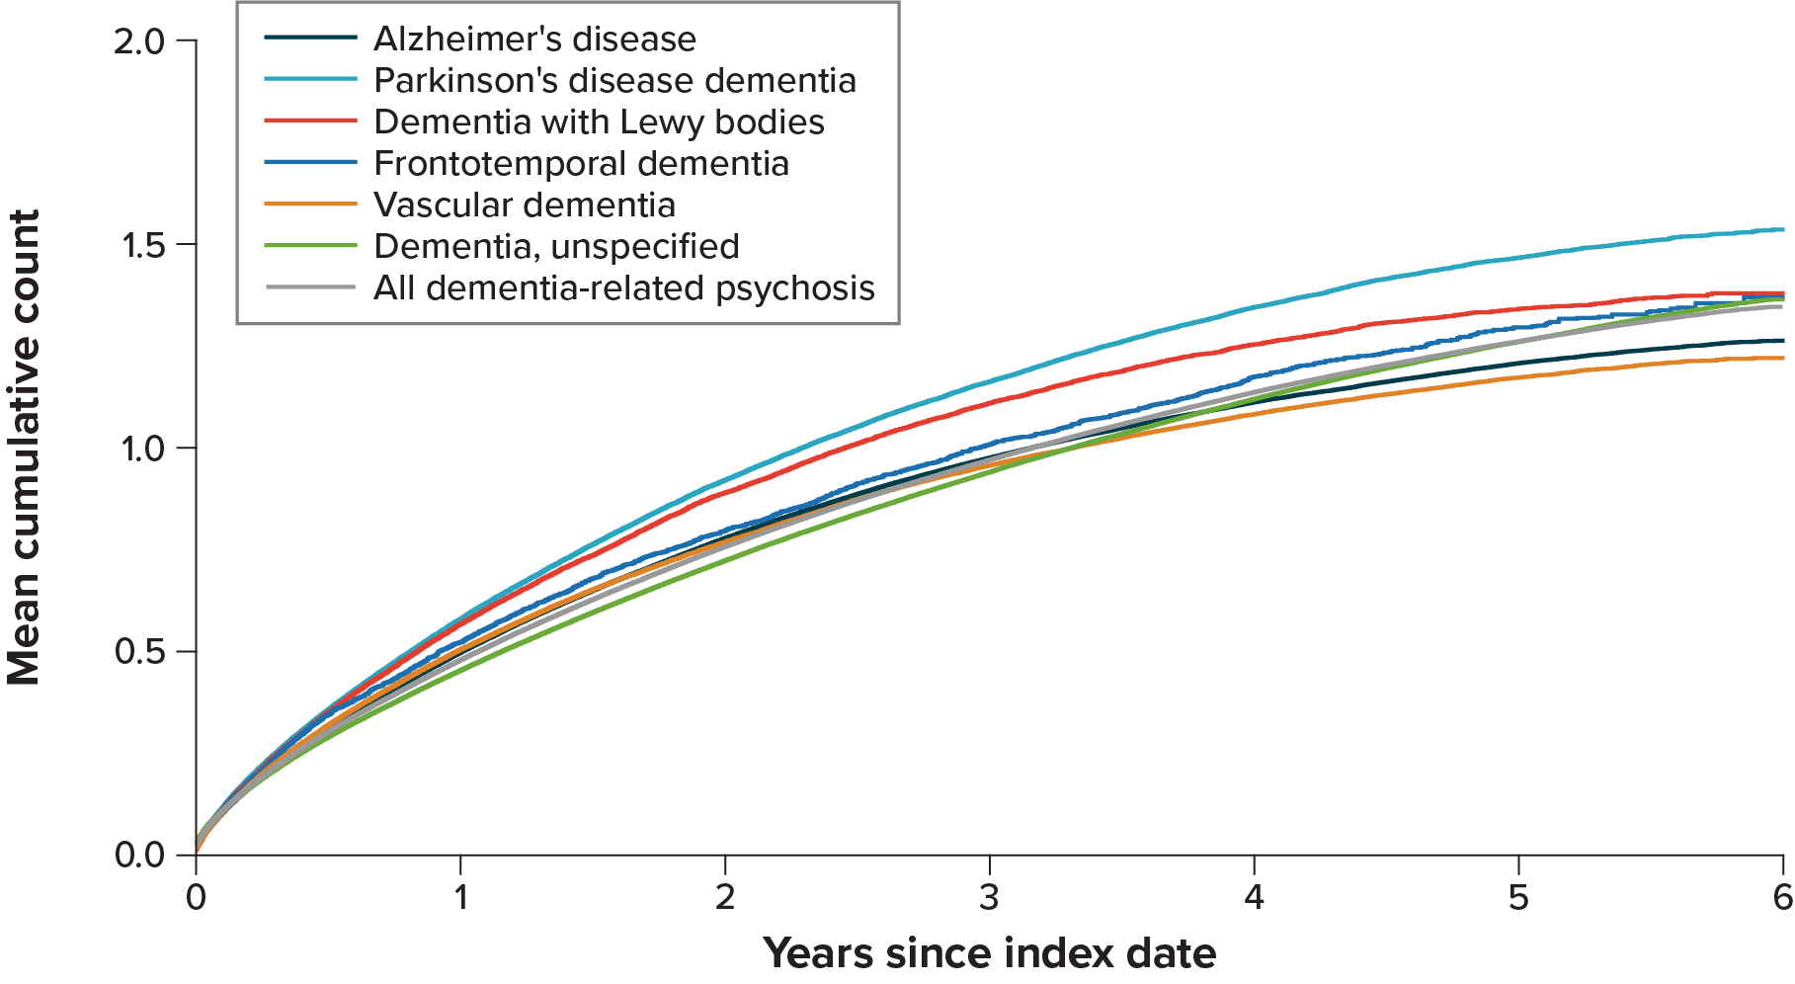
CI = confidence interval.
Alzheimer's disease: 6-year mean cumulative count = 1.3 (95% CI, 1.2-1.3)
Dementia with Lewy bodies: 6-year mean cumulative count = 1.4 (95% CI, 1.3-1.4)
Dementia, unspecified: 6-year mean cumulative count = 1.4 (95% CI, 1.4-1.4)
Frontotemporal dementia: 6-year mean cumulative count = 1.4 (95% CI, 1.3-1.5)
Parkinson's disease dementia: 6-year mean cumulative count = 1.5 (95% CI, 1.5-1.6)
Vascular dementia: 6-year mean cumulative count = 1.2 (95% CI, 1.2-1.2)
All dementia-related psychosis: 6-year mean cumulative count = 1.3 (95% CI, 1.3-1.4)

- Aspiration Pneumonia
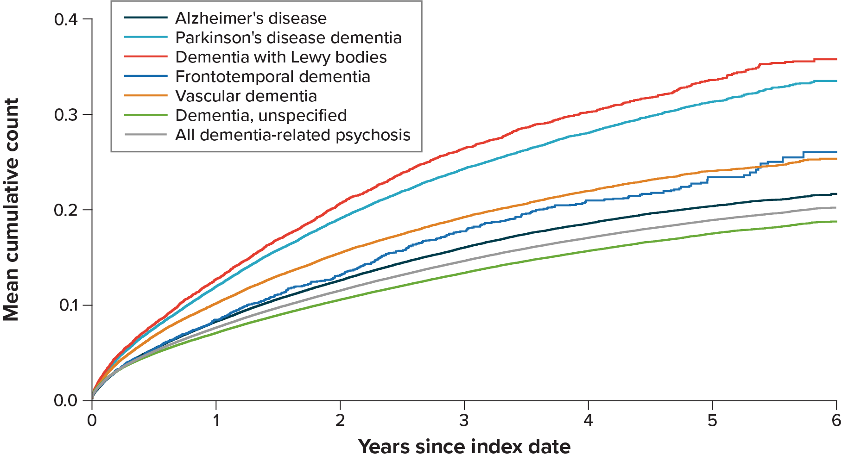

CI = confidence interval.
Alzheimer's disease: 6-year mean cumulative count = 0.2 (95% CI, 0.2-0.2)
Dementia with Lewy bodies: 6-year mean cumulative count = 0.4 (95% CI, 0.3-0.4)
Dementia, unspecified: 6-year mean cumulative count = 0.2 (95% CI, 0.2-0.2)
Frontotemporal dementia: 6-year mean cumulative count = 0.3 (95% CI, 0.2-0.3)
Parkinson's disease dementia: 6-year mean cumulative count = 0.3 (95% CI, 0.3-0.3)
Vascular dementia: 6-year mean cumulative count = 0.3 (95% CI, 0.2-0.3)
All dementia-related psychosis: 6-year mean cumulative count = 0.2 (95% CI, 0.2-0.2)

- Serious Hospitalized Infections
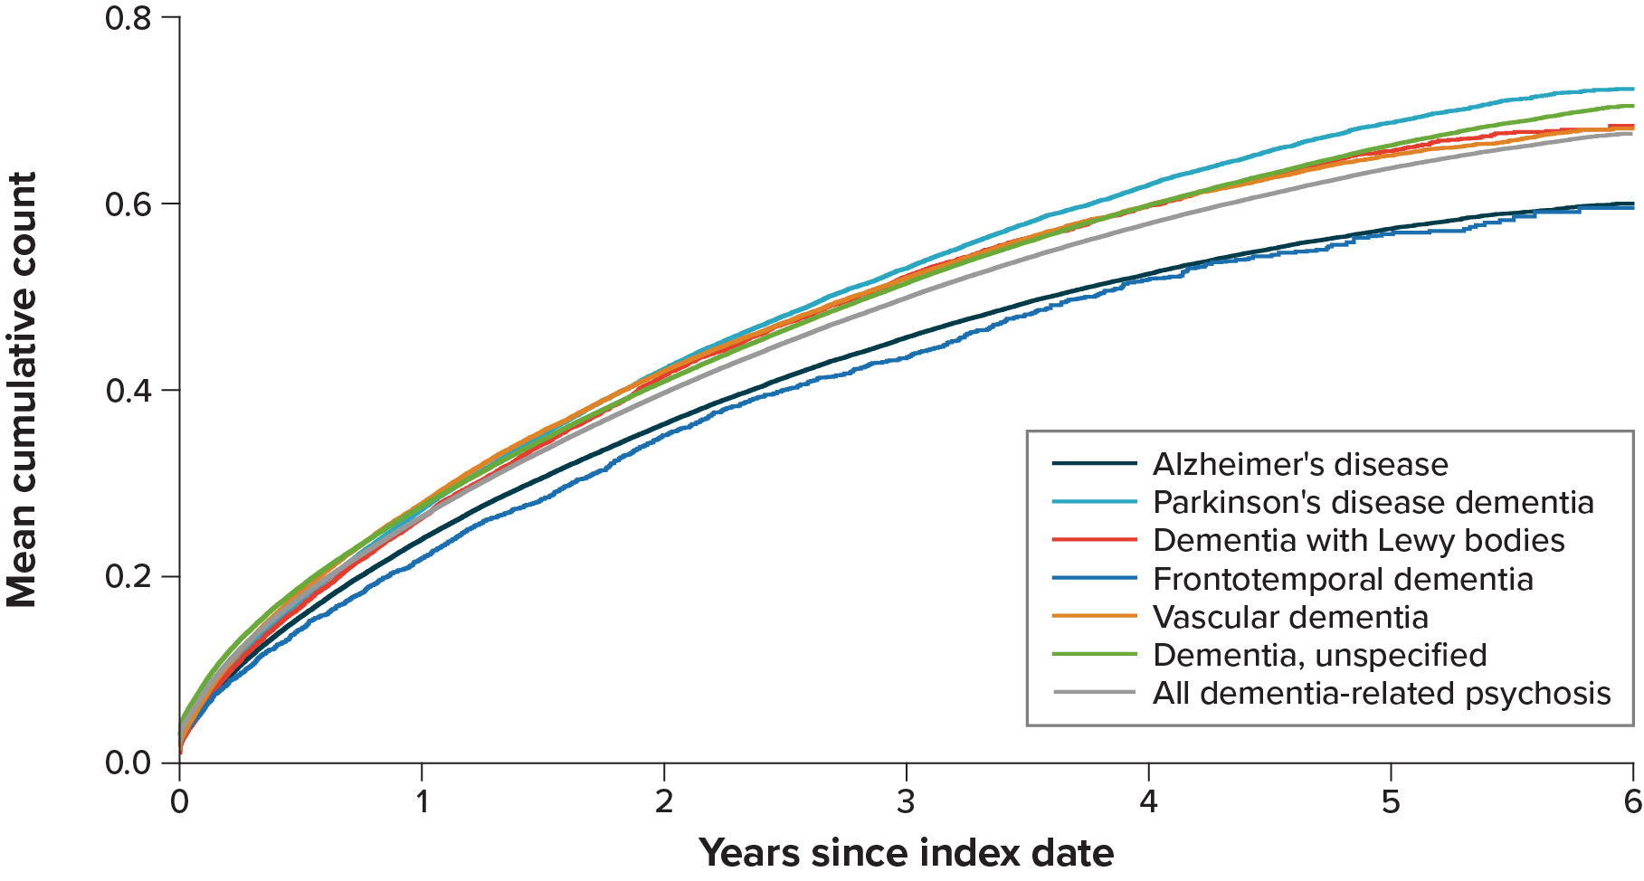
CI = confidence interval.
Alzheimer's disease: 6-year mean cumulative count = 0.6 (95% CI, 0.6-0.6)
Dementia with Lewy bodies: 6-year mean cumulative count = 0.7 (95% CI, 0.7-0.7)
Dementia, unspecified: 6-year mean cumulative count = 0.7 (95% CI, 0.7-0.7)
Frontotemporal dementia: 6-year mean cumulative count = 0.6 (95% CI, 0.6-0.6)
Parkinson's disease dementia: 6-year mean cumulative count = 0.7 (95% CI, 0.7-0.7)
Vascular dementia: 6-year mean cumulative count = 0.7 (95% CI, 0.7-0.7)
All dementia-related psychosis: 6-year mean cumulative count = 0.7 (95% CI, 0.7-0.7)

- Parenteral Anti-infective Treatments
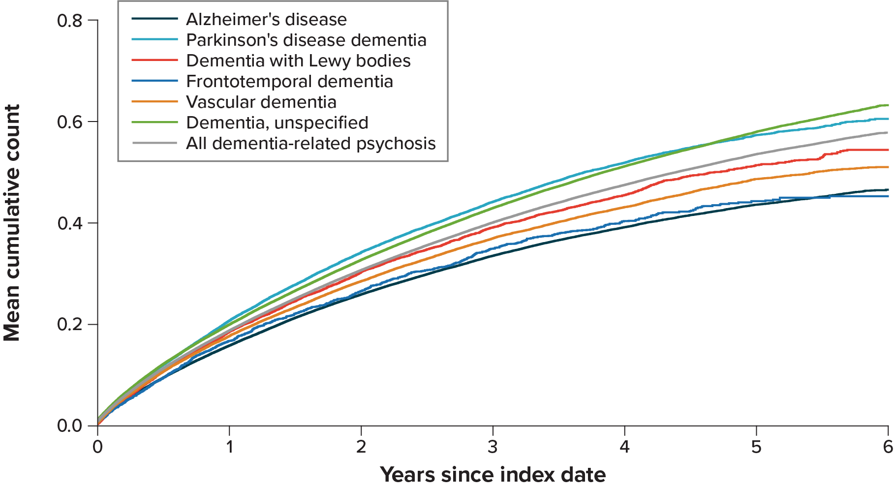
CI = confidence interval.
Alzheimer's disease: 6-year mean cumulative count = 0.5 (95% CI, 0.5-0.5)
Dementia with Lewy bodies: 6-year mean cumulative count = 0.5 (95% CI, 0.5-0.6)
Dementia, unspecified: 6-year mean cumulative count = 0.6 (95% CI, 0.6-0.6)
Frontotemporal dementia: 6-year mean cumulative count = 0.5 (95% CI, 0.4-0.5)
Parkinson's disease dementia: 6-year mean cumulative count = 0.6 (95% CI, 0.6-0.6)
Vascular dementia: 6-year mean cumulative count = 0.5 (95% CI, 0.5-0.5)
All dementia-related psychosis: 6-year mean cumulative count = 0.6 (95% CI, 0.6-0.6)

- Skilled Nursing Facility Stays
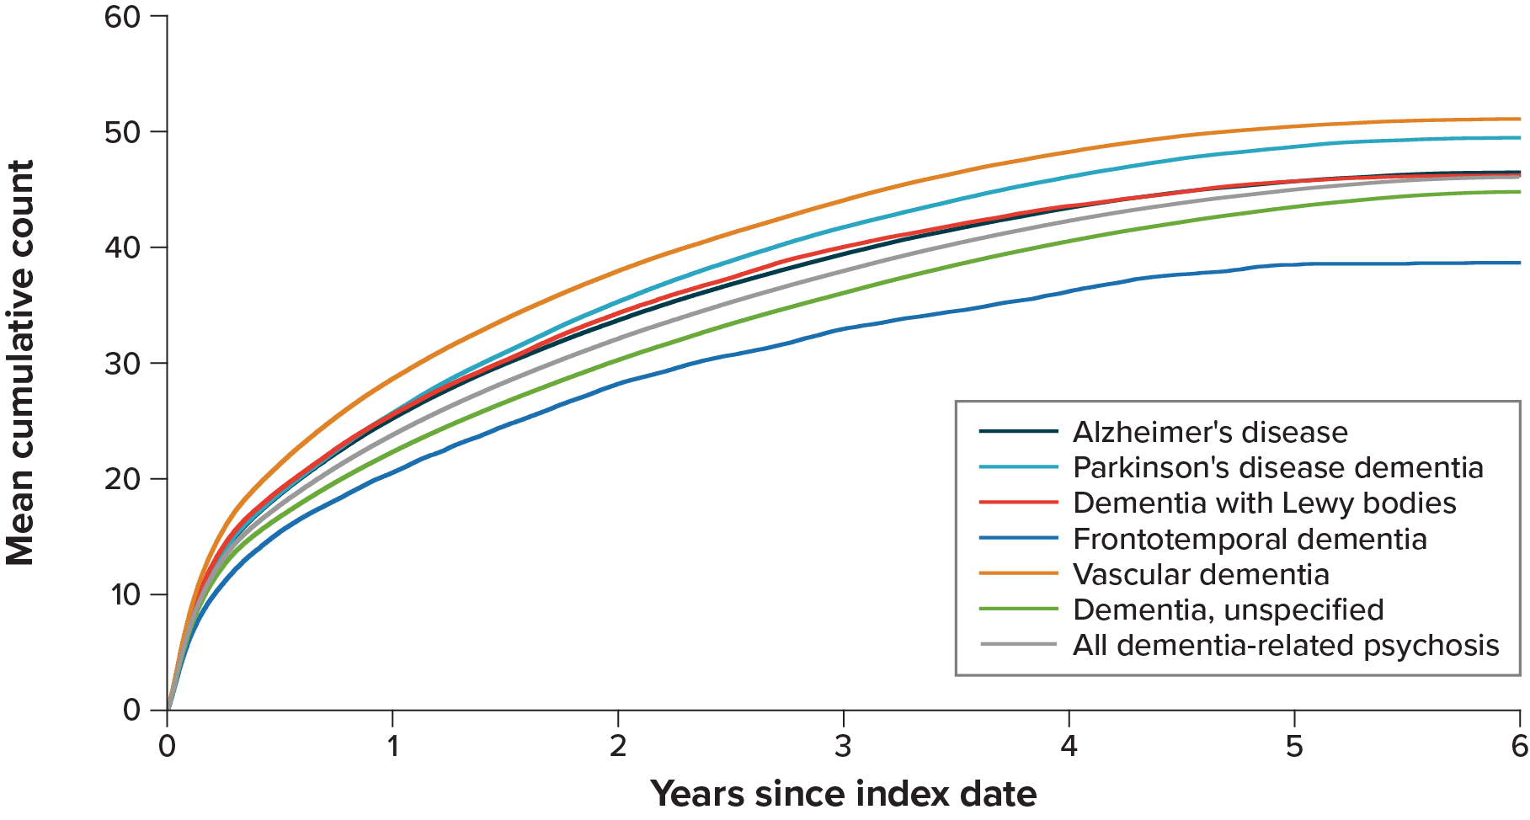
CI = confidence interval.
Alzheimer's disease: 6-year mean cumulative count = 46.5 (95% CI, 45.9-47.0)
Dementia with Lewy bodies: 6-year mean cumulative count = 46.2 (95% CI, 44.5-47.6)
Dementia, unspecified: 6-year mean cumulative count = 44.8 (95% CI, 44.3-45.1)
Frontotemporal dementia: 6-year mean cumulative count = 38.7 (95% CI, 35.8-42.4)
Parkinson's disease dementia: 6-year mean cumulative count = 49.5 (95% CI, 48.3-50.5)
Vascular dementia: 6-year mean cumulative count = 51.1 (95% CI, 50.3-52.2)
All dementia-related psychosis: 6-year mean cumulative count = 46.1 (95% CI, 45.7-46.4)

- Days of Inpatient Hospital Stays
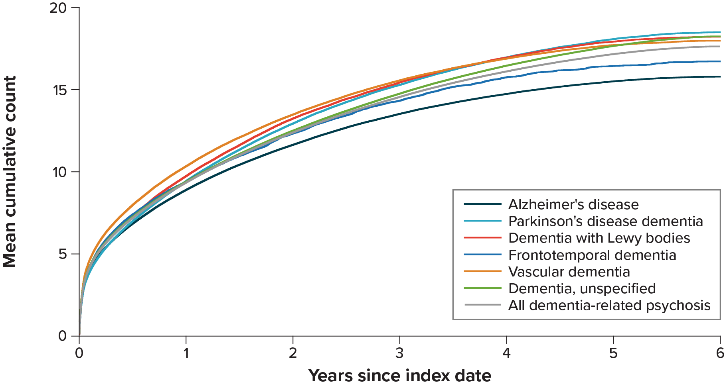
CI = confidence interval.
Alzheimer's disease: 6-year mean cumulative count = 15.8 (95% CI, 15.7-16.0)
Dementia with Lewy bodies: 6-year mean cumulative count = 18.2 (95% CI, 17.8-18.7)
Dementia, unspecified: 6-year mean cumulative count = 18.2 (95% CI, 18.1-18.4)
Frontotemporal dementia: 6-year mean cumulative count = 16.7 (95% CI, 16.0-17.5)
Parkinson's disease dementia: 6-year mean cumulative count = 18.5 (95% CI, 18.2-18.8)
Vascular dementia: 6-year mean cumulative count = 18.0 (95% CI, 17.8-18.2)
All dementia-related psychosis: 6-year mean cumulative count = 17.6 (95% CI, 17.6-17.7)

- Home Healthcare Episodes
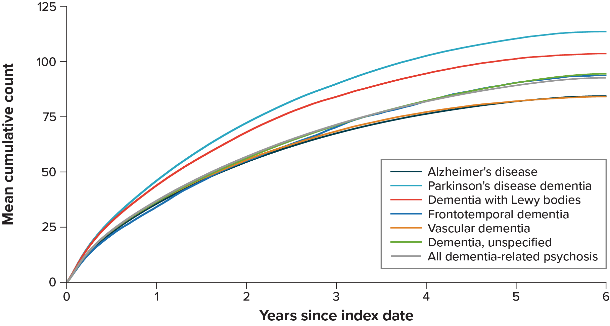
CI = confidence interval.
Alzheimer's disease: 6-year mean cumulative count = 84.4 (95% CI, 83.2-85.6)
Dementia with Lewy bodies: 6-year mean cumulative count = 103.6 (95% CI, 100.2-108.0)
Dementia, unspecified: 6-year mean cumulative count = 94.4 (95% CI, 93.5-95.4)
Frontotemporal dementia: 6-year mean cumulative count = 93.6 (95% CI, 85.6-102.5)
Parkinson's disease dementia: 6-year mean cumulative count = 113.5 (95% CI, 111.2-115.9)
Vascular dementia: 6-year mean cumulative count = 84.1 (95% CI, 82.3-86.0)
All dementia-related psychosis: 6-year mean cumulative count = 92.6 (95% CI, 91.7-93.3)

- Emergency Department Visits
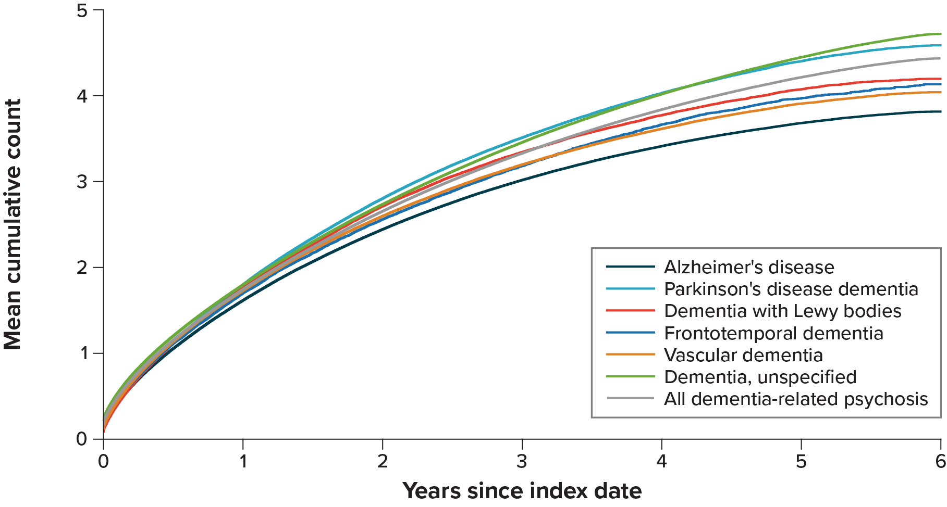
CI = confidence interval.
Alzheimer's disease: 6-year mean cumulative count = 3.8 (95% CI, 3.8-3.8)
Dementia with Lewy bodies: 6-year mean cumulative count = 4.2 (95% CI, 4.1-4.3)
Dementia, unspecified: 6-year mean cumulative count = 4.7 (95% CI, 4.7-4.7)
Frontotemporal dementia: 6-year mean cumulative count = 4.1 (95% CI, 3.9-4.4)
Parkinson's disease dementia: 6-year mean cumulative count = 4.6 (95% CI, 4.5-4.6)
Vascular dementia: 6-year mean cumulative count = 4.0 (95% CI, 4.0-4.1)
All dementia-related psychosis: 6-year mean cumulative count = 4.4 (95% CI, 4.4-4.5)

- Characteristics of Initial Antipsychotic Treatment in Patients With Dementia-Related Psychosis
Comedication | AD,  n = 50,164 | PDD,  n ≈ 14,970 | DLB,  n ≈ 5,280 | FTD,  n ≈ 1,610 | VD,  n ≈ 18,720 | Unspecified dementia,  n ≈ 64,130 | All dementia-related psychosis,  n = 134,022
Time to treatment initiation with any antipsychotic after index date
Mean (SD), days | 198 (317.6) | 218 (329.7) | 181 (293.8) | 178 (315.1) | 180 (301.4) | 278 (395.7) | 238 (361.0)
Type of antipsychotic initially prescribed, n (%)
Clozapine | 18 (0.0) | 40 (0.3) | 16 (0.3) | <11 | <11 | <11 | 63 (0.0)
Quetiapine | 24,219 (49.0) | 9,389 (63.3) | 3,413 (65.4) | 834 (52.5) | 8,667 (46.9) | 29,373 (46.3) | 64,577 (48.8)
Olanzapine | 5,664 (11.5) | 990 (6.7) | 397 (7.6) | 173 (10.9) | 2,275 (12.3) | 6,880 (10.9) | 14,344 (10.8)
Risperidone | 12,784 (25.9) | 2,095 (14.1) | 746 (14.3) | 367 (23.1) | 4,773 (25.8) | 15,838 (25.0) | 32,289 (24.4)
Aripiprazole | 1,513 (3.1) | 366 (2.5) | 118 (2.3) | 59 (3.7) | 663 (3.6) | 2,569 (4.1) | 4,705 (3.6)
Brexpiprazole | 21 (0.0) | <11 | <11 | 0 (0.0) | <11 | 29 (0.0) | 56 (0.0)
Pimavanserin | 227 (0.5) | 893 (6.0) | 247 (4.7) | <11 | 62 (0.3) | 52 (0.1) | 980 (0.7)
Other atypical antipsychotic | 261 (0.5) | 54 (0.4) | 16 (0.3) | 11 (0.7) | 110 (0.6) | 285 (0.4) | 640 (0.5)
Haloperidol | 4,236 (8.6) | 798 (5.4) | 257 (4.9) | 122 (7.7) | 1,643 (8.9) | 5,759 (9.1) | 11,270 (8.5)
Other conventional antipsychotic | 1,221 (2.5) | 342 (2.3) | 74 (1.4) | 32 (2.0) | 523 (2.8) | 3,344 (5.3) | 5,098 (3.9)
Strength, mean (SD), mg
Clozapine | 33 (22.3) | 28 (13.3) | 27 (6.3) | NR | 36 (22.4) | 47 (38.4) | 33 (22.3)
Quetiapine | 34 (28.7) | 32 (23.9) | 32 (25.6) | 34 (28.3) | 35 (31.1) | 33 (25.7) | 33 (27.0)
Olanzapine | 4 (2.7) | 4 (2.8) | 4 (2.5) | 5 (3.4) | 4 (2.7) | 4 (2.8) | 4 (2.8)
Risperidone | 0 (0.4) | 0 (0.4) | 0 (0.4) | 1 (0.4) | 1 (0.4) | 0 (0.4) | 0 (0.4)
Aripiprazole | 4 (3.7) | 4 (3.1) | 4 (3.0) | 4 (2.6) | 5 (3.4) | 4 (3.5) | 4 (3.5)
Brexpiprazole | 1 (0.5) | 1 (0.6) | NR | NR | 1 (0.6) | 1 (0.4) | 1 (0.5)
Pimavanserin | 19 (5.1) | 18 (4.6) | 18 (4.1) | 17 (0.0) | 19 (6.0) | 19 (5.1) | 18 (4.8)
Other atypical antipsychotic | 27 (18.8) | 28 (24.2) | 15 (13.1) | 33 (22.2) | 27 (18.9) | 25 (17.6) | 26 (18.2)
Haloperidol | 1 (1.4) | 1 (1.5) | 2 (1.6) | 2 (1.5) | 1 (1.3) | 1 (1.4) | 1 (1.4)
Other conventional antipsychotic | 10 (11.7) | 10 (5.1) | 10 (5.3) | 13 (11.5) | 11 (11.8) | 10 (6.5) | 10 (8.2)
AD = Alzheimer’s disease; DLB = dementia with Lewy bodies; FTD = frontotemporal dementia; NR = not reported; SD = standard deviation; PDD = Parkinson’s disease dementia; VD = vascular dementia.
Note: The n for each dementia group represents the number of patients who initiated an antipsychotic during follow-up. The n’s displayed for PDD, DLB, FTD, and VD are approximations to maintain masking of cells with <11 counts, as is required by the Centers for Medicare and Medicaid Services privacy policy.
- Antipsychotic Treatment Status Over Follow-up in Patients With Dementia-Related Psychosis
- Alzheimer’s Disease
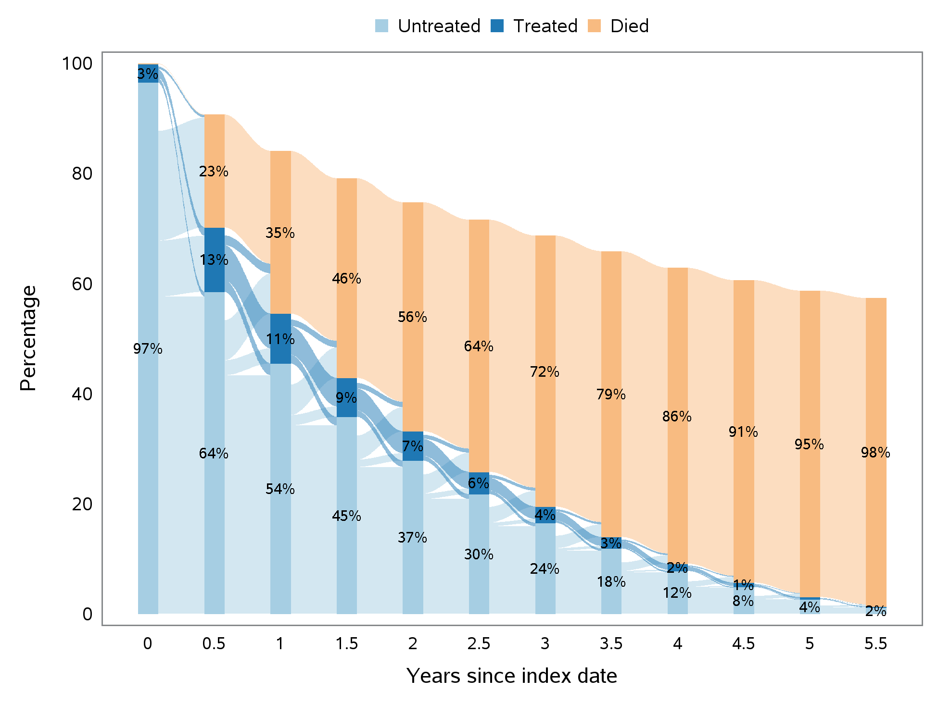

- Parkinson’s Disease Dementia
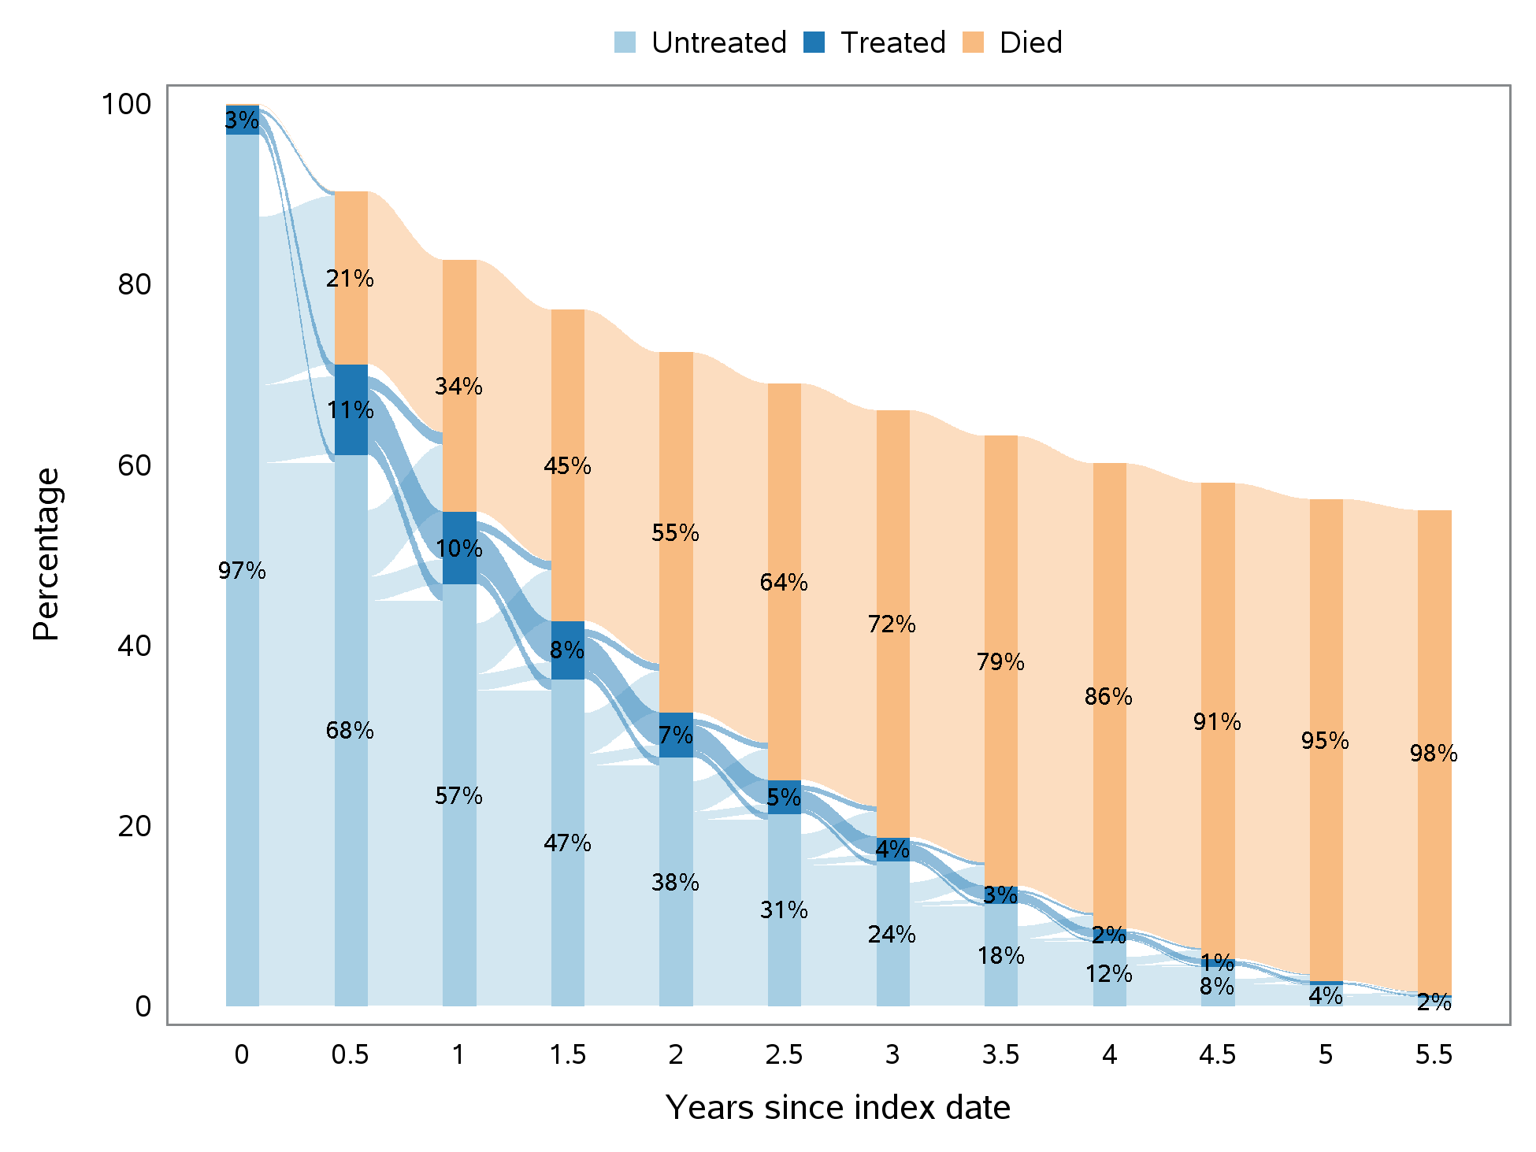

- Dementia With Lewy Bodies
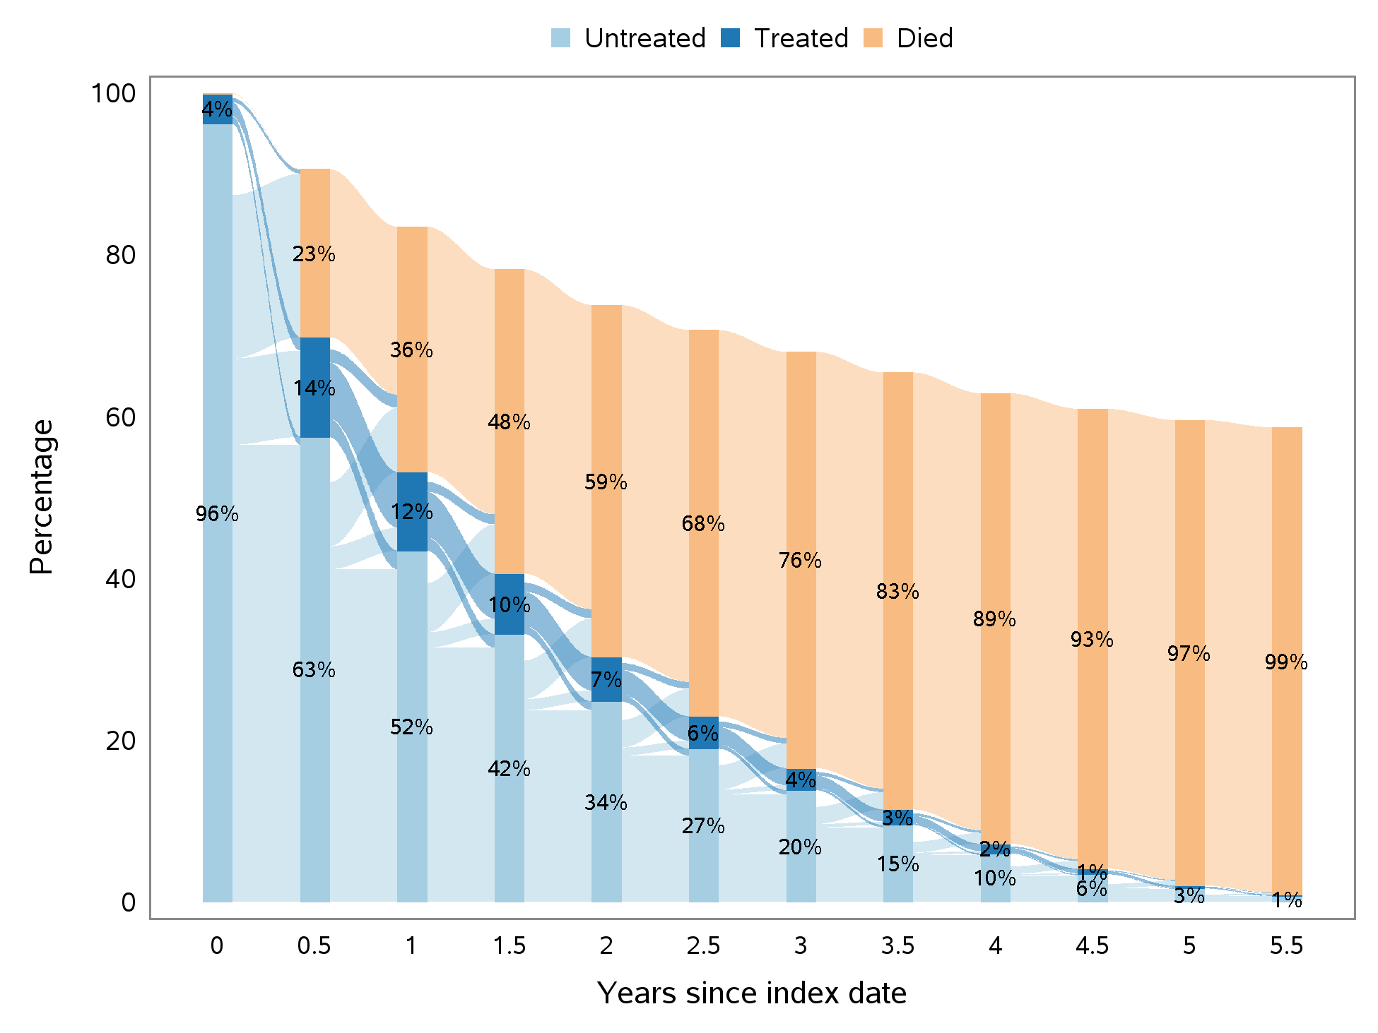

- Frontotemporal Dementia
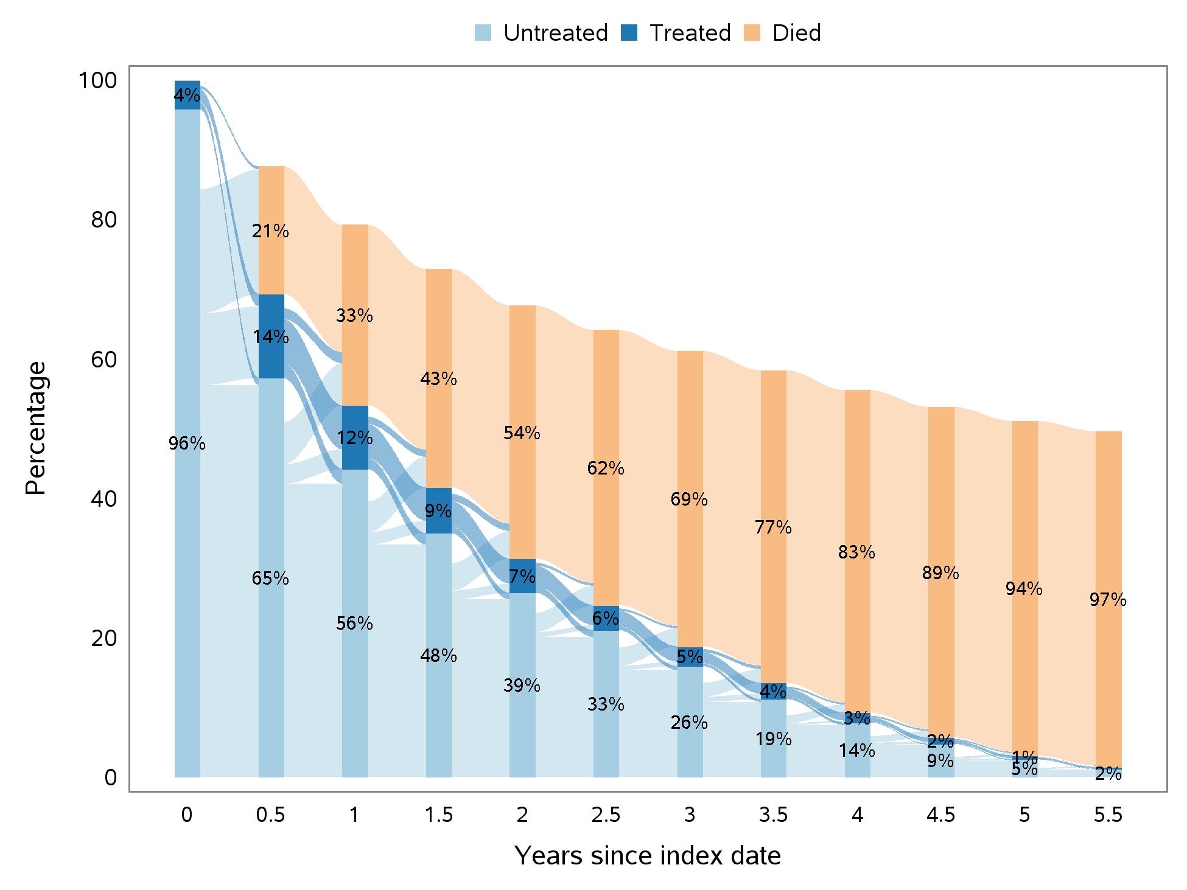

- Vascular Dementia
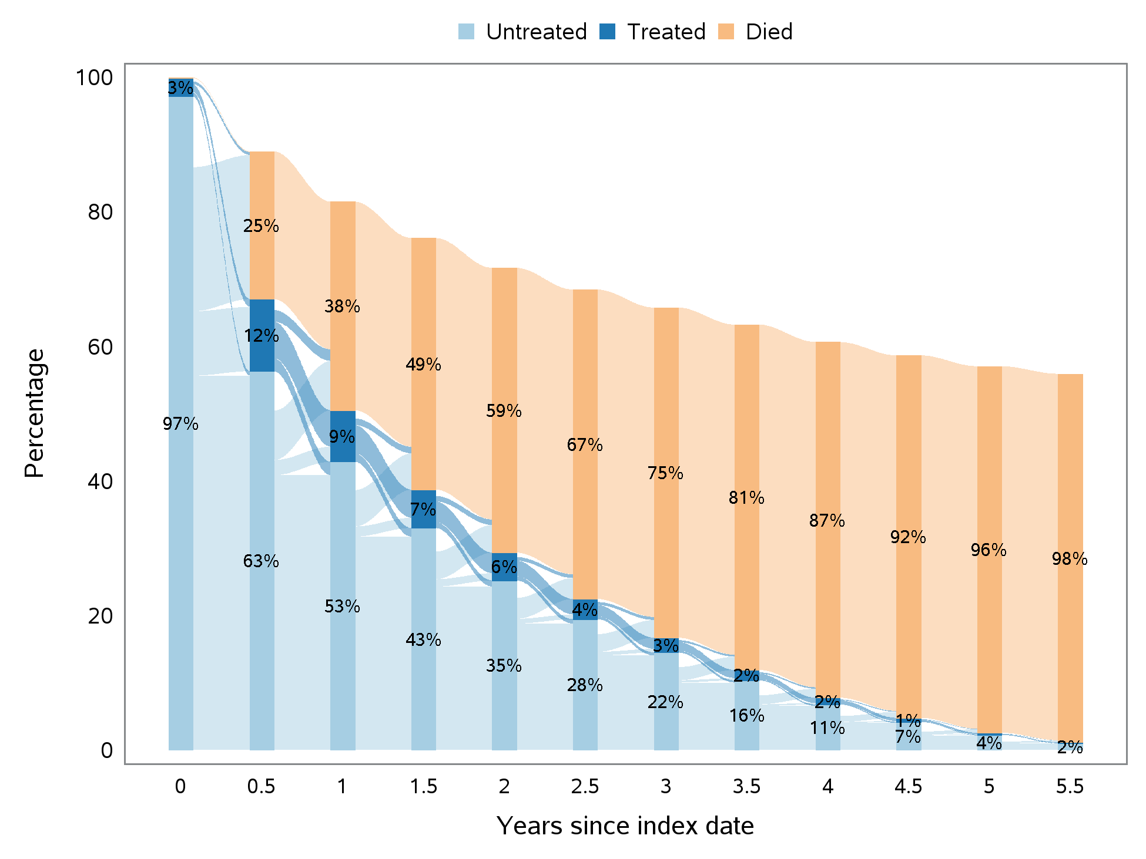

- Dementia, Unspecified
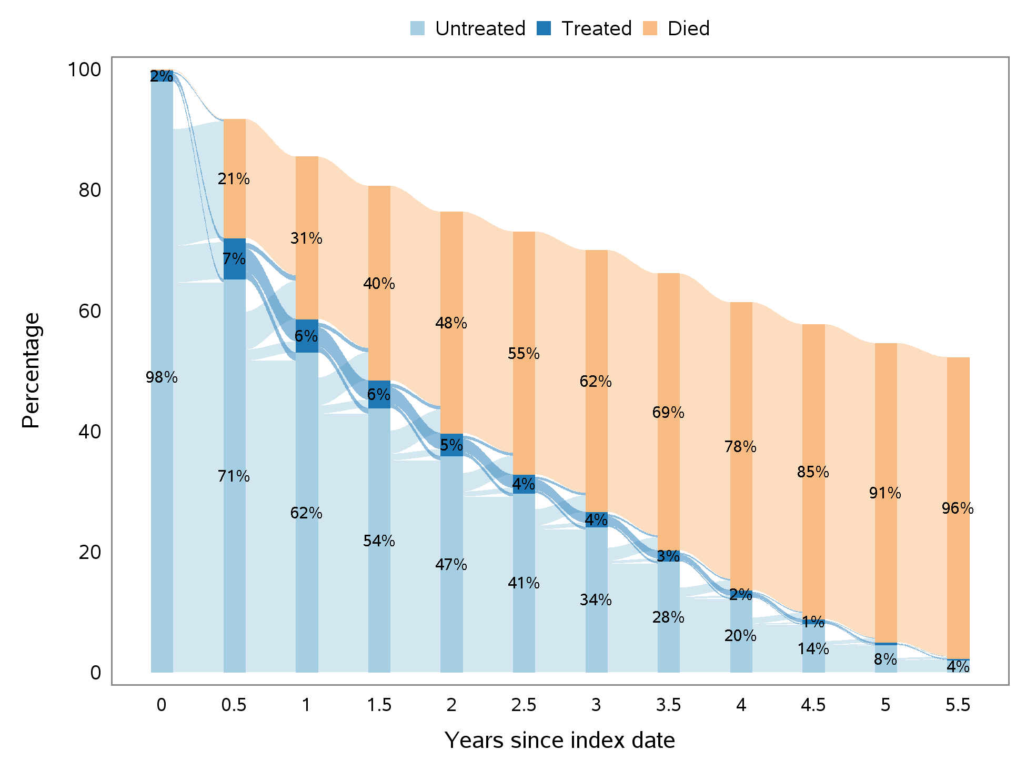

- All Dementia-Related Psychosis
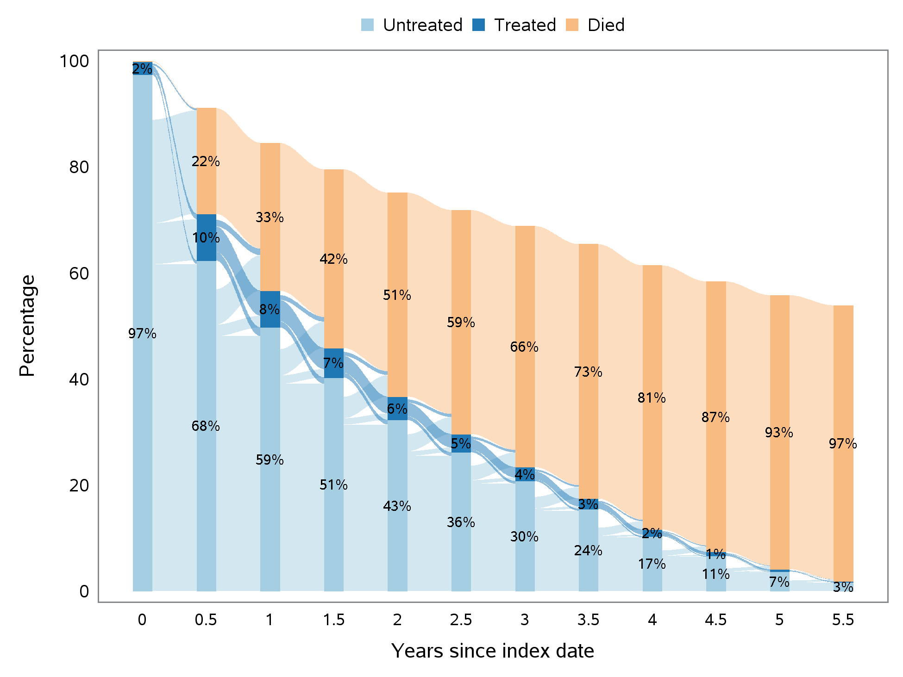

References
1. Glasheen WP, Cordier T, Gumpina R, Haugh G, Davis J, Renda A. Charlson Comorbidity Index: ICD-9 update and ICD-10 translation. Am Health Drug Benefits. 2019 Jun-Jul;12(4):188-97.
2. Cuthbertson CC, Kucharska-Newton A, Faurot KR, Sturmer T, Jonsson Funk M, Palta P, et al. Controlling for frailty in pharmacoepidemiologic studies of older adults: validation of an existing Medicare claims–based algorithm. Epidemiology. 2018 Jul;29(4):556-61. doi:http://dx.doi.org/10.1097/ede.0000000000000833.
3. Faurot KR, Jonsson Funk M, Pate V, Brookhart MA, Patrick A, Hanson LC, et al. Using claims data to predict dependency in activities of daily living as a proxy for frailty. Pharmacoepidemiol Drug Saf. 2015 Jan;24(1):59-66. doi:http://dx.doi.org/10.1002/pds.3719.
4. Xu B, Boero IJ, Hwang L, Le QT, Moiseenko V, Sanghvi PR, et al. Aspiration pneumonia after concurrent chemoradiotherapy for head and neck cancer. Cancer. 2015 Apr 15;121(8):1303-11. doi:http://dx.doi.org/10.1002/cncr.29207.
5. McCarthy EP, Iezzoni LI, Davis RB, Palmer RH, Cahalane M, Hamel MB, et al. Does clinical evidence support ICD-9-CM diagnosis coding of complications? Med Care. 2000 Aug;38(8):868-76. doi:http://dx.doi.org/10.1097/00005650-200008000-00010.
6. Schneeweiss S, Robicsek A, Scranton R, Zuckerman D, Solomon DH. Veteran's affairs hospital discharge databases coded serious bacterial infections accurately. J Clin Epidemiol. 2007 Apr;60(4):397-409. doi:http://dx.doi.org/10.1016/j.jclinepi.2006.07.011.
7. Wiese AD, Griffin MR, Stein CM, Schaffner W, Greevy RA, Mitchel EF, Jr., et al. Validation of discharge diagnosis codes to identify serious infections among middle age and older adults. BMJ Open. 2018;8(6):e020857-e. doi:http://dx.doi.org/10.1136/bmjopen-2017-020857.

ICD-9-CM = International Classification of Diseases, 9th Revision, Clinical Modification.
ICD-10-CM = International Classification of Diseases, 10th Revision, Clinical Modification.
ICD-10-PCS = International Classification of Diseases, Tenth Revision, Procedure Coding System.
CPT = Current Procedural Terminology.

