CriSTAL Tool
Date: ___/___ /_____ |  |  | Consultancy team:
☐ ☐ | Age >75 (1 point)  Admitted via Emergency Department (1 point)
☐ | Nursing home resident /in supported accommodation (either: 1 point)
☐ | Meets >= selected deterioration criteria on admission (max 1 point if it meets >2 RRT criteria)
 | ☐ | 1 - Decreased LOC: Glasgow Coma Score change >2 or AVPU =P or U
 | ☐ | 2 - Systolic blood pressure <90 mmHg
 | ☐ | 3 - Respiratory rate <5 or >30 per minute
 | ☐ | 4 - Pulse rate <40 or >140 per minute
 | ☐ | 5 - Need for oxygen therapy or known oxygen saturation <90%
 | ☐ | 6 - Hypoglycaemia: BGL 1.0 - 4.0 mmol/L
 | ☐ | 7 - Repeat or prolonged seizures (> once in 24 hours or >5 minutes duration)
 | ☐ | 8 - Low urinary output (<15 ml/hour or <0.5 ml/kg/hour)
AND | OTHER RISK FACTORS /PREDICTORS (tick as many as relevant- max 7 points)
 | Personal history of active disease:
☐ | 1 - Advanced malignancy (Stage III or IV for solid tumors, or, metastatic, terminal, incurable)
☐ | 2 - Chronic kidney disease (Stage IV or V or GFR < 30mL/min)
☐ | 3 - Chronic heart failure (NYHFC III or IV or heart failure with shortness of breath with activity (III) or at rest (IV))
☐ | 4 - Chronic obstructive pulmonary disease (GOLD criteria 3 severe FEV1 30-40% or 4 very severe FEV1 <30%)
☐ | 5 - New cerebrovascular disease (New stroke as reason for hospital admission, or stroke during this admission)
☐ | 6 - Myocardial infarction, new or pre-existing (documented EGC changes / Troponin rise)
☐ | 7 - Moderate/severe liver disease (Cirrhosis stage III or IV or liver cancer)
☐ | Evidence of cognitive impairment (tick as many as relevant – only 1 point if >1 mental condition)  ☐ Long term mental disorder ☐ Dementia ☐ Behavioural alterations (acute or chronic, including confusion or delirium) ☐ Mental disability from stroke
☐ | Proteinuria on a spot urine sample: ++ or >30 mg albumin/g creatinine  ☐ Yes (1 point) ☐ No ☐ unknown
☐ | Abnormal ECG (atrial fibrillation, ventricular tachycardia, other abnormal rhythm or >5 ectopics/min, changes to Q or ST waves) (tick as many as relevant – only 1 point if >1 abnormality)  ☐ Acute abnormality ☐ Chronic abnormality ☐ Both chronic and acute this assessment  ☐ No abnormality ☐ Don’t know
☐  ☐ | Previous hospitalisation for at least one night in past year (only 1 point if >1 hospital admission)  ☐ Yes ☐ No ☐ Not documented  Total No. of hospitalisations in the past year ______  Previous ICU admission for at least one night in past year (only 1 point if >1 ICU admission)  ☐ Yes ☐ No ☐ Unknown
AND | Evidence of frailty (Clinical Frailty score)
☐ | Rockwood < 5 ☐ Yes (0 point) Rockwood 5 or 6 ☐ Yes (1 point) Rockwood ≥7 ☐ Yes (2 points)  Actual CFS score ______
CriSTAL score ______

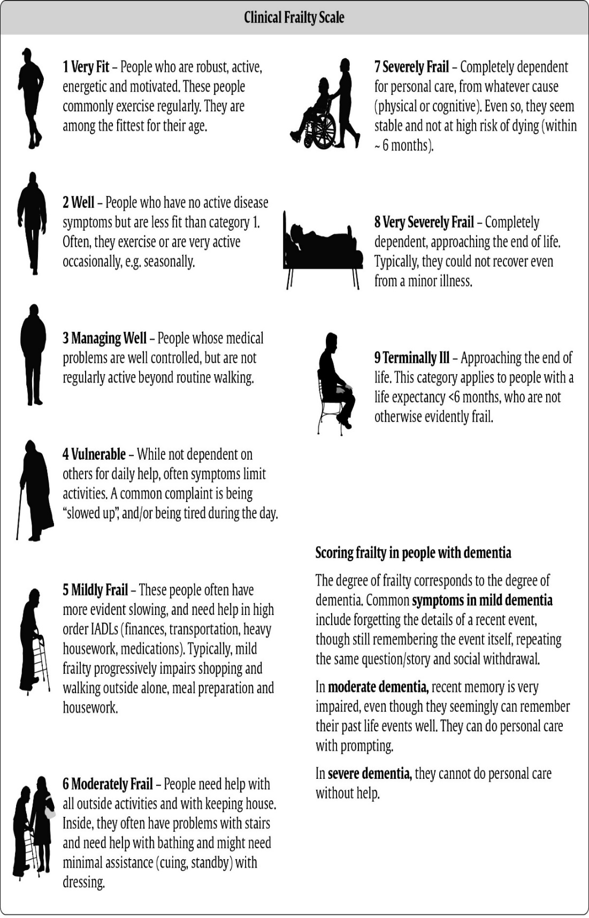

Supportive and Palliative Care Indicators Tool (SPICTTM)
InterACT screening only uses these initial six General Indicators of SPICT
The SPICTTM is used to help identify people whose health is deteriorating.
Assess them for unmet supportive and palliative care needs. Plan care.
Date: ___/___ /_____ |  |  | Consultancy team:
Look for any general indicators of poor or deteriorating health.

☐ | Unplanned hospital admission(s) (1 point)
☐ | Performance status is poor or deteriorating, with limited reversibility.  (e.g. The person stays in bed or in a chair for more than half the day) (1 point)
☐ | Depends on others for care due to increasing physical and/or mental health problems.
☐ | ☐ | The person’s carer needs more help and support. (1 point)
☐ | Progressive weight loss; remains underweight; low muscle mass (1 point)
☐ | Persistent symptoms despite optimal treatment of underlying condition(s) (1 point)
☐ | The person (or family) asks for palliative care; chooses to reduce, stop or not have treatment; or wishes to focus on quality of life (1 point)
Look for clinical indicators of one or multiple life-limiting conditions

Cancer
☐ | Functional ability deteriorating a due to progressive cancer.
☐ | Too frail for cancer treatment or treatment is for symptom control.
Dementia/frailty
☐ | Unable to dress, walk or eat without help.
☐ | Eating and drinking less; difficulty with swallowing.
☐ | Urinary and faecal incontinence.
☐ | Not able to communicate by speaking; little social interaction.
☐ | Frequent falls; fractured femur.
☐ | Recurrent febrile episodes or infections; aspiration pneumonia.
Neurological disease
☐ | Progressive deterioration in physical and/or cognitive function despite optimal therapy.
☐ | Speech problems with increasing difficulty communicating and/or progressive difficulty with swallowing.
☐ | Recurrent aspiration pneumonia; breathless or respiratory failure.
☐ | Persistent paralysis after stroke with significant loss of function and ongoing disability.
Heart/ vascular disease
☐ | Heart failure or extensive, untreatable coronary artery disease; with breathlessness or chest pain at rest or on minimal effort.
☐ | Severe, inoperable peripheral vascular disease.
Respiratory disease
☐ | Severe, chronic lung disease; with breathlessness at rest or on minimal effort between exacerbations.
☐ | Persistent hypoxia needing long term oxygen therapy.
☐ | Has needed ventilation for respiratory failure or ventilation is contraindicated.
Kidney disease
☐ | Stage 4 or 5 chronic kidney disease (eGFR <30ml/min) with deteriorating health.
☐ | Kidney failure complicating other life limiting conditions or treatments.
☐ | Stopping or not starting dialysis.
Liver disease
☐ | Cirrhosis with one or more complications in the past year:  - Diuretic resistant ascites  - Hepatic encephalopathy  - Hepatorenal syndrome  - Bacterial peritonitis  - Recurrent variceal bleeds
☐ | Liver transplant is not possible
Other conditions
☐ | Deteriorating and at risk of dying with other conditions or complications that are not reversible; any treatment available will have a poor outcome.

