Supplementary Materials

Associations of sleeping, sedentary and physical activity with phenotypic age acceleration: a cross-sectional isotemporal substitution model

Appendix 1: Supplementary Methods
Appendix 2: Supplemental Results

Appendix 1
Supplementary Methods
2.1 Study population
In this study, we used data from two NHANES survey cycles (2007–2008 and 2009–2010) to investigate sleeping, sedentary behavior, physical activity and phenotypic age acceleration.
2.2 Measurements and variables
PhenoAgeAccel was calculated by age and nine biomarkerswhich were shown below:
Phenotypic Age = 141.50 + $\frac{\ln\left\{−0.00553×\ln\left(1−mortality risk\right)\right\}}{0.090165}$
where Mortality risk = 1 − exp ($\frac{−1.51714 × exp (xb)}{0.0076927 }$)
and
xb = − 19.907 − 0.0336 × albumin + 0.0095 × creatinine +0.1953 × glucose +
0.0954 × ln (C−reactive protein) − 0.0120 × lymphocyte percentage + 0.0268 × mean cell volume + 0.3306 ×red blood cell distribution width + 0.00188 × alkaline phosphatase +0.0554 × white blood cell count + 0.0804 × chronological age
PhenoAgeAccel = Phenotypic Age − Age

Appendix 2
Supplementary Results
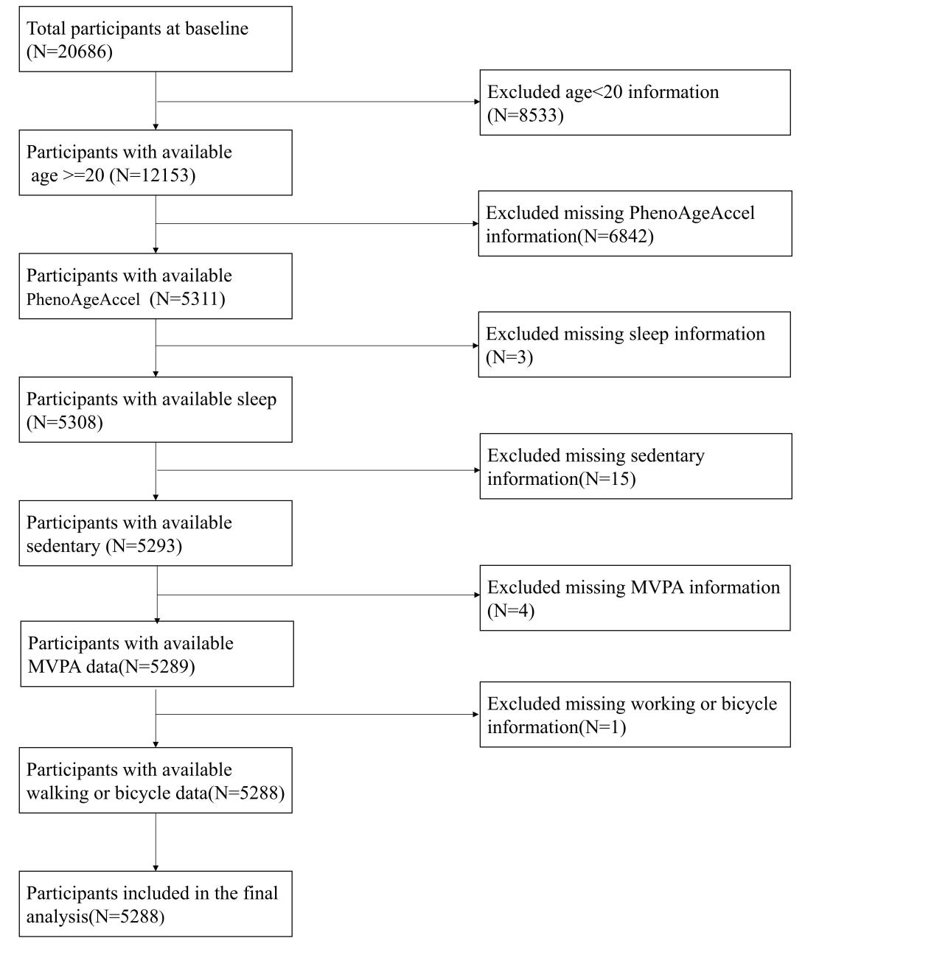
Figure S1 Flow chart of the population included in the final analysis of our study.

Table S1. The Classifications of Covariates.
Covariates | Classifications
Sex | 1: Men; 2: women
Race | 0: non-Hispanic white; 1: others
Education | 0: under high school; 1: high school or above
Drinking | 0: non-drinker; 1: ever-drinker; 2: current-drinker
Smoking status | 0: non-smoker; 1: ever-smoker; 2: current-smoker
Coffee | 0: <one cup per day; 1: ≥one cup per day)
Body mass index | 0: ≤28 kg/m²; 1: > 28 kg/m²

