SUPPLEMENTARY MATERIAL

Supplementary Figure 1. Plot of the percentage of rehospitalizations by mean duration of hospitalization (days), by year
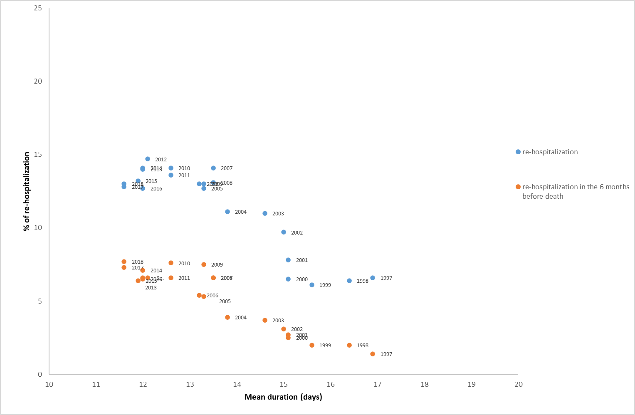

Supplementary Table 1. Primary diagnosis of hospitalizations for selected years
n hospitalizations (%) | 1996-2018  (n=2320) | 1996  (n=145) | 1997  (n=561) | 2006  (n=392) | 2007  (n=375) | 2017  (n=156)
Infectious and parasitic diseases  Neoplasms  Endocrine, nutritional, metabolic diseases  Hematologic diseases  Mental disorders  Neurological diseases  Cardiovascular diseases  Respiratory system diseases  Gastrointestinal diseases  Diseases of the genitourinary system  Dermatological diseases  Diseases musculoskeletal system  Congenital anomalies  Symptoms, signs and ill-defined  Injury and poisoning  Factors influencing health status and contact with health services | 6 (0.3)  694 (29.9)  205 (8.8)  128 (5.5)  132 (5.7)  630 (27.2)  1509 (65.0)  804 (34.7)  618 (26.6)  390 (16.8)  53 (2.3)  362 (15.6)  6 (0.3)  349 (15.0)  630 (27.2)  295 (12.7) | 0 (0.0)  9 (6.2)  3 (2.1)  1 (0.7)  3 (2.1)  14 (9.7)  50 (34.5)  8 (5.5)  6 (4.1)  10 (6.9)  3 (2.1)  13 (9.0)  0 (0.0)  8 (5.5)  11 (7.6)  0 (0.0) | 1 (0.2)  65 (11.6)  28 (5.0)  7 (1.3)  21 (3.7)  90 (16.0)  214 (38.2)  40 (7.1)  54 (9.6)  49 (8.7)  5 (0.9)  38 (6.8)  1 (0.2)  31 (5.5)  37 (6.6)  10 (1.8) | 0 (0.0)  60 (15.3)  9 (2.3)  14 (3.6)  6 (1.5)  18 (4.6)  154 (39.3)  62 (15.8)  52 (13.3)  12 (3.1)  2 (0.5)  28 (7.1)  0 (0.0)  18 (4.6)  38 (9.7)  25 (6.4) | 0 (0.0)  55 (14.7)  12 (3.2)  9 (2.4)  3 (0.8)  17 (4.5)  142 (37.9)  68 (18.1)  48 (12.8)  22 (5.9)  6 (1.6)  22 (5.9)  0 (0.0)  16 (4.3)  44 (11.7)  21 (5.6) | 0 (0.0)  16 (10.3)  2 (1.3)  6 (3.9)  1 (0.6)  3 (1.9)  55 (35.3)  46 (29.5)  16 (10.3)  7 (4.5)  0 (0.0)  4 (2.6)  0 (0.0)  8 (5.1)  24 (15.4)  3 (1.9)

Supplementary Table 2. Linear regression for the association between the length of hospital stay and readmission (all and in the six months before death) in two time periods

 | Association of the length of hospital stay with
Time period | 30-day rehospitalization | 30-day rehospitalizations in the 6 months before death
1996-2006 | β=-2.30, SE=0.65  p=0.008 | β=-1.29, SE=0.29  p=0.002
2007-2018 | β=-0.66, SE=0.53  p=0.241 | β=-0.10, SE=0.49  p=0.846
Abbreviations: SE, standard error.

