Additional file I
File name: perspectives_on_sleep_Additional_file_1_BMC_Geriatrics
File format: Microsoft Word document (.docx)
Title of data: Thematic mind maps: Perspectives on sleep of people living with dementia in nursing homes: A qualitative interview study
Description of the data: The thematic mind maps of PLWD and nurses present the described analyses in the manuscript.

Thematic mindmaps: Perspectives on sleep of people living with dementia living in nursing homes: A qualitative interview study
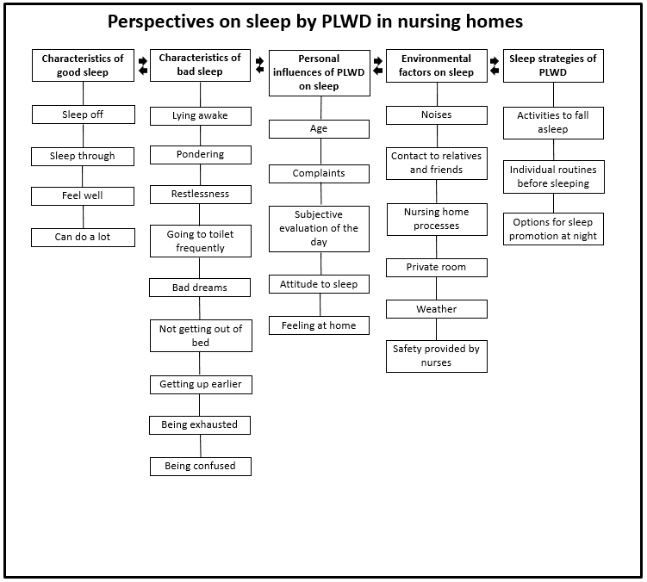Figure 1: Thematic mind map of PLWD
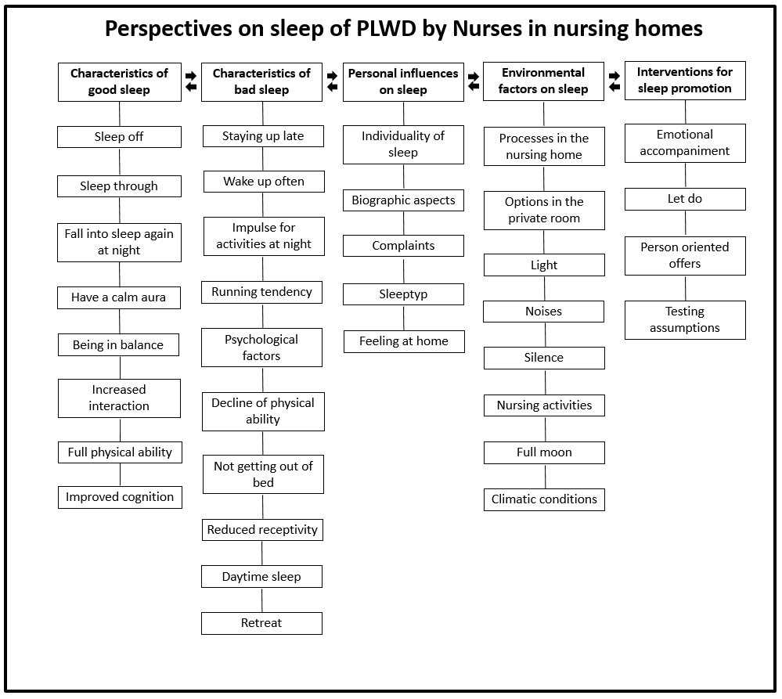
Figure 2: Thematic mind map of nurses

