Supplementary Information Index

Supplementary Information Appendix 1. Methods (cont) |  | Page 2
Supplementary Information Appendix 2. A key for Figure  2 detailing the characteristics of the studies included in the meta analysis. |  | Page 3
Supplementary Information Table 1. Full search strategy. |  | Page 4-5
Supplementary Information Table 2. PROBAST assessment |  | Page 6-9
Supplementary Information Appendix 3. PRISMA checklist. |  | Page 10
References |  | Page 11

Supplementary Information Appendix 1. Methods (cont)

The random effects meta-analysis was conducted in JASP software(1). DerSimonian Laird model was used. Forest plots and funnel plots were generated using JASP. In the case of missing 95%CI for AUC-ROC results, the following formula was used to estimate the 95%CI:

$$CI=AUC ± Z_{1-\frac{α}{2}} ×se$$

$$se= \sqrt{\frac{q_{0}+\left(n_{1}-1\right)q_{1}+\left(n_{2}-1\right)q_{2}}{n_{1}n_{2}}}$$

$q_{0}=AUC\left(1-AUC\right) { q}_{1}=\frac{AUC}{2-AUC}-{AUC}^{2} q_{2}= \frac{{2AUC}^{2}}{1+AUC}-{AUC}^{2}$

An AUC-ROC value for a single point was estimated for instances where only sensitivity and specificity were reported. The AUC min was calculated geometrically using the following formula:

$${AUC}_{min}=\frac{( sensitivity+specificity )}{2}$$

For AUC max, depending on the type of receiver operating characteristic (ROC) curve, the AUC can be approximated as the means of the maximum and minimum area. In the formula below, F denotes the false positive rate, and H denotes the true positive rate.

$${AUC}_{max}=\begin{matrix}1-2F\left(1-H\right), & if F≤0.5<H \\ 1-\frac{F}{2H}, & if F ≤H <0.5 \\ 1-\frac{1-H}{2\left(1-F\right)}, & if 0.5 <F ≤H\end{matrix}$$

Deviations from the PROSPERO Protocol
There were three deviations from our original protocol registered in PROSPERO. Firstly, ‘PsychINFO’ and ‘Cochrane Central Register of Controlled Trials’ databases were not utilised due to a lack of relevant papers. Secondly, we chose to assess bias and study the quality of studies using the PROBAST method which is more appropriate for systematic reviews aiming to assess the performance of machine learning models in predicting clinical outcomes. Finally, due to a lengthy review process we have extended the inclusion criteria to February 2023, ensuring a more up-to-date cover of the available literature.

Supplementary Information Appendix 2. A key for Figure 2 detailing the characteristics of the studies included in the meta-analysis.

Mortality within 6-months
Duarte, 2015_1 - predicting 6-month mortality using PROMPT.
Pilotto, 2010_1 - predicting 1-month mortality in men using MPI combined with linear regression.
Pilotto, 2010_2 - predicting 1-month mortality in women using MPI combined with linear regression; Sanclaro, 2012_1 - predicting 1-month mortality using MPI.
Sanclaro, 2012_2 - predicting 6-month mortality using MPI.

Mortality within 6-months or more
Sanclaro, 2012_3 - predicting 12-month mortality using MPI.
Gomes, 2021_1 - predicting all-cause mortality using ANN.
Gomes, 2021_2 - predicting all-cause mortality using RF.
Gomes, 2021_3 - predicting all-cause mortality using SVM.
Morris, 2020_1 - predicting all-cause hospital mortality in the derivation cohort using qEMAT.
Morris, 2020_2 - predicting all-cause hospital mortality in the validation cohort using qEMAT.
Morris, 2020_3 - predicting all-cause hospital mortality in the derivation cohort using fEMAT.
Morris, 2020_4 - predicting all-cause hospital mortality in the validation cohort using fEMAT.
Morris, 2020_5 - predicting all-cause hospital mortality in the Michigan Trauma Quality Improvement Program cohort using qEMAT.
Diaz-Ramirez, 2021_1 - predicting mortality using the individual outcome method.
Diaz-Ramirez, 2021_2 - predicting mortality using the union method.
Diaz-Ramirez, 2021_3 - predicting mortality using the baBIC method.
Diaz-Ramirez, 2021_4 - predicting mortality using the intersection method.
Diaz-Ramirez, 2021_5 - predicting mortality using the full method
Verdu-Rotellar, 2022_1 – predicting risk of death or hospitalization (compound outcome) in the validation cohort using multiple logistic regression
Verdu-Rotellar, 2022_2 – predicting risk of death or hospitalization (compound outcome) in the derivation cohort using multiple logistic regression
Parenica, 2012_1 – predicting 1-year mortality in the TAVI cohort using EuroScore
Parenica, 2012_2 – predicting 1-year mortality in the SAVR+TAVI cohort using EuroScore

Supplementary Information Table 1A. Full search strategy.
Database | Search # | Search query | Results
Embase | #1 | 'machine learning*':ti,ab,kw OR 'artificial intelligence*':ti,ab,kw OR 'deep learning*':ti,ab,kw OR 'statistical learning*':ti,ab,kw OR algorithm*:ti,ab,kw OR 'expert system*':ti,ab,kw OR 'neural network*':ti,ab,kw OR 'natural language processing*':ti,ab,kw OR 'predictive model*':ti,ab,kw | 533,598
Embase | #2 | 'clinical outcome*':ti,ab,kw OR 'critical care outcome*':ti,ab,kw OR 'patient-reported outcome*':ti,ab,kw | 150,193
Embase | #3 | 'older adult*':ti,ab,kw OR 'over 65*':ti,ab,kw OR 'elderly*':ti,ab,kw OR 'geriatric*':ti,ab,kw OR 'over 80*':ti,ab,kw OR ‘aged*’:ti,ab,kw OR 'aged'/exp OR 'very elderly'/exp | 4,107,851
Embase | #4 | #1 AND #2 AND #3 | 602
PubMed | #1 | (((((((((((((((((machine learning* [Title/Abstract]) OR (artificial intelligence*[Title/Abstract])) OR (deep learning*[Title/Abstract])) OR (statistical learning*[Title/Abstract])) OR (algorithm*[Title/Abstract])) OR (expert system*[Title/Abstract])) OR (neural network*[Title/Abstract])) OR (natural language processing*[Title/Abstract])) OR (predictive model*[Title/Abstract])) OR (machine learning*[Text Word])) OR (artificial intelligence*[Text Word])) OR (deep learning*[Text Word])) OR (statistical learning*[Text Word])) OR (algorithm*[Text Word])) OR (expert system*[Text Word])) OR (neural network*[Text Word])) OR (natural language processing*[Text Word])) OR (predictive model*[Text Word]) | 587, 901
PubMed | #2 | ((((((clinical outcome*[Title/Abstract]) OR (critical care outcome*[Title/Abstract])) OR (patient-reported outcome*[Title/Abstract])) OR (clinical outcome[Text Word])) OR (clinical outcome*[Text Word])) OR (critical care outcome*[Text Word])) OR (patient-reported outcome*[Text Word]) | 231,062
PubMed | #3 | (((((((((((((older adult*[Title/Abstract]) OR (over 65*[Title/Abstract])) OR (elderly*[Title/Abstract])) OR (geriatric*[Title/Abstract])) OR (over 80*[Title/Abstract])) OR (aged*[Title/Abstract])) OR (very elderly*[Title/Abstract])) OR (older adult*[Text Word])) OR (over 65*[Text Word])) OR (elderly*[Text Word])) OR (geriatric*[Text Word])) OR (over 80*[Text Word])) OR (aged*[Text Word])) OR (very elderly*[Text Word]) | 5,889,093
PubMed | #4 | #1 AND #2 AND #3 | 1,831
Web of Science Core collection | #1 | TS = ("machine learning*" or "artificial intelligence*" or "deep learning*" or "statistical learning*" or "algorithm*" or "expert system*" or "neural network*" or "natural language processing*" or "predictive model*") | 2,937,326
Web of Science Core collection | #2 | TS = ("clinical outcome*" or "critical care outcome* " or "patient-reported outcome*") | 256,594
Web of Science Core collection | #3 | TS = ("older adult*" or "over 65*" or "elderly*" or "geriatric*" or "over 80*" or "aged*" or "very elderly*") | 1,127,319
Web of Science Core collection | #4 | #1 AND #2 AND #3 | 208
Web of Science BIOSIS citation index | #1 | TS = ("machine learning*" or "artificial intelligence*" or "deep learning*" or "statistical learning*" or "algorithm*" or "expert system*" or "neural network*" or "natural language processing*" or "predictive model*") | 298,050
Web of Science BIOSIS citation index | #2 | TS = ("clinical outcome*" or "critical care outcome* " or "patient-reported outcome*") | 126,219
Web of Science BIOSIS citation index | #3 | TS = ("older adult*" or "over 65*" or "elderly*" or "geriatric*" or "over 80*" or "aged*" or "very elderly*") | 1,569,198
Web of Science BIOSIS citation index | #4 | #1 AND #2 AND #3 | 693
Scopus | #1 | ( TITLE-ABS-KEY ( "machine learning" ) OR TITLE-ABS-KEY ( "artificial intelligence*" ) OR TITLE-ABS-KEY ( "deep learning*" ) OR TITLE-ABS-KEY ( "statistical learning" ) OR TITLE-ABS-KEY ( "algorithm*" ) OR TITLE-ABS-KEY ( "expert system*" ) OR TITLE-ABS-KEY ( "neural network*" ) OR TITLE-ABS-KEY ( "natural language processing*" ) OR TITLE-ABS-KEY ( "predictive model*" ) ) | 4,365,173
Scopus | #2 | ( TITLE-ABS-KEY ( "clinical outcome*" ) OR TITLE-ABS-KEY ( "critical care outcome*" ) OR TITLE-ABS-KEY ( "patient reported outcome*" ) ) | 356,431
Scopus | #3 | ( TITLE-ABS-KEY ( "older adult*" ) OR TITLE-ABS-KEY ( "over 65*" ) OR TITLE-ABS-KEY ( "over 80*" ) OR TITLE-ABS-KEY ( "aged*" ) OR TITLE-ABS-KEY ( "elderly*" ) OR TITLE-ABS-KEY ( "very elderly*" ) OR TITLE-ABS-KEY ( "geriatric*" ) ) | 5,947,699
Scopus | #4 | #1 AND #2 AND #3 | 3,511
ProQuest | #1 | ab(“machine learning*” OR “artificial intelligence*” OR “deep learning*” OR “statistical learning*” OR “algorithm*” or “expert system*” OR “neural network*” OR “natural language processing*” OR “predictive model*”) OR ti(“machine learning*” OR “artificial intelligence*” OR “deep learning*” OR “statistical learning*” OR “algorithm*” or “expert system*” OR “neural network*” OR “natural language processing*” OR “predictive model*”) | 748,457
ProQuest | #2 | ab(“clinical outcome*” OR “critical care outcome*” OR “patient reported outcome*”) OR ti(“clinical outcome*” OR “critical care outcome*” OR “patient reported outcome*”) | 37,997
ProQuest | #3 | ab(“older adult*” OR “over 65*” OR “elderly*” OR “geriatric*” OR “over 80*” OR “aged*” OR “very elderly*”) OR ti(“older adult*” OR “over 65*” OR “elderly*” OR “geriatric*” OR “over 80*” OR “aged*” OR “very elderly*”) | 415,856
ProQuest | #4 | #1 AND #2 AND #3 | 37
Supplementary Information Table 1B. Updated search strategy (up to February 2023).
Database | Search # | Search query | Results
Embase | #1 | machine learning*':ti,ab,kw OR 'artificial intelligence*':ti,ab,kw OR 'deep learning*':ti,ab,kw OR 'statistical learning*':ti,ab,kw OR algorithm*:ti,ab,kw OR 'expert system*':ti,ab,kw OR 'neural network*':ti,ab,kw OR 'natural language processing*':ti,ab,kw OR 'predictive model*':ti,ab,kw | 640,972
Embase | #2 | clinical outcome*':ti,ab,kw OR 'critical care outcome*':ti,ab,kw OR 'patient-reported outcome*':ti,ab,kw | 415,041
Embase | #3 | older adult*':ti,ab,kw OR 'over 65*':ti,ab,kw OR 'elderly*':ti,ab,kw OR 'geriatric*':ti,ab,kw OR 'over 80*':ti,ab,kw OR ‘aged*’:ti,ab,kw OR 'aged'/exp OR 'very elderly'/exp | 4,530,680
Embase | #4 | #1 AND #2 AND #3 AND [01-12-2021]/sd NOT [01-03-2023]/sd | 414
PubMed | #1 | (((((((((((((((((machine learning* [Title/Abstract]) OR (artificial intelligence*[Title/Abstract])) OR (deep learning*[Title/Abstract])) OR (statistical learning*[Title/Abstract])) OR (algorithm*[Title/Abstract])) OR (expert system*[Title/Abstract])) OR (neural network*[Title/Abstract])) OR (natural language processing*[Title/Abstract])) OR (predictive model*[Title/Abstract])) OR (machine learning*[Text Word])) OR (artificial intelligence*[Text Word])) OR (deep learning*[Text Word])) OR (statistical learning*[Text Word])) OR (algorithm*[Text Word])) OR (expert system*[Text Word])) OR (neural network*[Text Word])) OR (natural language processing*[Text Word])) OR (predictive model*[Text Word]) | 678,926
PubMed | #2 | ((((((clinical outcome*[Title/Abstract]) OR (critical care outcome*[Title/Abstract])) OR (patient-reported outcome*[Title/Abstract])) OR (clinical outcome[Text Word])) OR (clinical outcome*[Text Word])) OR (critical care outcome*[Text Word])) OR (patient-reported outcome*[Text Word]) | 263,858
PubMed | #3 | (((((((((((((older adult*[Title/Abstract]) OR (over 65*[Title/Abstract])) OR (elderly*[Title/Abstract])) OR (geriatric*[Title/Abstract])) OR (over 80*[Title/Abstract])) OR (aged*[Title/Abstract])) OR (very elderly*[Title/Abstract])) OR (older adult*[Text Word])) OR (over 65*[Text Word])) OR (elderly*[Text Word])) OR (geriatric*[Text Word])) OR (over 80*[Text Word])) OR (aged*[Text Word])) OR (very elderly*[Text Word]) | 6,053,672
PubMed | #4 | #1 AND #2 AND #3 Filters: from 2021/12/1 - 2023/2/28 | 109
Web of Science Core collection | #1 | TS = ("machine learning*" or "artificial intelligence*" or "deep learning*" or "statistical learning*" or "algorithm*" or "expert system*" or "neural network*" or "natural language processing*" or "predictive model*") | 3,324,223
Web of Science Core collection | #2 | TS = ("clinical outcome*" or "critical care outcome* " or "patient-reported outcome*") | 292,183
Web of Science Core collection | #3 | TS = ("older adult*" or "over 65*" or "elderly*" or "geriatric*" or "over 80*" or "aged*" or "very elderly*") | 1,237,508
Web of Science Core collection | #4 | #1 AND #2 AND #3 and 2023 or 2022 or 2021 (Publication Years) | 89
Web of Science BIOSIS citation index | #1 | TS = ("machine learning*" or "artificial intelligence*" or "deep learning*" or "statistical learning*" or "algorithm*" or "expert system*" or "neural network*" or "natural language processing*" or "predictive model*") | 337,621
Web of Science BIOSIS citation index | #2 | TS = ("clinical outcome*" or "critical care outcome* " or "patient-reported outcome*") | 137,777
Web of Science BIOSIS citation index | #3 | TS = ("older adult*" or "over 65*" or "elderly*" or "geriatric*" or "over 80*" or "aged*" or "very elderly*") | 1,677,302
Web of Science BIOSIS citation index | #4 | #1 AND #2 AND #3 and 2022 or 2023 (Publication Years) | 112
Scopus | #1 | ( TITLE-ABS-KEY ( "machine learning" ) OR TITLE-ABS-KEY ( "artificial intelligence*" ) OR TITLE-ABS-KEY ( "deep learning*" ) OR TITLE-ABS-KEY ( "statistical learning" ) OR TITLE-ABS-KEY ( "algorithm*" ) OR TITLE-ABS-KEY ( "expert system*" ) OR TITLE-ABS-KEY ( "neural network*" ) OR TITLE-ABS-KEY ( "natural language processing*" ) OR TITLE-ABS-KEY ( "predictive model*" ) ) | 4,928,389
Scopus | #2 | ( TITLE-ABS-KEY ( "clinical outcome*" ) OR TITLE-ABS-KEY ( "critical care outcome*" ) OR TITLE-ABS-KEY ( "patient reported outcome*" ) ) | 434,883
Scopus | #3 | ( TITLE-ABS-KEY ( "older adult*" ) OR TITLE-ABS-KEY ( "over 65*" ) OR TITLE-ABS-KEY ( "over 80*" ) OR TITLE-ABS-KEY ( "aged*" ) OR TITLE-ABS-KEY ( "elderly*" ) OR TITLE-ABS-KEY ( "very elderly*" ) OR TITLE-ABS-KEY ( "geriatric*" ) ) | 6,325,412
Scopus | #4 | #1 AND #2 AND #3 AND ( LIMIT-TO ( PUBYEAR , 2023 ) OR LIMIT-TO ( PUBYEAR , 2022 ) ) | 3,511
ProQuest | #1 | ab(“machine learning*” OR “artificial intelligence*” OR “deep learning*” OR “statistical learning*” OR “algorithm*” or “expert system*” OR “neural network*” OR “natural language processing*” OR “predictive model*”) OR ti(“machine learning*” OR “artificial intelligence*” OR “deep learning*” OR “statistical learning*” OR “algorithm*” or “expert system*” OR “neural network*” OR “natural language processing*” OR “predictive model*”) | 885,835
ProQuest | #2 | ab(“clinical outcome*” OR “critical care outcome*” OR “patient reported outcome*”) OR ti(“clinical outcome*” OR “critical care outcome*” OR “patient reported outcome*”) | 44,453
ProQuest | #3 | ab(“older adult*” OR “over 65*” OR “elderly*” OR “geriatric*” OR “over 80*” OR “aged*” OR “very elderly*”) OR ti(“older adult*” OR “over 65*” OR “elderly*” OR “geriatric*” OR “over 80*” OR “aged*” OR “very elderly*”) | 365,276
ProQuest | #4 | #1 AND #2 AND #3 AND Limits Applied (Date of publication 2022, 2023.) | 18
Supplementary Information Table 2. PROBAST assessment.

Authors; Year; Country | Participants | Predictors | Outcomes | Analysis | Overall Risk of Bias
Abdul Ghffar et al; 2020; USA
OptiML fusion model predicting in-hospital cardiovascular mortality. | Low | Low | Low | Low | Low
OptiML fusion model predicting in-hospital all-cause mortality. | Low | Low | Low | Low | Low
OptiML fusion model predicting 30-day cardiovascular mortality. | Low | Low | Low | Low | Low
OptiML fusion model predicting 30-day all-cause mortality. | Low | Low | Low | Low | Low
Belmin et al, 2022; France
Random Forest model predicting 14-day risk of ED admission. | Low | Low | Low | Low | Low
Bories et al, 2022 ; France
RF model predicting hospitalisation for bleeding events. | Low | Low | Low | Low | Low
SVM model predicting hospitalisation for bleeding events. | Low | Low | Low | Low | Low
XGBoost model predicting hospitalisation for bleeding events. | Low | Low | Low | Low | Low
Bowen et al; 2021; USA
Multilevel mixed modelling predicting pain perception in the last 7 days. | Low | Low | Unclear | Unclear | Unclear
Chen et al; 2020; China
Subdistribution hazards regression model predicting survival in patients with early stage uterine papillary carcinoma. | Low | Low | Low | Low | Low
Chung et al; 2020; Taiwan
ANN model 1 predicting favourable or poor outcome at 3 months following AIS. | Low | Low | Low | Unclear | Unclear
ANN model 2 predicting favourable or poor outcome at 3 months following AIS. | Low | Low | Low | Unclear | Unclear
Considine et al; 2019; Australia
Multivariable logistic regression model predicting emergency interhospital transfer from subacute to acute care. | Low | Low | Low | Low | Low
Das et al; 2003; USA
ANN model predicting recurrent bleeding. | Low | Low | Low | Low | Low
ANN model predicting death. | Low | Low | Low | Low | Low
ANN model predicting therapeutic interventions for control of haemorrhage. | Low | Low | Low | Low | Low
Multiple-logistic regression model predicting recurrent bleeding. | Low | Low | Low | Low | Low
Multiple-logistic regression model predicting death. | Low | Low | Low | Low | Low
Multiple-logistic regression model predicting therapeutic interventions for control of haemorrhage. | Low | Low | Low | Low | Low
Diaz-Ramirez et al; 2021; USA
baBIC model predicting time to first ADL dependence. | Low | Low | Low | Low | Low
baBIC model predicting time to first IADL difficulty. | Low | Low | Low | Low | Low
baBIC model predicting time to first mobility dependence. | Low | Low | Low | Low | Low
baBIC model predicting time to death. | Low | Low | Low | Low | Low
Duarte et al; 2015; USA
PROMPT model predicting time to death. | Low | Low | Low | Low | Low
Falsetti et al; 2021; Italy
XGBoost model predicting therapeutic failure. | Low | Low | Low | Low | Low
XGBoost model predicting stroke/TIA. | Low | Low | Low | Low | Low
XGBoost model predicting major bleeding. | Low | Low | Low | Low | Low
Ford et al; 2021; UK
Logistic Regression model predicting dementia. | Low | Low | Low | Low | Low
Naïve Bayes model predicting dementia. | Low | Low | Low | Low | Low
RF model predicting dementia. | Low | Low | Low | Low | Low
Fransvea et al, 2022 ; Italy
Elastic-Net model predicting 30-day-mortality. | Low | Low | Low | Low | Low
SVM model predicting 30-day-mortality. | Low | Low | Low | Low | Low
KNN model predicting 30-day-mortality. | Low | Low | Low | Low | Low
DT Classifier model predicting 30-day-mortality. | Low | Low | Low | Low | Low
Multilayer Perceptron model predicting 30-day-mortality. | Low | Low | Low | Low | Low
Friz et al, 2022 ; Italy
Adaptive Boosting model predicting 30-day all-cause readmissions after decompensated heart failure. | Low | Low | Low | Low | Low
Gradient Boosting model predicting 30-day all-cause readmissions after decompensated heart failure. | Low | Low | Low | Low | Low
XGBoost model predicting 30-day all-cause readmissions after decompensated heart failure. | Low | Low | Low | Low | Low
Random Forest model predicting 30-day all-cause readmissions after decompensated heart failure. | Low | Low | Low | Low | Low
Gomes et al; 2021; Germany
ANN model predicting all-cause intrahospital mortality. | Low | Low | Low | Low | Low
RF model predicting all-cause intrahospital mortality. | Low | Low | Low | Low | Low
SVM model predicting all-cause intrahospital mortality. | Low | Low | Low | Low | Low
Han et al; 2012; USA
Logistic regression model predicting six-month mortality. | Low | Low | Low | Low | Low
Ko et al; 2014; USA
Linear discriminant 10-variable model predicting colonoscopy average risk screening. | Low | Low | Low | Low | Low
Linear discriminant 30-variable model predicting colonoscopy average risk screening. | Low | Low | Low | Low | Low
CART 7 variable model predicting colonoscopy average risk screening. | Low | Low | Low | Low | Low
Linear discriminant 10-variable model predicting colonoscopy high risk screening. | Low | Low | Low | Low | Low
Linear discriminant 30-variable model predicting colonoscopy high risk screening. | Low | Low | Low | Low | Low
CART 7 variable model predicting colonoscopy high risk screening. | Low | Low | Low | Low | Low
Linear discriminant 10-variable model predicting colonoscopy surveillance. | Low | Low | Low | Low | Low
Linear discriminant 30-variable model predicting colonoscopy surveillance. | Low | Low | Low | Low | Low
CART 7 variable model predicting colonoscopy surveillance. | Low | Low | Low | Low | Low
Linear discriminant 10-variable model predicting colonoscopy diagnostic. | Low | Low | Low | Low | Low
Linear discriminant 30-variable model predicting colonoscopy diagnostic. | Low | Low | Low | Low | Low
CART 7 variable model predicting colonoscopy diagnostic. | Low | Low | Low | Low | Low
Li Kuan Ong et al, 2023 ; Sigapore, UK, Australia
Model 1 predicting dose accumulated, Grade 1 GU toxicity. | Low | Low | Low | Low | Low
Model 1a predicting dose predicted, Grade 1 GU toxicity. | Low | Low | Low | Low | Low
Model 2 predicting Grade 2 GU toxicity. | Low | Low | Low | Low | Low
Maurer et al, 2023 ; USA
POTTER model predicting 30-day-mortality. | Low | Low | Low | Low | Low
Morris et al; 2020; USA
fEMAT model predicting all-cause in-hospital mortality. | Low | Low | Low | Low | Low
qEMAT model predicting all-cause in-hospital mortality. | Low | Low | Low | Low | Low
Ocagli et al; 2021; Italy
RF model predicting 4AT delirium score. | Low | Low | Low | Unclear | Unclear
Parenica et al; 2012; Czech Republic
EuroSCORE model predicting 1-year mortality . | Low | Low | Low | Unclear | Unclear
Pilotto et al; 2010; Italy
MPI model predicting 30-day-mortality . | Low | Low | Low | Low | Low
NYHA model predicting 30-day-mortality . | Low | Low | Low | Low | Low
EFFECT model predicting 30-day-mortality . | Low | Low | Low | Low | Low
ADHERE model predicting 30-day-mortality . | Low | Low | Low | Low | Low
Pompei et al; 1994; USA
Logistic regression model predicting Delirium. | Low | Low | Low | Low | Low
Ren et al, 2022 ; China
RF model predicting the occurrence of in-hospital complications within 30 days of admission. | Low | Low | Low | Unclear | Unclear
Rossi et al; 2021; Italy
Multivariable Cox model predicting the probabilities of developing myeloid neoplasms. | Low | Low | Low | Low | Low
Sancarlo et al; 2012; Italy
MPI model predicting 1-month all-cause mortality. | Low | Low | Low | Low | Low
MPI model predicting 6-month all-cause mortality. | Low | Low | Low | Low | Low
MPI model predicting 12-month all-cause mortality. | Low | Low | Low | Low | Low
Sax et al; 2021; USA
Logistic Regression model predicting any 30-day serious adverse event. | Low | Low | Low | Low | Low
LASSO model predicting any 30-day serious adverse event. | Low | Low | Low | Low | Low
DT model predicting any 30-day serious adverse event. | Low | Low | Low | Low | Low
RF model predicting any 30-day serious adverse event. | Low | Low | Low | Low | Low
XGBoost model predicting any 30-day serious adverse event. | Low | Low | Low | Low | Low
Shardell et al; 2021; USA
Weighted DT model predicting sex-specific serum 25-hydroxyvitamin D thresholds that best discriminated incident slow gait. | Low | Low | Low | Low | Low
Suzuki et al; 2020; Japan
Multiple logistic regression model predicting 180-day all-cause mortality. | Low | Low | Low | Low | Low
Thongprayoon et al, 2023 ; USA, Thailand
Unsupervised consensus clustering model predicting distinct clusters of patients and their post-transplant outcomes. | Low | Low | Low | Low | Low
Velagapudi et al; 2021; USA
Logistic regression model predicting thrombolysis in cerebral infarction on first pass. | Low | Low | Low | Low | Low
RF model predicting thrombolysis in cerebral infarction on first pass. | Low | Low | Low | Low | Low
SVM model predicting thrombolysis in cerebral infarction on first pass. | Low | Low | Low | Low | Low
Naïve Bayes model predicting thrombolysis in cerebral infarction on first pass. | Low | Low | Low | Low | Low
XGBoost model predicting thrombolysis in cerebral infarction on first pass. | Low | Low | Low | Low | Low
Venerito et al, 2022 ; Italy
Logistic regression model predicting 3-month giant cell arthritis flare. | Low | Low | Low | Low | Low
Simple DT model predicting 3-month giant cell arthritis flare. | Low | Low | Low | Low | Low
RF model predicting 3-month giant cell arthritis flare. | Low | Low | Low | Low | Low
Venturini et al; 2021; Italy
Conditional RF (M1) predicting discharge. | Low | Low | Low | Low | Low
RF (M2) predicting discharge. | Low | Low | Low | Low | Low
Ordinal forest (M3) predicting discharge. | Low | Low | Low | Low | Low
Partitional tree (M4) predicting discharge. | Low | Low | Low | Low | Low
Conditional inference tree (M5) predicting discharge. | Low | Low | Low | Low | Low
Conditional RF (M1) predicting decease (mortality). | Low | Low | Low | Low | Low
RF (M2) predicting decease (mortality). | Low | Low | Low | Low | Low
Ordinal forest (M3) predicting decease (mortality). | Low | Low | Low | Low | Low
Partitional tree (M4) predicting decease (mortality). | Low | Low | Low | Low | Low
Conditional inference tree (M5) predicting decease (mortality). | Low | Low | Low | Low | Low
Conditional RF (M1) predicting ICU transfer. | Low | Low | Low | Low | Low
RF (M2) predicting ICU transfer. | Low | Low | Low | Low | Low
Ordinal forest (M3) predicting ICU transfer. | Low | Low | Low | Low | Low
Partitional tree (M4) predicting ICU transfer. | Low | Low | Low | Low | Low
Conditional inference tree (M5) predicting ICU transfer. | Low | Low | Low | Low | Low
Verdu-Rotellar et al, 2022 ; Spain
Multivariable logistic regression predicting 30-day mortality. | Low | Low | Low | Low | Low
Multivariable logistic regression predicting 30-day hospitalisation. | Low | Low | Low | Low | Low
Zarkowsky et al; 2021; USA
Multivariable logistic regression model predicting short-stay discharge appropriateness. | Low | Low | Low | Low | Low
Multivariable logistic regression model predicting survival at 30 days. | Low | Low | Low | Low | Low
Multilayer perceptron model predicting short-stay discharge appropriateness. | Low | Low | Low | Low | Low
Multilayer perceptron model predicting survival at 30 days. | Low | Low | Low | Low | Low
Zhou et al; 2021; USA
GA-KPLS model predicting heart failure with preserved ejection fraction risk. | Low | Low | Low | Low | Low
LASSO model predicting heart failure with preserved ejection fraction risk. | Low | Low | Low | Low | Low
RF model predicting heart failure with preserved ejection fraction risk. | Low | Low | Low | Low | Low
Ridge Regression model predicting heart failure with preserved ejection fraction risk. | Low | Low | Low | Low | Low
SVM model predicting heart failure with preserved ejection fraction risk. | Low | Low | Low | Low | Low
Logistic Regression model predicting heart failure with preserved ejection fraction risk. | Low | Low | Low | Low | Low

Supplementary Information Appendix 3. PRISMA checklist.
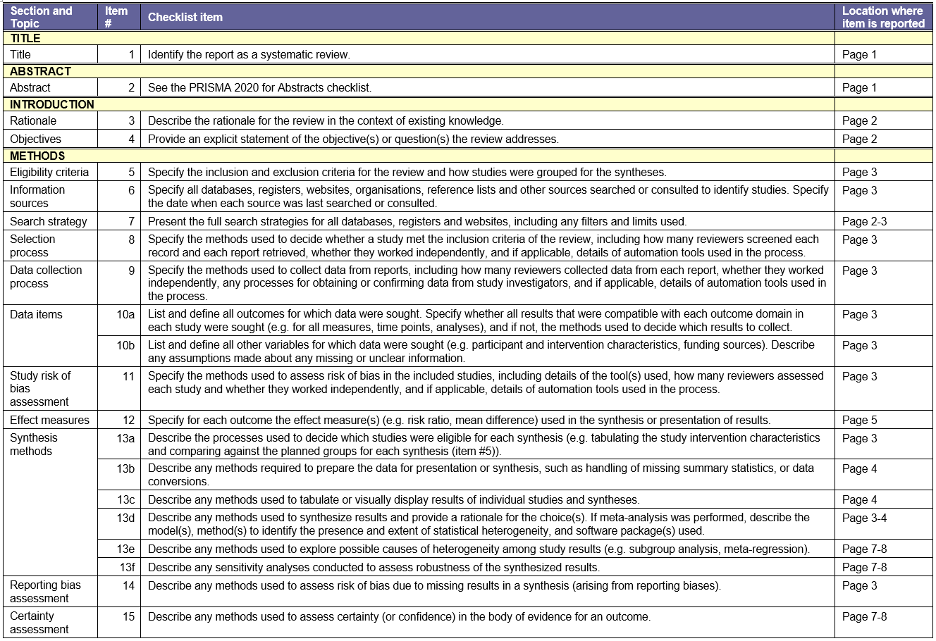
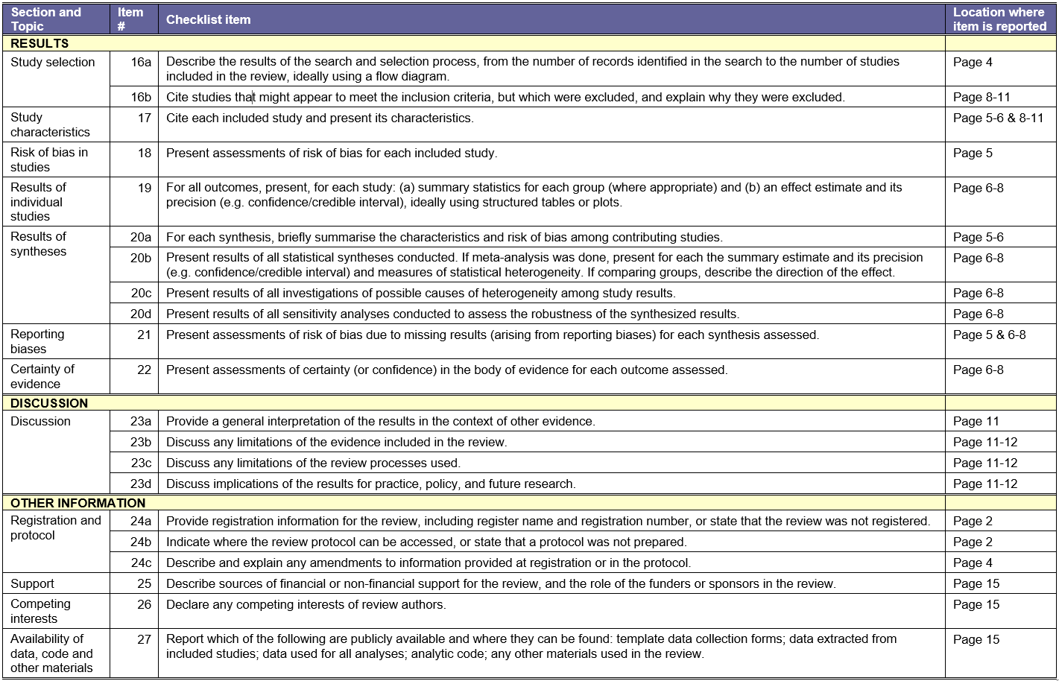

References
1. Team J. JASP (Version 0.16.3)[Computer software]. JASP Team; 2022.

