Supplementary Online Content

Supplementary Material 1. PRISMA 2020 Checklist
Supplementary Material 2. Search strategy
Supplementary Material 3. Funnel plot
Supplementary Material 4. Risk of bias summary (randomized controlled trials)
Supplementary Material 5. Forest plot of the effect of dance therapy on specific cognitive subdomains
Supplementary Material 6. Tests for Publication Bias (Egger's test)

Supplementary Material 1. PRISMA 2020 Checklist
Section and Topic | Item # | Checklist item | Location where item is reported
TITLE
Title | 1 | Identify the report as a systematic review. | 1
ABSTRACT
Abstract | 2 | See the PRISMA 2020 for Abstracts checklist. | 1
INTRODUCTION
Rationale | 3 | Describe the rationale for the review in the context of existing knowledge. | 2-4
Objectives | 4 | Provide an explicit statement of the objective(s) or question(s) the review addresses. | 4
METHODS
Eligibility criteria | 5 | Specify the inclusion and exclusion criteria for the review and how studies were grouped for the syntheses. | 5-6
Information sources | 6 | Specify all databases, registers, websites, organisations, reference lists and other sources searched or consulted to identify studies. Specify the date when each source was last searched or consulted. | 5
Search strategy | 7 | Present the full search strategies for all databases, registers and websites, including any filters and limits used. | 5, Supplementary Material 2
Selection process | 8 | Specify the methods used to decide whether a study met the inclusion criteria of the review, including how many reviewers screened each record and each report retrieved, whether they worked independently, and if applicable, details of automation tools used in the process. | 5
Data collection process | 9 | Specify the methods used to collect data from reports, including how many reviewers collected data from each report, whether they worked independently, any processes for obtaining or confirming data from study investigators, and if applicable, details of automation tools used in the process. | 6
Data items | 10a | List and define all outcomes for which data were sought. Specify whether all results that were compatible with each outcome domain in each study were sought (e.g. for all measures, time points, analyses), and if not, the methods used to decide which results to collect. | 6
Data items | 10b | List and define all other variables for which data were sought (e.g. participant and intervention characteristics, funding sources). Describe any assumptions made about any missing or unclear information. | 6, Table1
Study risk of bias assessment | 11 | Specify the methods used to assess risk of bias in the included studies, including details of the tool(s) used, how many reviewers assessed each study and whether they worked independently, and if applicable, details of automation tools used in the process. | 6-7
Effect measures | 12 | Specify for each outcome the effect measure(s) (e.g. risk ratio, mean difference) used in the synthesis or presentation of results. | 7
Synthesis methods | 13a | Describe the processes used to decide which studies were eligible for each synthesis (e.g. tabulating the study intervention characteristics and comparing against the planned groups for each synthesis (item #5)). | 7
Synthesis methods | 13b | Describe any methods required to prepare the data for presentation or synthesis, such as handling of missing summary statistics, or data conversions. | 7
Synthesis methods | 13c | Describe any methods used to tabulate or visually display results of individual studies and syntheses. | 7
Synthesis methods | 13d | Describe any methods used to synthesize results and provide a rationale for the choice(s). If meta-analysis was performed, describe the model(s), method(s) to identify the presence and extent of statistical heterogeneity, and software package(s) used. | 7
Synthesis methods | 13e | Describe any methods used to explore possible causes of heterogeneity among study results (e.g. subgroup analysis, meta-regression). | 7
Synthesis methods | 13f | Describe any sensitivity analyses conducted to assess robustness of the synthesized results. | 7
Reporting bias assessment | 14 | Describe any methods used to assess risk of bias due to missing results in a synthesis (arising from reporting biases). | 7, Supplementary Material 4
Certainty assessment | 15 | Describe any methods used to assess certainty (or confidence) in the body of evidence for an outcome. | 7
RESULTS
Study selection | 16a | Describe the results of the search and selection process, from the number of records identified in the search to the number of studies included in the review, ideally using a flow diagram. | 8
Study selection | 16b | Cite studies that might appear to meet the inclusion criteria, but which were excluded, and explain why they were excluded. | 8
Study characteristics | 17 | Cite each included study and present its characteristics. | 8-9, Table1
Risk of bias in studies | 18 | Present assessments of risk of bias for each included study. | 9, 14,  Supplementary Material 4
Results of individual studies | 19 | For all outcomes, present, for each study: (a) summary statistics for each group (where appropriate) and (b) an effect estimate and its precision (e.g. confidence/credible interval), ideally using structured tables or plots. | 10-14
Results of syntheses | 20a | For each synthesis, briefly summarise the characteristics and risk of bias among contributing studies. | 10-14
Results of syntheses | 20b | Present results of all statistical syntheses conducted. If meta-analysis was done, present for each the summary estimate and its precision (e.g. confidence/credible interval) and measures of statistical heterogeneity. If comparing groups, describe the direction of the effect. | 10-14
Results of syntheses | 20c | Present results of all investigations of possible causes of heterogeneity among study results. | 10-14
Results of syntheses | 20d | Present results of all sensitivity analyses conducted to assess the robustness of the synthesized results. | 15
Reporting biases | 21 | Present assessments of risk of bias due to missing results (arising from reporting biases) for each synthesis assessed. | 15
Certainty of evidence | 22 | Present assessments of certainty (or confidence) in the body of evidence for each outcome assessed. | 15
DISCUSSION
Discussion | 23a | Provide a general interpretation of the results in the context of other evidence. | 15
Discussion | 23b | Discuss any limitations of the evidence included in the review. | 15-21
Discussion | 23c | Discuss any limitations of the review processes used. | 21
Discussion | 23d | Discuss implications of the results for practice, policy, and future research. | 22
OTHER INFORMATION
Registration and protocol | 24a | Provide registration information for the review, including register name and registration number, or state that the review was not registered. | 5
Registration and protocol | 24b | Indicate where the review protocol can be accessed, or state that a protocol was not prepared. | 5
Registration and protocol | 24c | Describe and explain any amendments to information provided at registration or in the protocol. | 5
Support | 25 | Describe sources of financial or non-financial support for the review, and the role of the funders or sponsors in the review. | 22
Competing interests | 26 | Declare any competing interests of review authors. | 22
Availability of data, code and other materials | 27 | Report which of the following are publicly available and where they can be found: template data collection forms; data extracted from included studies; data used for all analyses; analytic code; any other materials used in the review. | Appendix, Table1
From: Page MJ, McKenzie JE, Bossuyt PM, Boutron I, Hoffmann TC, Mulrow CD, et al. The PRISMA 2020 statement: an updated guideline for reporting systematic reviews. BMJ 2021;372:n71. doi: 10.1136/bmj.n71. For more information, visit: http://www.prisma-statement.org/

Supplementary Material 2. Search strategy
PubMed (from the inception to September 23, 2023)
 | Search terms | Results
#1 | "cognitive dysfunction"[MeSH Terms] OR "cognition disorders"[MeSH Terms] OR "MCI"[Title/Abstract] OR "mild cognitive impairment*"[Title/Abstract] OR "cognitive impairment*"[Title/Abstract] OR "mild neurocognitive disorder*"[Title/Abstract] OR "cognitive decline"[Title/Abstract] OR "cognitive defect*"[Title/Abstract] OR "mental deterioration*"[Title/Abstract] OR "pre-dementia"[Title/Abstract] | 198,797
#2 | "dancing"[MeSH Terms] OR "dance therapy"[MeSH Terms] OR "danc*"[Title/Abstract] OR "Movement"[Title/Abstract] OR "movement therap*"[Title/Abstract] OR "authentic movement"[Title/Abstract] OR "movement psychot*"[Title/Abstract] OR "dance movement"[Title/Abstract] OR "therapeutic dance"[Title/Abstract] OR "dance-based"[Title/Abstract] OR "square dance"[Title/Abstract] OR "tango"[Title/Abstract] OR "waltz"[Title/Abstract] OR "ballroom"[Title/Abstract] OR "latin"[Title/Abstract] | 349,178
#3 | ("random*"[Title/Abstract] OR "trial"[Title] OR "clinical trial*"[Publication Type] OR "randomized controlled trial"[Publication Type] OR "controlled clinical trial"[Publication Type]) NOT ("animals"[MeSH Terms] NOT "humans"[MeSH Terms]) | 1,770,645
#4 | #1 AND #2 AND #3 | 256

Supplementary Material 3. Funnel plot
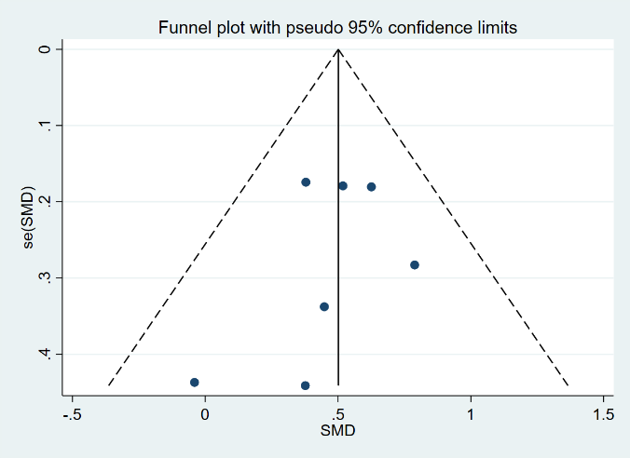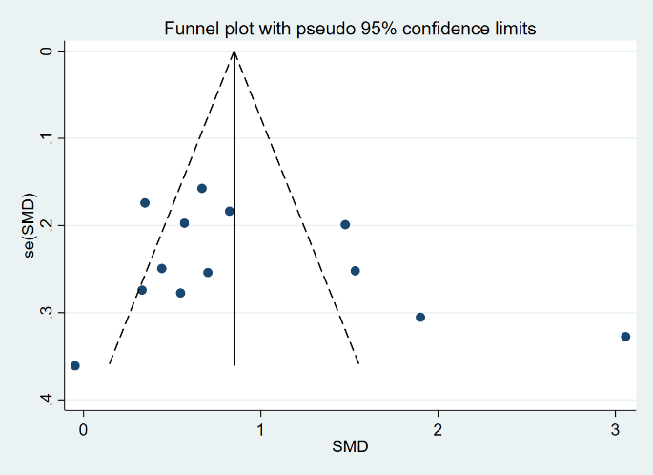
Figure 3.1 Funnel plot of global cognition Figure 3.2 Funnel plot of memory

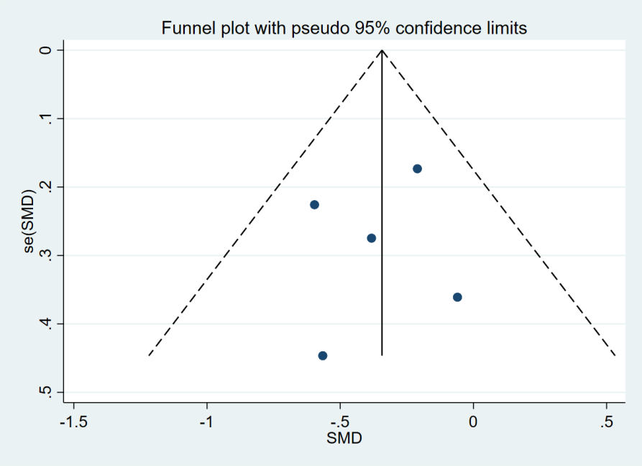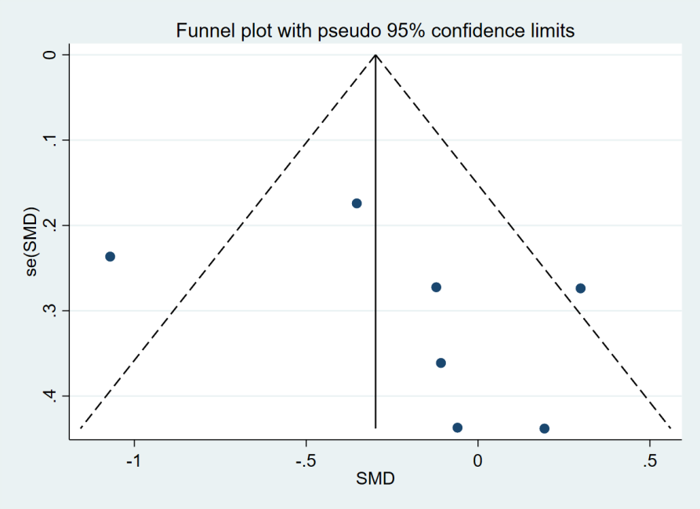
Figure 3.3 Funnel plot of executive function Figure 3.4 Funnel plot of processing speed

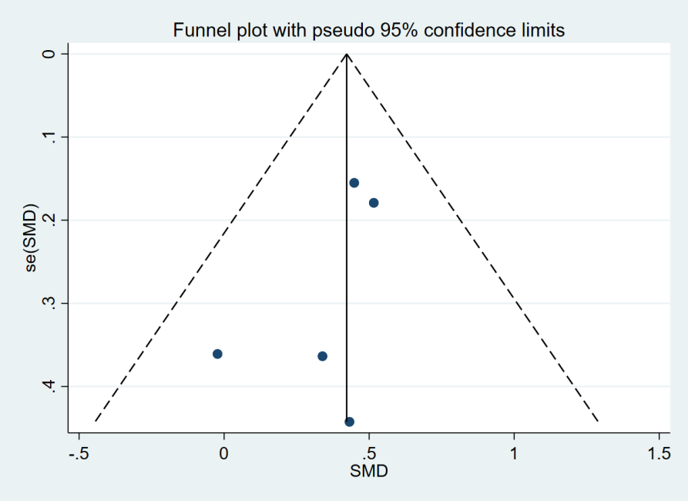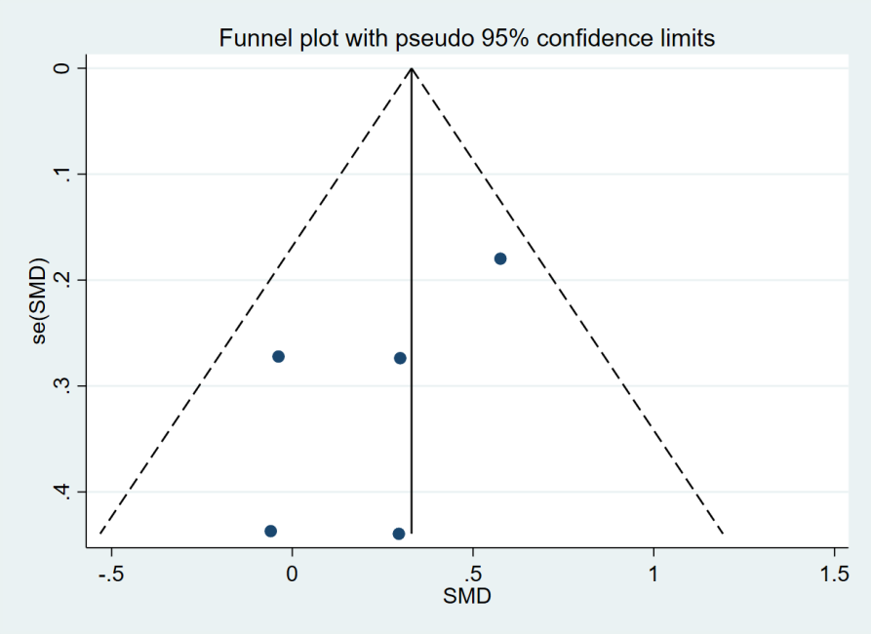
Figure 3.5 Funnel plot of attention Figure 3.6 Funnel plot of language

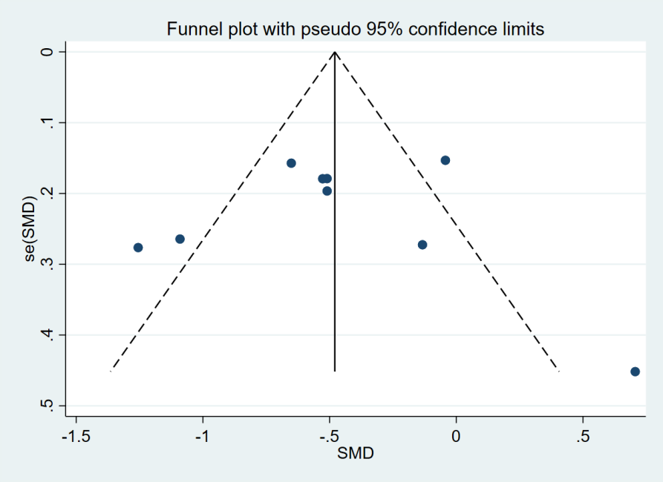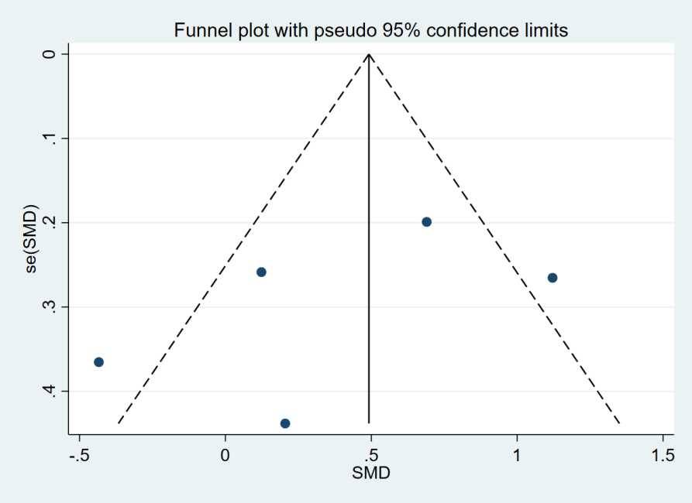
Figure 3.7 Funnel plot of mental health Figure 3.8 Funnel plot of quality of life
Supplementary Material 4. Risk of bias summary (randomized controlled trials)
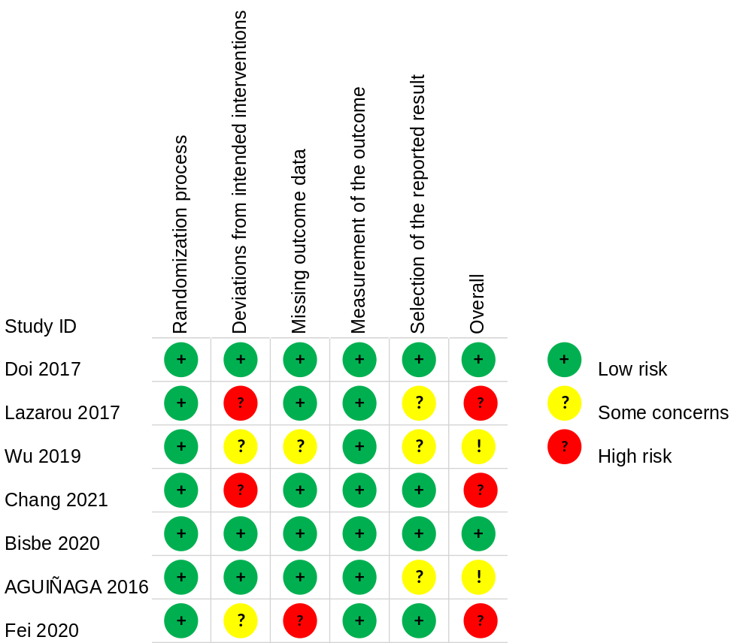

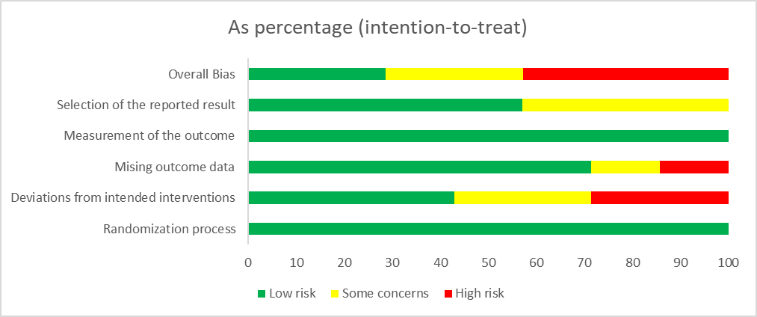
Supplementary Material 5. Forest plot of the effect of dance therapy on specific cognitive subdomains
Figure 5.1 Forest plot of the effect of dance therapy on memory. CI, confidence interval; SMD, standardized mean difference.

Figure 5.2 Forest plot of the effect of dance therapy on executive function. CI, confidence interval; SMD, standardized mean difference.

Figure 5.3 Forest plot of the effect of dance therapy on processing speed. CI, confidence interval; TMT-A, Trail Making Test A; SDMT, Symbol Digit Modalities Test; SMD, standardized mean difference.

Figure 5.4 Forest plot of the effect of dance therapy on visuospatial ability. CI, confidence interval; SMD, standardized mean difference.

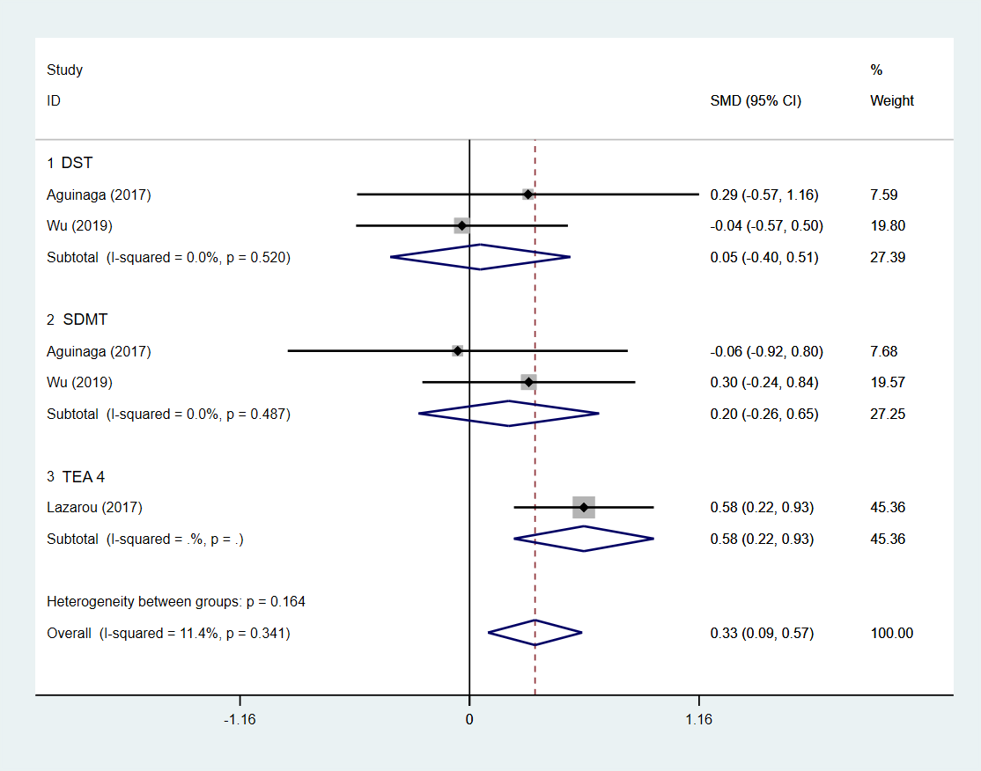
Figure 5.5 Forest plot of the effect of dance therapy on attention. CI, confidence interval; DST, Digit Span Test; SDMT, Symbol Digit Modalities Test; TEA 4, Test of Everyday Attention 4; SMD, standardized mean difference.

Figure 5.6 Forest plot of the effect of dance therapy on language. CI, confidence interval; SMD, standardized mean difference.

Supplementary Material 6. Tests for Publication Bias (Egger's test)
Global cognition outcome-Egger's test
Std_Eff | Coef. | Std. Err. | t | P>|t| | [95% Conf. Interval]
slope | .0534437 | .7420939 | 0.07 | 0.944 | -1.579894 | 1.686781
bias | 3.635739 | 3.28924 | 1.11 | 0.293 | -3.60383 | 10.87531

Memory outcome-Egger's test
Std_Eff | Coef. | Std. Err. | t | P>|t| | [95% Conf. Interval]
slope | .6525444 | .207419 | 3.15 | 0.025 | -.1193568 | 1.185732
bias | -.6857757 | .8814341 | -0.78 | 0.472 | -2.951574 | 1.580023

Executive function outcome-Egger's test
Std_Eff | Coef. | Std. Err. | t | P>|t| | [95% Conf. Interval]
slope | -.2415606 | .3359745 | -0.72 | 0.524 | -1.310781 | .8276602
bias | -.4252617 | 1.334275 | -0.32 | 0.771 | -4.67152 | 3.820997

Processing speed outcome-Egger's test
Std_Eff | Coef. | Std. Err. | t | P>|t| | [95% Conf. Interval]
slope | -.856055 | .5671991 | -1.51 | 0.192 | -2.314087 | .6019766
bias | 2.169845 | 2.09818 | 1.03 | 0.348 | -3.223699 | 7.56339

Attention outcome-Egger's test
Std_Eff | Coef. | Std. Err. | t | P>|t| | [95% Conf. Interval]
slope | .8435014 | .3293663 | 2.56 | 0.083 | -.204689 | 1.891692
bias | -2.006719 | 1.216299 | -1.65 | 0.198 | -5.877527 | 1.864088

Language outcome-Egger's test
Std_Eff | Coef. | Std. Err. | t | P>|t| | [95% Conf. Interval]
slope | .6263012 | .1625253 | 3.85 | 0.031 | .1090731 | 1.143529
bias | -.9577881 | .7013168 | -1.37 | 0.265 | -3.189691 | 1.274115

Mental health outcome-Egger's test
Std_Eff | Coef. | Std. Err. | t | P>|t| | [95% Conf. Interval]
slope | -.4632197 | .5107257 | -0.91 | 0.395 | -1.670894 | .7444546
bias | -.0827516 | 2.508284 | -0.03 | 0.975 | -6.013901 | 5.848398

Quality of life outcome-Egger's test
Std_Eff | Coef. | Std. Err. | t | P>|t| | [95% Conf. Interval]
slope | 1.452193 | .8923789 | 1.63 | 0.202 | -1.387754 | 4.292141
bias | -3.644442 | 3.268695 | -1.11 | 0.346 | -14.04689 | 6.758004

