APPENDIX
Appendix Figure 1. Directed acyclic graph illustrating the relationships among exposure, outcome, and confounders.
Appendix Figure 2. Detailed steps of the statistical analysis.

Appendix Table 1. Variables included in our study.

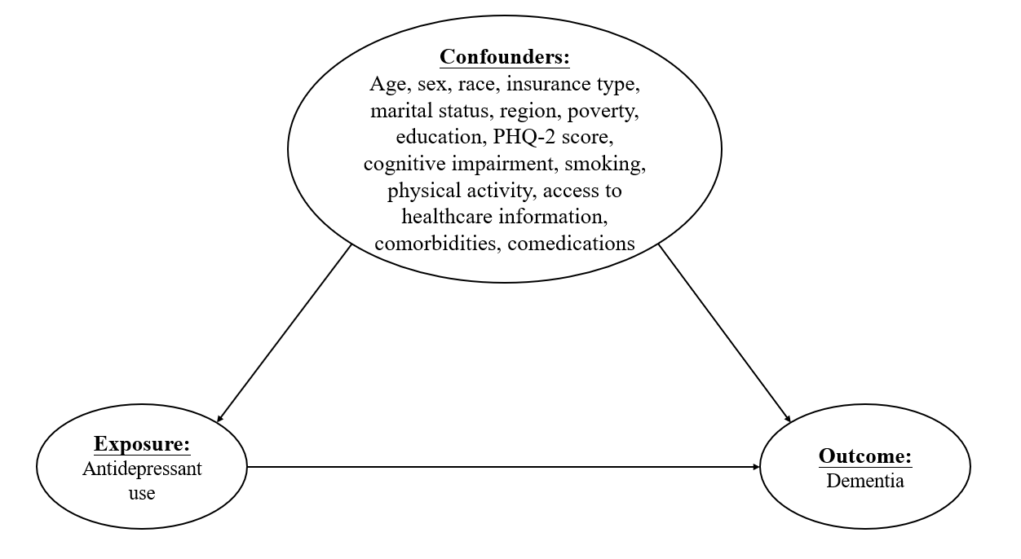
Appendix Figure 1. Directed acyclic graph illustrating the relationships among exposure, outcome, and confounders.

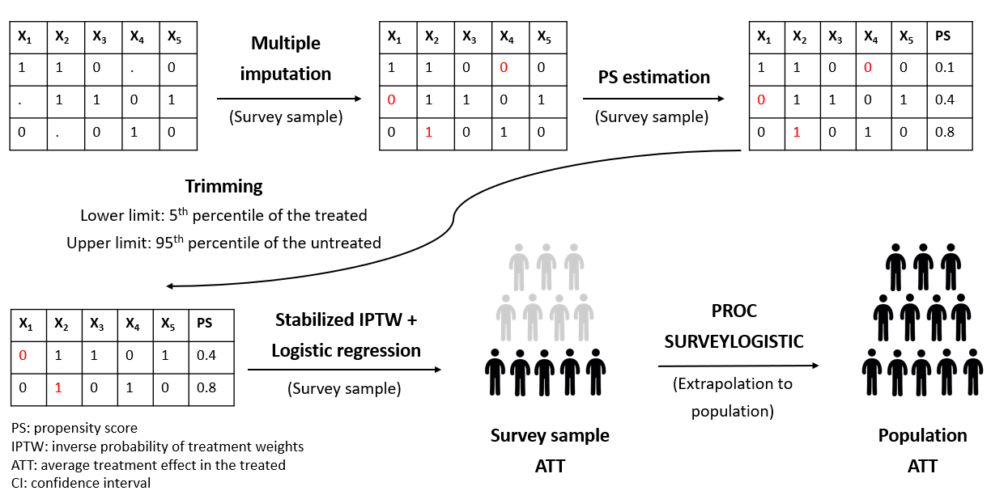
Appendix Figure 2. Detailed steps of the statistical analysis.

Appendix Table 1. Data sources and operational definitions of the variables included in the study
Variable | MEPS File name | MEPS Variable name | Operational definition or codes for the study variables
Study population
Depression | Medical Conditions file | ICD9CODX | 296.20-296.25, 296.30-296.35, 300.4, 311  PPV: 92%(15)
Depression | Medical Conditions file | ICD10CDX | F32.0-32.9, F33.0-33.3, F33.8, F33.9, F34.1 & F41.2  PPV: 91.06%
PHQ-2 | Full-Year Consolidated File | PHQ242 | PHQ-2 score ranges from 0-6. The authors identified a score of 3 as the optimal cutpoint when using the PHQ-2 to screen for depression.  If the score is 2 or greater, major depressive disorder is likely (sensitivity: 86% and specificity: 78%)(17)
Exposure/Comparison
SSRIs | Prescribed medicines file | TC1S1_1, TC2S1_1 | 208
SNRIs | Prescribed medicines file | TC1S1_1, TC2S1_1 | 308
Psychotherapy | Outpatient Visits | VSTCTGRY | 4
Psychotherapy | Office-Based Medical Provider Visits | VSTCTGRY | 4
Outcome
Dementia | Medical Conditions file | ICD9CODX | 290, 331.0, 331.1, 331.2, 331.82, 331.83, 331.9, 438.0, 780.93  PPV: 73.2-93.6%(15)
Dementia | Medical Conditions file | ICD10CDX | F00, F01, F03, F04, G30, G31.0, G31.1, G31.8, G31.9, I69.91, R41  PPV: 73.2-93.6%(15)
Cognitive impairment | Full-Year Consolidated File | COGLIM31, COGLIM53, DFCOG42 | COGLIM31, COGLIM53: cognitive limitations  DFCOG42: serious cognitive difficulties  Both are yes/no questions
Covariates
Age | Full-Year Consolidated File | AGE31X | -1: inapplicable  Continuous variable
Sex | Full-Year Consolidated File | SEX | 1: male (ref)  2: female
Race | Full-year Consolidated File | RACEV1X | 1: White – No other race reported (ref)  2: Black – No other race reported  3: AI/AN - No other race  4: Asian/Native Hawaiian/Pacific Islander  6: Multiple races reported
Region | Full-Year Consolidated File | REGION31 | Census region  1: Northeast (ref)  2: Midwest  3: South  4: West
Education | Full-Year Consolidated File | HIDEG | Highest degree when first entered MEPS  1: No degree  2: General education development (ref)  3: High school diploma  4: Bachelor’s degree  5: Master’s degree  6: Doctorate degree  7: Other degree  8: Under 16 - inapplicable
Type of insurance | Full-Year Consolidated File | INSCOV11 | 1: Any private  2: Public only  3: Uninsured
Poverty | Full-Year Consolidated File | POVCAT10  POVCAT11  POVCAT12  ... | Family income as % of poverty line  1: poor/negative (less than 100% (poverty line)) (ref)  2: near poor (100% to less than 125%)  3: low income (125% to less than 200%)  4: middle income (200% to less than 400%)  5: high income (>=400%)
Marital status | Full-year Consolidated File | MARRY31X | 1: married (ref)  2: widowed  3: divorced  4: separated  5: never married  6: under age 16 – inapplicable  7: married in round  8: widowed in round  9: divorced in round  10: separated in round
Physical inactivity | Full-Year Consolidated File | WLKLIM31 | Limitation in physical functioning  1: Yes  2: No (ref)
Smoking | Full-Year Consolidated File | ADSMOK42 | Currently smoke  -9: not ascertained  -1: inapplicable  1: yes  2: no (ref)
Access to care | Full-year Consolidated File | MDDLAY42 | Delayed in getting necessary medical care  -9: not ascertained  -8: DK  -7: refused  -1: inapplicable  1: yes  2: no (ref)
Access to care | Full-year Consolidated File | MDUNAB42 | Unable to get necessary medical care  -9: not ascertained  -8: DK  -7: refused  -1: inapplicable  1: yes  2: no (ref)
Access to care | Full-year Consolidated File | PMDLAY42 | Delayed in getting necessary prescribed medications  -9: not ascertained  -8: DK  -7: refused  -1: inapplicable  1: yes  2: no (ref)
Access to care | Full-year Consolidated File | PMUNRS42 | Unable to get necessary prescribed medications  -9: not ascertained  -8: DK  -7: refused  -1: inapplicable  1: yes  2: no (ref)
Comorbidities
Cancer | Medical Conditions file | ICD9CODX | 140-209
Cancer | Medical Conditions file | ICD10CODX | C00-C96
Type 2 diabetes | Medical Conditions file | ICD9CODX | 250
Type 2 diabetes | Medical Conditions file | ICD10CODX | E11
Hyperlipidemia | Medical Conditions file | ICD9CODX | 272
Hyperlipidemia | Medical Conditions file | ICD10CODX | E78
Hypertension | Medical Conditions file | ICD9CODX | 401-405
Hypertension | Medical Conditions file | ICD10CODX | I10-I16
Ischemic stroke | Medical Conditions file | ICD9CODX | 433-437
Ischemic stroke | Medical Conditions file | ICD10CODX | I63-I68
Coronary heart disease | Medical Conditions file | ICD9CODX | 410-414
Coronary heart disease | Medical Conditions file | ICD10CODX | I20-I25
Osteoarthritis | Medical Conditions file | ICD9CODX | 715
Osteoarthritis | Medical Conditions file | ICD10CODX | M15-M19
Parkinson’s disease | Medical Conditions file | ICD9CODX | 332.0
Parkinson’s disease | Medical Conditions file | ICD10CODX | G20
Anxiety | Medical Conditions file | ICD9CODX | 300.0, 300.2, 300.3, 309.8
Anxiety | Medical Conditions file | ICD10CODX | F40, F41, F42, F93.0–F93.2
Sleep disorder | Medical Conditions file | ICD9CODX | 307.4, 780.5
Sleep disorder | Medical Conditions file | ICD10CODX | G47.8, G47.9
Schizophrenia | Medical Conditions file | ICD9CODX | 295.0–295.9
Schizophrenia | Medical Conditions file | ICD10CODX | F20–F29
Bipolar disorder | Medical Conditions file | ICD9CODX | 296.0–296.1, 296.4–296.8
Bipolar disorder | Medical Conditions file | ICD10CODX | F30, F31, F34.0
Comedications
Analgesics | Prescribed medicines file | TC1S1 | 58
Benzodiazepines | Prescribed medicines file | TC1S1 | 69
Anxiolytics, sedatives, and hypnotics | Prescribed medicines file | TC1S1 | 67
Antidepressants other than SSRI/SNRI | Prescribed medicines file | TC1S1_1 | 76, 209, 306, 307
Antipsychotics | Prescribed medicines file | TC1S1  TC2S1 | 251
Antiparkinsonian agents | Prescribed medicines file | TC1S1 | 66
Abbreviations: PHQ, Patient Health Questionnaire; SSRI, selective serotonin reuptake inhibitors; SNRI, serotonin and norepinephrine reuptake inhibitors

