Appendix

Figure A.1. Conceptual framework

Household socio-economic conditions
Living arrangement
Demographic profile
Financial security
Mental/ Physical health
Risk of malnutrition:
- Underweight
- Overweight
- Metabolic risk (waist to hip ratio)
- Food insecurity
- Hospitalization

Figure A.2. Generalized Structural Equation Model with response variable as the HRG 1 and 2 of MUST and structural variables-mental, cognitive, physical health and work status/ pension availability, Male, LASI, Wave 1

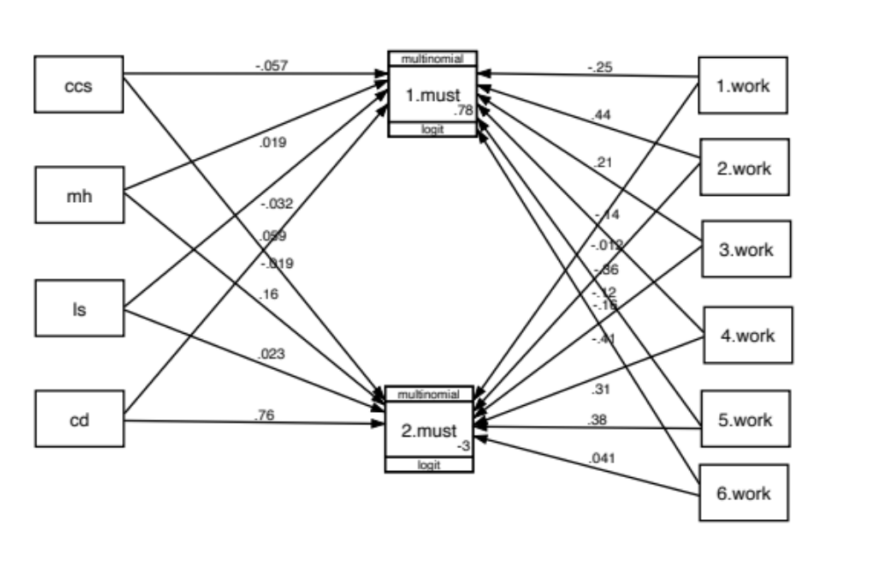

Figure A.3. Generalized Structural Equation Model with response variable as the HRG 1 and 2 of MUST and structural variables-mental, cognitive, physical health and work status/ pension availability, Female, LASI, Wave 1

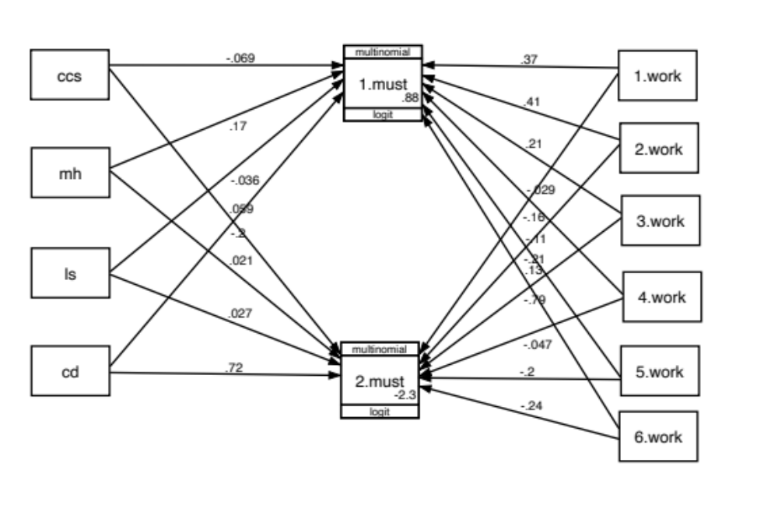

Note: Abbreviations used in the abridged GSEM (multinomial logit): demographic and socio-economic variables not controlled
must- Malnutrition Universal Screening Tool
Work- type of work and availability of pension
1.work-ever worked but not currently working with pension
2.work- ever worked but not currently working without pension
3.work- working-agriculture
4.work- working-business etc
5.work- working-salaried expecting pension
6.work- working-salaried not expecting pension
ccs-composite cognitive score
mh- mental health score
ls- life satisfaction score
cd- chronic disease

