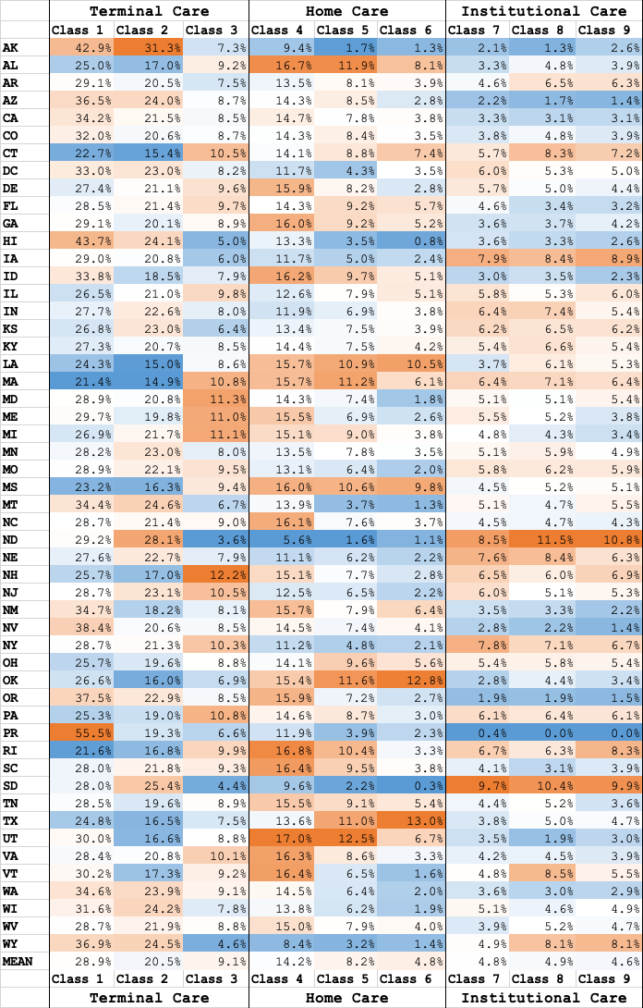
Additional Table 1. Within-state variation in the proportions of decedents belonging to each place of care trajectory class compared to the national average, color coded for each class
 | Home | Skilled home care | Institutional

