Additional file 1
Supplementary Figure A.
GIS map of Nepal Highlighting the Two Study Districts.
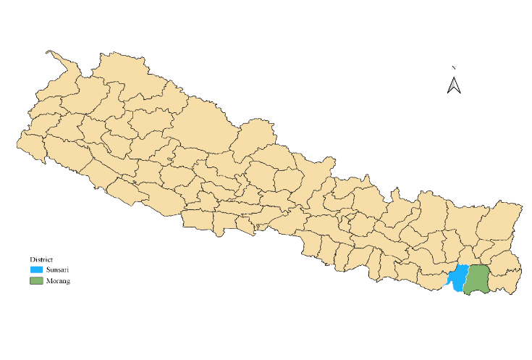
Supplementary Table 1.
Demographic and Socioeconomic Characteristics of Nepal and the Study Districts.
Attributes | National | Study districts
Attributes | National | Morang | Sunsari
Total household number (in thousand) | 5427 | 214 | 162
Total population (in thousand) | 26495 | 965 | 764
60+ population (in thousand) | 2154 | 80 | 57
60+ male (in thousand) | 1064 | 40 | 28
60+ female (in thousand) | 1090 | 40 | 29
Aging index | 15.11 | 16.68 | 14.46
Mean age at marriage (years) | 20.6 | 22.8 | 22.7
Life expectancy at birth (years) | 66.6 | 67.3 | 67.2
Literate population (6 years and above, %) | 66.6% | 70.9% | 68.9%
¹National rank of the district by literacy status | - | 25 | 33
Urbanization level (%) | 29.0% | 44.2% | 34.3%
Note. ¹National literacy rate urban: 82.3% and rural: 62.5%. In the eastern region, where the two study districts are located, rates are slightly higher (67.2%) than the national average. National literacy for the older population is low: 26.2% for ages 60-64 and 20.8% for 65+. Source: National Population and Housing Census 2011, Nepal

