Additional File 5 – Forest Plots for Secondary Outcomes

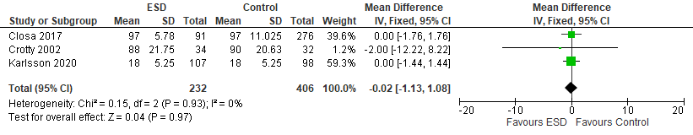
Figure S1: Forest plot for function

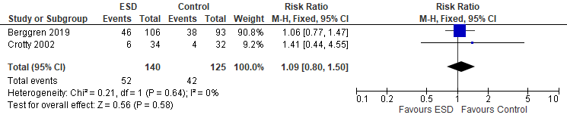
Figure S2: Forest plot for number of fallers

