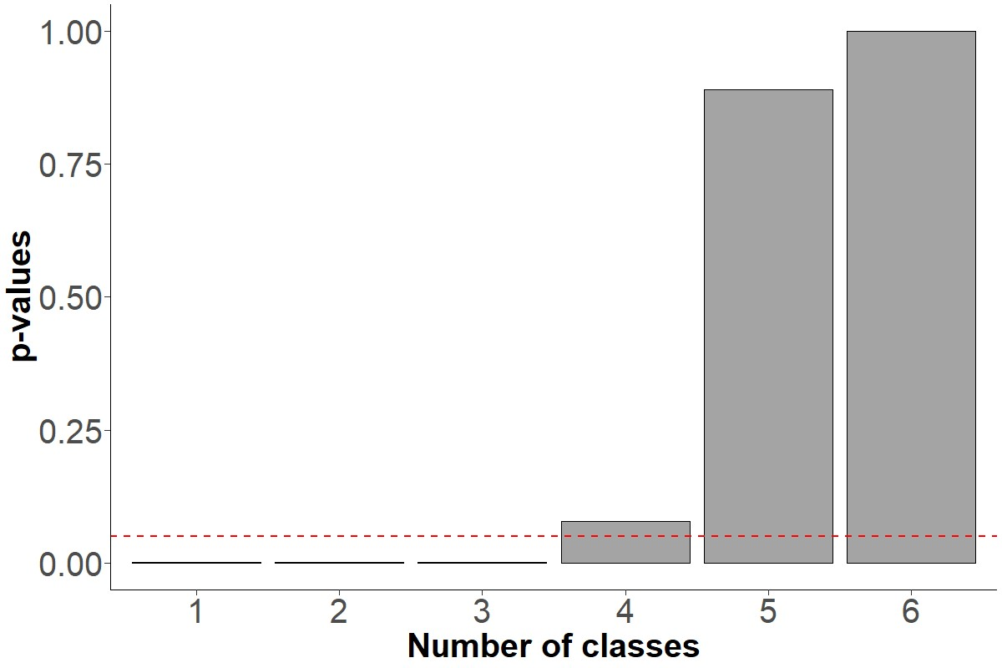
Supplemental Figure 1: Distribution of p-values of bootstrapped likelihood ratios for competing latent classes. The horizontal dashed line indicates the p-value at 5%.

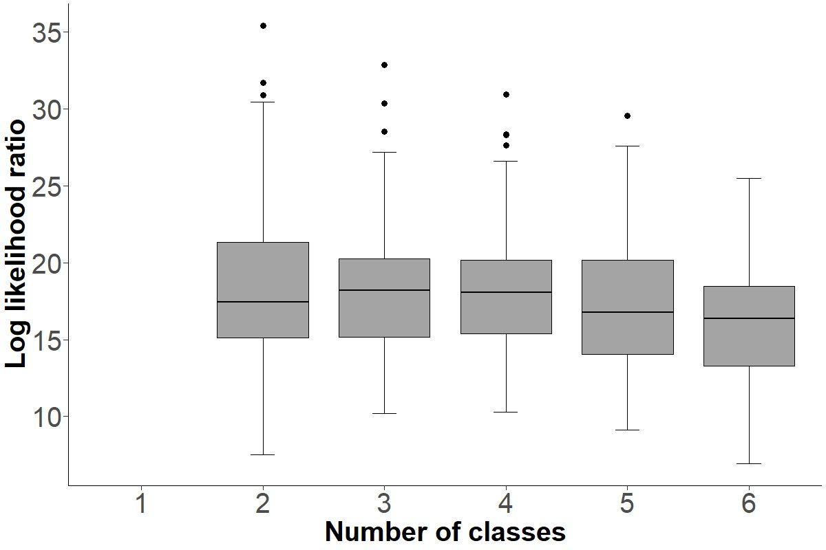Supplemental Figure 2: Distribution of bootstrapped likelihood ratios for competing latent classes.

