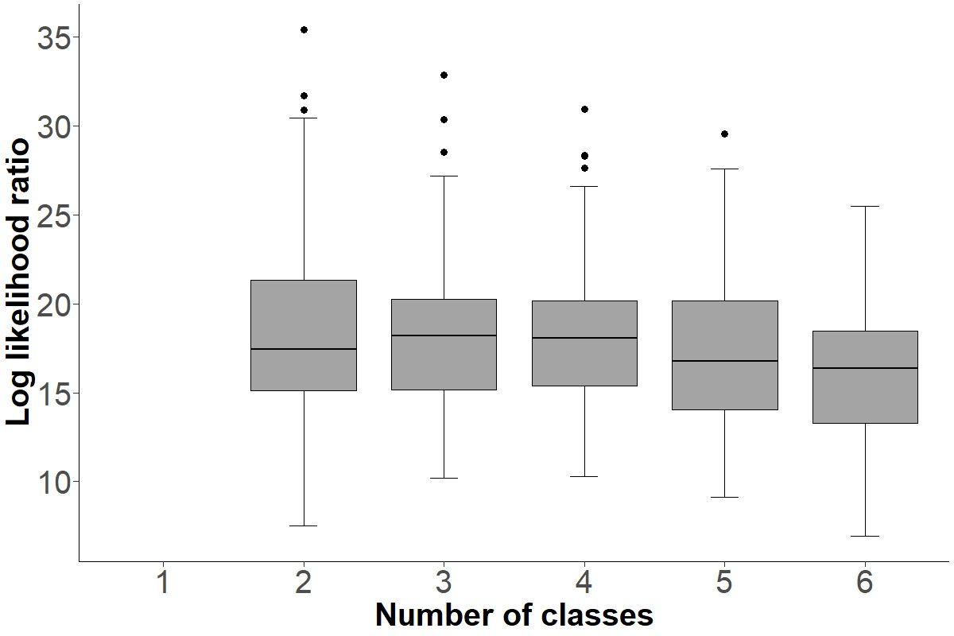Supplemental Figure 2: Distribution of bootstrapped likelihood ratios for competing latent classes.

