Additional file 1. Comparison of mean EQ-5D-5L values (A) and Barthel Index scores (B) between baseline and six months, stratified by CFS score.
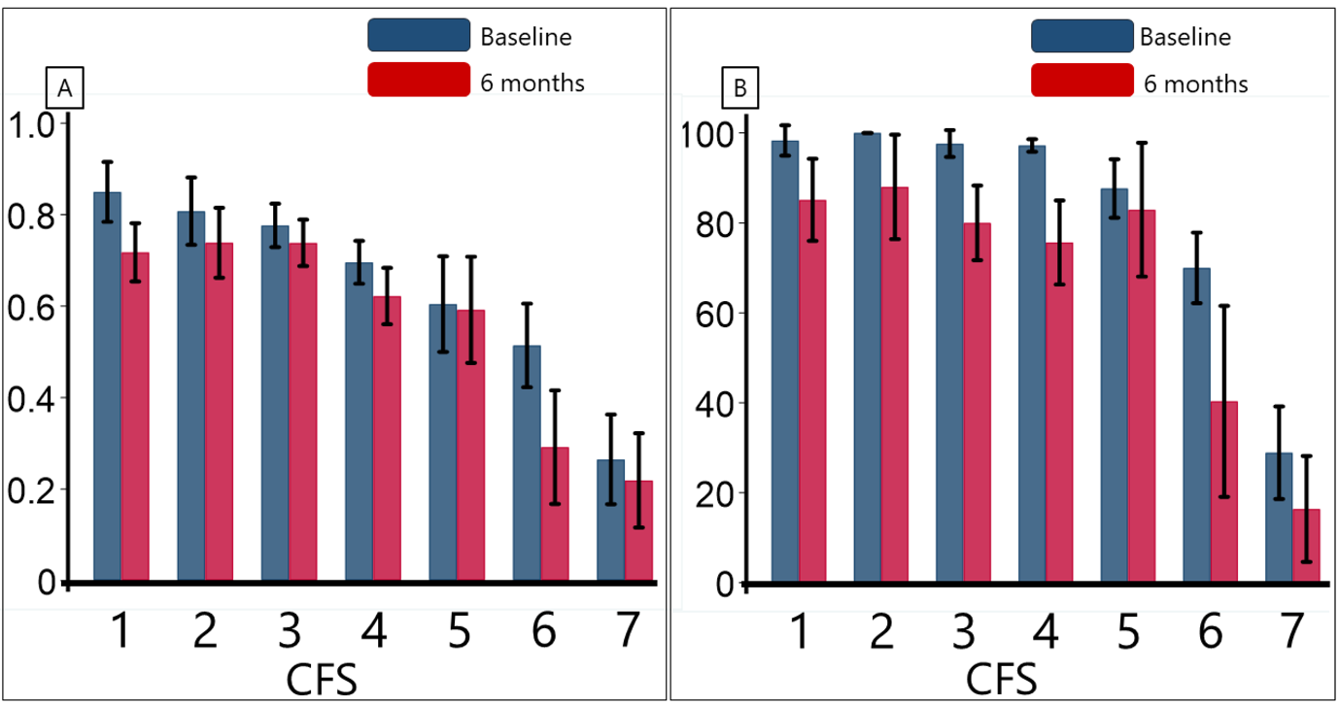
EQ-5D-5L: five-level EuroQol five-dimensional questionnaire, CFS: Clinical Frailty Scale

