Additional file 2. Differences in EQ-5D-5L for the not frail (A) and frail (B) groups: a spider graph depicting all five domains.
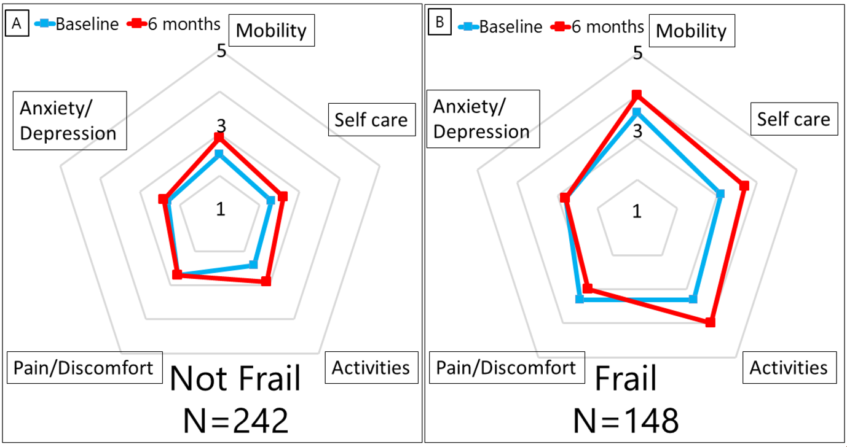
For the not frail group, the scores for mobility (1.5 vs. 1.9, p=0.001), self-care (1.3 vs. 1.6, p=0.009), and activities (1.4 vs. 1.9, p<0.001) worsened significantly, while the scores for pain/discomfort (1.7 vs. 1.7, p=0.71) and anxiety/depression (1.3 vs. 1.4, p=0.14) remained unchanged. For the frail group, there was significant worsening in the scores for mobility (2.6 vs. 3.0, p<0.001), self-care (2.1 vs. 2.7, p<0.001), and activities (2.3 vs. 3.0, p<0.001). However, the score for pain/discomfort significantly improved (2.3 vs. 2.0, p<0.001) and the score for anxiety/depression remained stable (1.8 vs. 1.8, p=1.00).
EQ-5D-5L: five-level EuroQol five-dimensional questionnaire

