Supplementary Material 1 PubMed search strategies
1#: “ Aged”[Mesh]
2#: “older” OR ”older adult” OR “older” OR “elderly” OR “the aged”
3# :1# OR 2#
4# :fear of falling
5# :“influence factors” OR “risk factors”
6# :3# AND 4# AND 5#

Detail search strategies for all databases (updated to September 2, 2023)
1.PubMed (847 studies)
1# “ Aged”[Mesh]
2# “older” OR ”older adult” OR “older” OR “elderly” OR “the aged”
3# 1# OR 2#
4# fear of falling
5# “influence factors” OR “risk factors”
6# 3# AND 4# AND 5#
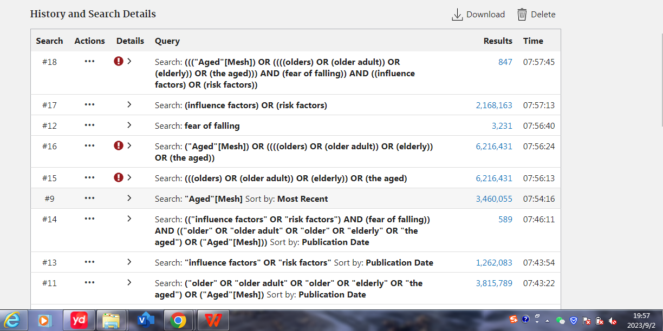

2. Web of science (2108 studies)
((TS=(fear of falling)) AND TS=(Aged OR older OR older adult OR elderly )) AND TS=(influence factors OR risk factors)
1# “ Aged”[Mesh]
2# “older” OR ”older adult” OR “older” OR “elderly” OR “the aged”
3# 1# OR 2#
4# fear of falling
5# “influence factors” OR “risk factors”
6# 3# AND 4# AND 5#
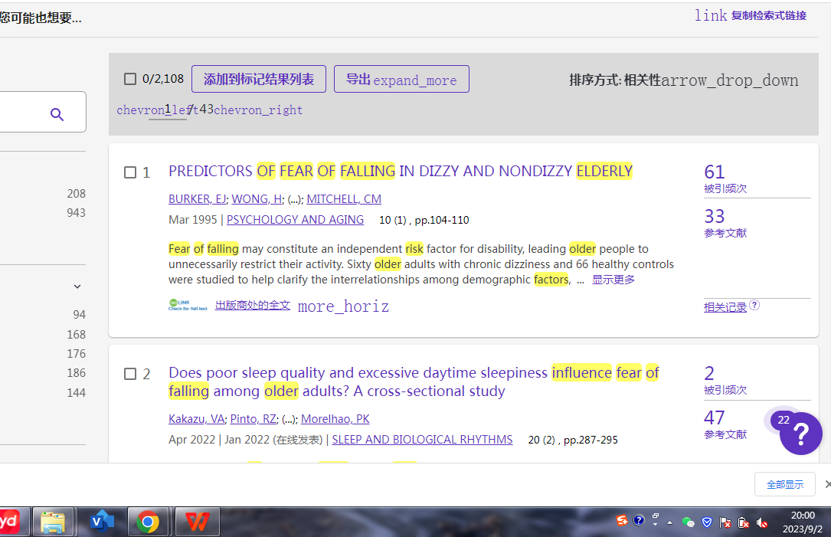

- Embase (346 studies)

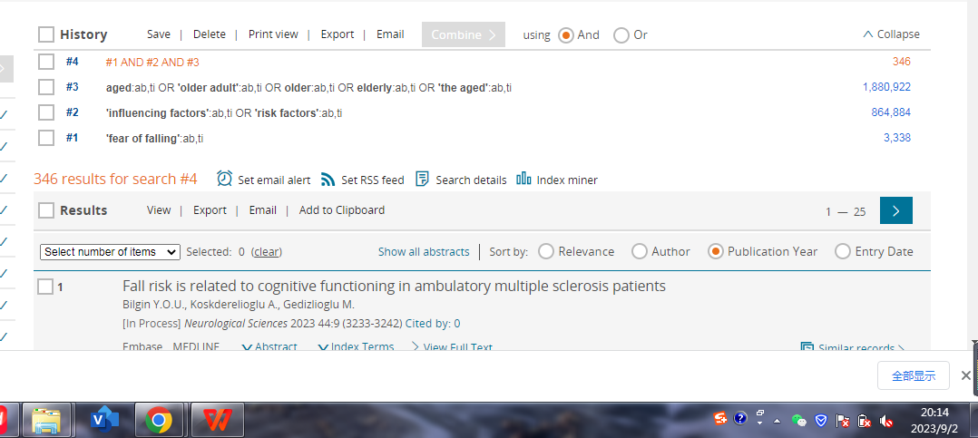

- The Cochran Library(150 studies)
