Supplementary 5: Sub-group analyses based on cognitive measures

Ai. Pooled SMD (after excluding trials which used MMSE)

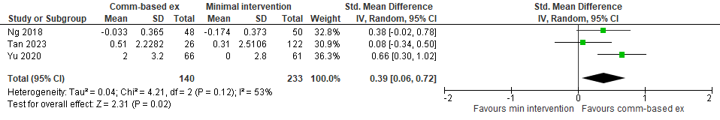

Aii. Pooled MD (after excluding trials which used MMSE)

