Supplementary 6: Sub-group analyses based on quality of life measures

Ai. Pooled SMD for EQ-5D

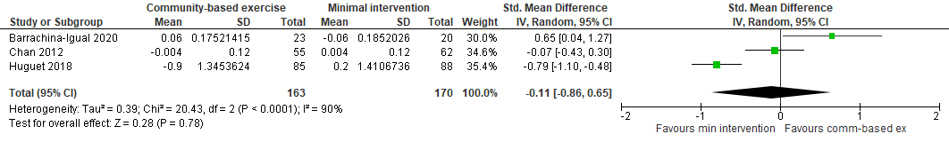

Aii. Pooled MD for EQ-5D

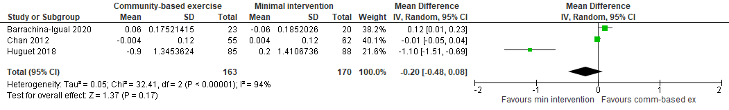

Bi. Pooled SMD for SF-36

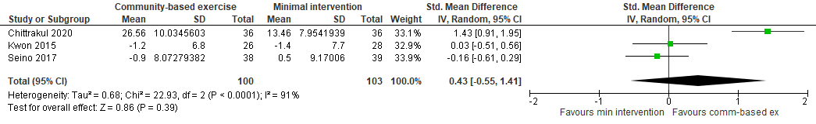

Bii. Pooled MD for SF-36

