Supplementary Materials

Content
Table S1. Patterns of ‘Not able to answer’, ‘Missing’, and ‘NA’ Data Across Two Cohorts: 2008- 2018 and 2014-2018…...………………………………………………………………1
Table S2. 77 CLHLS Questionnaire Items and the Corresponding 16 Features……………………..…………………………………………………………..…….6
Table S3. Descriptive Analysis of Cohorts: 2008-2018 and 2014-2018………………………………..…….……………………………………………………9
Table S4. Hyperparameter Tuning Results for Elastic Net Regression (ENR), Decision Tree (DT), Random Forest (RF), K-Nearest Neighbor (KNN) and eXtreme Gradient Boosting (XGBoost) with 16 Features……………………………….………………………………...11
Table S5. Hyperparameter Tuning Results for ENR, DT, RF, KNN and XGBoost with 8 Features………………………………………………………………………………………12
Figure S1. Variable Importance of XGBoost-Built Model Predicting 4-Year All-Cause Mortality. in Older Adults with 8 Features………..………………………………………....13
Figure S2. Partial Dependence Plots for the XGBoost-Built Model Predicting 4-Year All-Cause Mortality in Older Adults with 8 Features……………………………………………14
Table S1. Patterns of ‘Not able to answer’, ‘Missing’, and ‘NA’ Data Across Two Cohorts: 2008- 2018 and 2014-2018
Number | Description | Not able to answer (%) |  |  | Missing^{b}  (%) |  |  | NA^{c}  (%)
Number | Description | 2008ª | 2014ª |  | 2008 | 2014 |  | 2008 | 2014
Basic information
1 | Sex | 0 | 0 |  | 0 | 0 |  | 0 | 0
2 | Was the place of birth an urban area or a rural area at time of birth? | 5  (0.04%) | 2  (0.04%) |  | 7  (0.05%) | 1  (0.02%) |  | 4  (0.03%) | 441  (8.17%)
Life evaluation and personality
3 | How do you feel about your life right now? | 1626  (11.93%) | 336  (6.23%) |  | 0 | 1  (0.02%) |  | 0 | 60  (1.11%)
4 | How do you feel about your own health status now? | 1624  (11.92%) | 336  (6.23%) |  | 0 | 1  (0.02%) |  | 0 | 62  (1.15%)
5 | Do you always look on the bright side of things? | 1865  (13.69%) | 436  (8.08%) |  | 0 | 1  (0.02%) |  | 0 | 60  (1.11%)
6 | Do you often feel fearful or anxious? | 1926  (14.14%) | 500  (9.26%) |  | 0 | 1  (0.02%) |  | 0 | 61  (1.13%)
7 | Do you often feel lonely and isolated? | 1948  (14.30%) | 474  (8.78%) |  | 0 | 1  (0.02%) |  | 0 | 64  (1.19%)
8 | Can you make your own decisions concerning your personal affairs? | 2009  (14.75%) | 549  (10.17%) |  | 0 | 1  (0.02%) |  | 0 | 66  (1.22%)
9 | Do you feel the older you get, the more useless you are? | 2040  (14.97%) | 517  (9.58%) |  | 0 | 1  (0.02%) |  | 0 | 65  (1.20%)
General ability
10 | What time of day is it right now (morning, afternoon, evening)? | 1958  (14.37%) | 480  (8.89%) |  | 0 | 1  (0.02%) |  | 0 | 64  (1.19%)
11 | What is the animal year of this year? | 2133  (15.66%) | 614  (11.38%) |  | 0 | 1  (0.02%) |  | 0 | 64  (1.19%)
12 | What is the date (Chinese calendar day and month) of the mid-autumn festival? | 2196  (16.12%) | 646  (11.97%) |  | 0 | 1  (0.02%) |  | 0 | 65  (1.20%)
13 | What is the season right now, spring, summer, fall, winter? | 2046  (15.02%) | 575  (10.65%) |  | 0 | 1  (0.02%) |  | 0 | 65  (1.20%)
14 | What is the name of this district or town? | 2104  (15.44%) | 568  (10.52%) |  | 0 | 1  (0.02%) |  | 0 | 72  (1.33%)
15 | Please nameas many kinds of food as possible in 1 minute. | 1443  (10.59%) | 124  (2.30%) |  | 70  (0.51%) | 14  (0.26%) |  | 0 | 158  (2.93%)
Reaction capacity
16 | Repeat the name of “table” at first attempt | 2405  (17.65%) | 655  (12.14%) |  | 0 | 1  (0.02%) |  | 0 | 67  (1.24%)
17 | Repeat the name of “apple”at first attempt | 2412  (17.70%) | 656  (12.15%) |  | 0 | 1  (0.02%) |  | 0 | 98  (1.82%)
18 | Repeat the name of “clothes”at first attempt | 2437  (17.89%) | 668  (12.38%) |  | 0 | 1  (0.02%) |  | 0 | 121  (2.24%)
Attention and calculation ability
19 | $20-$3=? | 2653  (19.47%) | 800  (14.82%) |  | 0 | 1  (0.02%) |  | 0 | 65  (1.20%)
20 | $20-$3-$3=? | 2773  (20.35%) | 844  (15.64%) |  | 0 | 1  (0.02%) |  | 0 | 68  (1.26%)
21 | $20-$3-$3-$3=? | 2856  (20.96%) | 888  (16.45%) |  | 0 | 1  (0.02%) |  | 0 | 68  (1.26%)
22 | $20-$3-$3-$3-$3=? | 2915  (21.40%) | 921  (17.07%) |  | 0 | 1  (0.02%) |  | 0 | 72  (1.33%)
23 | $20-$3-$3-$3-$3-$3=? | 2942  (21.59%) | 940  (17.42%) |  | 0 | 1  (0.02%) |  | 0 | 110  (2.04%)
24 | Draw the figure | 5092  (37.38%) | 1675  (31.04%) |  | 2521  (18.50%) | 740  (13.71%) |  |  | 149  (2.76%)
Recall
25 | Repeat the name of “table” a while later | 2847  (20.90%) | 896  (16.60%) |  | 0 | 1  (0.02%) |  | 0 | 65  (1.20%)
26 | Repeat the name of “apple” a while later | 2876  (21.11%) | 907  (16.81%) |  | 0 | 1  (0.02%) |  | 0 | 74  (1.37%)
27 | Repeat the name of “clothes” while later | 2891  (21.22%) | 935  (17.32%) |  | 0 | 1  (0.02%) |  | 0 | 73  (1.35%)
Language
28 | Name “pen” | 2089  (15.33%) | 571  (10.58%) |  | 0 | 1  (0.02%) |  | 0 | 67  (1.24%)
29 | Name “watch” | 2116  (15.53%) | 582  (10.78%) |  | 0 | 1  (0.02%) |  | 0 | 74  (1.37%)
30 | Repeat a sentence | 2728  (20.02%) | 748  (13.86%) |  | 0 | 1  (0.02%) |  | 0 | 84  (1.56%)
31 | Taking paper using right hand | 2580  (18.94%) | 764  (14.16%) |  | 0 | 2  (0.04%) |  | 0 | 70  (1.30%)
32 | Fold paper | 2791  (20.49%) | 834  (15.45%) |  | 0 | 2  (0.04%) |  | 0 | 71  (1.32%)
33 | Put paper on the floor | 2868  (21.05%) | 882  (16.34%) |  | 0 | 2  (0.04%) |  | 0 | 71  (1.32%)
Lifestyle
34 | Please tell us the staple food you eat | 0 | 0 |  | 0 | 0 |  | 0 | 56  (1.04%)
35 | How often eat fresh fruit? | 0 | 1  (0.02%) |  | 1  (0.01%) | 0 |  | 0 | 60  (1.11%)
36 | How often eat vegetables? | 1  (0.01%) | 1  (0.02%) |  | 1  (0.01%) | 0 |  | 0 | 60  (1.11%)
37 | What kind of grease do you mainly use for cooking | 1  (0.01%) | 2  (0.04%) |  | 1  (0.01%) | 6  (0.11%) |  | 1  (0.01%) | 85  (1.57%)
38 | How often eat meat at present? | 9  (0.07%) | 1  (0.02%) |  | 0 | 0 |  | 0 | 92  (1.70%)
39 | How often eat fish at present? | 9  (0.07%) | 1  (0.02%) |  | 0 | 0 |  | 0 | 94  (1.74%)
40 | How often eat egg at present? | 9  (0.07%) | 1  (0.02%) |  | 0 | 0 |  | 0 | 92  (1.70%)
41 | How often eat bean at present? | 10  (0.07%) | 1  (0.02%) |  | 0 | 0 |  | 0 | 95  (1.76%)
42 | How often eat salt-preserved vegetables at present? | 10  (0.07%) | 1  (0.02%) |  | 0 | 0 |  | 0 | 97  (1.80%)
43 | How often eat sugar at present? | 9  (0.07%) | 1  (0.02%) |  | 0 | 0 |  | 0 | 97  (1.80%)
44 | How often eat tea at present? | 9  (0.07%) | 1  (0.02%) |  | 0 | 8  (0.15%) |  | 0 | 99  (1.83%)
45 | How often eat garlic at present? | 9  (0.07%) | 1  (0.02%) |  | 0 | 1  (0.02%) |  | 0 | 96  (1.78%)
46 | How often eat milk products at present? | 9  (0.07%) | 1  (0.02%) |  | 0 | 0 |  | 0 | 97  (1.80%)
47 | How often eat nut products at present? | 10  (0.07%) | 1  (0.02%) |  | 0 | 4  (0.07%) |  | 0 | 97  (1.80%)
48 | Do you smoke at the present time? | 0 | 0 |  | 0 | 2  (0.04%) |  | 0 | 69  (1.28%)
49 | Do you drink alcohol at the present time? | 0 | 0 |  | 0 | 0 |  | 0 | 93  (1.72%)
50 | Do you do exercises regularly at present? | 0 | 2  (0.04%) |  | 0 | 3  (0.06%) |  | 0 | 166  (3.08%)
51 | Do you do house work at present? | 0 | 0 |  | 0 | 0 |  | 0 | 67  (1.24%)
52 | Do you grow vegetables & do other field work at present? | 0 | 0 |  | 0 | 0 |  | 0 | 65  (1.20%)
53 | Do you do garden work? | 0 | 0 |  | 0 | 0 |  | 0 | 72  (1.33%)
54 | Do you read newspapers/books at present? | 0 | 0 |  | 0 | 0 |  | 0 | 71  (1.32%)
55 | Do you raise domestic animals/pets at present? | 0 | 0 |  | 0 | 0 |  | 0 | 73  (1.35%)
56 | Do you play cards/mah-jongg at present? | 0 | 0 |  | 0 | 0 |  | 0 | 70  (1.30%)
57 | Do you watch tv or listen to radio at present? | 0 | 0 |  | 0 | 0 |  | 0 | 67  (1.24%)
58 | Do you take part. in some social activities at present? | 0 | 0 |  | 0 | 0 |  | 0 | 76  (1.41%)
Activities of daily living
59 | Feeding | 0 | 0 |  | 0 | 0 |  | 0 | 149  (2.76%)
60 | Bathing | 0 | 0 |  | 1  (0.01%) | 7  (0.13%) |  | 0 | 80  (1.48%)
61 | Dressing | 0 | 0 |  | 0 | 0 |  | 0 | 75  (1.39%)
62 | Toileting | 0 | 0 |  | 0 | 0 |  | 0 | 74  (1.37%)
63 | Indoor transferring | 0 | 0 |  | 0 | 1  (0.02%) |  | 0 | 85  (1.57%)
64 | Continence | 0 | 0 |  | 0 | 0 |  | 0 | 75  (1.39%)
65 | Able to go outside to visit neighbors? | 0 | 0 |  | 0 | 5  (0.09%) |  | 0 | 62  (1.15%)
66 | Able to go shopping by self? | 0 | 0 |  | 0 | 4  (0.07%) |  | 0 | 61  (1.13%)
67 | Able to make food by self? | 0 | 0 |  | 0 | 2  (0.04%) |  | 0 | 63  (1.16%)
68 | Able to wash clothes by self? | 0 | 0 |  | 0 | 1  (0.02%) |  | 0 | 68  (1.26%)
69 | Able to walk one kilometer? | 0 | 0 |  | 0 | 0 |  | 0 | 69  (1.28%)
70 | Able to carry 5kg weight? | 0 | 0 |  | 0 | 0 |  | 0 | 64  (1.19%)
71 | Able to crouch and stand three times? | 0 | 0 |  | 0 | 0 |  | 0 | 64  (1.19%)
72 | Able to take public transportation? | 0 | 0 |  | 0 | 2  (0.04%) |  | 0 | 80  (1.48%)
Personal background and family structure
73 | How many years did you attend school? | 24  (0.18%) | 2  (0.04%) |  | 9  (0.07%) | 2  (0.04%) |  | 4  (0.03%) | 46  (0.85%)
74 | How do you rate your economic status compared with others in your local area? | 32  (0.23%) | 42  (0.78%) |  | 0 | 0 |  | 0 | 73  (1.35%)
75 | Current marital status | 0 | 0 |  | 0 | 1  (0.02%) |  | 0 | 110  (2.04%)
76 | To whom do you usually talk most frequently in daily life? | 2  (0.02%) | 56  (1.04%) |  | 3  (0.02%) | 24  (0.44%) |  | 0 | 111  (2.06%)
77 | Who do you first for help when you have problems/difficulties? | 4  (0.03%) | 42  (0.78%) |  | 3  (0.02%) | 15  (0.28%) |  | 0 | 2246  (41.62%)
ªN_{2008-2018 cohort} = 13624; N_{2014-2018 cohort} = 5397; ^{b}Missing refers to artificial missing values; NA refers to system missing value.
We consider 'Not able to answer' as missing values. Moreover, for the imputation of missing values, we use the mode to fill the variables (or features) for both the 2008-2018 (for model development and internal validation) and 2014-2018 cohorts (for temporal validation) respectively.
Table S2. 77 CLHLS Questionnaire Items and the Corresponding 16 Features
Number of features | Variables/Features | Items
1 | Sex | 1. Sex
2 | Place of birth | 2. Was the place of birth an urban area or a rural area at time of birth?
3 | Education | 3. How many years did you attend school?
4 | Marital status | 4. Current marital status
5 | Economic status | 5. How do you rate your economic status compared with other local people?
6 | Smoking | 6. Do you smoke at the present time?
7 | Drinking | 7. Do you drink alcohol at the present time?
8 | Exercising | 8. Do you do exercises regularly at present?
9 | Self-report life satisfaction | 9. How do you feel about your life right now?
10 | Self-report health | 10. How do you feel about your own health status now?
11 | Psychological resilience | 11. Do you often feel fearful or anxious?
11 | Psychological resilience | 12. Do you often feel lonely and isolated?
11 | Psychological resilience | 13. Do you feel the older you get, the more useless you are?
11 | Psychological resilience | 14. Can you make your own decisions concerning your personal affairs?
11 | Psychological resilience | 15. Do you always look on the bright side of things?
11 | Psychological resilience | 16. To whom do you usually talk most frequently in daily life?
11 | Psychological resilience | 17. Who do you ask first for help when you have problems or difficulties?
12 | Cognitive function | 18. What time of day is it right now (morning, afternoon, evening)?
12 | Cognitive function | 19. What is the animal year of this year?
12 | Cognitive function | 20. What is the date (Chinese calendar day and month) of the mid-autumn festival?
12 | Cognitive function | 21. What is the season right now, spring, summer, fall, winter?
12 | Cognitive function | 22. What is the name of this district or town?
12 | Cognitive function | 23. Please nameas many kinds of food as possible in 1 minute.
12 | Cognitive function | 24. Repeat the name of "table" at first attempt
12 | Cognitive function | 25. Repeat the name of "apple" at first attempt
12 | Cognitive function | 26. Repeat the name of "clothes" at first attempt
12 | Cognitive function | 27. $20-$3=?
12 | Cognitive function | 28. $20-$3-$3=?
12 | Cognitive function | 29. $20-$3-$3-$3=?
12 | Cognitive function | 30. $20-$3-$3-$3-$3=?
12 | Cognitive function | 31. $20-$3-$3-$3-$3-$3=?
12 | Cognitive function | 32. Draw the figure
12 | Cognitive function | 33. Repeat the name of "table" a while later
12 | Cognitive function | 34. Repeat the name of "apple" a while later
12 | Cognitive function | 35. Repeat the name of "clothes" a while later
12 | Cognitive function | 36. Name "pen"
12 | Cognitive function | 37. Name "watch"
12 | Cognitive function | 38. Repeat a sentence
12 | Cognitive function | 39. Taking paper using right hand
12 | Cognitive function | 40. Fold paper
12 | Cognitive function | 41. Put paper on the floor
13 | PDI | 42. Please tell us the staple food you eat
13 | PDI | 43. How often eat fresh fruit?
13 | PDI | 44. How often eat vegetables?
13 | PDI | 45. What kind of grease do you mainly use for cooking?
13 | PDI | 46. How often eat meat at present?
13 | PDI | 47. How often eat fish at present?
13 | PDI | 48. How often eat egg at present?
13 | PDI | 49. How often eat bean at present?
13 | PDI | 50. How often eat salt-preserved vegetables at present?
13 | PDI | 51. How often eat sugar at present?
13 | PDI | 52. How often eat tea at present?
13 | PDI | 53. How often eat garlic at present?
13 | PDI | 54. How often eat milk products at present?
13 | PDI | 55. How often eat nut products at present?
14 | Leisure acitivities | 56. Do you do house work at present?
14 | Leisure acitivities | 57. Do you grow vegetables & do other field work at present?
14 | Leisure acitivities | 58. Do you do garden work?
14 | Leisure acitivities | 59. Do you read newspapers/books at present?
14 | Leisure acitivities | 60. Do you raise domestic animals/pets at present?
14 | Leisure acitivities | 61. Do you play cards/mah-jongg at present?
14 | Leisure acitivities | 62. Do you watch tv or listen to radio at present?
14 | Leisure acitivities | 63. Do you take part in some social activities at present?
15 | ADL | 64. Feeding
15 | ADL | 65. Bathing
15 | ADL | 66. Dressing
15 | ADL | 67. Toileting
15 | ADL | 68. Indoor transferring
15 | ADL | 69. Continence
16 | IADL | 70. Able to go outside to visit neighbors?
16 | IADL | 71. Able to go shopping by self?
16 | IADL | 72. Able to make food by self?
16 | IADL | 73. Able to wash clothes by self?
16 | IADL | 74. Able to walk one kilometer?
16 | IADL | 75. Able to carry 5kg weight?
16 | IADL | 76. Able to crouch and stand three times?
16 | IADL | 77. Able to take public transportation?

Table S3. Descriptive Analysis of Cohorts: 2008-2018 and 2014-2018
Number | Feature | Code | Type | 2008 |  |  | 2014 |  |  | p-value^{c}
 |  |  |  | survivor | deceased |  | survivor | deceased |  | 2008 | 2014
1 | Sex | sex | Factor |  |  |  |  |  |  | <0.001 | 0.206
 | Male | 0 |  | 3723^{b}  (27.33%) | 2156  (15.83%) |  | 1602  (29.60%) | 954  (17.68%)
 | Female | 1 |  | 4493  (32.98%) | 3252  (23.87%) |  | 1733  (32.02%) | 1108 (20.53%)
2 | Birth place | birth_place | Factor |  |  |  |  |  |  | 0.002 | 0.713
 | Urban | 0 |  | 957  (7.02%) | 538  (3.95%) |  | 264  (4.88%) | 169 (3.13%)
 | Rural | 1 |  | 7259  (53.28%) | 4870  (35.75%) |  | 3071  (56.73%) | 1893 (35.08%)
3 | Education | edu | Factor |  |  |  |  |  |  | <0.001 | <0.001
 | No formal education | no |  | 5062  (37.16%) | 4049  (29.72%) |  | 1909  (35.27%) | 1418 (26.27%)
 | 1 to 6 | 1_6 |  | 2589  (19.00%) | 1143  (8.39%) |  | 1187  (21.93%) | 567 (10.51%)
 | 7 to more | 7_more |  | 565  (4.15%) | 216  (1.59%) |  | 239  (4.42%) | 77 (1.43%)
4 | Marital status | marri_status | Factor |  |  |  |  |  |  | <0.001 | <0.001
 | Without spouse | 0 |  | 4675  (34.31%) | 4457  (32.71%) |  | 1687  (31.17%) | 1528 (28.31%)
 | Have spouse | 1 |  | 3541  (25.99%) | 951  (6.98%) |  | 1648  (30.45%) | 534  (9.89%)
5 | Economic status | econo_status | Factor |  |  |  |  |  |  | <0.001 | 0.245
 | Affluence | affluence |  | 261  (1.92%) | 113  (0.83%) |  | 109  (2.01%) | 54  (1.00%)
 | General | general |  | 5548  (40.72%) | 3595  (26.38%) |  | 2422  (44.74%) | 1483  (27.48%)
 | Poverty | poverty |  | 2407  (17.67%) | 1700  (12.48%) |  | 804  (14.85%) | 525 (9.73%)
6 | Smoking | smoking | Factor |  |  |  |  |  |  | <0.001 | <0.001
 | Yes | 0 |  | 1654  (12.14%) | 789  (5.79%) |  | 588  (10.86%) | 274  (5.08%)
 | No | 1 |  | 6562  (48.17%) | 4619  (33.90%) |  | 2747  (50.75%) | 1788 (33.13%)
7 | Drinking | drinking | Factor |  |  |  |  |  |  | <0.001 | <0.001
 | Yes | 0 |  | 1615  (11.85%) | 812  (5.96%) |  | 567  (10.47%) | 250  (4.63%)
 | No | 1 |  | 6601  (48.45%) | 4596  (33.73%) |  | 2768  (51.14%) | 1812  (33.57%)
8 | Exercising | exercising | Factor |  |  |  |  |  |  | <0.001 | <0.001
 | Yes | 0 |  | 2732  (20.05%) | 998  (7.33%) |  | 1025  (18.94%) | 342  (6.34%)
 | No | 1 |  | 5484  (40.25%) | 4410  (32.37%) |  | 2310  (42.68%) | 1720  (31.87%)
9 | Self-report life satisfaction | life_satisfaction | Numeric | 3.69  (0.80) | 3.68  (0.75) |  | 3.82  (0.76) | 3.78  (0.75) |  | 0.464 | 0.027
10 | Self-report health | health | Numeric | 3.53  (0.90) | 3.46  (0.88) |  | 3.43  (0.86) | 3.19  (0.82) |  | <0.001 | <0.001
11 | Psychological resilience | psycho_reliance | Numeric | 21.22  (3.06) | 20.70  (3.29) |  | 21.12  (2.84) | 20.32  (2.87) |  | <0.001 | <0.001
12 | Cognitive function | cognitive_fun | Numeric | 26.40  (4.20) | 24.40  (5.47) |  | 27.76  (2.99) | 25.93  (4.40) |  | <0.001 | <0.001
13 | PDIª | PDI | Numeric | 48.42  (6.08) | 46.78  (6.10) |  | 47.16  (5.61) | 45.67  (5.46) |  | <0.001 | <0.001
14 | Leisure acitivities | leisure_activities | Numeric | 18.60  (6.06) | 13.50  (5.48) |  | 20.18  (6.18) | 14.39  (6.06) |  | <0.001 | <0.001
15 | ADLª | ADL | Numeric | 6.34  (1.31) | 7.77  (3.07) |  | 6.24  (1.04) | 8.10  (3.33) |  | <0.001 | <0.001
16 | IADLª | IADL | Numeric | 11.75  (5.05) | 17.30  (5.99) |  | 10.65  (4.21) | 16.76  (6.26) |  | <0.001 | <0.001
ªPDI = overall plant-based diet index, ADL = activity of daily living, IADL = instrumental activity of daily living; ^{b}Frequency (proportion)/ mean (standard deviation); ^{c}Chi-square test for factor type and t-test for numeric type.

Table S4. Hyperparameter Tuning Results for Elastic Net Regression (ENR), Decision Tree (DT), Random Forest (RF), K-Nearest Neighbor (KNN) and eXtreme Gradient Boosting (XGBoost) with 16 Features
Learner | Parameter set | Search space | Parameter result |  |  |  |  | AUC
CV |  |  | 1 | 2 | 3 | 4 | 5 | 1 | 2 | 3 | 4 | 5
ENR | s | 1e-04 to 10000 | 0.004072723 | 0.004360547 | 0.0004624161 | 0.007223278 | 0.02193468 | 0.782 | 0.785 | 0.786 | 0.784 | 0.787
ENR | alpha | 0e+00 to 1 | 0.6471561 | 0.4780939 | 0.9199594 | 0.5645738 | 0.1785097
DT | minsplit | 2e+00 to 128.0 | 81 | 4 | 2 | 21 | 4 | 0.766 | 0.763 | 0.761 | 0.763 | 0.763
DT | minbucket | 1e+00 to 64.0 | 44 | 34 | 62 | 57 | 55
DT | cp | 1e-04 to 0.1 | 0.0003473957 | 0.0005712981 | 0.0001785751 | 0.0001261947 | 0.0002425394
RF | mtry.ratio | 0.0 to 1 | 0.06965079 | 0.06515356 | 0.06720133 | 0.09885725 | 0.1044549 | 0.787 | 0.787 | 0.783 | 0.787 | 0.782
RF | replace | NA* | FALSE | FALSE | TRUE | FALSE | TRUE
RF | sample.fraction | 0.1 to 1 | 0.3089502 | 0.2036893 | 0.7544046 | 0.9321583 | 0.3614707
RF | num.trees | 1.0 to 2000 | 1077 | 1091 | 1856 | 184 | 1995
KNN | k | 1 to 50 | 38 | 47 | 32 | 30 | 38 | 0.768 | 0.769 | 0.759 | 0.766 | 0.763
KNN | distance | 1 to 5 | 2.0585 | 2.216668 | 1.463168 | 1.348855 | 1.437785
KNN | kernel | NA* | gaussian | inv | cos | cos | cos
XGBoost | nrounds | 1e+00 to 5000 | 3931 | 4133 | 3378 | 4016 | 4133 | 0.787 | 0.789 | 0.786 | 0.789 | 0.782
XGBoost | eta | 1e-04 to 1 | 0.0399705 | 0.04260577 | 0.003673874 | 0.01064548 | 0.0002722646
XGBoost | max_depth | 1e+00 to 20 | 1 | 5 | 15 | 3 | 19
XGBoost | colsample_bytree | 1e-01 to 1 | 0.2924096 | 0.5163034 | 0.4680019 | 0.9048134 | 0.6839875
XGBoost | colsample_bylevel | 1e-01 to 1 | 0.5785542 | 0.8146966 | 0.7952632 | 0.2729495 | 0.7137028
XGBoost | lambda | 1e-03 to 1000 | 25.47094 | 0.01528155 | 91.38381 | 0.05050151 | 0.01227855
XGBoost | alpha | 1e-03 to 1000 | 0.006643897 | 38.24817 | 0.06449964 | 45.28747 | 3.206413
XGBoost | subsample | 1e-01 to 1 | 0.7505099 | 0.3298259 | 0.1600927 | 0.9469936 | 0.7237393
*The replace levels in RF including TRUE, FALSE; The kernel levels in KNN including: rectangular, optimal, epanechnikov, biweight, triweight, cos, logscale.
Learner | Parameter set | Search space | Parameter result |  |  |  |  | AUC
CV |  |  | 1 | 2 | 3 | 4 | 5 | 1 | 2 | 3 | 4 | 5
ENR | s | 1e-04 to 10000 | 0.004791336 | 0.0002756646 | 0.001668478 | 0.000465869 | 0.00419304 | 0.788 | 0.786 | 0.784 | 0.781 | 0.784
ENR | alpha | 0e+00 to 1 | 0.6851973 | 0.2804501 | 0.9360801 | 0.6261882 | 0.6326837
DT | minsplit | 2e+00 to 128.0 | 126 | 10 | 111 | 22 | 2 | 0.760 | 0.769 | 0.768 | 0.754 | 0.762
DT | minbucket | 1e+00 to 64.0 | 63 | 31 | 49 | 32 | 39
DT | cp | 1e-04 to 0.1 | 0.0003025149 | 0.0001503902 | 0.0001114313 | 0.0005671278 | 0.0002401699
RF | mtry.ratio | 0.0 to 1 | 0.0620489 | 0.02784915 | 0.07899587 | 0.09131232 | 0.06062353 | 0.784 | 0.788 | 0.788 | 0.786 | 0.783
RF | replace | NA | FALSE | FALSE | FALSE | FALSE | TRUE
RF | sample.fraction | 0.1 to 1 | 0.1775025 | 0.5616456 | 0.1562276 | 0.1148639 | 0.1283728
RF | num.trees | 1.0 to 2000 | 813 | 693 | 964 | 1092 | 1056
KNN | k | 1 to 50 | 30 | 49 | 49 | 45 | 50 | 0.768 | 0.783 | 0.776 | 0.772 | 0.770
KNN | distance | 1 to 5 | 1.789343 | 3.512196 | 2.726922 | 3.345659 | 3.440494
KNN | kernel | NA | cos | rectangular | rank | rectangular | rank
XGBoost | nrounds | 1e+00 to 5000 | 3977 | 4479 | 2942 | 843 | 1545 | 0.791 | 0.790 | 0.788 | 0.785 | 0.784
XGBoost | eta | 1e-04 to 1 | 0.009022581 | 0.004956269 | 0.004286549 | 0.1315102 | 0.01517813
XGBoost | max_depth | 1e+00 to 20 | 10 | 19 | 18 | 7 | 19
XGBoost | colsample_bytree | 1e-01 to 1 | 0.2963944 | 0.6166799 | 0.7820289 | 0.6846735 | 0.1843133
XGBoost | colsample_bylevel | 1e-01 to 1 | 0.316349 | 0.3814324 | 0.2790622 | 0.3536997 | 0.4568933
XGBoost | lambda | 1e-03 to 1000 | 2.847048 | 15.3629 | 0.003699077 | 0.001015807 | 0.001004004
XGBoost | alpha | 1e-03 to 1000 | 17.05961 | 1.480238 | 6.317742 | 11.548 | 30.12491
XGBoost | subsample | 1e-01 to 1 | 0.2778729 | 0.1774248 | 0.7404084 | 0.9982821 | 0.6595513
Table S5. Hyperparameter Tuning Results for ENR, DT, RF, KNN and XGBoost with 8 Features
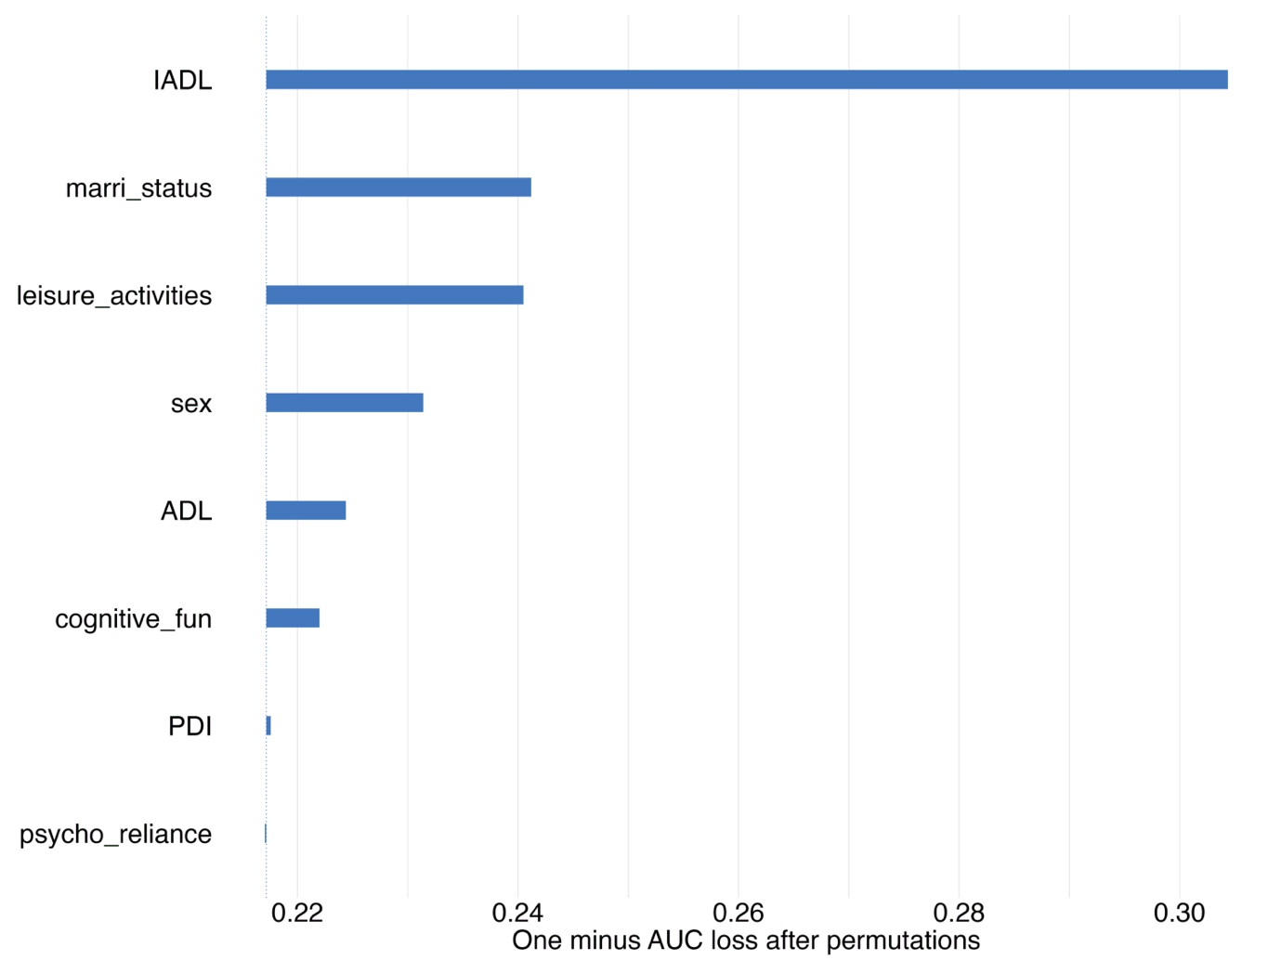
Fig. S1. Variable Importance of XGBoost-Built Model Predicting 4-Year All-Cause Mortality. in Older Adults with 8 Features. Note. IADL = Instrumental Activities of Daily Living; leisure_activities = leisure activities; marri_status = marital status; ADL = Activities of Daily Living; cognitive_fun = cognitive function; PDI = Plant-Diet Index; psycho_reliance = psychological resilience. For additional explanations regarding the titles, please see Supplementary Material, Table S3. The same below.

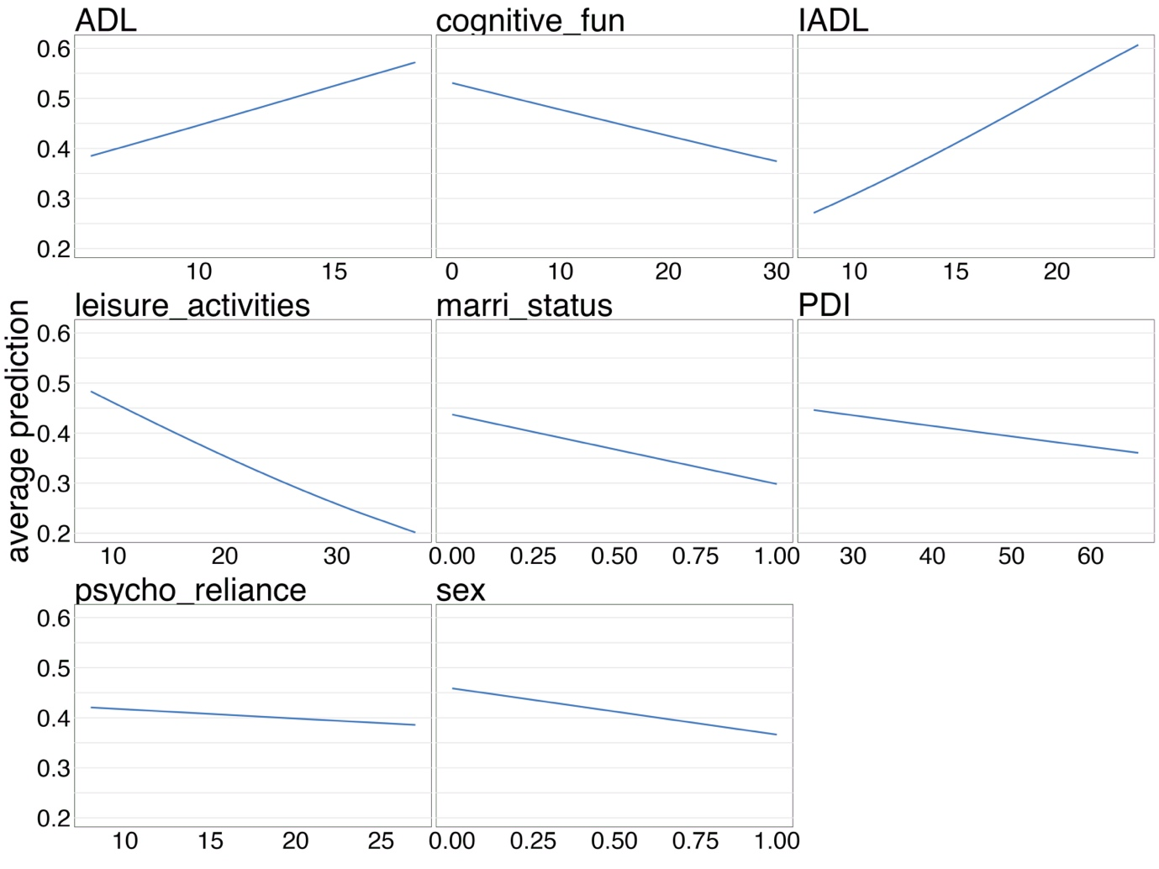
Fig. S2. Partial Dependence Plots for the XGBoost-Built Model Predicting 4-Year All-Cause Mortality in Older Adults with 8 Features

