Health-economic evaluation of orthogeriatric co-management for patients with pelvic or vertebral fragility fractures

Supplementary material

Supplementary Fig. 1 Flow-chart of study population
Study population
(n_{p} = 21,036; n_{v} = 33,827)
Exclusions:
Younger than 80 years (n_{p} = 8,293; n_{v} = 22,168)
Treated in hospital with > 5% change in care system (n_{p} = 12,071; n_{v} = 20,736)
Treated in hospital with very high number of cases (n_{p} = 292; n_{v} = 579)
Implausibly low index charges (n_{p} = 0; n_{v} = 1)
Insufficient insurance status for baseline or follow-up (n_{p} = 22; n_{v} = 57)
Fracture in washout-period (n_{p} = 175; n_{v} = 477)
Inpatient hospital stay after death (n_{p} = 9; n_{v} = 18)
Patients treated in OGCM hospitals
(n = 24,633)
Patients treated in non-OGCM hospitals
(n = 9,194)
Vertebral fracture cohort
(n = 33,827)
With inpatient stay due to fragility fracture in 2014-2018
(n_{p} = 41,898; n_{v} = 77,863)
Pelvic fracture cohort
(n = 21,036)
Patients treated in OGCM hospitals
(n = 14,973)
Patients treated in non-OGCM hospitals
(n = 6,063)

n_{p}: Number of patients with pelvic fractures; n_{v}: Number of patients with vertebral fractures

Supplementary Fig. 2 Hospital volume (fracture cases per hospital) for OGCM and non-OGCM hospitals in both cohorts
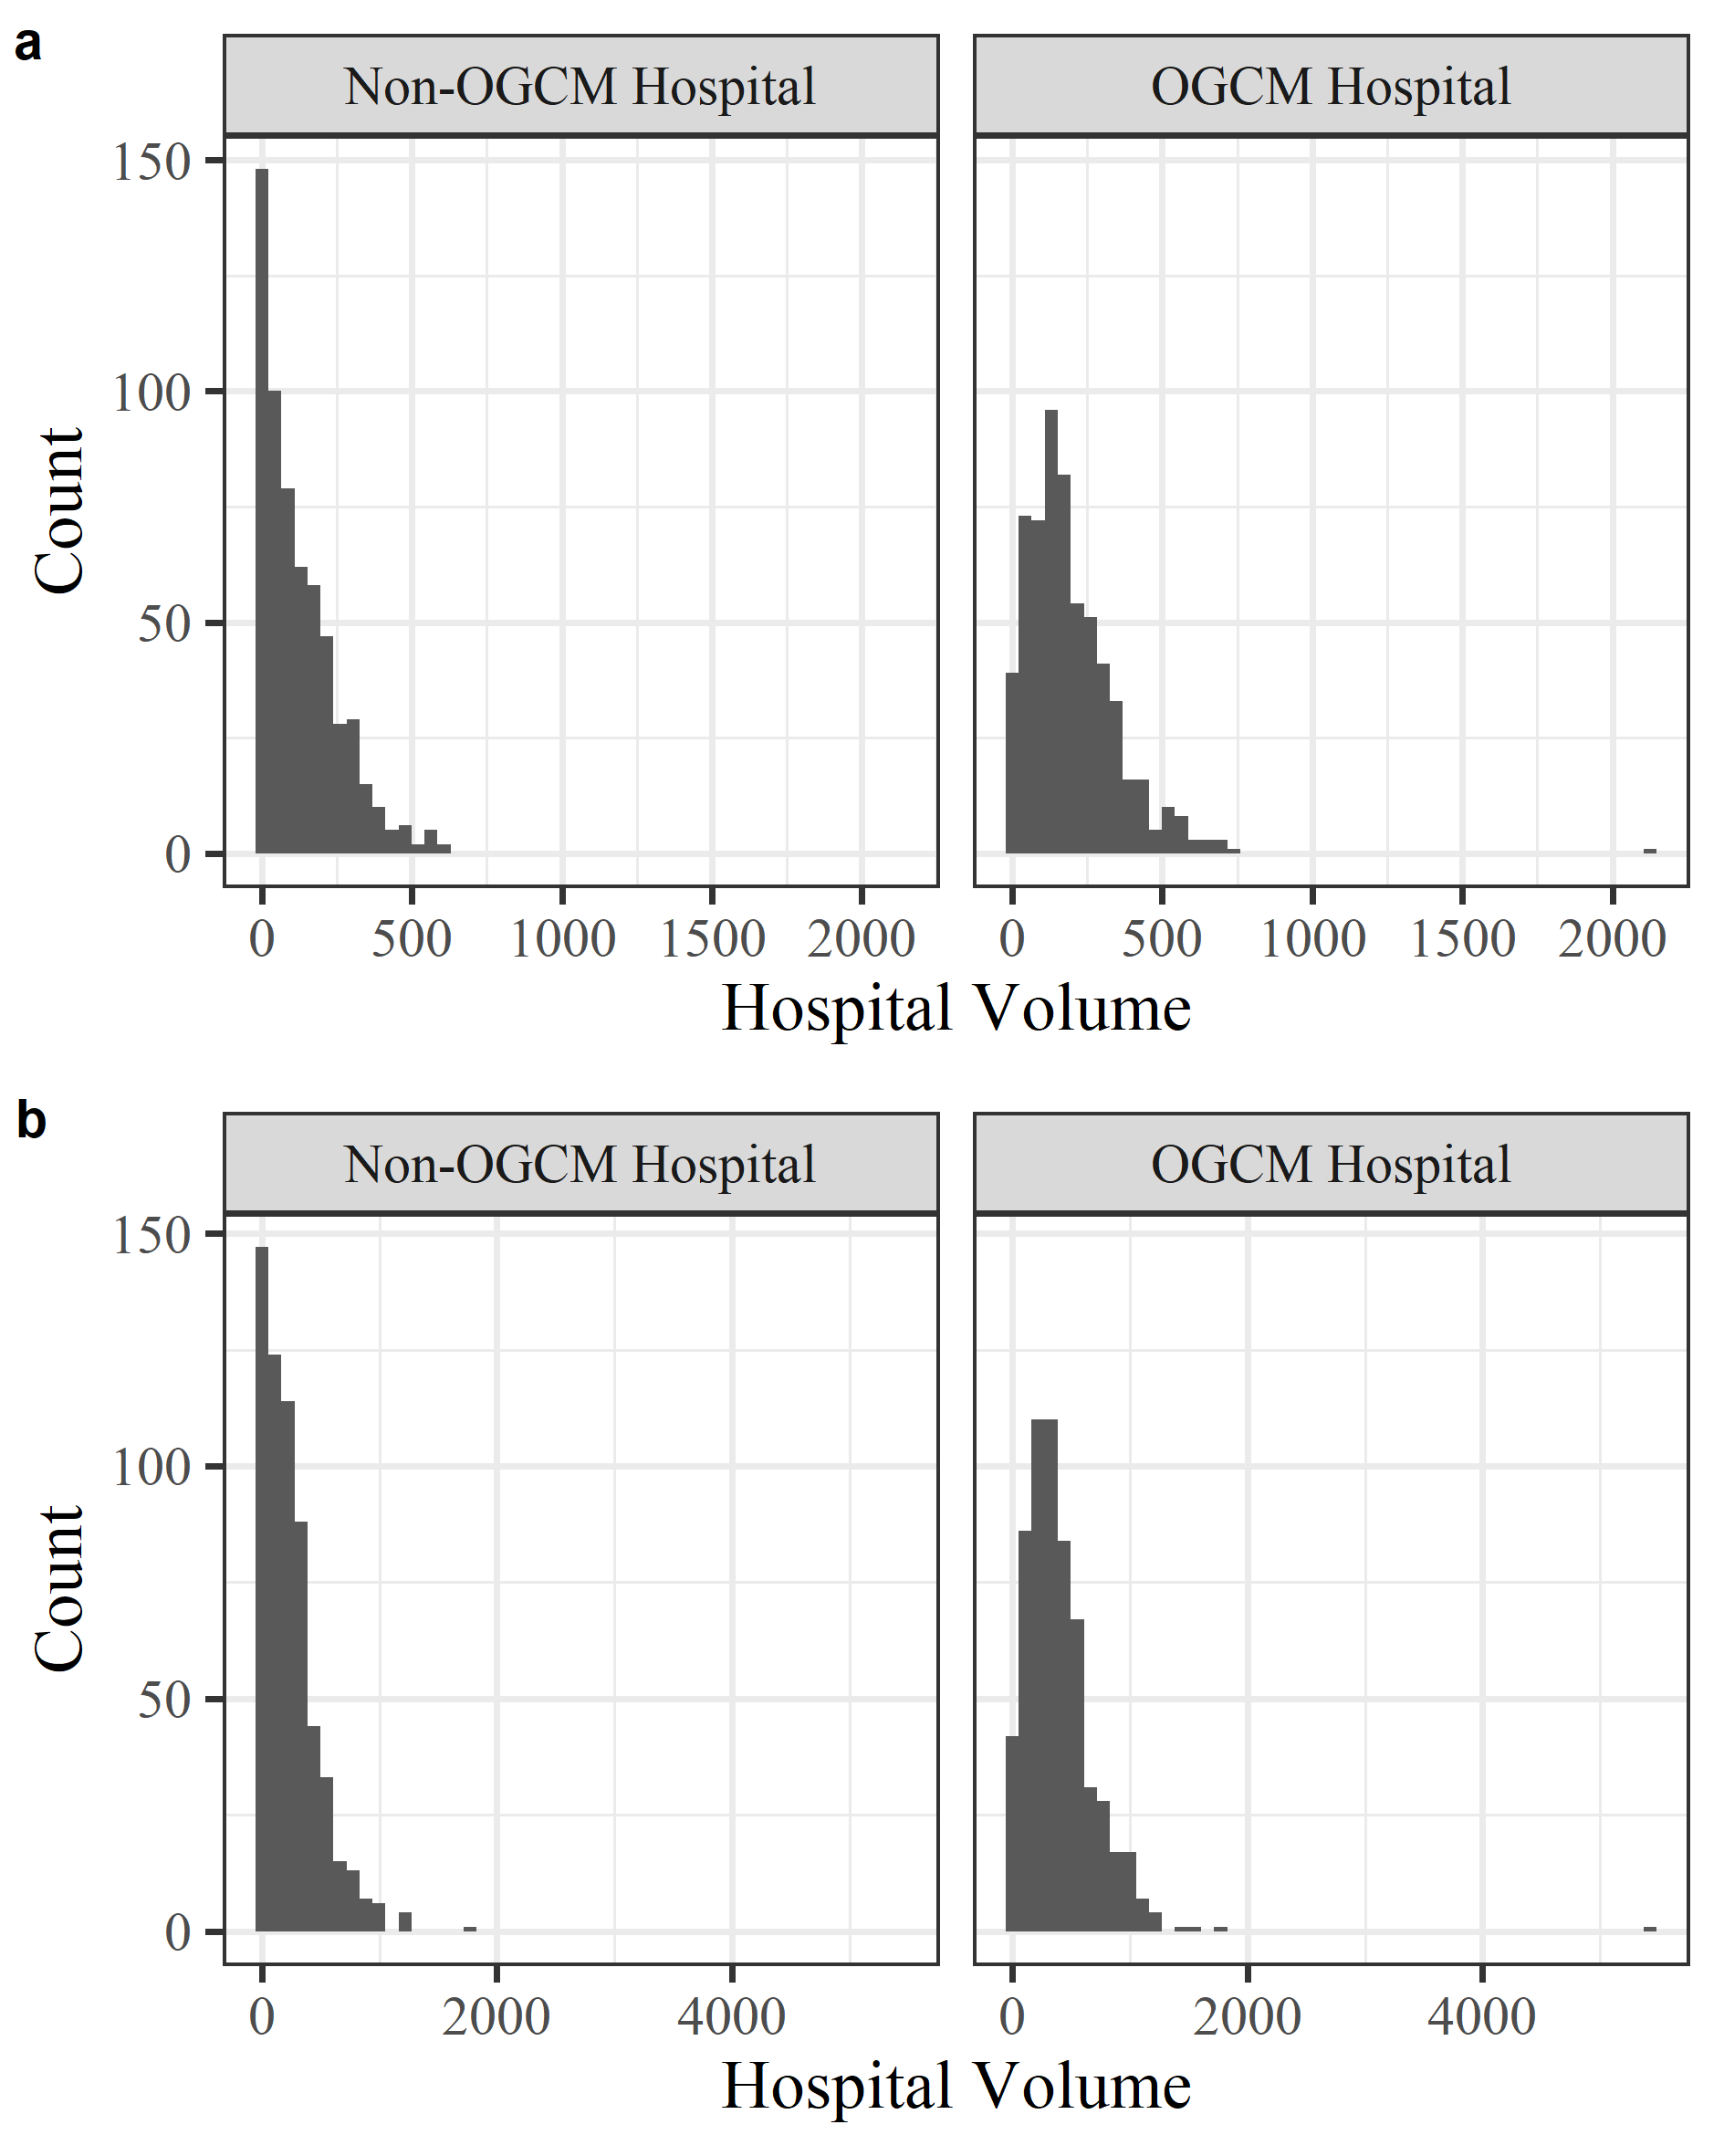

These values were weighted by the insurer’s coverage in the respective federal state. a: Pelvic fracture cohort, b: Vertebral fracture cohort. All cases belonging to the outlier in the OGCM hospital group were excluded during data preprocessing.

Supplementary table 1 Medication based comorbidities before and after EB for pelvic fractures
Baseline: 1 year | OGCM group (N=14,973) | Non-OGCM group (N=6,063)
Baseline: 1 year |  | Before EB | After EB
Medication-based comorbidities [%]
Acid related disorders | 52.09 (49.96) | 52.07 (49.96) | 52.09 (49.96)
Bone diseases (osteoporosis) | 12.22 (32.75) | 13 (33.63) | 12.21 (32.74)
Cancer | 0.64 (7.98) | 0.58 (7.58) | 0.64 (8)
Cardiovascular diseases (incl.  hypertension) | 88.78 (31.56) | 88.37 (32.06) | 88.78 (31.56)
Dementia | 7.59 (26.48) | 7.03 (25.56) | 7.59 (26.48)
Diabetes mellitus | 19.47 (39.6) | 20.47 (40.35) | 19.47 (39.6)
Epilepsy | 10 (30) | 9.93 (29.91) | 10 (30)
Glaucoma | 9.7 (29.59) | 10.09 (30.13) | 9.69 (29.58)
Gout, Hyperuricemia | 11.87 (32.34) | 13 (33.63) | 11.87 (32.34)
HIV | Excluded due to less than 50 observations
Hyperlipidemia | 30.21 (45.92) | 30.23 (45.93) | 30.22 (45.92)
Intestinal inflammatory diseases | 0.91 (9.52) | 1.14 (10.61) | 0.91 (9.52)
Iron deficiency anemia | 7.75 (26.75) | 6.78 (25.14) | 7.75 (26.74)
Migraines | Excluded due to less than 50 observations
Pain | 64.1 (47.97) | 61.26 (48.72) | 64.1 (47.97)
Parkinson’s disease | 6.93 (25.4) | 6.61 (24.85) | 6.93 (25.4)
Psychological disorders (sleep disorder,  depression) | 35.58 (47.88) | 37.09 (48.31) | 35.59 (47.88)
Psychoses | 17.06 (37.62) | 17.05 (37.61) | 17.07 (37.63)
Respiratory illness (asthma, COPD) | 13.64 (34.33) | 13.69 (34.38) | 13.64 (34.32)
Rheumatologic conditions | 33.69 (47.27) | 35.31 (47.8) | 33.68 (47.26)
Thyroid disorders | 23.74 (42.55) | 24.08 (42.76) | 23.75 (42.56)
Tuberculosis | Excluded due to less than 50 observations
Standard deviation is stated in parentheses; EB = Entropy balancing; OGCM = Orthogeriatric co-management

Supplementary table 2 Descriptive statistics before and after EB for vertebral fractures
Baseline: 1 year | OGCM group (N=24,633) | Non-OGCM group (N=9,194)
Baseline: 1 year |  | Before EB | After EB
Female gender [%] | 76.07 (42.66) | 76.59 (42.34) | 76.09 (42.65)
Age: Mean [years] | 86.21 (4.26) | 86.11 (4.17) | 86.21 (4.26)
Vertebral fracture cases per hospital: Mean | 614 (315) | 449 (257) | 612 (316)
Treatment in 2014 [%] | 16.7 (37.3) | 23.34 (42.3) | 16.73 (37.32)
Treatment in 2015 [%] | 18.58 (38.9) | 20.6 (40.45) | 18.58 (38.89)
Treatment in 2016 [%] | 20.16 (40.12) | 20.09 (40.07) | 20.17 (40.13)
Treatment in 2017 [%] | 21.9 (41.36) | 17.53 (38.03) | 21.89 (41.35)
Care dependence during baseline: Mean [months]
nursing home | 1.27 (3.5) | 1.26 (3.47) | 1.27 (3.5)
care level 1 | 0.06 (0.63) | 0.06 (0.67) | 0.06 (0.63)
care level 2 | 2.87 (4.72) | 2.69 (4.61) | 2.87 (4.72)
care level 3 | 1.72 (3.85) | 1.69 (3.82) | 1.72 (3.85)
care level 4 | 0.86 (2.86) | 0.84 (2.82) | 0.86 (2.86)
care level 5 | 0.12 (1.09) | 0.1 (0.98) | 0.12 (1.09)
Costs during baseline: Mean [€]
for inpatient hospital treatment | 4,377 (7,257) | 3,880 (6,582) | 4,376 (7,254)
for medication | 1,302 (1,604) | 1,224 (1,505) | 1,302 (1,604)
for outpatient treatment | 1,128 (911) | 1,145 (871) | 1,129 (912)
for outpatient hospital treatment | 24.15 (112) | 22.07 (100) | 24.18 (112)
for medical devices | 178 (409) | 171 (390) | 178 (409)
for long-term care | 4,976 (6,078) | 4,805 (6,023) | 4,975 (6,077)
Medication-based comorbidities [%]
Acid related disorders | 53.82 (49.85) | 53.8 (49.86) | 53.83 (49.85)
Bone diseases (osteoporosis) | 13.68 (34.37) | 14.06 (34.77) | 13.68 (34.37)
Cancer | 0.68 (8.21) | 0.62 (7.85) | 0.68 (8.21)
Cardiovascular diseases (incl.  hypertension) | 88.27 (32.18) | 87.81 (32.72) | 88.28 (32.17)
Dementia | 6.34 (24.36) | 6.32 (24.33) | 6.34 (24.36)
Diabetes mellitus | 20.51 (40.38) | 20.38 (40.29) | 20.5 (40.37)
Epilepsy | 11.05 (31.36) | 10.8 (31.04) | 11.05 (31.35)
Glaucoma | 9.63 (29.5) | 9.63 (29.5) | 9.62 (29.49)
Gout, Hyperuricemia | 12.45 (33.01) | 13.32 (33.99) | 12.45 (33.01)
HIV | Excluded due to less than 50 observations
Hyperlipidemia | 33.13 (47.07) | 31.92 (46.62) | 33.13 (47.07)
Intestinal inflammatory diseases | 1.08 (10.32) | 1.11 (10.47) | 1.08 (10.31)
Iron deficiency anemia | 6.52 (24.69) | 6.07 (23.88) | 6.52 (24.69)
Migraines | Excluded due to less than 50 observations
Pain | 67.88 (46.69) | 66.06 (47.35) | 67.89 (46.69)
Parkinson’s disease | 7.74 (26.73) | 7.85 (26.9) | 7.75 (26.73)
Psychological disorders (sleep disorder,  depression) | 33.67 (47.26) | 35.36 (47.81) | 33.67 (47.26)
Psychoses | 13.78 (34.47) | 14.36 (35.07) | 13.77 (34.46)
Respiratory illness (asthma, COPD) | 15.92 (36.58) | 14.74 (35.45) | 15.91 (36.58)
Rheumatologic conditions | 38.69 (48.7) | 41.08 (49.2) | 38.7 (48.71)
Thyroid disorders | 23.85 (42.62) | 24.74 (43.16) | 23.84 (42.61)
Tuberculosis | Excluded due to less than 50 observations
Standard deviation is stated in parentheses; EB = Entropy balancing; OGCM = Orthogeriatric co-management

Sensitivity Analysis: Accounting for clusters
To account for clusters introduced by cases being treated in the same hospitals, we recalculated the analyses including random intercepts for hospitals. However, we could not recalculate all models in this manner as random intercepts included in both, the logistic regression of the first part and the generalized linear regression with gamma distribution of the second part of two-part models, led to non-convergence. Thus, we only applied a random intercept in the logistic regression (first part) as in this way the random intercept term did not only affect cases for which costs occurred. The reported incremental cost-effectiveness ratios reflect the relations of the differences between OGCM and non-OGCM groups estimated by the respective model of total costs and effectiveness. Lastly, we report cost-effectiveness acceptability curves based on net-monetary regressions that also included random intercepts for hospitals. Estimated costs and outcomes can be found in supplementary Tables 3 and 4 and the cost-effectiveness acceptability curves can be found in supplementary Fig 3.

Supplementary table 3 Costs and outcome estimates for pelvic fractures estimated with random intercept for hospitals
Outcome | OGCM group  (n = 14,973) | Non-OGCM group  (n = 6,063) | Difference | SE
Costs [€]
Totalª | 22,529 | 21,252 | 1,277*** | 319
Inpatientª | 11,109 | 10,172 | 937*** | 281
Thereof during index stayª | 5,817 | 4,974 | 844*** | 234
Medication^{b} | 1,399 | 1,391 | 7.51 | 50.17
Outpatient^{b} | 1,016 | 1,023 | -7.07 | 31.67
Outpatient hospital^{b} | 17.28 | 16.01 | 1.27 | 3.59
Medical devices^{b} | 292 | 299 | -7.11 | 11.84
Long-term care^{c} | 8,257 | 8,080 | 177 | 136
Length of stay [days]
Total stayª | 18.43 | 14.91 | 3.52*** | 0.5612
Thereof in hospitalª | 15.09 | 11.05 | 4.04*** | 0.4002
Thereof in rehabilitation facility^{b} | 1.81 | 2.35 | -0.5407 | 0.2761
Effectiveness
Life year^{c} | 0.8176 | 0.8121 | 0.0055 | 0.0066
Fracture-free life year^{c} | 0.7685 | 0.7643 | 0.0042 | 0.0071
ICER
€ per life year gained | 232,265
€ per fracture-free life year gained | 304,157
* p < .05; ** p < .01; *** p < .001
ª estimated with a gamma regression with random intercept term for hospitals; ^{b} estimated with a two-part model with logistic and gamma part with random intercept term for hospitals in logistic part; ^{c} estimated with a linear mixed regression with random intercept term for hospitals; OGCM = Orthogeriatric co-management; SE = Robust standard error

Supplementary table 4 Costs and outcome estimates for vertebral fractures estimated with random intercept for hospitals
Outcome | OGCM group  (n = 24,633) | Non-OGCM group  (n = 9,194) | Difference | SE
Costs [€]
Totalª | 22,917 | 22,267 | 650* | 267
Inpatientª | 12,600 | 11,894 | 706** | 239
Thereof during index stayª | 6,277 | 5,568 | 710*** | 155
Medication^{b} | 1,464 | 1,451 | 12.79 | 28.78
Outpatient^{b} | 1,007 | 1,038 | -31.28 | 33.34
Outpatient hospital^{b} | 17.63 | 17.51 | 0.121 | 1.65
Medical devices^{b} | 265 | 283 | -18.37* | 8.74
Long-term care^{c} | 7,087 | 7,040 | 47.03 | 112
Length of stay [days]
Total stayª | 16.78 | 14.42 | 2.35*** | 0.4446
Thereof in hospitalª | 14.36 | 11.54 | 2.83*** | 0.3819
Thereof in rehabilitation facility^{b} | 1.39 | 2.03 | -0.638*** | 0.1655
Effectiveness
Life year^{c} | 0.8371 | 0.8483 | -0.0112* | 0.0049
Fracture-free life year^{c} | 0.7854 | 0.7952 | -0.0098 | 0.0056
ICER
€ per life year gained | Dominated^{d}
€ per fracture-free life year gained | Dominated^{d}
* p < .05; ** p < .01; *** p < .001
ª estimated with a gamma regression with random intercept term for hospitals; ^{b} estimated with a two-part model with logistic and gamma part with random intercept term for hospitals in logistic part; ^{c} estimated with a linear mixed regression with random intercept term for hospitals; ^{d} OGCM was more costly and less effective than non-OGCM group; OGCM = Orthogeriatric co-management; SE = Robust standard error

Supplementary Fig. 3 Cost-effectiveness acceptability curves for total costs estimated with random intercepts for hospitals

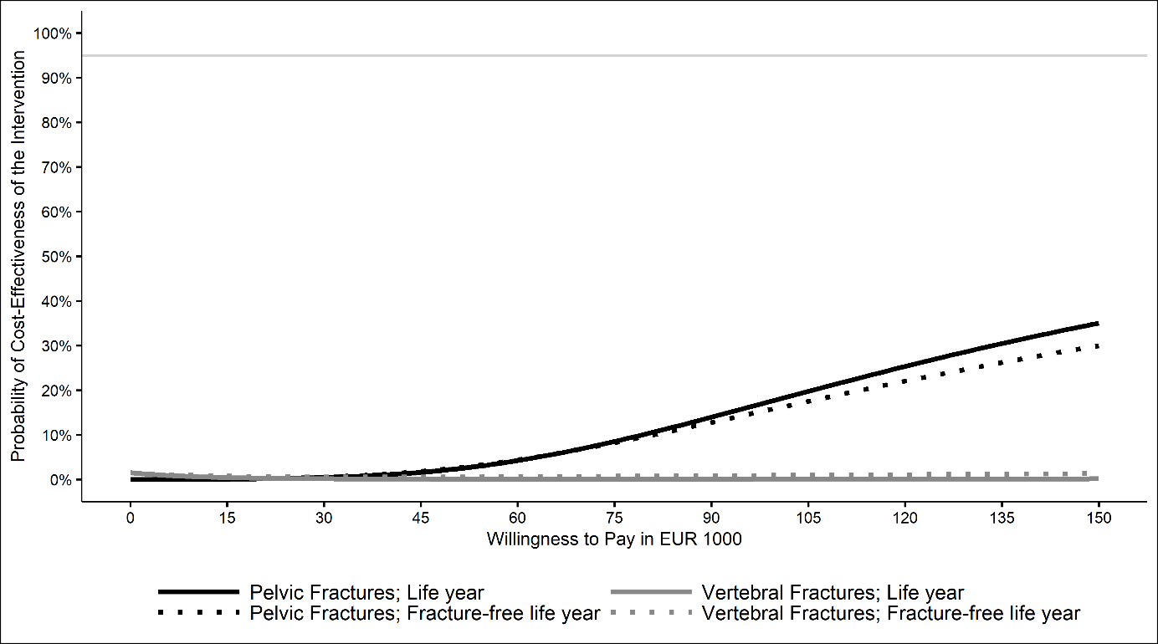

Sensitivity analyses: Without balancing for hospital volume
Supplementary table 5 Costs and outcome estimates for pelvic fractures estimated without balancing for hospital volume
Outcome | OGCM group  (n = 14,973) | Non-OGCM group  (n = 6,063) | Difference | SE
Costs [€]
Totalª | 22,572 | 21,202 | 1370*** | 202
Inpatientª | 11,288 | 10,015 | 1272*** | 140
Thereof during index stayª | 6,012 | 4,941 | 1071*** | 61.5
Medication^{b} | 1,391 | 1,341 | 50.4* | 23.15
Outpatient^{b} | 1,010 | 1,039 | -29.05 | 16.28
Outpatient hospital^{b} | 22.87 | 18.99 | 3.88* | 1.55
Medical devices^{b} | 292 | 307 | -15.15* | 7.01
Long-term care^{c} | 8,256 | 8,152 | 104 | 106
Length of stay [days]
Total stayª | 18.93 | 15.06 | 3.87*** | 0.2264
Thereof in hospitalª | 15.25 | 10.58 | 4.67*** | 0.1483
Thereof in rehabilitation facility^{b} | 3.68 | 4.47 | -0.7975*** | 0.1437
Effectiveness
Life year^{c} | 0.8149 | 0.8141 | 0.0008 | 0.0053
Fracture-free life year^{c} | 0.7666 | 0.7685 | -0.0019 | 0.0056
ICER
€ per life year gained | 1,712,781
€ per fracture-free life year gained | Dominated^{d}
* p < .05; ** p < .01; *** p < .001
ª estimated with a gamma regression; ^{b} estimated with a two-part model with logistic and gamma part; ^{c} tested with a two sample t-test; OGCM = Orthogeriatric co-management; SE = Standard error; ^{d} OGCM was more costly and less effective than non-OGCM group; OGCM = Orthogeriatric co-management; SE = Robust standard error

Supplementary table 6 Costs and outcome estimates for vertebral fractures estimated without balancing for hospital volume
Outcome | OGCM group  (n = 24,633) | Non-OGCM group  (n = 9,194) | Difference | SE
Costs [€]
Totalª | 23,060 | 22,267 | 793*** | 184
Inpatientª | 12,898 | 11,924 | 974*** | 142
Thereof during index stayª | 6,675 | 5,685 | 989*** | 70.05
Medication^{b} | 1,458 | 1,450 | 7.79 | 20.48
Outpatient^{b} | 1,003 | 1,047 | -44.51*** | 10.25
Outpatient hospital^{b} | 22.56 | 23.85 | -1.29 | 1.33
Medical devices^{b} | 265 | 276 | -10.6 | 5.72
Long-term care^{c} | 7,089 | 7,182 | -93 | 80.98
Length of stay [days]
Total stayª | 17.47 | 14.48 | 2.99*** | 0.202
Thereof in hospitalª | 14.92 | 11.11 | 3.81*** | 0.159
Thereof in rehabilitation facility^{b} | 2.55 | 3.38 | -0.8269*** | 0.1009
Effectiveness
Life year^{c} | 0.8363 | 0.845 | -0.0087* | 0.004
Fracture-free life year^{c} | 0.7843 | 0.7906 | -0.0062 | 0.0043
ICER
€ per life year gained | Dominated^{d}
€ per fracture-free life year gained | Dominated^{d}
* p < .05; ** p < .01; *** p < .001
ª estimated with a gamma regression; ^{b} estimated with a two-part model with logistic and gamma part; ^{c} tested with a two sample t-test; OGCM = Orthogeriatric co-management; SE = Standard error; ^{d} OGCM was more costly and less effective than non-OGCM group; OGCM = Orthogeriatric co-management; SE = Robust standard error

Supplementary Fig. 4 Cost-effectiveness acceptability curves for total costs estimated without balancing for hospital volume
