Online supplementary material

This appendix is a part of the original submission.

Supplement to: Sukyoung Jung, Yunhwan Lee, Kirang Kim, Sohyun Park. Association of Dietary Inflammatory Index with Sarcopenic Obesity and Frailty in Older Adults
Supplemental Figure 1. Study participants flow chart, The Korean Frailty and Aging Cohort Study (KFACS)
Participants who completed nutrition surveys
(n=1002)

< 400 kcal of energy intake
(n=3)
(n=17,135)

Valid energy intake
(n=999)

Missing in sarcopenia assessment
(n=5)

Completed sarcopenic assessment
(n=994)

Missing frailty assessment
(n=44)

Final analytic sample
(n=950)

Supplemental Table 1. Description of Fried frailty index components and criteria for adding 1 point
Component | Criteria for adding 1 point
Unintended weight loss ª | Unintended weight loss of ≥ 4.5 kg during the last year
Weakness ª | Grip strength of < 26 kg for men and < 18 kg for women
Exhaustion ^{b} | 3 or more days in a week in “I felt that everything I did was an effort” or “I could not get going” questions
Slow walking speed ª | Walking speed of < 1 m/s after walking 4 m at a normal rhythm
Low physical activity ^{c} | MET-minutes/week of < 494.65 kcal for men and < 283.50 kcal for women
Abbreviation: MET, metabolic equivalent task.
ª Source: Chen LK, Woo J, Assantachai P, et al. Asian Working Group for Sarcopenia: 2019 Consensus Update on Sarcopenia Diagnosis and Treatment. J Am Med Dir Assoc. 2020;21:300-307.e302.
^{b} Source: Orme JG, Reis J, Herz EJ. Factorial and discriminant validity of the Center for Epidemiological Studies Depression (CES-D) scale. J Clin Psychol. 1986;42:28-33.
^{c} Source: Son J, Kim S, Won C, Choi H, Kim B, Park M. Physical frailty predicts medical expenses in community-dwelling, elderly patients: three-year prospective findings from living profiles of older people surveys in Korea. European Geriatric Medicine. 2015;6:412-416.
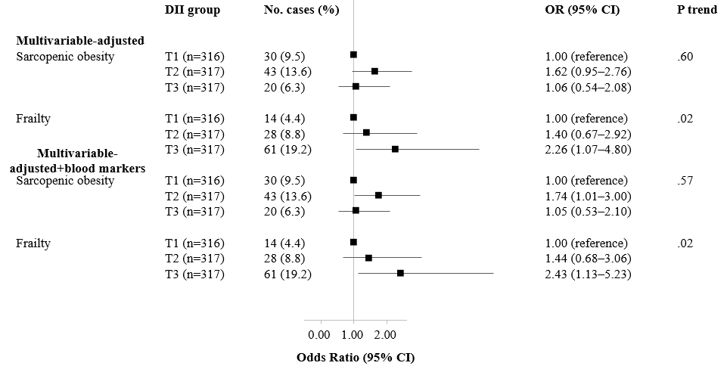
Supplemental Figure 2. Odds ratios (95% confidence intervals) for sarcopenic obesity and frailty by tertiles of the dietary inflammatory index score after further adjusting for blood markers
Abbreviations: T, tertile; DII, dietary inflammatory index; OR, odds ratio; CI, confidence interval
Data source: Korean Frailty and Aging Cohort Survey (KFACS)
Note: Multinomial logistic regression models are used to estimate odds ratios and their corresponding 95% confidence intervals for the presence of SO and frailty versus robust by comparing tertile 2 and 3 with tertile 1 of the DII as the exposure variables. The number of each SO and frailty cases and their percentages are presented as No. cases (%) according to the DII tertile. P for trends is determined by treating the median value of the DII score as a continuous variable using multinomial logistic regression models. The multivariable-adjusted model is adjusted for age, sex, education level, monthly household income level, family structure, number of chronic diseases, number of prescribed drugs, chewing status, smoking status, alcohol consumption, physical activity level, and total energy intake. We also presented the findings after further adjusting for total cholesterol, triglycerides, fasting blood glucose, and hs-CRP.

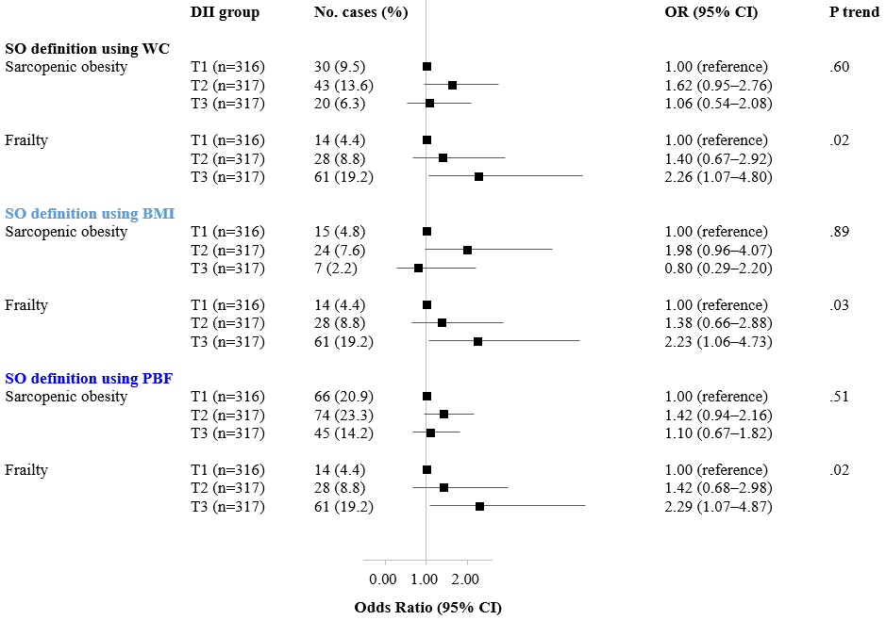 Supplemental Figure 3. Odds ratios (95% confidence intervals) for sarcopenic obesity and frailty by tertiles of the dietary inflammatory index score using different definitions of sarcopenic obesity
Abbreviations: T, tertile; DII, dietary inflammatory index; OR, odds ratio; CI, confidence interval; WC, waist circumference; BMI, body mass index; PBF, percent body fat; SO, sarcopenic obesity.
Data source: Korean Frailty and Aging Cohort Survey (KFACS)
Note: Multinomial logistic regression models are used to estimate odds ratios and their corresponding 95% confidence intervals for the presence of SO and frailty versus robust by comparing tertile 2 and 3 with tertile 1 of the DII as the exposure variables. The number of each SO and frailty cases and their percentages are presented as No. cases (%) according to the DII tertile. P for trends is determined by treating the median value of the DII score as a continuous variable using multinomial logistic regression models. The multivariable-adjusted model is adjusted for age, sex, education level, monthly household income level, family structure, number of chronic diseases, number of prescribed drugs, chewing status, smoking status, alcohol consumption, physical activity level, and total energy intake. A BMI of 25 or higher, a PBF of 25 for men, and a PBF of 30 for women were used as cut-offs for defining obesity for comparison.
Supplemental Table 2. Sample size and percentage of study participants who consumed nutrients in the dietary inflammatory index less or greater than the KDRIs by frailty and sarcopenic obesity status (n=950) ª
 | Robust group | Sarcopenic obesity group | Frailty group | P value ª
Individual components of DII [n (%), <KDRIs]
Anti-inflammatory effect
Fiber
≥AI | 1 (0.1) | 0 (0.0) | 0 (0.0) | 0.88
<AI | 753 (99.9) | 93 (100.0) | 103 (100.0)
Vitamin A
≥RNI | 320 (42.4) | 34 (36.6) | 29 (28.2) | 0.02
<RNI | 434 (57.6) | 59 (63.4) | 74 (71.8)
Vitamin D
≥AI | 65 (8.6) | 13 (14.0) | 5 (4.9) | 0.08
<AI | 689 (91.4) | 80 (86.0) | 98 (95.2)
Vitamin E
≥AI | 118 (15.7) | 16 (17.2) | 3 (2.9) | 0.002
<AI | 636 (84.4) | 77 (82.8) | 100 (97.1)
Vitamin C
≥RNI | 309 (41.0) | 39 (41.9) | 25 (24.3) | 0.004
<RNI | 445 (59.0) | 54 (58.1) | 78 (75.7)
Vitamin B₁
≥RNI | 305 (40.5) | 47 (50.5) | 31 (30.1) | 0.01
<RNI | 449 (59.6) | 46 (49.5) | 72 (69.9)
Vitamin B₂
≥RNI | 188 (24.9) | 33 (35.5) | 21 (20.4) | 0.04
<RNI | 566 (75.1) | 60 (64.5) | 82 (79.6)
Niacin
≥RNI | 407 (54.0) | 56 (60.2) | 39 (37.9) | 0.003
<RNI | 347 (46.0) | 37 (39.8) | 64 (62.1)
Vitamin B₆
≥RNI | 315 (41.8) | 44 (47.3) | 25 (24.3) | 0.001
<RNI | 439 (58.2) | 49 (52.7) | 78 (75.7)
Folate
≥RNI | 140 (18.6) | 22 (23.7) | 10 (9.7) | 0.03
<RNI | 614 (81.4) | 71 (76.3) | 93 (90.3)
Pro-inflammatory effect
Energy
≥EER | 179 (23.7) | 27 (29.0) | 20 (19.4) | 0.29
<EER | 575 (76.3) | 66 (71.0) | 83 (80.6)
Carbohydrate
≥RNI | 717 (95.1) | 89 (95.7) | 88 (85.4) | 0.0004
<RNI | 37 (4.9) | 4 (4.3) | 15 (14.6)
Protein
≥RNI | 345 (45.8) | 52 (55.9) | 22 (21.4) | <.0001
<RNI | 409 (54.2) | 41 (44.1) | 81 (78.6)
Vitamin B₁₂
≥RNI | 441 (58.5) | 65 (69.9) | 43 (41.8) | 0.0002
<RNI | 313 (41.5) | 28 (30.1) | 60 (58.3)
Iron
≥RNI | 569 (75.5) | 79 (85.0) | 57 (55.3) | <.0001
<RNI | 185 (24.5) | 14 (15.1) | 46 (44.7)
Cholesterol
≥300mg | 157 (20.8) | 25 (26.9) | 11 (10.7) | 0.01
<300mg | 597 (79.2) | 68 (73.1) | 92 (89.3)
Abbreviations: DII, dietary inflammatory index; KDRI, Dietary Reference Intakes for Koreans; AI, adequate intake; RNI, recommended nutrient intake; EER, estimated energy requirement.
Data source: KFACS, Korean Frailty and Aging Cohort Survey
Note: Sample size and percentage were presented.
ª P values for differences between frailty or sarcopenic obesity status were obtained using the chi-square test.

