Supplementary Table 1 Health care utilization by chronic conditions among Chinese older people (baseline)
Health care utilization | Use of health care service (%)
Health care utilization | Yes | No | P
Outpatient |  |  | <0.001
No chronic condition | 63 (16.32) | 834 (29.19)
One chronic condition | 141 (36.53) | 1064 (37.24)
Multimorbidity | 182 (47.15) | 959 (33.57)
Inpatient |  |  | <0.001
No chronic condition | 87 (13.38) | 810 (31.24)
One chronic condition | 222 (34.15) | 983 (37.91)
Multimorbidity | 341 (52.46) | 800 (30.85)
Unmet hospitalization needs |  |  | 0.394
No chronic condition | 8 (19.05) | 889 (27.77)
One chronic condition | 16 (38.10) | 1189 (37.14)
Multimorbidity | 18 (42.86) | 1123 (35.08)

Supplementary Table 2 Association between chronic conditions changes and health care utilization among older people in rural Shandong, China (N=2785) (Crude model)
 | Outpatient |  | Inpatient |  | Unmet hospitalization needs
 | OR [95% CI] | P | OR [95% CI] | P | OR [95% CI] | P
Chronic conditions
Unchanged chronic conditions
Remained no chronic condition | 1.000 |  | 1.000 |  | 1.000
Remained one chronic condition | 1.691 [1.209, 2.365] | 0.002 | 1.880 [0.329, 0.934] | <0.001 | 3.446 [1.310, 9.062] | 0.012
Unchanged multimorbidity (chronic conditions unchanged) | 2.402 [1.755, 3.288] | <0.001 | 3.796 [2.862, 5.035] | <0.001 | 5.806 [2.313, 14.573] | <0.001
Progressive chronic conditions
No chronic condition→ One chronic condition | 1.276 [0.791, 2.056] | 0.318 | 1.473 [0.971, 2.233] | 0.068 | 3.096 [0.983, 9.757] | 0.054
No chronic condition→ Emerging multimorbidity | 1.792 [1.048, 3.063] | 0.033 | 2.583 [1.551, 4.303] | <0.001 | 6.342 [1.936, 20.777] | 0.002
One chronic condition→ Emerging multimorbidity | 2.137 [1.481, 3.083] | <0.001 | 3.223 [2.343, 4.433] | <0.001 | 7.187 [2.735, 18.885] | <0.001
Progressive multimorbidity (chronic conditions increased) | 3.271 [2.214, 4.832] | <0.001 | 4.969 [3.461, 7.134] | <0.001 | 10.758 [3.994, 28.972] | <0.001

Supplementary Table 3 Subgroups analysis by intergenerational financial support.
 | Outpatient |  | Inpatient |  | Unmet hospitalization needs
 | OR [95% CI] | P | OR [95% CI] | P | OR [95% CI] | P
With intergenerational financial support group
Chronic conditions
Unchanged chronic conditions
Remained no chronic condition | 1.000 |  | 1.000 |  | 1.000
Remained one chronic condition | 1.522 [1.034, 2.239] | 0.033 | 1.950 [1.344, 2.829] | <0.001 | 3.446 [1.310, 9.062] | 0.012
Unchanged multimorbidity (chronic conditions unchanged) | 1.834 [1.276, 2.636] | 0.001 | 3.921 [2.761, 5.569] | <0.001 | 5.806 [2.313, 14.573] | <0.001
Progressive chronic conditions
No chronic condition→ One chronic condition | 1.056 [0.577, 1.932] | 0.860 | 1.440 [0.847, 2.447] | 0.178 | 3.096 [0.983, 9.757] | 0.054
No chronic condition→ Emerging multimorbidity | 1.754 [0.927, 3.318] | 0.084 | 3.302 [1.853, 5.881] | <0.001 | 6.342 [1.936, 20.777] | 0.002
One chronic condition→ Emerging multimorbidity | 1.857 [1.203, 2.864] | 0.005 | 3.877 [2.627, 5.721] | <0.001 | 7.187 [2.735, 18.885] | <0.001
Progressive multimorbidity (chronic conditions increased) | 2.403 [1.526, 3.810] | <0.001 | 5.137 [3.300, 8.007] | <0.001 | 10.758 [3.994, 28.972] | <0.001
Without intergenerational financial support group
Unchanged chronic conditions
Remained no chronic condition | 1.000 |  | 1.000 |  | 1.000
Remained one chronic condition | 2.412 [1.236, 4.704] | 0.010 | 1.938 [1.174, 3.198] | 0.010 | 2.450 [0.908, 6.608] | 0.077
Unchanged multimorbidity (chronic conditions unchanged) | 4.592 [2.414, 8.733] | <0.001 | 3.735 [2.319, 6.015] | <0.001 | 2.949 [1.133, 7.671] | 0.027
Progressive chronic conditions
No chronic condition→ One chronic condition | 2.582 [1.098, 6.072] | 0.030 | 1.588 [0.851, 2.964] | 0.146 | 2.367 [0.675, 8.299] | 0.178
No chronic condition→ Emerging multimorbidity | 2.129 [0.711, 6.373] | 0.177 | 1.983 [0.906, 4.341] | 0.087 | 3.947 [1.068, 14.581] | 0.040
One chronic condition→ Emerging multimorbidity | 3.267 [1.602, 6.664] | 0.001 | 2.610 [1.535, 4.438] | <0.001 | 5.695 [2.116, 15.325] | 0.001
Progressive multimorbidity (chronic conditions increased) | 7.558 [3.405, 16.775] | <0.001 | 6.268 [3.309, 11.873] | <0.001 | 6.759 [2.422, 18.857] | <0.001
Note: Covariates included gender, age, education, economic status, distance to the nearest medical clinic, ADL, and year.

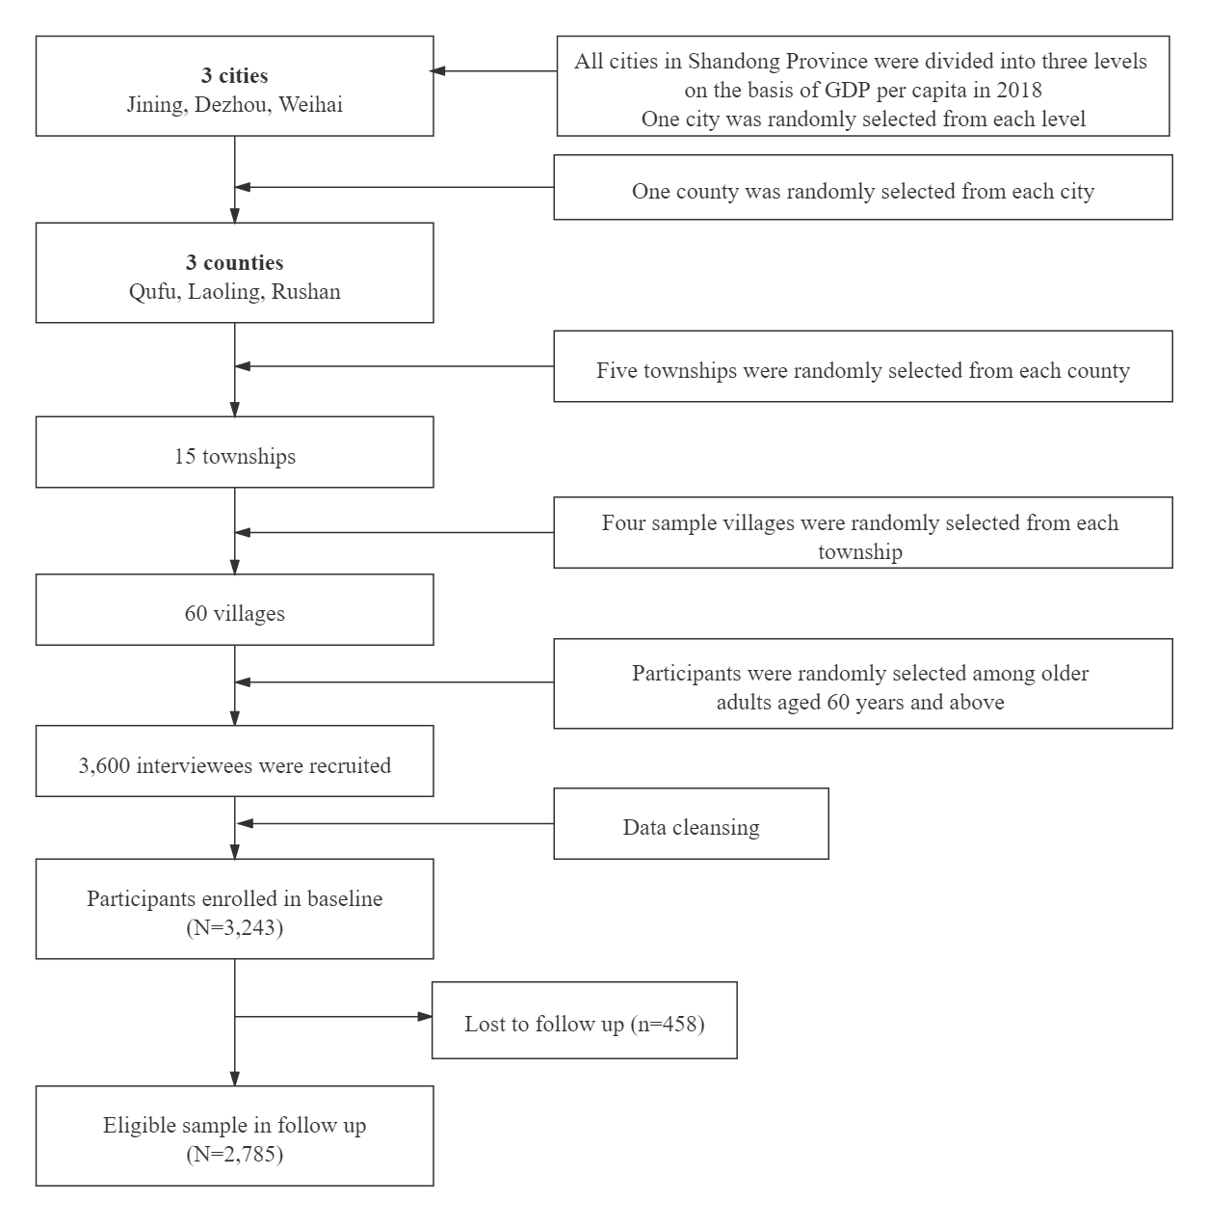
Supplementary Figure 1. Flowchart of participants selection in this study.

