Supplementary Material
Supplementary Table 1: Overview descriptives
Gender | Male | Female
n=421 | 52.7% (n= 222) | 47.3% (n=199)
Age n=419 | 78.8 ± 6.2 | 80.8 ± 6.7
height | 173.0 ±9.25 cm | 164 ± 13.7 cm
Body weight | 78.5 ± 14.4 kg | 68.0 ± 15.2 kg
BMI | 25.7 ± 3.86 | 24.4 ± 5.46

Supplementary Table 2: Overview ASA-Classification about the delirium rate
 |  |  | Delirium
ASA (n=399) |  |  | No | Yes
I | n=17 | 4.3% | 16 | 1 | 5.9%
II | n= 131 | 32.8% | 125 | 4 | 3.1%
III | n= 227 | 56.9% | 189 | 36 | 15.9%
IV | n= 24 | 6.0% | 16 | 7 | 29.2%

Supplementary Table 3 Presentation of the distribution of patients in the individual disciplines and the respective delirium rates.
Surgical discipline | elective/  emergency | n | % of total | Delirium | n | %
Orthopaedic and  Trauma Surgery | elective | 46 | 11.5 % | No | 40 | 90.9 %
 |  |  |  | Yes | 4 | 9.09 %
 | emergency | 111 | 27.7 % | No | 90 | 81.81 %
 |  |  |  | Yes | 20 | 18.18 %
Oral and Maxillofacial Surgery | elective | 83 | 20.7 % | No | 77 | 92,77 %
 |  |  |  | Yes | 6 | 7.22 %
 | emergency | 7 | 1.7 % | No | 5 | 71.43 %
 |  |  |  | Yes | 2 | 28.57 %
Vascular Surgery | elective | 111 | 27.7 % | No | 102 | 91.89 %
 |  |  |  | Yes | 9 | 8.11 %
 | emergency | 16 | 4.0 % | No | 12 | 75.00 %
 |  |  |  | Yes | 4 | 25.55 %
General Surgery | elective | 27 | 6.7 % | No | 26 | 0.0 %
 |  |  |  | Yes | 0 | 0.0 %
 | emergency | 0 | 0.0 % | No | 0 | 0.0 %
 |  |  |  | Yes | 0 | 0.0 %

Supplementary Table 4: Overview of the main diagnoses within the individual specialist disciplines.
Main diagnosis | Counts | % of total
Orthopaedic and
Trauma Surgery
Accident | 33 | 7.9 %
Orthopaedic issue | 131 | 31.4 %
Oral and Maxillofacial Surgery
Dentoalveolar | 13 | 3.1 %
Osteonecrosis | 15 | 3.6 %
Infection | 1 | 0.2 %
Trauma | 13 | 3.1 %
Tumor | 46 | 11.0 %
Vascular and General Surgery
Aneurysma | 34 | 8.2 %
PAD(peripheral artery disease) | 34 | 8.2 %
Stenosis | 28 | 6.7 %
Hernia | 12 | 2.9 %
Stoma | 3 | 0.7 %
Woundhealing disorder | 20 | 4.8 %
Malignoma | 16 | 3.8 %
others | 18 | 4.3 %

Supplementary Table 5: Overview of the type of surgeries within the individual specialist disciplines.
Type of surgery | Counts | % of total
Orthopaedic and
Trauma Surgery
shoulder prothesis | 6 | 1.5 %
Hip-TEP (total endoprosthesis) | 43 | 10.5 %
Lavage | 4 | 1.0 %
Osteosynthesis | 2 | 0.5 %
Medullary Nail | 19 | 4.6 %
vertebral fixateur | 14 | 3.4 %
plate removal | 16 | 3.9 %
Wound debridement | 35 | 8.5 %
Kyphoplasty | 6 | 1.5 %
Knee-TEP | 11 | 2.7 %
Oral and Maxillofacial Surgery
dentoalveolar surgery | 14 | 3.4 %
Decortication | 14 | 3.4 %
Wound management | 2 | 0.5 %
Biopsy/Panendo | 10 | 2.4 %
Osteosynthesis | 36 | 8.8 %
Tumor resection | 18 | 4.4 %
Reconstruction | 10 | 2.4 %
Vascular Surgery
vascular Stents | 31 | 7.6 %
TEA (thrombendarteriectomy) | 33 | 8.0 %
vascular prothesis | 8 | 2.0 %
Amputation | 10 | 2.4 %
Aneurysma | 1 | 0.2 %
Bypass | 3 | 0.7 %
General Surgery
laparoscopic surgery | 7 | 1.7 %
Herniotomy | 9 | 2.2 %
Tumorresection | 3 | 0.7 %
Thoracoscopic surgery | 5 | 1.2 %
Stoma | 2 | 0.5 %
others | 38 | 9.3 %

Supplementary Figure 1: Overview of the evaluation of a) CFS vs. Delirium, b) SARC-F vs. Delirium and c) MNA-SF vs. Delirium about the occurrence of delirium.
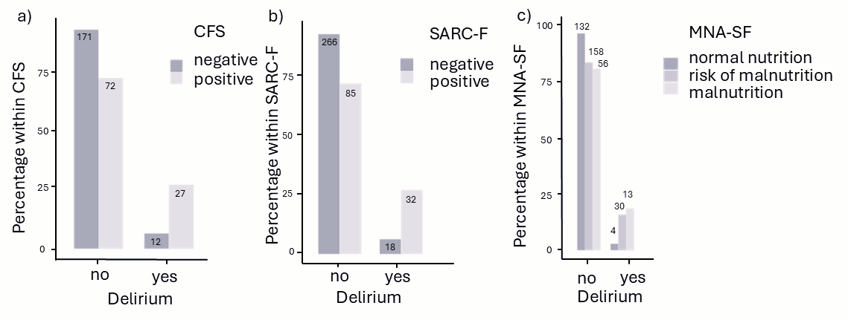
Presentation of delirium rates in patients with a) characteristics indicating frailty in CFS; the association with delirium was 5.34 times higher with an OR of 5.34 [95% CI: 2.57;11.1]; b) sarcopenia, assessed with SARC-F; with an OR of 5.56 [95% CI: 2.97;10.4], the association with delirium was 5.56 times higher; c) impaired nutritional status; With normal nutritional status, the delirium rate was 2.9% (n=4), with the risk of malnutrition at 16% (n=30) and with manifest malnutrition at 18.8% (n=13). A significant correlation was shown with Χ2(2)=16.5, p<0.001, Cramer's V=0.205

Supplementary Table 6: Results of CFS related to the occurrence of delirium in elective and emergency patients.
CFS | elective/  emergency | n | % of total | Delirium | n | %
no frailty | elective | 124 | 46.2% | No | 118 | 95.16%
 |  |  |  | Yes | 6 | 4.84%
 | emergency | 53 | 19.7% | No | 47 | 88.68%
 |  |  |  | Yes | 6 | 11.32%
possible frailty | elective | 31 | 11.6% | No | 26 | 83.87%
 |  |  |  | Yes | 5 | 16.13%
 | emergency | 60 | 22.4% | No | 44 | 73.33%
 |  |  |  | Yes | 16 | 26.67%

Supplementary Table 7: Results of SARC-F related to the occurrence of delirium in elective and emergency patients.
SARC-F | elective/  emergency | n | % of total | Delirium | n | %
no sarcopenia | elective | 209 | 54.3% | No | 199 | 95.21%
 |  |  |  | Yes | 10 | 4.78%
 | emergency | 65 | 16.9% | No | 57 | 87.69%
 |  |  |  | Yes | 8 | 12.31%
possible sarcopenia | elective | 48 | 12.5% | No | 40 | 83.33%
 |  |  |  | Yes | 8 | 16.67%
 | emergency | 63 | 16.4% | No | 45 | 71.48%
 |  |  |  | Yes | 18 | 28.57%

Supplementary Table 8: Results of MNA-SF related to the occurrence of delirium in elective and emergency patients.
MNA-SF | elective/  emergency | n | % of total | Delirium | n | %
normal nutritional status | elective | 102 | 27.0% | No | 100 | 98.04%
 |  |  |  | Yes | 2 | 1.96%
 | emergency | 30 | 7.9% | No | 28 | 93.33%
 |  |  |  | Yes | 2 | 6.67%
risk of malnutrition | elective | 122 | 32.4% | No | 107 | 87.70%
 |  |  |  | Yes | 15 | 12.30%
 | emergency | 61 | 16.2% | No | 47 | 77.05%
 |  |  |  | Yes | 14 | 22.95%
malnutrition | elective | 32 | 8.5% | No | 31 | 96.88%
 |  |  |  | Yes | 1 | 3.12%
 | emergency | 30 | 8.0% | No | 23 | 76.67%
 |  |  |  | Yes | 7 | 23.33%

Supplementary Figure 2: Evaluation of triceps skinfold thickness and grip strength measurements.
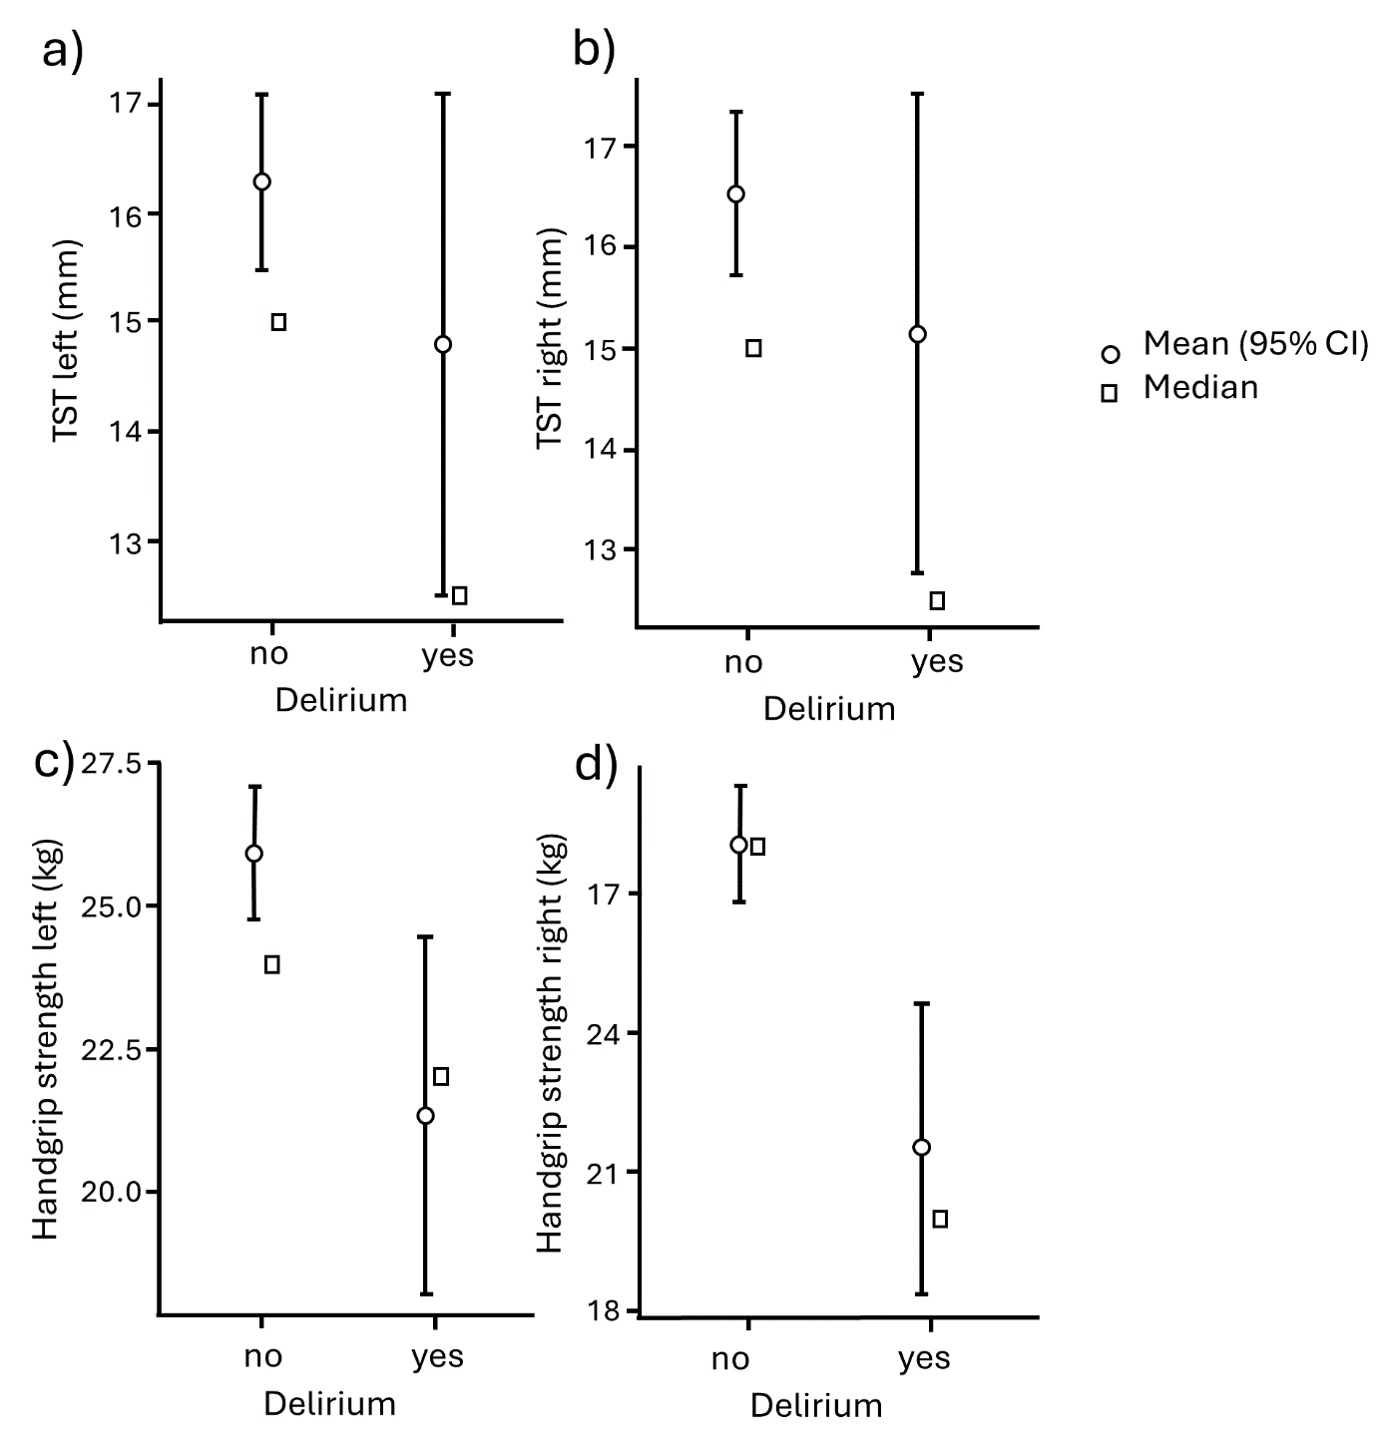
a) Triceps skinfold thickness measurement on the left side. b) Triceps skinfold thickness measurement on the right side. c) Grip strength measurement on the left-hand side, with delirium occurrence. d) Grip strength measurement on the right-hand side, with delirium occurrence.

Supplementary Table 9. Overview Model Coefficients: Models for predictability of the preoperative parameters (CFS, SARC-F, MNA-SF, Grip strength left and right) of delirium. *Note. The cut-off value is set to 0.5.
Model Fit Measures
 |  |  |  |  | Overall Model Test
Model | Deviance | AIC | BIC | R²N | χ² | df | p
1 | 141 | 153 | 174 | 0.187 | 22.80 | 5 | < .001
Model Coefficients – Transplant failure yes/no
 |  |  |  |  |  | 95% Confidence Interval
Predictor | Estimate | SE | Z | p | Odds ratio | Lower | Upper
Intercept | -30.049 | 14.791 | -2.032 | 0.042 | 0.0495 | 0.00273 | 0.900
CFS | 0.4345 | 0.2104 | 2.065 | 0.039 | 15.442 | 102.242 | 2.332
SARC-F | 0.0645 | 0.1042 | 0.618 | 0.536 | 10.666 | 0.86950 | 1.308
MNA-SF | -0.0375 | 0.1008 | -0.372 | 0.710 | 0.9632 | 0.79059 | 1.173
left (kg) | -0.0182 | 0.0516 | -0.353 | 0.724 | 0.9819 | 0.88752 | 1.086
right (kg) | -0.0147 | 0.0527 | -0.280 | 0.780 | 0.9854 | 0.88871 | 1.093
*Note. Estimates represent the log odds of "Delirium = yes" vs. "Delirium = no"

