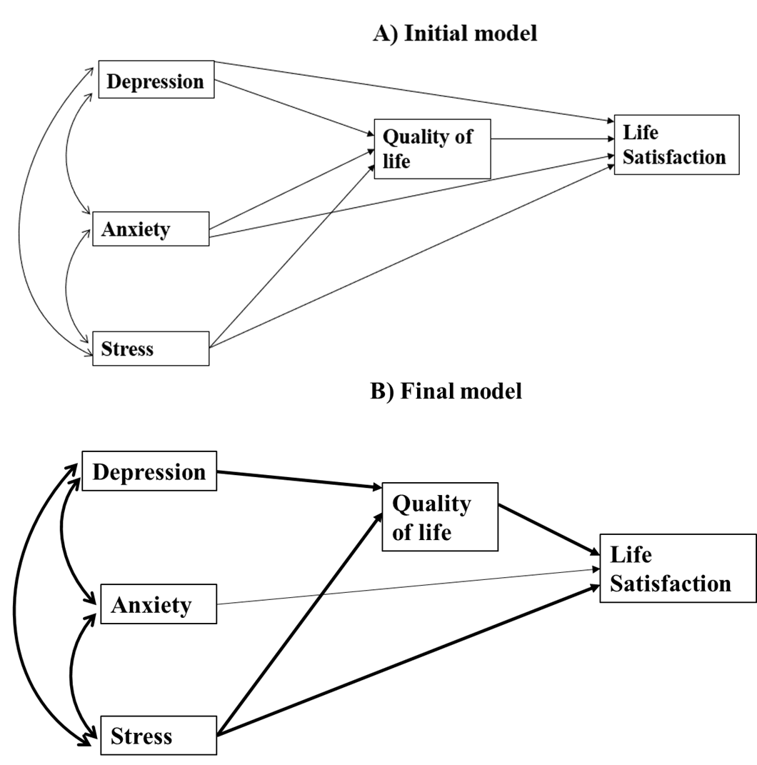

Supplemental Figure 1. Pathways between depression, anxiety, stress, quality of life and life satisfaction. A) initial and B) Final model.
Footnote: Single-headed arrows indicate directional relationships, showing the hypothesized influence of one variable on another. Bold arrows highlight pathways found to be statistically significant in the path analysis. The final model is adjusted for age, ethnicity, marital status, educational status, and family dependency for daily activities.

