eFigure 1 Restricted cubic spline analysis of the association between GNRI and risk of postoperative complications.

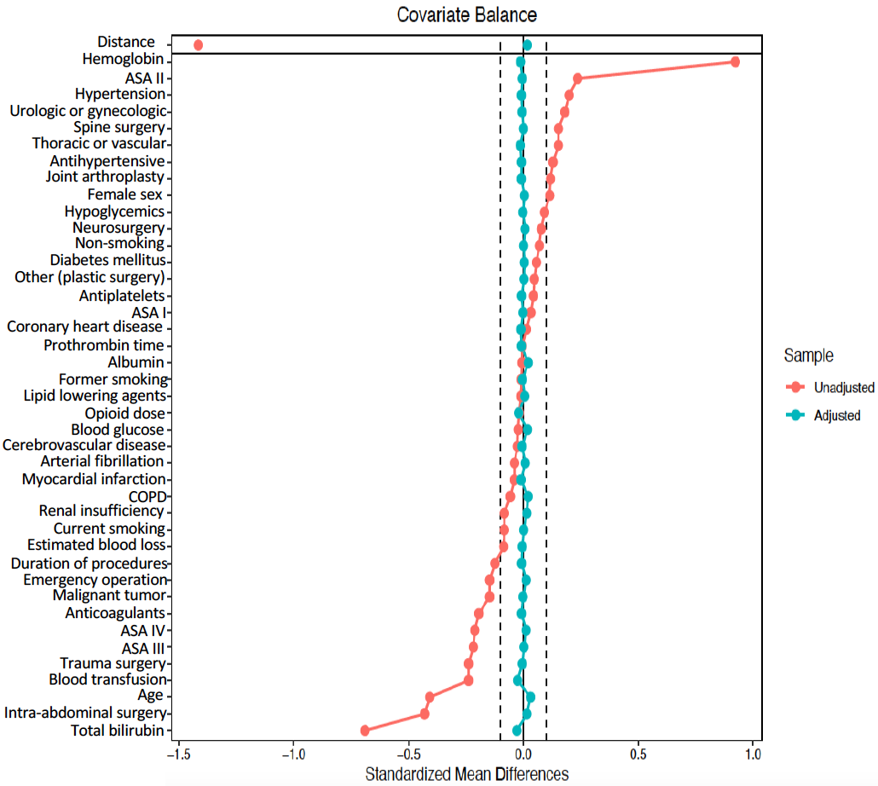
eFigure 2 The result of the love plot for the propensity score matching analysis.

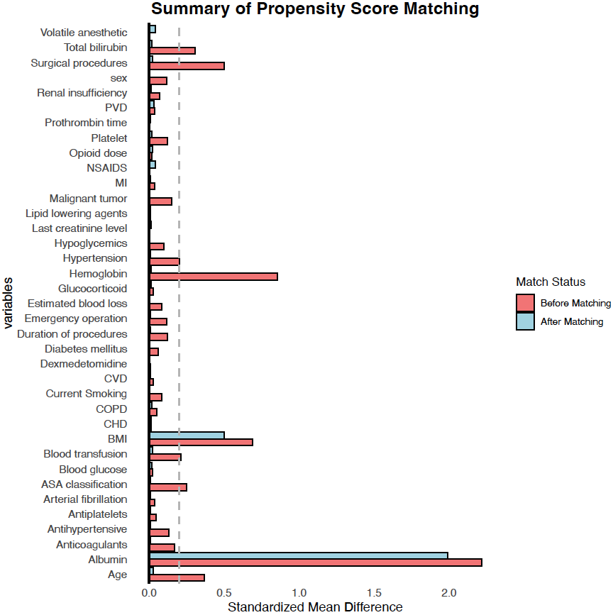
eFigure 3 The result of the summary plot for the propensity score matching analysis.

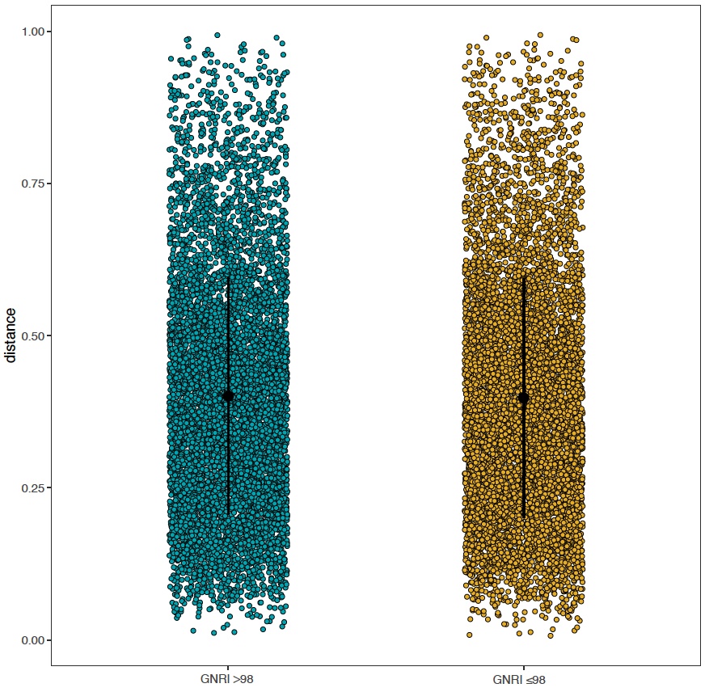
eFigure 4 The result of the jitter plot after the propensity score matching analysis.

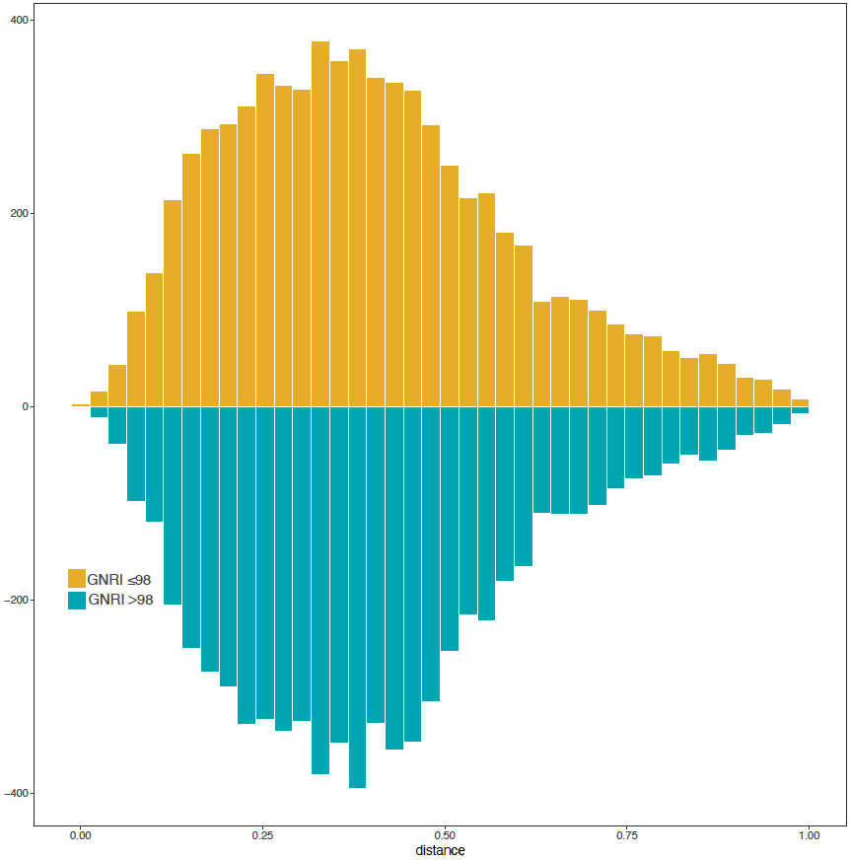
eFigure 5 The result of the histogram plot after the propensity score matching analysis.

eTable 1 Multivariable analysis of factors associated with heart injury
Factor | P-value | OR | CI. 2.5 % | CI. 97.5 %
Age | <0.001 | 1.066 | 1.052 | 1.081
Coronary heart disease | <0.001 | 1.658 | 1.377 | 1.989
Arterial fibrillation | <0.001 | 7.958 | 6.165 | 10.205
myocardial infarction | 0.035 | 1.556 | 1.014 | 2.313
Malignant tumor | <0.001 | 1.57 | 1.279 | 1.935
Antihypertensive | <0.001 | 1.369 | 1.178 | 1.591
Last creatinine level | <0.001 | 1.003 | 1.002 | 1.005
ASA IV | <0.001 | 6.373 | 2.58 | 19.614
Emergency operation | 0.031 | 1.506 | 1.03 | 2.167
Joint arthroplasty | 0.017 | 1.837 | 1.13 | 3.081
Thoracic or vascular | <0.001 | 2.474 | 1.555 | 4.083
Duration of procedures | <0.001 | 1.004 | 1.003 | 1.004
Estimated blood loss | <0.001 | 1 | 1 | 1
GNRI ≤98 | 0.002 | 1.274 | 1.089 | 1.489

eTable 2 Multivariable analysis of factors associated with arrhythmia
Factor | P-value | OR | CI. 2.5 % | CI. 97.5 %
Age | <0.001 | 1.074 | 1.055 | 1.094
Arterial fibrillation | <0.001 | 15.891 | 11.92 | 21.075
Malignant tumor | <0.001 | 1.966 | 1.484 | 2.627
Anticoagulants | 0.023 | 1.401 | 1.043 | 1.862
Last creatinine level | 0.008 | 1.003 | 1 | 1.004
Prothrombin time | 0.032 | 1.024 | 1.002 | 1.046
ASA IV | 0.002 | 10.639 | 3.032 | 67.754
Joint arthroplasty | 0.008 | 3.024 | 1.383 | 7.239
Thoracic or vascular | <0.001 | 4.842 | 2.349 | 11.154
Duration of procedures | <0.001 | 1.003 | 1.002 | 1.004
Volatile anesthetic | 0.024 | 1.807 | 1.115 | 3.121
GNRI ≤98 | 0.015 | 1.305 | 1.053 | 1.618

eTable 3 Multivariable analysis of factors associated with heart failure
Factor | P-value | OR | CI. 2.5 % | CI. 97.5 %
Age | <0.001 | 1.111 | 1.076 | 1.147
Hypertension | 0.004 | 1.789 | 1.206 | 2.684
Diabetes mellitus | <0.001 | 2.216 | 1.494 | 3.267
Arterial fibrillation | <0.001 | 4.622 | 2.382 | 8.329
Myocardial infarction | 0.001 | 3.403 | 1.495 | 6.847
Last creatinine level | 0.008 | 1.003 | 1 | 1.006
Thoracic or vascular | 0.029 | 3.239 | 1.211 | 10.413
Duration of procedures | <0.001 | 1.005 | 1.003 | 1.006
GNRI ≤98 | 0.003 | 1.947 | 1.26 | 3.027

eTable 4 Multivariable analysis of factors associated with myocardial infarction
Factor | P-value | OR | CI. 2.5 % | CI. 97.5 %
Age | <0.001 | 1.08 | 1.04 | 1.12
Hypertension | 0.008 | 1.928 | 1.196 | 3.186
Diabetes mellitus | <0.001 | 2.356 | 1.499 | 3.685
Coronary heart disease | 0.031 | 1.77 | 1.04 | 2.95
Myocardial infarction | <0.001 | 3.89 | 1.735 | 7.943
Antiplatelets | 0.035 | 1.804 | 1.024 | 3.075
Last creatinine level | <0.001 | 1.008 | 1.005 | 1.011
Emergency operation | 0.002 | 3.333 | 1.488 | 6.667
Duration of procedures | <0.001 | 1.004 | 1.002 | 1.006
Estimated blood loss | 0.001 | 1 | 1 | 1.001
Glucocorticoid | 0.01 | 2.647 | 1.343 | 5.966

eTable 5 Multivariable analysis of factors associated with cardiac arrest
Factor | P-value | OR | CI. 2.5 % | CI. 97.5 %
Age | 0.003 | 1.074 | 1.024 | 1.124
Lipid lowering | 0.002 | 3.018 | 1.447 | 5.804
Estimated blood loss | <0.001 | 1 | 1 | 1.001

eTable 6 Multivariable analysis of factors associated with AKI
Factor | P-value | OR | CI. 2.5 % | CI. 97.5 %
Age | <0.001 | 1.043 | 1.031 | 1.055
Hypertension | <0.001 | 1.307 | 1.136 | 1.503
Peripheral vascular disease | 0.03 | 1.255 | 1.019 | 1.535
Renal dysfunction | <0.001 | 2.637 | 1.881 | 3.643
Antihypertensive | 0.003 | 1.234 | 1.072 | 1.421
Blood glucose | <0.001 | 1.051 | 1.021 | 1.08
Last creatinine level | <0.001 | 1.007 | 1.005 | 1.009
Total bilirubin | <0.001 | 1.004 | 1.003 | 1.005
Prothrombin time | <0.001 | 1.034 | 1.016 | 1.052
ASA IV | <0.001 | 5.058 | 2.417 | 11.595
Emergency operation | 0.004 | 1.627 | 1.165 | 2.242
Intra-abdominal surgery | <0.001 | 2.432 | 1.647 | 3.727
Joint arthroplasty | <0.001 | 2.341 | 1.544 | 3.667
Duration of procedures | <0.001 | 1.005 | 1.004 | 1.005
Estimated blood loss | <0.001 | 1 | 1 | 1.001
NSAIDS | <0.001 | 1.836 | 1.537 | 2.208
GNRI ≤98 | 0.01 | 1.194 | 1.043 | 1.367

eTable 7 Multivariable analysis of factors associated with pulmonary infection
Factor | P-value | OR | CI. 2.5 % | CI. 97.5 %
Age | <0.001 | 1.04 | 1.033 | 1.047
Current Smoking | 0.003 | 1.164 | 1.051 | 1.287
Myocardial infarction | 0.003 | 1.459 | 1.132 | 1.868
Cerebrovascular disease | <0.001 | 1.276 | 1.135 | 1.433
Renal dysfunction | 0.035 | 1.351 | 1.017 | 1.778
COPD | 0.015 | 1.301 | 1.048 | 1.604
Malignant tumor | <0.001 | 1.573 | 1.423 | 1.741
Anticoagulants | <0.001 | 1.352 | 1.193 | 1.53
Blood glucose | 0.005 | 1.027 | 1.008 | 1.046
Last creatinine level | 0.003 | 1.002 | 1.001 | 1.003
Platelet | <0.001 | 1.002 | 1.001 | 1.002
ASA IV | <0.001 | 5.084 | 3.311 | 7.904
Emergency operation | <0.001 | 2.889 | 2.345 | 3.552
Intra-abdominal surgery | <0.001 | 2.289 | 1.761 | 3.008
Joint arthroplasty | 0.001 | 1.645 | 1.245 | 2.194
Neurosurgery | <0.001 | 2.074 | 1.546 | 2.807
Thoracic or vascular | <0.001 | 2.738 | 2.084 | 3.635
Duration of procedures | <0.001 | 1.005 | 1.004 | 1.005
Blood transfusion | <0.001 | 1.351 | 1.225 | 1.49
Opioid dose | <0.001 | 1.003 | 1.002 | 1.004
GNRI ≤98 | <0.001 | 1.203 | 1.117 | 1.296

eTable 8 Multivariable analysis of factors associated with surgical site infection
Factor | P-value | OR | CI. 2.5 % | CI. 97.5 %
Blood glucose | 0.001 | 1.052 | 1.021 | 1.081
Platelet | <0.001 | 1.002 | 1.001 | 1.003
ASA IV | 0.012 | 2.793 | 1.315 | 6.593
Emergency operation | <0.001 | 3.461 | 2.594 | 4.578
Intra-abdominal surgery | <0.001 | 6.193 | 3.255 | 13.751
Neurosurgery | 0.002 | 3.255 | 1.617 | 7.495
Thoracic or vascular | 0.008 | 2.739 | 1.377 | 6.256
Other (plastic surgery, etc.) | <0.001 | 3.84 | 1.914 | 8.821
Duration of procedures | <0.001 | 1.005 | 1.004 | 1.005
NSAIDS | <0.001 | 1.357 | 1.149 | 1.61
Opioid dose | <0.001 | 1.003 | 1.002 | 1.004
GNRI ≤98 | <0.001 | 1.323 | 1.149 | 1.523

eTable 9 Multivariable analysis of factors associated with sepsis
Factor | P-value | OR | CI. 2.5 % | CI. 97.5 %
Age | 0.013 | 1.056 | 1.011 | 1.101
Last creatinine level | <0.001 | 1.006 | 1.003 | 1.008
Emergency operation | <0.001 | 4.855 | 2.393 | 9.509
Duration of procedures | <0.001 | 1.005 | 1.003 | 1.007
Opioid dose | 0.005 | 1.006 | 1.002 | 1.011

eTable 10 Multivariable analysis of factors associated with stroke
Factor | P-value | OR | CI. 2.5 % | CI. 97.5 %
Hypertension | 0.009 | 1.568 | 1.121 | 2.215
Coronary heart disease | 0.008 | 1.676 | 1.131 | 2.43
Cerebrovascular disease | <0.001 | 5.367 | 3.785 | 7.573
Peripheral vascular disease | 0.026 | 1.57 | 1.045 | 2.319
Blood glucose | <0.001 | 1.144 | 1.078 | 1.207
Spine surgery | 0.036 | 4.866 | 1.375 | 31.003
Joint arthroplasty | 0.035 | 4.908 | 1.393 | 31.236
Neurosurgery | <0.001 | 13.423 | 4.02 | 83.526
Duration of procedures | 0.035 | 1.002 | 1 | 1.003

eTable 11 Multivariable analysis of factors associated with ICU admission
Factor | P-value | OR | CI. 2.5 % | CI. 97.5 %
Age | <0.001 | 1.075 | 1.066 | 1.085
Women | 0.044 | 1.098 | 1.003 | 1.202
Coronary heart disease | 0.04 | 1.146 | 1.005 | 1.305
Arterial fibrillation | 0.002 | 1.531 | 1.161 | 2.008
Myocardial infarction | 0.008 | 1.495 | 1.109 | 2.004
Cerebrovascular disease | 0.014 | 1.199 | 1.036 | 1.385
Peripheral vascular disease | 0.007 | 1.244 | 1.06 | 1.456
Renal dysfunction | <0.001 | 1.913 | 1.389 | 2.609
COPD | <0.001 | 1.809 | 1.409 | 2.31
Antihypertensive | <0.001 | 1.193 | 1.091 | 1.305
Lipid lowering | 0.041 | 1.199 | 1.006 | 1.425
Anticoagulants | <0.001 | 1.568 | 1.337 | 1.836
Blood glucose | 0.001 | 1.04 | 1.017 | 1.063
Platelet | <0.001 | 1.001 | 1.001 | 1.002
Total bilirubin | 0.001 | 1.001 | 1 | 1.002
Prothrombin time | <0.001 | 1.037 | 1.019 | 1.057
ASA III | 0.005 | 1.914 | 1.238 | 3.046
ASA IV | <0.001 | 17.569 | 9.99 | 31.51
Emergency operation | <0.001 | 4.382 | 3.394 | 5.649
Intra-abdominal surgery | <0.001 | 3.519 | 2.626 | 4.759
Neurosurgery | <0.001 | 96.368 | 69.637 | 134.567
Duration of procedures | <0.001 | 1.005 | 1.005 | 1.006
Estimated blood loss | <0.001 | 1.001 | 1.001 | 1.001
Blood transfusion | 0.002 | 1.228 | 1.076 | 1.4
NSAIDS | <0.001 | 1.238 | 1.112 | 1.38
Glucocorticoid | 0.028 | 1.134 | 1.014 | 1.27
Volatile anesthetic | 0.002 | 1.375 | 1.126 | 1.69
Opioid dose | <0.001 | 1.006 | 1.005 | 1.007
GNRI ≤98 | <0.001 | 1.269 | 1.158 | 1.39

eTable 12 Multivariable analysis of factors associated with ICU length of stay
Factor | P-value | OR | CI. 2.5 % | CI. 97.5 %
Age | <0.001 | 1.018 | 1.011 | 1.025
Women | <0.001 | 1.198 | 1.11 | 1.293
Coronary heart disease | 0.001 | 1.202 | 1.079 | 1.339
Cerebrovascular disease | <0.001 | 1.279 | 1.128 | 1.451
Peripheral vascular disease | 0.001 | 1.228 | 1.082 | 1.392
Renal dysfunction | 0.001 | 1.689 | 1.257 | 2.27
Antihypertensive | 0.026 | 1.084 | 1.01 | 1.165
Anticoagulants | 0.014 | 1.186 | 1.035 | 1.358
Blood glucose | <0.001 | 1.075 | 1.053 | 1.097
Last creatinine level | <0.001 | 1.009 | 1.007 | 1.01
ASA IV | <0.001 | 81.163 | 50.779 | 129.725
Emergency operation | <0.001 | 4.469 | 3.493 | 5.719
Intra-abdominal surgery | 0.004 | 1.392 | 1.11 | 1.744
Neurosurgery | <0.001 | 6.996 | 5.324 | 9.192
Thoracic or vascular | 0.044 | 1.284 | 1.007 | 1.636
Duration of procedures | <0.001 | 1.004 | 1.003 | 1.004
Estimated blood loss | <0.001 | 1 | 1 | 1.001
Blood transfusion | 0.034 | 1.133 | 1.01 | 1.271
GNRI ≤98 | 0.001 | 1.132 | 1.049 | 1.222

eTable 13 Multivariable analysis of factors associated with postoperative LOS
Factor | P-value | OR | CI. 2.5 % | CI. 97.5 %
Age | <0.001 | 1.058 | 1.036 | 1.08
Diabetes mellitus | <0.001 | 1.654 | 1.313 | 2.083
Malignant tumor | <0.001 | 4.006 | 3.061 | 5.241
Anticoagulants | <0.001 | 2.246 | 1.533 | 3.292
Last creatinine level | <0.001 | 1.009 | 1.005 | 1.013
Platelet | <0.001 | 1.003 | 1.001 | 1.004
Total bilirubin | <0.001 | 1.007 | 1.004 | 1.01
ASA IV | <0.001 | 243.923 | 63.65 | 934.766
Emergency operation | <0.001 | 40.821 | 20.084 | 82.971
Spine surgery | 0.004 | 2.84 | 1.395 | 5.784
Intra-abdominal surgery | <0.001 | 12.795 | 6.555 | 24.973
Joint arthroplasty | <0.001 | 4.771 | 2.405 | 9.463
Neurosurgery | <0.001 | 14.089 | 6.387 | 31.078
Thoracic or vascular | <0.001 | 43.942 | 21.608 | 89.36
Other (plastic surgery, etc.) | <0.001 | 26.344 | 12.679 | 54.738
Duration of procedures | <0.001 | 1.026 | 1.024 | 1.027
Estimated blood loss | 0.007 | 1 | 1 | 1.001
Blood transfusion | 0.001 | 1.798 | 1.283 | 2.519
NSAIDS | <0.001 | 2.179 | 1.692 | 2.807
Opioid dose | <0.001 | 1.008 | 1.006 | 1.011
GNRI ≤98 | <0.001 | 1.677 | 1.332 | 2.111

eTable 14 Multivariable analysis of factors associated with 30-day readmission
Factor | P-value | OR | CI. 2.5 % | CI. 97.5 %
Cerebrovascular disease | 0.002 | 1.74 | 1.212 | 2.431
COPD | 0.017 | 2.037 | 1.073 | 3.499
Emergency operation | 0.01 | 2.074 | 1.134 | 3.496
Intra-abdominal surgery | 0.031 | 3.542 | 1.337 | 14.387
Duration of procedures | 0.004 | 1.002 | 1.001 | 1.003

eTable 15 Multivariable analysis of factors associated with 30-day reoperation
Factor | P-value | OR | CI. 2.5 % | CI. 97.5 %
Cerebrovascular disease | 0.011 | 1.71 | 1.104 | 2.542
Duration of procedures | <0.001 | 1.003 | 1.002 | 1.004

