Appendix A: Search terms
Table 1: Search terms for Web of Science
5 | #4 AND #3 AND #2 AND #1 | 1,164
4 | ((TS=(hospital*)) OR TS=(inpatient)) OR TS=(inpatients) | 1,541,632
3 | (((TS=(risk prediction)) OR TS=(risk assessment)) OR TS=(risk score)) OR TS=(prediction model) | 1,339,975
2 | ((TS=(accidental Falls)) OR TS=(falling)) OR TS=(fall) | 309,681
1 | ((((TS=(aged)) OR TS=(senior citizen)) OR TS=(older adults)) OR TS=(senium)) OR TS=(elderly) | 1,204,683

Table 2: Search terms for Pubmed
5 | (((((((aged[MeSH Terms]) OR (senior citizen[Title/Abstract])) OR (older adults[Title/Abstract])) OR (senium[Title/Abstract])) OR (elderly[Title/Abstract])) AND (((inpatients[MeSH Terms]) OR (hospital*[Title/Abstract])) OR (inpatient[Title/Abstract]))) AND (((accidental Falls[MeSH Terms]) OR (falling[Title/Abstract])) OR (fall[Title/Abstract]))) AND ((((risk prediction[Title/Abstract]) OR (risk assessment[Title/Abstract])) OR (risk score[Title/Abstract])) OR (prediction model[Title/Abstract])) | 363
4 | (((risk prediction[Title/Abstract]) OR (risk assessment[Title/Abstract])) OR (risk score[Title/Abstract])) OR (prediction model[Title/Abstract]) | 159,700
3 | ((accidental Falls[MeSH Terms]) OR (falling[Title/Abstract])) OR (fall[Title/Abstract]) | 175,264
2 | ((((aged[MeSH Terms]) OR (senior citizen[Title/Abstract])) OR (older adults[Title/Abstract])) OR (senium[Title/Abstract])) OR (elderly[Title/Abstract]) | 3,585,132
1 | ((inpatients[MeSH Terms]) OR (hospital*[Title/Abstract])) OR (inpatient[Title/Abstract]) | 1,739,366

Table 3: Search terms for Cochrane Library
5 | #1 AND #2 AND #3 AND #4 | 1039
4 | (prediction model):ti,ab,kw OR (risk score):ti,ab,kw OR (risk assessment):ti,ab,kw OR (risk prediction):ti,ab,kw | 192874
3 | (accidental falls):ti,ab,kw OR (fall):ti,ab,kw OR (falling):ti,ab,kw | 25031
2 | (aged):ti,ab,kw OR (elderly):ti,ab,kw OR (senium):ti,ab,kw OR (older adults):ti,ab,kw OR (senior citizen):ti,ab,kw | 891225
1 | (inpatients):ti,ab,kw OR (inpatient):ti,ab,kw OR (hospital*):ti,ab,kw | 248051

Table 4: Search terms for Cumulative Index to Nursing and Allied Health Literature (CINAHL)
S5 | S1 AND S2 AND S3 AND S4 | 564
S4 | SU prediction model OR SU risk score OR SU risk assessment OR SU risk prediction | 162,611
S3 | SU accidental falls OR SU fall OR SU falling | 26,708
S2 | SU aged OR SU elderly OR SU senium OR SU older adults OR SU senior citizen | 958,184
S1 | SU inpatients OR SU hospital* OR SU inpatient | 317601

Table 5: Search terms for MEDLINE
5 | #4 AND #3 AND #2 AND #1 | 2,328
4 | ((TS=(hospital*)) OR TS=(inpatient)) OR TS=(inpatients) | 2,059,831
3 | (((TS=(risk prediction)) OR TS=(risk assessment)) OR TS=(risk score)) OR TS=(prediction model) | 932,540
2 | ((TS=(falling)) OR TS=(fall)) OR TS=(accidental Falls) | 181,783
1 | ((((TS=(senior citizen)) OR TS=(older adults)) OR TS=(senium)) OR TS=(elderly)) OR TS=(aged) | 6,104,351

Table 6: Search terms for Embase
5 | #1 AND #2 AND #3 AND #4 AND [aged]/lim | 2,623
4 | ('prediction model' OR 'risk score' OR 'risk assessment' OR 'risk prediction') AND [embase]/lim | 798,925
3 | ('accidental falls' OR 'fall' OR 'falling') AND [embase]/lim | 215,913
2 | ('aged' OR 'elderly' OR 'senium' OR 'older adults' OR 'senior citizen') AND [embase]/lim | 4,364,864
1 | ('inpatients' OR 'inpatient' OR 'hospital*') AND [embase]/lim | 9,588,152

Appendix B: Risk of bias and applicability assessment of included studies using Prediction model Risk Of Bias Assessment Tool (PROBAST).
Study | Risk of bias |  |  |  |  | Applicability |  |  |  | Overall
Study | Participants | Predictors | Outcome | Analysis |  | Participants | Predictors | Outcome |  | Risk of bias | Applicability
Dormosh 2023 | High | High | High | Low |  | Low | Low | Low |  | High | Low
Adeli 2023 | Low | Low | High | High |  | High | Low | Low |  | High | High
Zhao 2020 | High | High | High | High |  | Low | Low | Low |  | High | Low
Wijesinghe 2020 | High | High | Unclear | High |  | Low | Low | Low |  | High | Low
Kawazoe 2022 | High | High | Low | High |  | Low | Low | Low |  | High | Low
Chu 2022 | High | High | Low | High |  | Low | Low | Low |  | High | Low
Alharbi 2022 | High | High | Low | High |  | High | Low | Low |  | High | High
Peel 2021 | Low | Low | High | High |  | Low | Low | Low |  | High | Low
Vratsistas-Curto 2018 | Low | Low | High | High |  | High | Low | Low |  | High | High
Beauchet 2018 | Low | Low | High | High |  | High | Low | Low |  | High | High
GholamHosseini 2014 | Low | Low | High | High |  | Low | Low | Low |  | High | Low
Neumann 2013 | High | High | High | High |  | Low | Low | Low |  | High | Low
Marschollek 2012 | High | High | High | High |  | Low | Low | Low |  | High | Low

Appendix C: Sensitivity analyses were conducted using a successive elimination approach.
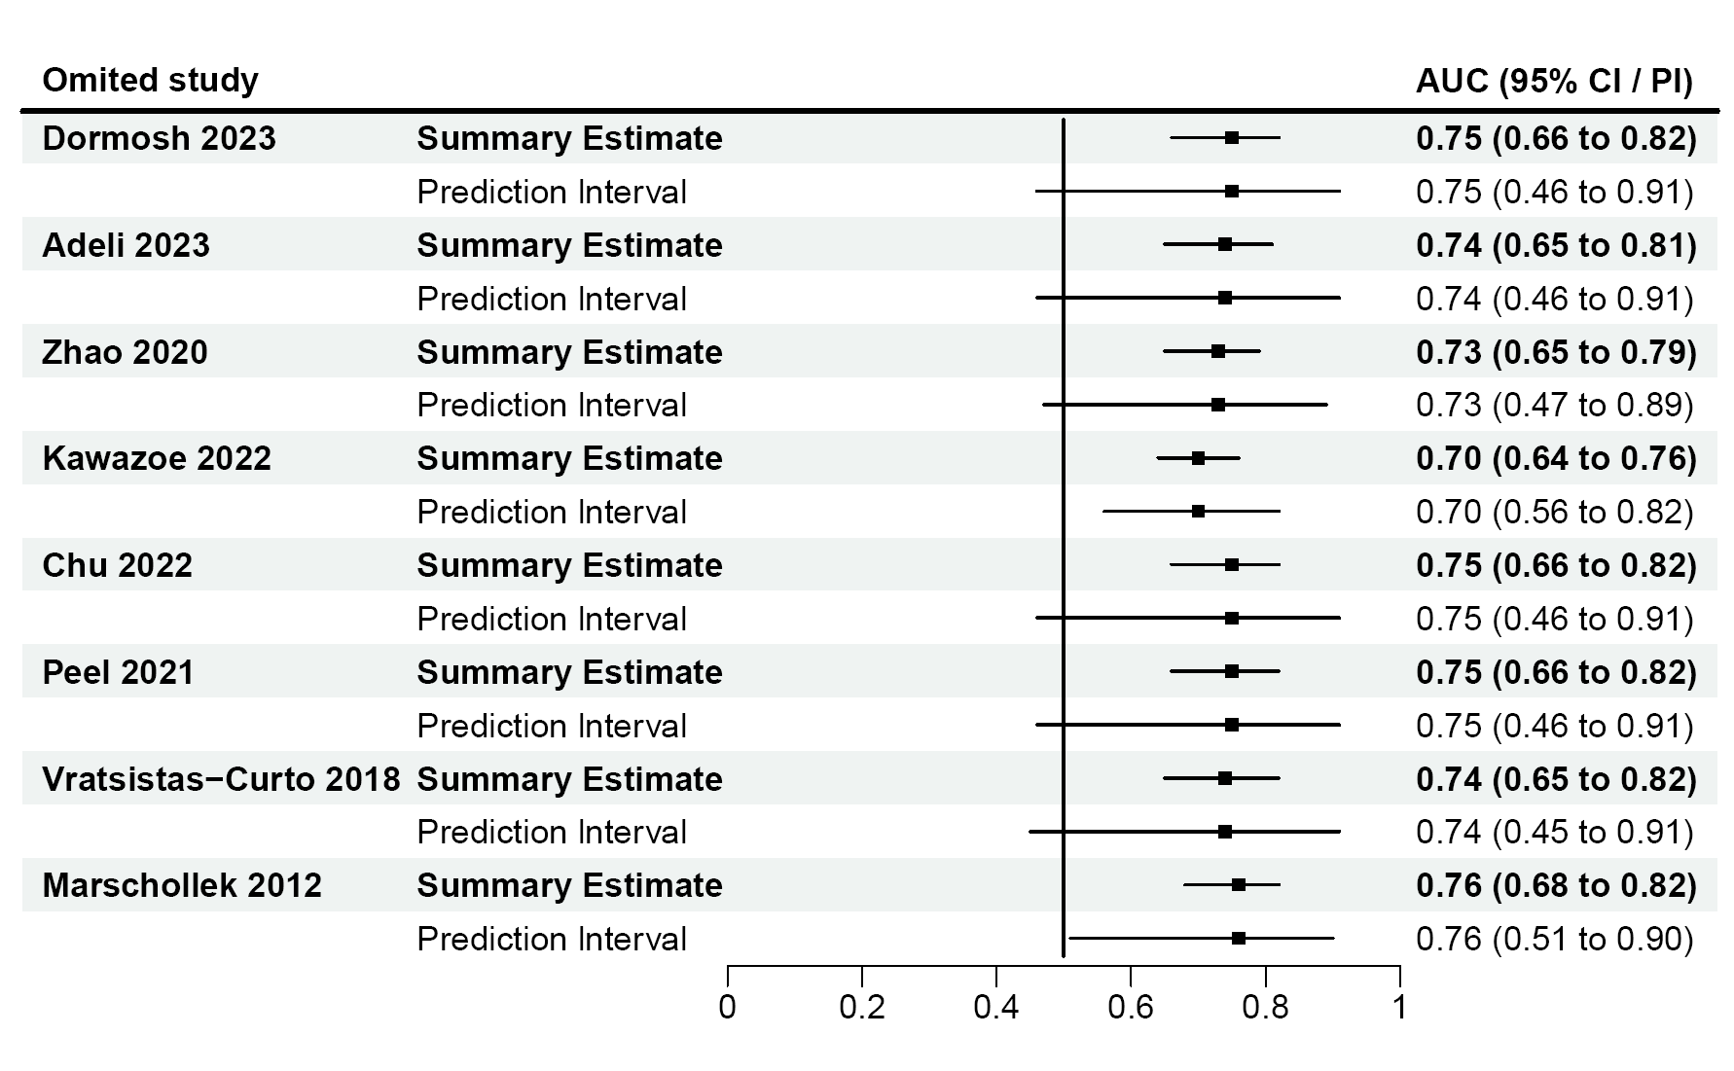
Note :CI: Confidence interval, PI: Prediction interval

Appendix D: Forest plots for subgroup analysis of logistic regression models(a) versus machine learning models(b).
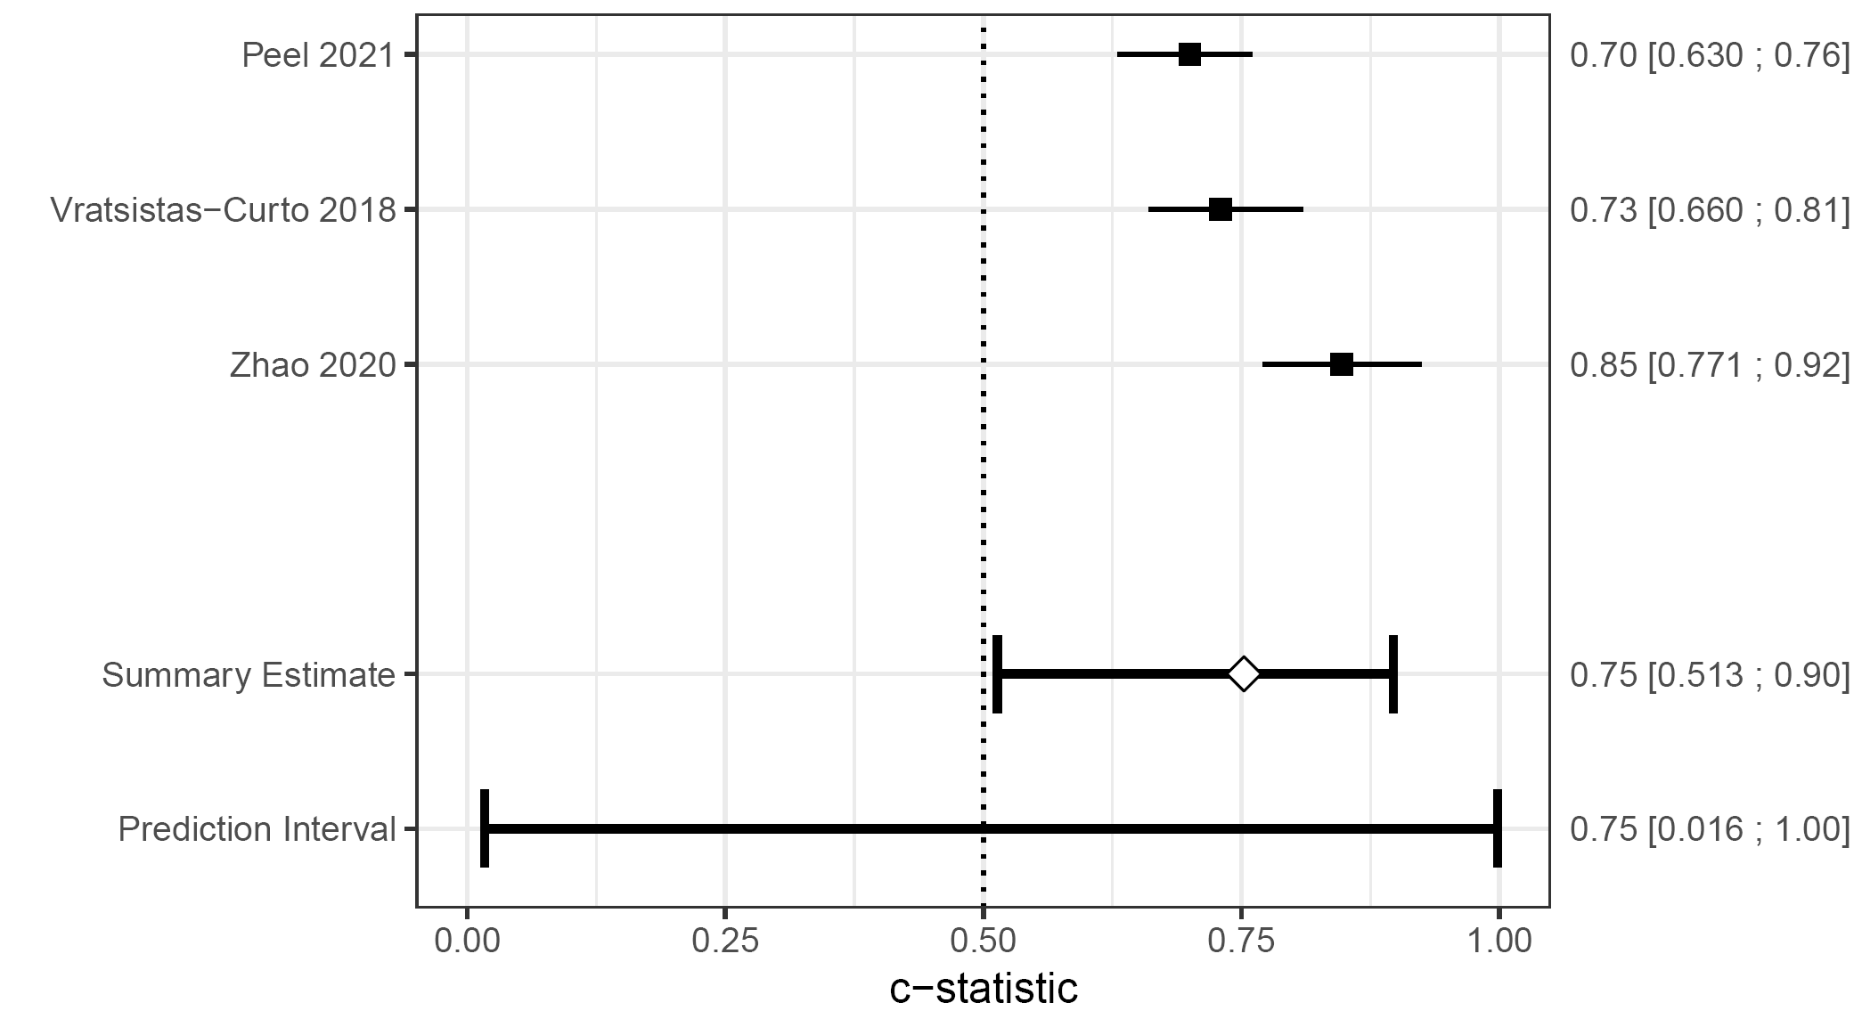
- Logistic regression models:
- Machine learning models:
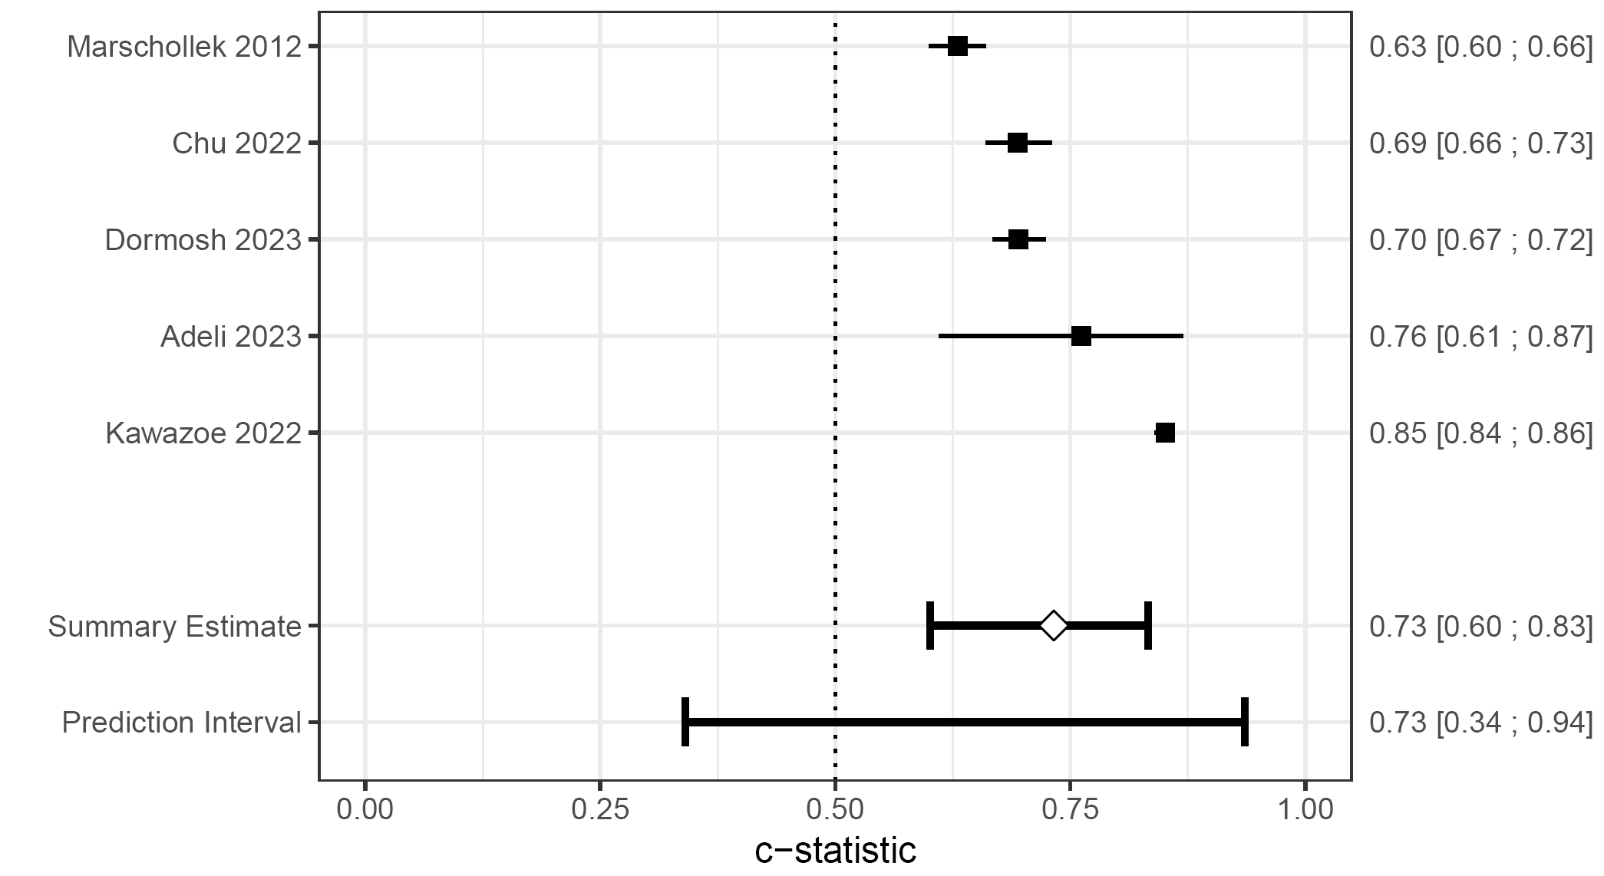

Appendix E: Funnel plot to assess publication bias.
