Supplementary Material
Study population
We developed and validated the prognostic model for one-year all-cause death in a
comprehensive geriatric assessment cohort in the Department of Geriatric, Peking Union Medical College Hospital (PUMCH). All hospitalized patients from January 1, 2018 to December 31, 2019 were potentially recruited in the cohort. The Inclusion and exclusion criteria of the cohort were showed in Supplementary table 1. Among 816 patients in the corhort,486 cases were included in analyze.

Comprehensive Geriatric Assessment
Comprehensive Geriatric Assessment (CGA) involves multidimensional assessment, which includes activities of daily living¹, physical function, cognition², anxiety³, depression⁴, frailty⁵, nutrition⁶, vision, hearing, sleep, constipation, fall, number of drugs and disease burden⁷ (Supplementary Table 2). Activities of daily living was assessed by both in admitted and discharge, other assessments were completed within 48 hours of admission. In order to make the investigators and participants fully understand the assessment, the tables used during all study periods were in Chinese.
Emiel O. Hoogendijk and colleagues have conducted a thorough discussion on the significance of the frailty concept in clinical practice, potential targets for preventing frailty, and promising future research directions⁸. Fried Frailty Phenotype (FP) and Frailty Index (FI) are the most frequently utilized tools in the review ⁹. The Fried Frailty Phenotype was proposed by Dr. Linda P. Fried and has a strong biological theoretical foundation ¹⁰. However, given that the focus of this paper is on the construction of a prediction model, we paid special attention to the practicality and convenience of the frailty assessment tool when selecting it. One of our team's earlier discoveries had reported that all three scales showed clinical utility but FRAIL may be best in practice because it is simple¹¹.Therefore, we adopted the FRAIL scale⁵. The FRAIL scale is a self-reported assessment tool that, compared to the FP, not only covers the assessment of physical frailty but also incorporates disease factors ⁵. The FRAIL scale has been clinically validated to distinguish between frail, prefrail, and non-frail elderly individuals¹², and meta-analysis has demonstrated its ability to predict mortality risk in community-dwelling populations ¹³.

Summary of candidate variables
Clinical data from baseline evaluation included 50 variables. Each variable was measured by geriatrics to determine the stability and predictive value. Literature review was also performed to identify variables with sufficient evidence as predictors in the model. In the end, 18 potential candidate variables were considered for inclusion in the prediction model, drawing upon existing literature as a basis for selection¹⁴⁻¹⁹ (Supplementary Table 3). Age, sex, length of stay (LOS), body mass index (BMI), weight loss, high-sensitive C-reactive protein (hsCRP), fall, frailty and Charlson Comorbidity Index (CCI) were included based on clinical judgement by geriatric experts. Activity of daily living (ADL), creatinine and albumin were included based on a prognostic index for 1 year mortality of older adults after hospital discharge. Short Physical Performance Battery (SPPB), depression, cognition, nutrition, impaired vision, and impaired hearing were included based on the Integrated Care for Older People raised by World Health Organization.

Continuous variable transformation
To improve model fit, all continuous predictors were first tested for normality and transformed appropriately if the association between a continuous predictor and the outcome was not linear²⁰. BMI was included as a continuous variable using restricted cubic splines with four knots ²¹. Due to the curvilinear relationship between the BMI and the endpoint (death), BMI was converted into categorical predictors (Supplementary Figure 1).

Missing data
Among 18 potential candidate variables, no predictors had a missing value of more than 20% (supplementary Figure 2A). Missing data were explored for patterns of missingness and were considered to be missing at random (supplementary Figure 2B).

Predictor Variables selection
Variable selection using the least absolute shrinkage and selection operator
(LASSO) time-to-event Cox regression model. LASSO model coefficient profiles of the 18 candidate variables. The Cox regression coefficients are estimated given a bound (“L1 norm”) to the sum of absolute standardized regression coefficients. The L1 norm regularization term typically shrinks many regression coefficients to zero (Figure 3A). Tuning parameter selection by cross-validation in the LASSO model. The solid vertical lines represent the partial likelihood deviance standard error (SE). The red dotted line indicates the cross-validation curve. The vertical dashed lines are drawn at the optimal values on the basis of the minimum criteria and 1-SE criteria. A λ value of 0.05 was chosen according to cross-validation. 5 variables were selected using LASSO regression to improve model accuracy and reduce model overfitting (Figure 3B).

Model performance
We used the decision curve analysis to assess the clinical applicability of the model in indicating death compared with the methods of universal screening death (an all-screening strategy) or no screening death (a none-screening strategy). If the model has a positive net benefit at the preferred risk thresholds, this indicates that applying the model at this risk threshold provides a better ratio of benefits to harm. The Net benefit of using the prediction model compared with screening patients assuming all of them would die was obvious (supplementary Table 4).

Supplementary tables
Supplementary Table1. Inclusion and exclusion criteria for the cohort of hospitalized patients
Inclusion criteria | exclusion criteria
Age greater than or equal to 65 years old | Death in the hospital
Length of hospital stay greater than 48 hours | Transferred to other departments during the hospital stay
 | Repeated hospitalizations

Supplementary Table 2. The contents, tools used and the interpretation of comprehensive geriatric assessment.
Item | Tools used | interpretation of the results
Activity of daily living | Barthel index | 0-100 score.  The higher the score, the more independent.
Physical function | Grip strength | Use a standard grip gauge to take 2 measurements, with the maximum reading added to the file.  The higher the number, the greater the grip strength(kg)
 | Walking speed in 6 meters | Walk 6 meters at daily walking pace, calculate speed (m/s)
 | Timed up-and-go test | Get up from the chair and walk three meters, Calculate the time to complete(s).  A quick measure of balance and mobility, the less time it takes to finish, the better.
 | Five Times Sit-to-Stand Test | Get up from the chair and sit down five times, counting the time it takes to complete(s),the shorter the better.
 | Short Physical Performance Battery | 0-12score.  Balance, walk speed, 5 sit-ups were comprehensive assessment, the higher the score, the better.
Cognition | Mini-Mental State Examination | 0-30 score.  The higher the score, the better.
Anxiety | Zung Self-Rating Anxiety Scale | The total score is calculated and multiplied by 1.25.  A score above 50 is considered anxiety.
Depression | Zung Self-Rating Depression Scale | The total score is calculated and multiplied by 1.25.  A score above 50 is considered depressed.
Frailty | FRAIL scale | 0-5 score.  Self-rating scale, the lower the score, the lower the frailty.
Nutrition | Mini-Nutritional Assessment-Short Form | 0-14 score.  The higher the score, the better.
Vision | Self-assessment | Visual impairment is defined as decreased vision that affects life.
Hearing | Self-assessment | Hearing impairment is defined as decreased hearing that affects life.
Sleep disturbance | Self-assessment | Poor sleep affects daily life or taking anti-insomnia medication.
Constipation | Self-assessment | At least 5 urinary or fecal  incontinences in the past 1 year.
Fall | Self-assessment | High risk of falls is defined as at least 1 falls in the past year.
Number of drugs | The number of all medications, including health supplements | The number of drugs≥5 is defined as polypharmacy.
Disease burden | Charlson Comorbidity Index | The higher the assessed value, the greater the disease burden.

Supplementary Table3.Definition and coding of the potential candidate predictors
Candidate predictors | Definition | Coding
Age | Age at admitted(year)
Sex | As stated | Binary (male=0, female=1)
LOS | Days of hospital stay（day）
BMI | Weight divided by height squared at admitted (kg/m2 ) | Binary (BMI＞20:0, BMI≤20:1)
Weight loss | Weight loss within 1 year at admitted (kg)
HsCRP-log | The log of serum high-sensitivity C-reactive protein at admitted(mg/L)
Fall | History of falls within the last year at admitted | Binary (no=0, yes=1)
FRAIL | Frailty assessed by FRAIL scale at admitted (point)
CCI | The burden of disease evaluated by Charlson comorbidity index at admitted
ADL-discharge | Barthel index when leaving the hospital(point)
CR | Serum creatinine level at admitted
ALB | Serum albumin level at admitted(g/L)
SPPB | Short Physical Performance Battery score at admitted (point)
Depression | Depression assessed by Zung Self-Rating Depression Scale at admitted (point) | Binary (SDS＜50:0,  SDS≥50:1)
MMSE | Cognition assessed by Mini Mental State Examination at admitted (point)
MNA-SF | Nutrition evaluated by Mini-Nutritional Assessment-Short Form at admitted (point)
Impaired vision | Self-reported vision loss at admitted | Binary (no=0, yes=1)
Impaired hearing | Self-reported hearing loss at admitted | Binary (no=0, yes=1)

Supplementary figures

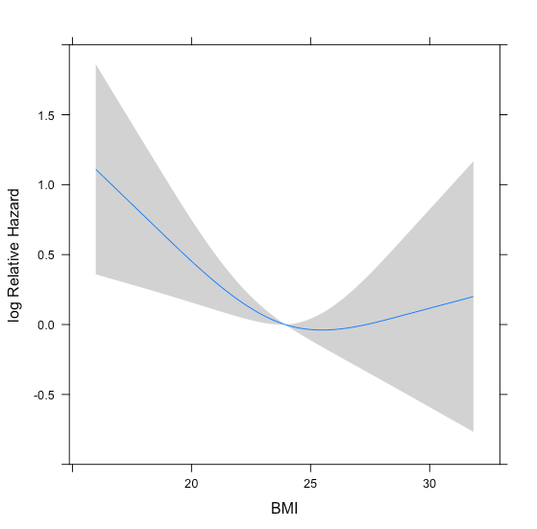
Supplementary Figure 1. Restricted cubic spline of the association between BMI and death.

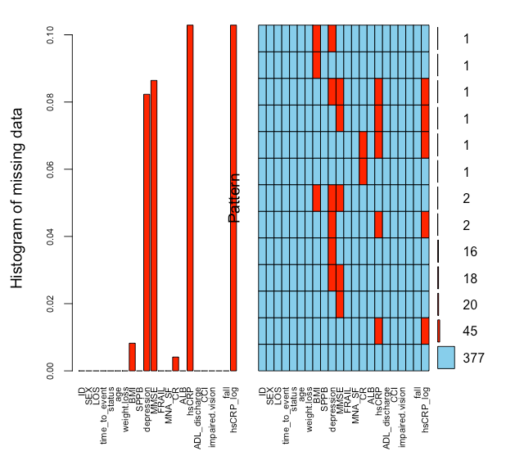
Supplementary Figure 2A. The missing data of all the potential candidate variables
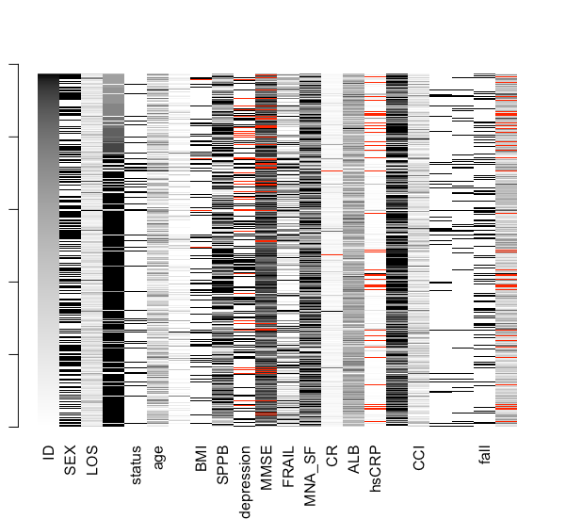
Supplementary Figure 2B. The missingness pattern of missing data of all the potential candidate variables.
Supplementary Figure 3A. LASSO model coefficient profiles of the 18 candidate variables.
Supplementary Figure 3B. Tuning parameter selection by cross-validation in the LASSO model.
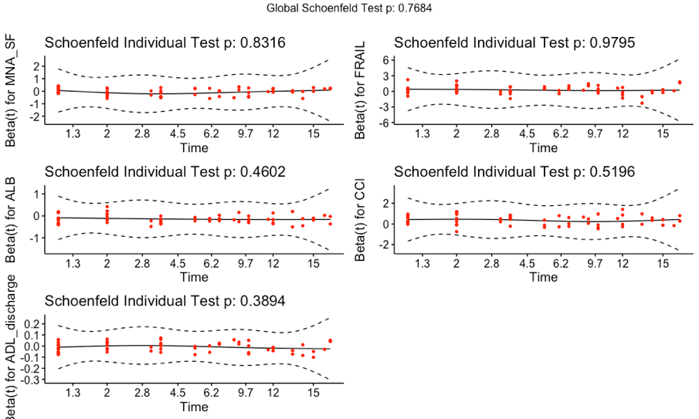
Supplementary Figure 4. Cox proportional hazards assumption for each covariate

Supplementary Figure 5A. The C-index at 1 year of the imputed dataset and the complete dataset

Figure 5B. The calibration plot between the predicted risk and the observed risk both in the imputed dataset and the complete dataset.

Figure 6.The decision curve analysis of the prediction model compared with the methods of universal screening patients or no screening patients in the imputed dataset and the complete dataset.
Reference
1. Mahoney FI, Barthel DW. FUNCTIONAL EVALUATION: THE BARTHEL INDEX. Md State Med J 1965; 14: 61-5.
2. Li H, Jia J, Yang Z. Mini-Mental State Examination in Elderly Chinese: A Population-Based Normative Study. Journal of Alzheimer's disease : JAD 2016; 53(2): 487-96.
3. Zung WW. A rating instrument for anxiety disorders. Psychosomatics 1971; 12(6): 371-9.
4. Zung WW. A SELF-RATING DEPRESSION SCALE. Arch Gen Psychiatry 1965; 12: 63-70.
5. Abellan van Kan G, Rolland YM, Morley JE, Vellas B. Frailty: toward a clinical definition. J Am Med Dir Assoc 2008; 9(2): 71-2.
6. Rubenstein LZ, Harker JO, Salva A, Guigoz Y, Vellas B. Screening for undernutrition in geriatric practice: developing the short-form mini-nutritional assessment (MNA-SF). J Gerontol A Biol Sci Med Sci 2001; 56(6): M366-72.
7. Charlson ME, Pompei P, Ales KL, MacKenzie CR. A new method of classifying prognostic comorbidity in longitudinal studies: development and validation. Journal of chronic diseases 1987; 40(5): 373-83.
8. Hoogendijk EO, Afilalo J, Ensrud KE, Kowal P, Onder G, Fried LP. Frailty: implications for clinical practice and public health. Lancet 2019; 394(10206): 1365-75.
9. Buta BJ, Walston JD, Godino JG, et al. Frailty assessment instruments: Systematic characterization of the uses and contexts of highly-cited instruments. Ageing Res Rev 2016; 26: 53-61.
10. Fried LP, Tangen CM, Walston J, et al. Frailty in older adults: evidence for a phenotype. J Gerontol A Biol Sci Med Sci 2001; 56(3): M146-56.
11. Li JJ, Jiang S, Zhu ML, Liu XH, Sun XH, Zhao SQ. Comparison of Three Frailty Scales for Prediction of Adverse Outcomes among Older Adults: A Prospective Cohort Study. J Nutr Health Aging 2021; 25(4): 419-24.
12. Aznar-Tortonda V, Palazón-Bru A, Gil-Guillén VF. Using the FRAIL scale to compare pre-existing demographic lifestyle and medical risk factors between non-frail, pre-frail and frail older adults accessing primary health care: a cross-sectional study. PeerJ 2020; 8: e10380.
13. Kojima G. Frailty Defined by FRAIL Scale as a Predictor of Mortality: A Systematic Review and Meta-analysis. J Am Med Dir Assoc 2018; 19(6): 480-3.
14. Pilotto A, Ferrucci L, Franceschi M, et al. Development and validation of a multidimensional prognostic index for one-year mortality from comprehensive geriatric assessment in hospitalized older patients. Rejuvenation Res 2008; 11(1): 151-61.
15. Walter LC, Brand RJ, Counsell SR, et al. Development and validation of a prognostic index for 1-year mortality in older adults after hospitalization. Jama 2001; 285(23): 2987-94.
16. Sullivan DH, Roberson PK, Johnson LE, Mendiratta P, Bopp MM, Bishara O. Association between inflammation-associated cytokines, serum albumins, and mortality in the elderly. J Am Med Dir Assoc 2007; 8(7): 458-63.
17. Aubert CE, Rodondi N, Terman SW, et al. HOSPITAL Score and LACE Index to Predict Mortality in Multimorbid Older Patients. Drugs Aging 2022; 39(3): 223-34.
18. Maeda K, Ishida Y, Nonogaki T, Mori N. Reference body mass index values and the prevalence of malnutrition according to the Global Leadership Initiative on Malnutrition criteria. Clin Nutr 2020; 39(1): 180-4.
19. Stajkovic S, Aitken EM, Holroyd-Leduc J. Unintentional weight loss in older adults. Cmaj 2011; 183(4): 443-9.
20. Steyerberg EW, Uno H, Ioannidis JPA, et al. Poor performance of clinical prediction models: the harm of commonly applied methods. Journal of Clinical Epidemiology 2018; 98: 133-43.
21. Harrell FE J, Lee KL, Pollock BG. Regression models in clinical studies: determining relationships between predictors and response. J Natl Cancer Inst 1988; 80: 1198-202.

