Additional files

Contents
1 IC measurement criteria
2 Evaluation Criteria for Covariates
3 Trajectories of intrinsic capacity in Chinese older adults
4 IC score among three IC trajectory groups
5 Participants characteristics among three IC trajectory groups
6 CVD events in IC trajectory groups
7 Sensitivity analysis

1 IC measurement criteria
Intrinsic Capacity (IC) was assessed across five domains according to the approach proposed by Susana López-Ortiz et al., which include Locomotion, Sensory, Vitality, Psychological, and Cognitive. We utilized relevant items from the China Health and Retirement Longitudinal Study (CHARLS) database, with criteria detailed in Table S1.
Table S1 Description of the domains, subdomains and indicators for the operationalization of intrinsic capacity with CHARLS
Domains | Measurements | Tests | Criteria
Cognition | Mini-Mental State Examination, MMSE (1) | Cognition orientation | If total score was  0-9, moderate to severe cognitive impairment = 0  10-26, mild to moderate cognitive impairment = 1  27-30, normal cognitive function = 2
Cognition | Mini-Mental State Examination, MMSE (1) | Serial 7’s test
Cognition | Mini-Mental State Examination, MMSE (1) | Drawing picture
Cognition | Mini-Mental State Examination, MMSE (1) | Recall (immediate word recall + delayed word recall)
Psychological | Center for Epidemiological Studies Depression Scale-10 , CESD10 (2, 3) | 10 items of core symptoms of depression with following options  A. Rarely or none of the time (<1 day) = 0  B. Some or a little of the time (1-2 days) = 1  C. Occasionally or a moderate amount of the time (3-4 days) = 2  D. Most or all of the time (5-7 days) = 3  Items 5 and 8 were reverse coded. Total score: 0-30 | If total score was  >=20, depressive disorder group = 0  10-19, depressive symptom group =1  <10, normal psychological status/non-depressive symptom = 2
Sensory | Vision | Near and distance vision, self-reported with Likert 5-scale  Near /distance vision: excellent/very good/ good = 0.5; fair = 0.25; poor = 0  Total score: Near vision + distance vision, 0-1  0, total or severe loss/alteration of vision = 0  0.25-0.75, moderate loss/alteration of vision = 0.5  1, normal or mild loss/alteration of vision = 1 | Total sensory score = Vision + hearing, 0-2  If total score was  0, total or severe loss/alteration of sensory = 0  0.5-1.5, moderate loss/alteration of sensory = 1  1, normal or mild loss/alteration of sensory = 2
Sensory | Hearing | Hearing problem, self-reported with Likert 5-scale  Hearing: excellent/very good/ good = 1; fair = 0.5; poor = 0
Vitality | Respiratory function (4) | Peak breathing flow (average value of twice)  Male: 350L/min，if<=350=0；>350=1  Female: 220L/min, if<=220=0；>220=1 | Total sensory score = Respiratory function + Hand Grip strength, 0-2  If total score was  0, malnutrition  1, risk of malnutrition  2, normal nutritional status
Vitality | Hand Grip strength (5) | Dominant hand strength (average value of twice)  Male: 36Kg，if <36=0；>=36=1  Female: 23Kg，if <23=0；>=23=1
Locomotion | Short Physical Performance Battery, SPPB (6, 7) | Chair stand test (five times repeated test)  Unable to complete or completes stands in >60 sec = 0  If chair stand time is 16.70 sec or more =1  If chair stand time is 13.70 to 16.69 sec = 2  If chair stand time is 11.20 to 13.69 sec = 3  If chair stand time is 11.19 sec or less = 4 | Total locomotion score = chair stand test + walking speed test + balance test, 0-12  If total score was  0-2, sarcopenia and cachexia = 0  3-9 possible sarcopenia = 1  10-12 robustness = 2
Locomotion | Short Physical Performance Battery, SPPB (6, 7) | Walking speed test (2.5 meters)  If time is more than 5.43 sec = 1  If time is 3.88 to 5.43 sec = 2  If time is 3.01 to 3.87 sec = 3  If time is less than 3.01 sec = 4
Locomotion | Short Physical Performance Battery, SPPB (6, 7) | Balance test (Side-by-side + Semi-Tandem + Tandem stand)  Side-by-side-stand/ Semi-Tandem Stand  If Held for 10 sec = 1  Not held for 10 sec / Not attempted = 0  Tandem Stand  Held for 10 sec =2  Held for 3 to 9.99 sec = 1  Held for < than 3 sec / Not attempted = 0  Total balance test score = Side-by-side + Semi-Tandem + Tandem stand, 0-4
Total IC score level: 9-10 points=high and stable capacity, 5-8 points = declining capacity, 0-4 points = significant loss of capacity

2 Evaluation Criteria for Covariates
Table S2 Description of the evaluation covariates criteria in CHARLS
Variables | Item | Criteria
Current smoking | The respondent self-reported current smoking habit | Yes, still smoking  No, never smoking or quit smoking
Current drinking | The respondent self-reported had an alcoholic beverage in the last 12 months | Yes  No
Social activities participation | The respondent self-reported participated in any social activities in the past month.  Social activities list include:  1. Interacted with friends  2. Played Ma-jong, played chess, played cards, or went to community club  3. Went to a sport, social, or other kind of club  4. Took part in a community-related organization  5. Done voluntary or charity work  6. Attended an educational or training course | Yes, at least one  No
Hypertension | Had a diagnosed with Hypertension by a doctor | Yes  No
Diabetes | Had a diagnosed with Diabetes by a doctor, or having high blood sugar | Yes  No
Dyslipidemia | Had a diagnosed with Dyslipidemia by a doctor | Yes  No

3 Trajectories of intrinsic capacity in Chinese older adults
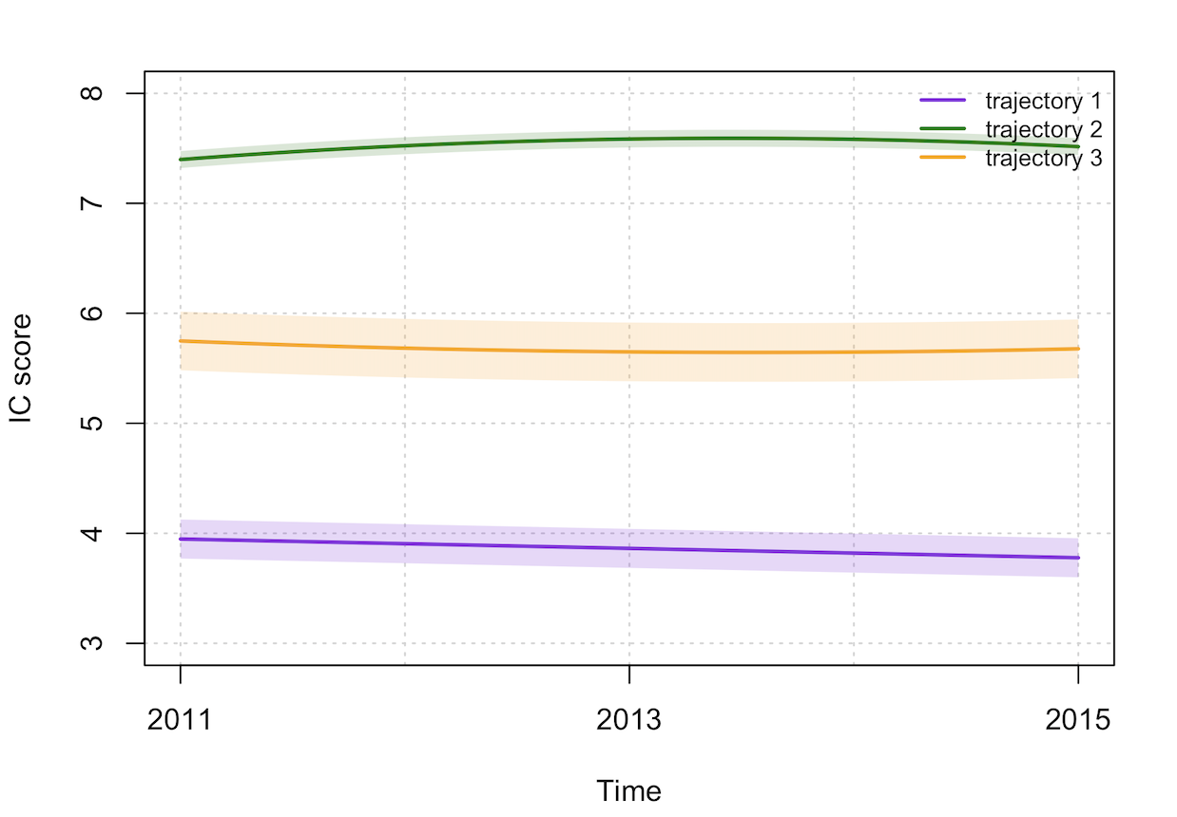
Fig S1 Trajectories of intrinsic capacity in Chinese older adults
(Note: Trajectory 1, Low IC with Slow Decline; Trajectory 2, High IC with Subsequent Decline; Trajectory 3, Moderate IC with Subsequent Increase

4 IC score among three IC trajectory groups
Table S3 IC score among three IC trajectory groups
 | Low IC with Slow Decline group | Moderate IC with Subsequent Increase group | High IC with Subsequent Decline group
2011y
Total IC (0-10) | 3.77±1.24 | 5.76±1.34 | 7.48±0.86
Locomotion (0-2) | 0.87±0.52 | 1.18±0.58 | 1.54±0.49
Sensory (0-2) | 1.03±0.56 | 1.32±0.53 | 1.57±0.50
Vitality (0-2) | 0.37±0.57 | 0.86±0.75 | 1.54±0.62
Psychology (0-2) | 1.15±0.69 | 1.64±0.54 | 1.89±0.31
Cognition (0-2) | 0.35±0.48 | 0.76±0.43 | 0.94±0.25
2013y
Total IC | 3.68±1.15 | 5.67±1.31 | 7.72±0.76
Locomotion (0-2) | 0.75±0.57 | 1.15±0.69 | 1.77±0.42
Sensory (0-2) | 0.99±0.53 | 1.29±0.50 | 1.53±0.51
Vitality (0-2) | 0.28±0.54 | 0.73±0.76 | 1.54±0.58
Psychology (0-2) | 1.33±0.66 | 1.75±0.47 | 1.93±0.25
Cognition (0-2) | 0.33±0.47 | 0.75±0.43 | 0.95±0.24
2015y
Total IC | 3.59±1.19 | 5.69±1.29 | 7.64±0.78
Locomotion (0-2) | 0.93±0.62 | 1.36±0.66 | 1.86±0.35
Sensory (0-2) | 0.94±0.49 | 1.22±0.49 | 1.42±0.50
Vitality (0-2) | 0.28±0.52 | 0.74±0.73 | 1.49±0.59
Psychology (0-2) | 1.17±0.71 | 1.69±0.53 | 1.94±0.24
Cognition (0-2) | 0.26±0.44 | 0.68±0.47 | 0.92±0.28

5 Participants characteristics among three IC trajectory groups
Table S4 Participants characteristics among three IC trajectory groups [n(%)]
Variables | n(%) | Traj 1 | Traj 2 | Traj 3 | P
Gender |  |  |  |  | <0.001
Male | 1 649 (49.4) | 357 (38.8) | 209 (56.5) | 1 083 (53.0)
Female | 1 687 (50.6) | 564 (61.2) | 161 (43.5) | 962 (47.0)
Age at baseline (years old) |  |  |  |  | <0.001
60-69 | 2 426 (72.7) | 515 (55.9) | 336 (90.8) | 1 575 (77.0)
70-79 | 834 (25.0) | 360 (39.1) | 32 (8.7) | 442 (21.6)
≥80 | 76 (2.3) | 46 (5.0) | 2 (0.5) | 28 (1.4)
Residence |  |  |  |  | <0.001
Rural | 2 249 (67.4) | 685 (74.4) | 223 (60.3) | 1 341 (65.6)
Urban | 1 087 (32.6) | 236 (25.6) | 147 (39.7) | 704 (34.4)
Education level |  |  |  |  | <0.001
Less than lower secondary | 3 168 (95.0) | 906 (98.4) | 338 (91.4) | 1 924 (94.1)
Upper secondary or vocational training | 132 (4.0) | 14 (1.5) | 24 (6.5) | 94 (4.6)
Tertiary | 36 (1.0) | 1 (0.1) | 8 (2.1) | 27 (1.3)
Marital status |  |  |  |  | <0.001
Married | 2 619 (78.5) | 658 (71.4) | 328 (88.6) | 1 633 (79.9)
Divorced/Widowed/Never Married | 717 (21.5) | 263 (28.6) | 42 (11.4) | 412 (20.1)
Working status |  |  |  |  | <0.001
Employed | 1 888 (56.6) | 454 (49.3) | 226 (61.1) | 1 208 (59.0)
Retired or unemployed | 1 395 (41.8) | 440 (47.8) | 142 (38.4) | 813 (39.8)
Missing | 53 (1.6) | 27 (2.9) | 2 (0.5) | 24 (1.2)
Current drinking |  |  |  |  | <0.001
Yes | 1 049 (31.4) | 238 (25.8) | 140 (37.8) | 671 (32.8)
No | 2 287 (68.6) | 683 (74.2) | 230 (62.2) | 1 374 (67.2)
Current smoking |  |  |  |  | 0.024
Yes | 1 056 (31.7) | 259 (28.1) | 119 (32.2) | 678 (33.2)
No | 2 280 (68.3) | 662 (71.9) | 251 (67.8) | 1 367 (66.8)
Social activities |  |  |  |  | <0.001
Yes | 1 502 (45.0) | 334 (36.3) | 193 (52.2) | 975 (47.7)
No | 1 834 (55.0) | 587 (63.7) | 177 (47.8) | 1 070 (52.3)
BMI categories |  |  |  |  | <0.001
Underweight | 313 (9.4) | 131 (14.2) | 14 (3.8) | 168 (8.2)
Normal weight | 1 358 (40.7) | 378 (41.0) | 136 (36.8) | 844 (41.3)
Overweight | 575 (17.2) | 110 (11.9) | 79 (21.4) | 386 (18.9)
Obesity | 730 (21.9) | 140 (15.3) | 140 (37.8) | 450 (22.0)
Missing | 360 (10.8) | 162 (17.6) | 1 (0.2) | 197 (9.6)
Hypertension |  |  |  |  | 0.237
Yes | 1 053 (31.6) | 310 (33.6) | 113 (30.5) | 630 (30.8)
No | 2 269 (68.0) | 604 (65.6) | 256 (69.2) | 1 409 (68.9)
Missing | 14 (0.4) | 7 (0.8) | 1 (0.3) | 6 (0.3)
Diabetes |  |  |  |  | 0.875
Yes | 232 (7.0) | 62 (6.7) | 28 (7.6) | 142 (6.9)
No | 3 080 (92.3) | 850 (92.3) | 340 (91.9) | 1 890 (92.5)
Missing | 24 (0.7) | 9 (1.0) | 2 (0.5) | 13 (0.6)
Dyslipidemia |  |  |  |  | 0.006
Yes | 325 (9.7) | 65 (7.1) | 44 (11.9) | 216 (10.6)
No | 2 954 (88.5) | 832 (90.3) | 323 (87.3) | 1 799 (88.0)
Missing | 57 (1.8) | 24 (2.6) | 3 (0.8) | 30 (1.4)
Total | 3 336 | 921 | 370 | 2 045
Note: Trajectory 1, Low IC with Slow Decline; Trajectory 2, High IC with Subsequent Decline; Trajectory 3, Moderate IC with Subsequent Increase.

6 CVD events in IC trajectory groups
Table S5 Number of CVD events at the follow-up points across IC trajectories groups
Follow-up year | No. at risk | No. event | Absence of CVD rate (%, 95% CI) | SE
High IC with Subsequent Decline group
2013 | 447 | 74 | 0.83 (0.80,0.87) | 0.018
2015 | 373 | 25 | 0.78 (0.74,0.82) | 0.019
2018 | 331 | 35 | 0.69 (0.65,0.74) | 0.022
2020 | 286 | 33 | 0.62 (0.57,0.66) | 0.023
Moderate IC with Subsequent Increase group
2013 | 1 872 | 305 | 0.84 (0.82,0.85) | 0.009
2015 | 1 566 | 111 | 0.78 (0.76,0.79) | 0.009
2018 | 1 346 | 202 | 0.66 (0.64,0.68) | 0.011
2020 | 1 033 | 98 | 0.59 (0.58,0.62) | 0.012
Low IC with Slow Decline group
2013 | 1 017 | 225 | 0.78 (0.75,0.81) | 0.013
2015 | 792 | 68 | 0.71 (0.69,0.74) | 0.014
2018 | 640 | 125 | 0.57 (0.54,0.61) | 0.016
2020 | 452 | 50 | 0.51 (0.48,0.54) | 0.017

7 Sensitivity analysis
Table s6 Sensitivity analysis of additionally adjusted for IC in 2011
 | High IC with Subsequent Decline | Moderate IC with Subsequent Increase | Low IC with Slow Decline
Case/Total | 167/447 | 716/1 872 | 468/1 017
Incidence density | 52.1 | 55.2 | 72.6
HR | 1 (reference) | 1.04 (0.86, 1.25) | 1.38 (1.09, 1.73)
Note: Incidence density, per 1,000 person-year; adjusted for gender, age, residence, educational level, marital status, and working status, current drinking, current smoking, social activities, hypertension, diabetes, dyslipidemia, and IC in 2011.

Table s7 Sensitivity analysis of additionally adjusted for IC in 2015
 | High IC with Subsequent Decline | Moderate IC with Subsequent Increase | Low IC with Slow Decline
Case/Total | 167/447 | 716/1 872 | 468/1 017
Incidence density | 52.1 | 55.2 | 72.6
HR | 1 (reference) | 1.25 (1.02, 1.52) | 1.99 (1.49, 2.67)
Note: Incidence density, per 1,000 person-year; adjusted for gender, age, residence, educational level, marital status, and working status, current drinking, current smoking, social activities, hypertension, diabetes, dyslipidemia, and IC in 2011.

Table s8 Sensitivity analysis of excluding CVD events in 2013 (n=2,367)
 | High IC with Subsequent Decline | Moderate IC with Subsequent Increase | Low IC with Slow Decline
Case/Total | 93/372 | 408/1 561 | 243/784
Incidence density | 30.5 | 33.1 | 41.0
HR | 1 (reference) | 1.19 (0.95, 1.51) | 1.66 (1.28, 2.16)
Note: Incidence density, per 1,000 person-year; adjusted for gender, age, residence, educational level, marital status, and working status, current drinking, current smoking, social activities, hypertension, diabetes, and dyslipidemia.

Reference
1. Folstein MF, Folstein SE, McHugh PR. "Mini-mental state". A practical method for grading the cognitive state of patients for the clinician. Journal of Psychiatric Research. 1975;12(3):189-98.
2. Andresen EM, Malmgren JA, Carter WB, Patrick DL. Screening for depression in well older adults: evaluation of a short form of the CES-D (Center for Epidemiologic Studies Depression Scale). Am J Prev Med. 1994;10(2):77-84.
3. Fu H, Si L, Guo R. What Is the Optimal Cut-Off Point of the 10-Item Center for Epidemiologic Studies Depression Scale for Screening Depression Among Chinese Individuals Aged 45 and Over? An Exploration Using Latent Profile Analysis. Frontiers In Psychiatry. 2022;13:820777.
4. Magave JA, Bezerra SJS, Matos AP, Pinto ACPN, Pegorari MS, Ohara DG. Peak Expiratory Flow as an Index of Frailty Syndrome in Older Adults: A Cross-Sectional Study. The Journal of Nutrition, Health & Aging. 2020;24(9):993-8.
5. Spexoto MCB, Ramírez PC, de Oliveira Máximo R, Steptoe A, de Oliveira C, Alexandre TdS. European Working Group on Sarcopenia in Older People 2010 (EWGSOP1) and 2019 (EWGSOP2) criteria or slowness: which is the best predictor of mortality risk in older adults? Age and Ageing. 2022;51(7).
6. de Fátima Ribeiro Silva C, Ohara DG, Matos AP, Pinto A, Pegorari MS. Short Physical Performance Battery as a Measure of Physical Performance and Mortality Predictor in Older Adults: A Comprehensive Literature Review. Int J Environ Res Public Health. 2021;18(20).
7. Guralnik JM, Simonsick EM, Ferrucci L, Glynn RJ, Berkman LF, Blazer DG, et al. A short physical performance battery assessing lower extremity function: association with self-reported disability and prediction of mortality and nursing home admission. Journal of Gerontology. 1994;49(2):M85-M94.

