Supplementary materials
Title: Associations between social support and frailty and the mediating role of mental and physical health: evidence from CHARLS
Supplementary Table 1. The theoretical hypotheses.
Supplementary Table 2. Definition and coding of the social support.
Supplementary Table 3. Definition and coding of the frailty.
Supplementary Table 4. Definition and coding of the mediating variable.
Supplementary Table 5. The percentages of participants with missing covariates.
Supplementary Table 6. Correlation matrix of the variables.
Supplementary Table 7. Model fit index of CFA and SEM.
Supplementary Table 8. Model fit indices of subgroup analysis.
Supplementary Table 9. Model fit index of sensitivity analyses.
Supplementary Table 10. The Confirmatory Factor Analysis of Social Support.
Supplementary Table 11. Direct effects model.
Supplementary Table 12. Hypotheses 1-10 results.
Supplementary Table 13. Indirect effects model.
Supplementary Table 14. Sensitivity analysis - People aged 45 years and older.
Supplementary Table 15. Sensitivity analysis - K-Nearest Neighbors.
Supplementary Table 16. Sensitivity analysis - mean imputation.
Supplementary Figure 1. Theoretical hypothesis graph.
FSS, Formal social support; ISS, Informal social support; MH, Mental health; PH, Physical health.
Supplementary Figure 2. The flow chart of participants through the study.
CHARLS, China Health and Retirement Longitudinal Study.
Supplementary Figure 3. Standardized coefficients for the full sample model with error terms.
FSS, Formal social support; ISS, Informal social support; MH, Mental health; PH, Physical health.
***P＜0.001.
Supplementary Figure 4. Sensitivity Analysis - The Relationships between FSS and ISS as well as MH and PH.
FSS, Formal social support; ISS, Informal social support; MH, Mental health; PH, Physical health.
***P＜0.001.

Supplementary Table 1. The theoretical hypotheses.
Hypotheses
H1. FSS have a negative effect on frailty.
H2. ISS have a negative effect on frailty.
H3. FSS has a direct positive effect on MH.
H4. FSS has a direct positive effect on PH.
H5. ISS has a direct positive effect on MH.
H6. ISS has a direct positive effect on PH.
H7. MH has a direct negative effect on frailty.
H8. PH has a direct negative effect on frailty.
H9. The relationship between FSS and frailty is mediated by MH or PH.
H10. The relationship between ISS and frailty is mediated by MH or PH.
Abbreviations: FSS, Formal social support; ISS, Informal social support; MH, Mental health; PH, Physical health.

Supplementary Table 2. Definition and coding of the social support.
Variable Name |  | Definition |  | Source of questionnaire questions
FSS | Pension amount | Income: pension from income module |  | Harmonized CHARLS Documentation  r1ipen
FSS | Number of activity places | Does your village /community have the following type of facilities? | Basketball | Community-questionnaire  JB029_1[1]
FSS | Number of activity places |  | Swimming pool | Community-questionnaire  JB029_1[2]
FSS | Number of activity places |  | Outside exercising facilities | Community-questionnaire  JB029_1[3]
FSS | Number of activity places |  | Table tennis/Room for Ping Pong | Community-questionnaire  JB029_1[4]
FSS | Number of activity places |  | Room for card games and chess games | Community-questionnaire  JB029_1[6]
FSS | Number of activity places |  | Activity center for the elderly | Community-questionnaire  JB029_1[11]
FSS | Number of activity places |  | Nursing Home | Community-questionnaire  JB029_1[13]
FSS | Type of social activity | Have you done any of these activities in the last month? |  | DA056
ISS | Children contact frequency | How often do you have contact with children either by phone, text mess-age, mail, or email? |  | CD004
ISS | Number of living children | Number of living children |  | Harmonized CHARLS Documentation  h1child
ISS | Living with partner | What is your marital status? |  | BE001
Abbreviations: FSS, Formal social support; ISS, Informal social support; CHARLS, China Health and Retirement Longitudinal Study.

Supplementary Table 3. Definition and coding of the frailty.
Variable Name |  | Definition | Source of questionnaire questions
Frailty | Shrinking | Have you gained or lost 5 or more kilograms in the last year? | DA047
Frailty | Shrinking | weight | Medical-questionnaire  QL002
Frailty | Shrinking | height | Medical-questionnaire  QI002
Frailty | Inactivity | During a usual week, did you walk for at least 10 minutes continuously? | DA051
Frailty | Exhaustion | I felt everything I did was an effort. | DC012
Frailty | Weakness | Maximum left hand grip strength 1 | Medical-questionnaire  QC003
Frailty | Weakness | Maximum right hand grip strength 1 | Medical-questionnaire  QC004
Frailty | Weakness | Maximum left hand grip strength 2 | Medical-questionnaire  QC005
Frailty | Weakness | Maximum right hand grip strength 2 | Medical-questionnaire  QC006
Frailty | Slowness | Walking speed time 1 | Medical-questionnaire  QG002
Frailty | Slowness | Walking speed time 2 | Medical-questionnaire  QG003

Supplementary Table 4. Definition and coding of the mediating variable.
Variable Name |  | Definition |  | Range | Source of questionnaire questions
MH | Depression score | I was bothered by things that don't usually bother me | <1 day=3;1-2 days=2;  3-4 days=1;5-7 days=0 | [0,30] | DC009
MH | Depression score | I had trouble keeping my mind on what I was doing | <1 day=3;1-2 days=2;  3-4 days=1;5-7 days=0 | [0,30] | DC010
MH | Depression score | I felt depressed | <1 day=3;1-2 days=2;  3-4 days=1;5-7 days=0 | [0,30] | DC011
MH | Depression score | I felt everything I did was an effort | <1 day=3;1-2 days=2;  3-4 days=1;5-7 days=0 | [0,30] | DC012
MH | Depression score | I felt hopeful about the future | <1 day=0;1-2 days=1;  3-4 days=2;5-7 days=3 | [0,30] | DC013
MH | Depression score | I felt fearful | <1 day=3;1-2 days=2;  3-4 days=1;5-7 days=0 | [0,30] | DC014
MH | Depression score | My sleep was restless | <1 day=3;1-2 days=2;  3-4 days=1;5-7 days=0 | [0,30] | DC015
MH | Depression score | I was happy | <1 day=0;1-2 days=1;  3-4 days=2;5-7 days=3 | [0,30] | DC016
MH | Depression score | I felt lonely | <1 day=3;1-2 days=2;  3-4 days=1;5-7 days=0 | [0,30] | DC017
MH | Depression score | I could not get "going" | <1 day=3;1-2 days=2;  3-4 days=1;5-7 days=0 | [0,30] | DC018
MH | Cognitive score | Please tell me today’s date (Year, Month, Day) | Correct answer =1  Wrong answer =0 | [0,11] | DC001
MH | Cognitive score | Please tell me the day of the week | Correct answer =1  Wrong answer =0 | [0,11] | DC002
MH | Cognitive score | What is the current season? | Correct answer =1  Wrong answer =0 | [0,11] | DC003
MH | Cognitive score | What does 100 minus 7 equal? | Correct answer =1  Wrong answer =0 | [0,11] | DC019
MH | Cognitive score | And 7 from that? | Correct answer =1  Wrong answer =0 | [0,11] | DC020
MH | Cognitive score | And 7 from that? | Correct answer =1  Wrong answer =0 | [0,11] | DC021
MH | Cognitive score | And 7 from that? | Correct answer =1  Wrong answer =0 | [0,11] | DC022
MH | Cognitive score | And 7 from that? | Correct answer =1  Wrong answer =0 | [0,11] | DC023
MH | Cognitive score | Please draw that picture on this paper | Correct answer =1  Wrong answer =0 | [0,11] | DC025
MH | Episodic memory score | Short-term word memory: please let us know the words you are able to recall | Recall a word = 1  Unable to recall =0 | [0,20] | DC006
MH | Episodic memory score | Long-term word memory: Please tell me any of the words that you remember now | Recall a word = 1  Unable to recall =0 | [0,20] | DC027
PH | Activities of daily living | Do you have any difficulty with dressing? | No difficulty =3; Difficult but achievable =2; Have difficulty and need help=1; Unable to complete =0 | [0,18] | DB010
PH | Activities of daily living | Do you have any difficulty with bathing or showering? | No difficulty =3; Difficult but achievable =2; Have difficulty and need help=1; Unable to complete =0 | [0,18] | DB011
PH | Activities of daily living | Do you have any difficulty with eating? | No difficulty =3; Difficult but achievable =2; Have difficulty and need help=1; Unable to complete =0 | [0,18] | DB012
PH | Activities of daily living | Do you have any difficulty with getting into or out of bed? | No difficulty =3; Difficult but achievable =2; Have difficulty and need help=1; Unable to complete =0 | [0,18] | DB013
PH | Activities of daily living | Do you have any difficulties with using the toilet? | No difficulty =3; Difficult but achievable =2; Have difficulty and need help=1; Unable to complete =0 | [0,18] | DB014
PH | Activities of daily living | Do you have any difficulties with controlling urination and defecation? | No difficulty =3; Difficult but achievable =2; Have difficulty and need help=1; Unable to complete =0 | [0,18] | DB015
PH | Instrumental activities of daily living | Do you have any difficulties with doing household chores? | No difficulty =3; Difficult but achievable =2; Have difficulty and need help=1; Unable to complete =0 | [0,15] | DB016
PH | Instrumental activities of daily living | Do you have any difficulties with preparing hot meals? | No difficulty =3; Difficult but achievable =2; Have difficulty and need help=1; Unable to complete =0 | [0,15] | DB017
PH | Instrumental activities of daily living | Do you have any difficulties with shopping for groceries? | No difficulty =3; Difficult but achievable =2; Have difficulty and need help=1; Unable to complete =0 | [0,15] | DB018
PH | Instrumental activities of daily living | Do you have any difficulties with managing your money? | No difficulty =3; Difficult but achievable =2; Have difficulty and need help=1; Unable to complete =0 | [0,15] | DB019
PH | Instrumental activities of daily living | Do you have any difficulties with taking medications? | No difficulty =3; Difficult but achievable =2; Have difficulty and need help=1; Unable to complete =0 | [0,15] | DB020
PH | Physical function | Do you have any difficulty with running or jogging about 1 Km? | No difficulty =3; Difficult but achievable =2; Have difficulty and need help=1; Unable to complete =0 | [0,18] | DB001
PH | Physical function | Do you have difficulty with getting up from a chair after sitting for a long period? | No difficulty =3; Difficult but achievable =2; Have difficulty and need help=1; Unable to complete =0 | [0,18] | DB005
PH | Physical function | Do you have difficulty with stooping, kneeling, or crouching? | No difficulty =3; Difficult but achievable =2; Have difficulty and need help=1; Unable to complete =0 | [0,18] | DB006
PH | Physical function | Do you have difficulty with reaching or extending your arms above shoulder level? | No difficulty =3; Difficult but achievable =2; Have difficulty and need help=1; Unable to complete =0 | [0,18] | DB007
PH | Physical function | Do you have difficulty with lifting or carrying weights over 10 jin, like a heavy bag of groceries? | No difficulty =3; Difficult but achievable =2; Have difficulty and need help=1; Unable to complete =0 | [0,18] | DB008
PH | Physical function | Do you have difficulty with picking up a small coin from a table? | No difficulty =3; Difficult but achievable =2; Have difficulty and need help=1; Unable to complete =0 | [0,18] | DB009
Abbreviations: MH, Mental health; PH, Physical health.
Supplementary Table 5. The percentages of participants with missing covariates.
Characteristic | Count | Missing Rate
Age | 4511 | 0.00%
Gender | 4511 | 0.00%
Area type | 4511 | 0.00%
Education | 4511 | 0.00%
Smoking | 4511 | 0.00%
Drinking | 4511 | 0.00%
Chronic disease | 4511 | 0.00%
Depression score | 4511 | 5.05%
Cognitive score | 4511 | 32.25%
Episodic memory score | 4511 | 0.00%
ADL | 4511 | 22.35%
IADL | 4511 | 0.00%
PH | 4511 | 0.00%
Abbreviations: ADL, Activities of daily living; IADL, Instrumental activities of daily living; PH, Physical health.

Supplementary Table 6. Correlation matrix of the variables .
Variables | (1) | (2) | (3) | (4) | (5) | (6) | (7) | (8) | (9) | (10) | (11) | (12) | (13)
Pension amount (1) | 1
Number of activity places (2) | 0.245** | 1
Type of social activity (3) | 0.188** | 0.132** | 1
Children contact frequency (4) | 0.211** | 0.115** | 0.095** | 1
Number of living children (5) | -0.195** | -0.082** | -0.047** | -0.240** | 1
Living with partner (6) | 0.067** | 0.010 | -0.040** | 0.157** | -0.095** | 1
Depression score (7) | 0.209** | 0.156** | 0.121** | 0.139** | -0.077** | 0.103** | 1
Cognitive score (8) | 0.257** | 0.145** | 0.144** | 0.211** | -0.178** | 0.150** | 0.246** | 1
Episodic memory score (9) | 0.227** | 0.090** | 0.170** | 0.183** | -0.145** | 0.104** | 0.196** | 0.353** | 1
Activities of daily living (10) | 0.082** | 0.085** | 0.072** | 0.066** | -0.065** | 0.049** | 0.266** | 0.126** | 0.145** | 1
Instrumental activities of daily living (11) | 0.092** | 0.073** | 0.099** | 0.092** | -0.086** | 0.056** | 0.261** | 0.225** | 0.196** | 0.527** | 1
Physical function (12) | 0.126** | 0.108** | 0.092** | 0.120** | -0.133** | 0.094** | 0.374** | 0.199** | 0.188** | 0.449** | 0.448** | 1
Frailty (13) | -0.159** | -0.098** | -0.110** | -0.145** | 0.123** | -0.093** | -0.437** | -0.192** | -0.219** | -0.244** | -0.275** | -0.332** | 1
P** < 0.01
Supplementary Table 7. Model fit index of CFA and SEM.
Model fit index | Acceptable fit index | CFA Fit index | Direct SEM fit index | Indirect SEM fit index
AGFI | >0.900 | 0.990 | 0.951 | 0.928
GFI | >0.900 | 0.996 | 0.977 | 0.952
SRMR | ≤0.080 | 0.022 | 0.057 | 0.057
RMSEA | ≤0.080 | 0.035 | 0.069 | 0.069
Abbreviations: CFA, confirmatory factor analysis; SEM, structural equation model; AGFI, adjusted goodness of fit index; GFI, goodness of fit index; SRMR, standardized root mean square residual; RMSEA, root mean square error of approximation.

Supplementary Table 8. Model fit indices of subgroup analysis.
Model fit index | Acceptable fit index | Sex subgroup | Gender subgroup | Area type subgroup | Education subgroup | Chronic disease subgroup | Household income subgroup
AGFI | >0.900 | 0.918 | 0.925 | 0.942 | 0.939 | 0.929 | 0.933
GFI | >0.900 | 0.946 | 0.951 | 0.962 | 0.960 | 0.953 | 0.956
SRMR | ≤0.080 | 0.058 | 0.057 | 0.042 | 0.045 | 0.057 | 0.054
RMSEA | ≤0.080 | 0.051 | 0.049 | 0.043 | 0.044 | 0.048 | 0.046
Abbreviations: AGFI, adjusted goodness of fit index; GFI, goodness of fit index; SRMR, standardized root mean square residual; RMSEA, root mean square error of approximation.

Supplementary Table 9. Model fit index of sensitivity analyses.
Model fit index | Acceptable fit index | Sensitivity analysis I ª | Sensitivity analysis II ^{b} | Sensitivity analysis III ^{c} | Sensitivity analysis Ⅳ ^{d} | Sensitivity analysis Ⅴ ^{e}
AGFI | >0.900 | 0.927 | 0.928 | 0.932 | 0.928 | 0.951
GFI | >0.900 | 0.952 | 0.952 | 0.955 | 0.952 | 0.969
SRMR | ≤0.080 | 0.056 | 0.056 | 0.055 | 0.057 | 0.040
RMSEA | ≤0.080 | 0.069 | 0.070 | 0.067 | 0.069 | 0.056
ª Sensitivity analysis I included people aged 45 years and older.
^{b} Sensitivity analysis II used K-Nearest Neighbors imputation method.
^{c} Sensitivity analysis III used mean value imputation.
^{d} Sensitivity analysis Ⅳ added error terms.
^{e} Sensitivity analysis Ⅴ added the Relationships between FSS and ISS as well as MH and PH.
Abbreviations: AGFI, adjusted goodness of fit index; GFI, goodness of fit index; SRMR, standardized root mean square residual; RMSEA, root mean square error of approximation; FSS, Formal social support; ISS, Informal social support; MH, Mental health; PH, Physical health.

Supplementary Table 10. The Confirmatory Factor Analysis of Social Support.
Path |  |  | Standardized Estimate | S.E. | C.R. | P-value
Type of social activity | ← | FSS | 0.280
Number of activity places | ← | FSS | 0.363 | 0.138 | 11.213 | ***
Pension amount | ← | FSS | 0.686 | 4609.887 | 10.231 | ***
Living with partner | ← | ISS | 0.229
Number of living children | ← | ISS | -0.436 | 0.717 | -9.323 | ***
Children contact frequency | ← | ISS | 0.573 | 0.539 | 9.125 | ***
Abbreviations: FSS, Formal social support; ISS, Informal social support; S.E., Standard error; C.R., Critical ratio.
***P＜0.001.

Supplementary Table 11. Direct effects model.
Path |  |  | Standardized Estimate (95% CI) | S.E. | C.R. | P-value
Type of social activity | ← | FSS | 0.332 (0.286,0.378) | 0.060 | 11.200 | ***
Number of activity places | ← | FSS | 0.414 (0.375,0.452)
Pension amount | ← | FSS | 0.579 (0.524,0.624) | 2243.445 | 10.090 | ***
Living with partner | ← | ISS | 0.272 (0.230,0.312) | 0.029 | 8.490 | ***
Number of living children | ← | ISS | -0.414 (-0.462, -0.372) | 0.147 | -8.822 | ***
Children contact frequency | ← | ISS | 0.568 (0.513,0.623)
Frailty | ← | FSS | -0.221 (-0.261, -0.187) | 0.056 | -8.770 | ***
Frailty | ← | ISS | -0.221 (-0.264, -0.182) | 0.036 | -7.723 | ***
Abbreviations: FSS, Formal social support; ISS, Informal social support; CI, Confidence interval; S.E., Standard error; C.R., Critical ratio.
***P＜0.001.

Supplementary Table 12. Hypotheses 1-10 results.
Hypotheses | Path | Standardized Estimate (β) | C.R. | P-value | Results
H1 | Formal Social Support→Frailty | -0.221 | -8.770 | *** | Supported
H2 | Informal Social Support→Frailty | -0.221 | -7.723 | *** | Supported
H3 | Formal Social Support→Mental Health | 0.720 | 8.407 | *** | Supported
H4 | Formal Social Support→Physical Health | 0.347 | 5.935 | *** | Supported
H5 | Informal Social Support→Mental Health | 0.679 | 6.411 | *** | Supported
H6 | Informal Social Support→Physical Health | 0.394 | 5.234 | *** | Supported
H7 | Mental Health→Frailty | -0.374 | -13.538 | *** | Supported
H8 | Physical Health→Frailty | -0.202 | -8.911 | *** | Supported
H9 | Formal Social Support→Mental Health/Physical Health→Frailty | -0.270/-0.070 | — | *** | Supported
H10 | Informal Social Support→Mental Health/Physical Health→Frailty | -0.254/-0.080 | — | *** | Supported
Abbreviations: C.R., Critical ratio.
***P＜0.001.

Supplementary Table 13. Indirect effects model.
Path |  |  | Standardized Estimate (95% CI) | S.E. | C.R. | P-value
MH | ← | FSS | 0.720 (0.595,0.909) | 0.526 | 8.407 | ***
PH | ← | ISS | 0.394 (0.223,0.544) | 0.356 | 5.234 | ***
MH | ← | ISS | 0.679 (0.484,0.861) | 0.454 | 6.411 | ***
PH | ← | FSS | 0.347 (0.222,0.502) | 0.396 | 5.935 | ***
Type of social activity | ← | FSS | 0.355 (0.301,0.404) | 0.068 | 12.049 | ***
Number of activity places | ← | FSS | 0.367 (0.288,0.424)
Pension amount | ← | FSS | 0.499 (0.397,0.577) | 1486.325 | 14.805 | ***
Depression score | ← | MH | 0.537 (0.491,0.574) | 0.112 | 20.784 | ***
Cognitive score | ← | MH | 0.528 (0.496,0.565)
Episodic memory score | ← | MH | 0.481 (0.448,0.516) | 0.051 | 23.217 | ***
Living with partner | ← | ISS | 0.311 (0.249,0.363) | 0.036 | 10.673 | ***
Number of living children | ← | ISS | -0.346 (-0.442, -0.242) | 0.113 | -13.086 | ***
Children contact frequency | ← | ISS | 0.418 (0.300,0.524)
Physical function | ← | PH | 0.661 (0.626,0.693) | 0.008 | 31.813 | ***
Instrumental activities  of daily living | ← | PH | 0.714 (0.675,0.753)
Activities of daily living | ← | PH | 0.686 (0.650,0.724) | 0.017 | 35.792 | ***
Frailty | ← | MH | -0.374 (-0.429, -0.314) | 0.011 | -13.538 | ***
Frailty | ← | PH | -0.202 (-0.257, -0.152) | 0.008 | -8.911 | ***
Abbreviations: FSS, Formal social support; ISS, Informal social support; MH, Mental health; PH, Physical health; CI, Confidence interval; S.E., Standard error; C.R., Critical ratio.
***P＜0.001.
Supplementary Table 14. Sensitivity analysis - People aged 45 years and older.
Path |  |  | Standardized Estimate | S.E. | C.R. | P-value
MH | ← | FSS | 0.728 | 0.356 | 13.330 | ***
PH | ← | ISS | 0.385 | 0.160 | 11.252 | ***
MH | ← | ISS | 0.673 | 0.232 | 12.635 | ***
PH | ← | FSS | 0.357 | 0.227 | 11.029 | ***
Type of social activity | ← | FSS | 0.350 | 0.066 | 12.554 | ***
Number of activity places | ← | FSS | 0.359
Pension amount | ← | FSS | 0.485 | 1540.351 | 14.069 | ***
Depression score | ← | MH | 0.538 | 0.095 | 23.853 | ***
Cognitive score | ← | MH | 0.554
Episodic memory score | ← | MH | 0.487 | 0.051 | 22.498 | ***
Living with partner | ← | ISS | 0.311 | 0.031 | 11.656 | ***
Number of living children | ← | ISS | -0.354 | 0.118 | -12.482 | ***
Children contact frequency | ← | ISS | 0.425
Physical function | ← | PH | 0.653 | 0.007 | 33.633 | ***
Instrumental activities  of daily living | ← | PH | 0.721
Activities of daily living | ← | PH | 0.678 | 0.017 | 34.116 | ***
Frailty | ← | MH | -0.370 | 0.009 | -15.173 | ***
Frailty | ← | PH | -0.198 | 0.008 | -9.360 | ***
Abbreviations: FSS, Formal social support; ISS, Informal social support; MH, Mental health; PH, Physical health; S.E., Standard error; C.R., Critical ratio.
***P＜0.001.

Supplementary Table 15. Sensitivity analysis - K-Nearest Neighbors.
Path |  |  | Standardized Estimate | S.E. | C.R. | P-value
MH | ← | FSS | 0.699 | 0.313 | 13.454 | ***
PH | ← | ISS | 0.415 | 0.174 | 11.769 | ***
MH | ← | ISS | 0.752 | 0.262 | 12.737 | ***
PH | ← | FSS | 0.322 | 0.210 | 10.222 | ***
Type of social activity | ← | FSS | 0.362 | 0.065 | 12.635 | ***
Number of activity places | ← | FSS | 0.369
Pension amount | ← | FSS | 0.513 | 1597.199 | 14.082 | ***
Depression score | ← | MH | 0.536 | 0.096 | 24.109 | ***
Cognitive score | ← | MH | 0.577
Episodic memory score | ← | MH | 0.476 | 0.052 | 22.372 | ***
Living with partner | ← | ISS | 0.319 | 0.034 | 11.944 | ***
Number of living children | ← | ISS | -0.323 | 0.120 | -12.025 | ***
Children contact frequency | ← | ISS | 0.399
Physical function | ← | PH | 0.668 | 0.008 | 33.566 | ***
Instrumental activities  of daily living | ← | PH | 0.709
Activities of daily living | ← | PH | 0.694 | 0.018 | 34.056 | ***
Frailty | ← | MH | -0.363 | 0.010 | -14.703 | ***
Frailty | ← | PH | -0.207 | 0.008 | -9.442 | ***
Abbreviations: FSS, Formal social support; ISS, Informal social support; MH, Mental health; PH, Physical health; S.E., Standard error; C.R., Critical ratio.
***P＜0.001.
Supplementary Table 16. Sensitivity analysis - mean imputation.
Path |  |  | Standardized Estimate | S.E. | C.R. | P-value
MH | ← | FSS | 0.767 | 0.253 | 12.114 | ***
PH | ← | ISS | 0.346 | 0.150 | 10.013 | ***
MH | ← | ISS | 0.587 | 0.134 | 10.893 | ***
PH | ← | FSS | 0.378 | 0.235 | 11.194 | ***
Type of social activity | ← | FSS | 0.345 | 0.068 | 12.137 | ***
Number of activity places | ← | FSS | 0.353
Pension amount | ← | FSS | 0.486 | 1623.455 | 13.712 | ***
Depression score | ← | MH | 0.551 | 0.197 | 18.870 | ***
Cognitive score | ← | MH | 0.416
Episodic memory score | ← | MH | 0.458 | 0.102 | 17.538 | ***
Living with partner | ← | ISS | 0.313 | 0.033 | 10.785 | ***
Number of living children | ← | ISS | -0.371 | 0.126 | -11.642 | ***
Children contact frequency | ← | ISS | 0.450
Physical function | ← | PH | 0.666 | 0.008 | 33.386 | ***
Instrumental activities  of daily living | ← | PH | 0.707
Activities of daily living | ← | PH | 0.701 | 0.018 | 33.956 | ***
Frailty | ← | MH | -0.393 | 0.018 | -13.952 | ***
Frailty | ← | PH | -0.199 | 0.008 | -9.312 | ***
Abbreviations: FSS, Formal social support; ISS, Informal social support; MH, Mental health; PH, Physical health; S.E., Standard error; C.R., Critical ratio.
***P＜0.001.

Supplementary Figure 1.
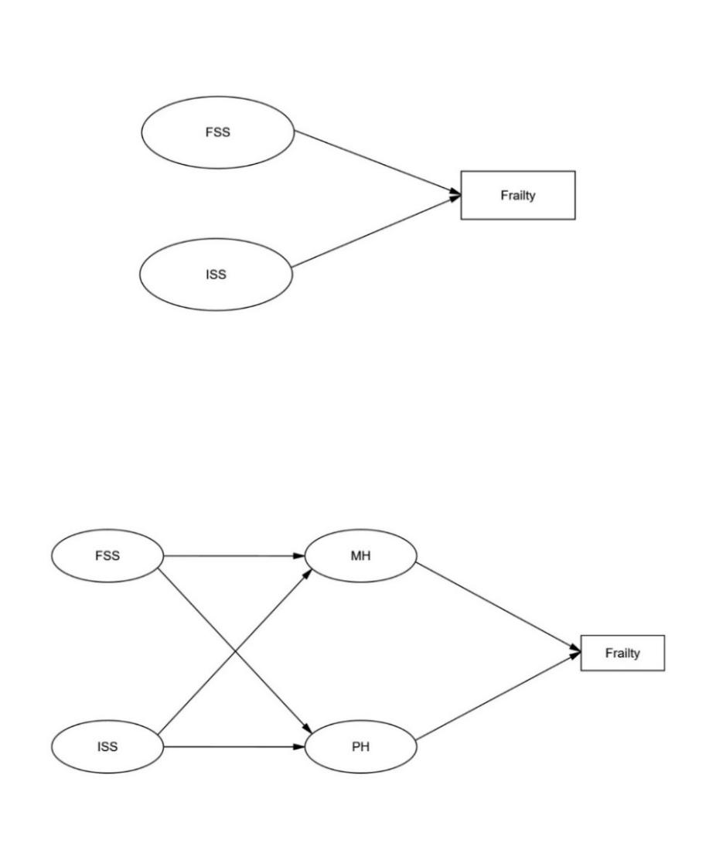

Supplementary Figure 2.
Participants who in the CHARLS ≥60 years old from 2011
(N=7209)
Final analytic sample
(N=4511)
Excluding participants who missing social support or frailty data
(N=2698)

Supplementary Figure 3.
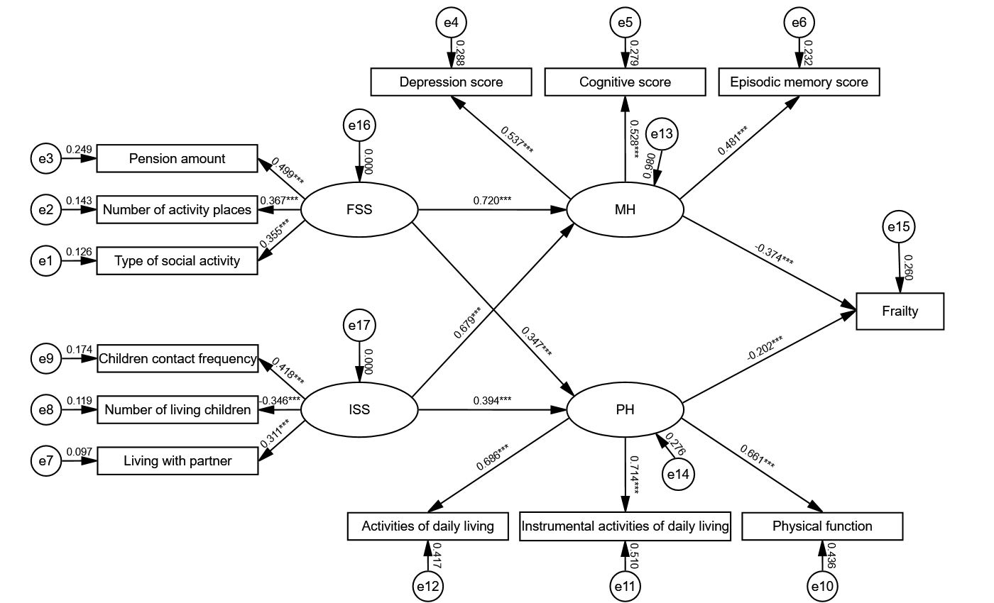

Supplementary Figure 4.
B
A

