Supplemental Online Content

eTable 1. Participants Demographic and Clinical Characteristics of all participants
eTable 2. The sensitivity and specificity of different steps for 4 simulation scenarios (male)
eTable 3. The sensitivity and specificity of different steps for 4 simulation scenarios (female)
eFig 1. Simulation scenarios from screening to diagnosis of sarcopenia in community setting with different screening tools(male)
eFig 2. Simulation scenarios from screening to diagnosis of sarcopenia in community setting with different screening tools(female)
eFig3. ROC and AUC of different steps for 4 simulation scenarios(male)
eFig4. ROC and AUC of different steps for 4 simulation scenarios(female)

eTable 1. Participants Demographic and Clinical Characteristics of all participants
Characteristic | N | Overall,  N = 2,453¹ | Non-sarcopenia,  N = 2,108¹ | Sarcopenia,  N = 345¹ | p-value²
Characteristic | N | N=2453¹ | N=2108¹ | N=345¹ | p-value²
Community | 2,453 |  |  |  | <0.001
Bei Cai |  | 327 (13.3%) | 293 (13.9%) | 34 (9.9%)
Hang Tou |  | 1,900 (77.5%) | 1,657 (78.6%) | 243 (70.4%)
Kang Qiao |  | 160 (6.5%) | 96 (4.6%) | 64 (18.6%)
Zhang Jiang |  | 66 (2.7%) | 62 (2.9%) | 4 (1.2%)
Age,mean(SD),y | 2,453 | 72.55(6.23) | 71.76(5.64) | 77.37(7.35) | <0.001
Gender | 2,453 |  |  |  | 0.100
Male |  | 1,038 (42.3%) | 878 (41.7%) | 160 (46.4%)
Female |  | 1,415 (57.7%) | 1,230 (58.3%) | 185 (53.6%)
Marriage | 2,453 |  |  |  | >0.999
Married |  | 2,450 (99.9%) | 2,105 (99.9%) | 345 (100.0%)
Never-married |  | 3 (0.1%) | 3 (0.1%) | 0 (0.0%)
Height,mean(SD),cm | 2,453 | 157.19(8.32) | 157.73(8.15) | 153.90(8.63) | <0.001
Weight,mean(SD),kg | 2,453 | 60.81(10.21) | 62.22(9.88) | 52.16(7.59) | <0.001
BMI,mean(SD),kg/m² | 2,453 | 24.57(3.43) | 24.99(3.36) | 22.02(2.65) | <0.001
Systolic bloodpressure, mean(SD),mmHg | 2,453 | 140.21(17.00) | 140.16(16.84) | 140.48(17.99) | 0.512
Diastolic blood pressure, mean(SD),mmHg | 2,453 | 77.94(10.10) | 78.20(9.95) | 76.37(10.83) | 0.001
Heart rate, mean(SD),p | 2,453 | 77.61(10.63) | 77.64(10.39) | 77.48(11.97) | 0.486
Education | 2,402 |  |  |  | 0.656
Below middle school |  | 1,396 (58.1%) | 1,201 (58.3%) | 195 (57.0%)
Middle school and above |  | 1,006 (41.9%) | 859 (41.7%) | 147 (43.0%)
History of chronic diseases | 2,453 |  |  |  | 0.752
No |  | 616 (25.1%) | 527 (25.0%) | 89 (25.8%)
Yes |  | 1,837 (74.9%) | 1,581 (75.0%) | 256 (74.2%)
Osteoporosis | 2,453 |  |  |  | <0.001
No |  | 2,380 (97.0%) | 2,059 (97.7%) | 321 (93.0%)
Yes |  | 73 (3.0%) | 49 (2.3%) | 24 (7.0%)
CKD | 2,453 |  |  |  | 0.722
No |  | 2,436 (99.3%) | 2,094 (99.3%) | 342 (99.1%)
Yes |  | 17 (0.7%) | 14 (0.7%) | 3 (0.9%)
COPD | 2,453 |  |  |  | 0.512
No |  | 2,433 (99.2%) | 2,092 (99.2%) | 341 (98.8%)
Yes |  | 20 (0.8%) | 16 (0.8%) | 4 (1.2%)
Diabetes | 2,453 |  |  |  | 0.376
No |  | 2,028 (82.7%) | 1,737 (82.4%) | 291 (84.3%)
Yes |  | 425 (17.3%) | 371 (17.6%) | 54 (15.7%)
Hypertension | 2,453 |  |  |  | 0.035
No |  | 1,137 (46.4%) | 959 (45.5%) | 178 (51.6%)
Yes |  | 1,316 (53.6%) | 1,149 (54.5%) | 167 (48.4%)
Heart failure | 2,453 |  |  |  | 0.532
No |  | 2,448 (99.8%) | 2,104 (99.8%) | 344 (99.7%)
Yes |  | 5 (0.2%) | 4 (0.2%) | 1 (0.3%)
Malignancy | 2,453 |  |  |  | 0.244
No |  | 2,378 (96.9%) | 2,047 (97.1%) | 331 (95.9%)
Yes |  | 75 (3.1%) | 61 (2.9%) | 14 (4.1%)
Surgery | 2,453 |  |  |  | 0.174
No |  | 1,566 (63.8%) | 1,357 (64.4%) | 209 (60.6%)
Yes |  | 887 (36.2%) | 751 (35.6%) | 136 (39.4%)
Medication | 2,452 |  |  |  | 0.781
No |  | 762 (31.1%) | 657 (31.2%) | 105 (30.4%)
Yes |  | 1,690 (68.9%) | 1,450 (68.8%) | 240 (69.6%)
Smoking | 2,453 |  |  |  | 0.033
No |  | 2,019 (82.3%) | 1,721 (81.6%) | 298 (86.4%)
Yes |  | 434 (17.7%) | 387 (18.4%) | 47 (13.6%)
Drinking | 2,452 |  |  |  | 0.847
No |  | 2,133 (87.0%) | 1,834 (87.0%) | 299 (86.7%)
Yes |  | 319 (13.0%) | 273 (13.0%) | 46 (13.3%)
Duration of sleep,  mean(SD),h | 2,453 | 6.79(1.52) | 6.79(1.48) | 6.80(1.74) | 0.784
Food habit | 2,453 |  |  |  | 0.035
No special |  | 2,273 (92.7%) | 1,960 (93.0%) | 313 (90.7%)
Vegetarian |  | 141 (5.7%) | 120 (5.7%) | 21 (6.1%)
High protein diet |  | 39 (1.6%) | 28 (1.3%) | 11 (3.2%)
Data set | 2,453 |  |  |  | 0.862
Training set |  | 1,718 (70.0%) | 1,475 (70.0%) | 243 (70.4%)
Validation set |  | 735 (30.0%) | 633 (30.0%) | 102 (29.6%)
Calf circumference,  mean(SD),cm | 2,453 | 33.35(3.00) | 33.76(2.88) | 30.80(2.37) | <0.001
¹n (%); Mean(SD)
²Pearson's Chi-squared test; Wilcoxon rank sum test; Fisher's exact test

eTable 2. The sensitivity and specificity of different steps for 4 simulation scenarios (male)
Simulation  scenario | Stage |  | Total | Sarcopenia  （+） | Non-sarcopenia（-） | Se | Sp
1 | Case_finding with SARC-F or SARC-CalF or CC | + | 476 ( 45.9) | 129 ( 80.6) | 347 ( 39.5) | 0.81 | 0.60
1 | Case_finding with SARC-F or SARC-CalF or CC | - | 562 ( 54.1) | 31 ( 19.4) | 531 ( 60.5) | 0.81 | 0.60
1 | Assessment with handgrip strength | + | 152( 31.9) | 95( 73.6) | 57( 16.4) | 0.74 | 0.84
1 | Assessment with handgrip strength | - | 324( 68.1) | 34( 26.4) | 290( 83.6) | 0.74 | 0.84
1 | Case_finding +Assessment  ( Possible sarcopenia) | + | 152 ( 14.6) | 95 ( 59.4) | 57 ( 6.5) | 0.59 | 0.94
1 | Case_finding +Assessment  ( Possible sarcopenia) | - | 886 ( 85.4) | 65 ( 40.6) | 821 ( 93.5) | 0.59 | 0.94
2 | Case_finding with CC | + | 472 (45.5) | 126 ( 78.8) | 346 ( 39.4) | 0.79 | 0.61
2 | Case_finding with CC | - | 566 ( 54.5) | 34 ( 21.2) | 532 ( 60.6) | 0.79 | 0.61
2 | Assessment with handgrip strength | + | 149( 31.6) | 92(73.0) | 57(16.5) | 0.73 | 0.84
2 | Assessment with handgrip strength | - | 323( 68.4) | 34(27.0) | 289(83.5) | 0.73 | 0.84
2 | Case_finding +Assessment  ( Possible sarcopenia) | + | 149 ( 14.4) | 92 ( 57.5) | 57 ( 6.5) | 0.57 | 0.94
2 | Case_finding +Assessment  ( Possible sarcopenia) | - | 889 ( 85.6) | 68 ( 42.5) | 821 ( 93.5) | 0.57 | 0.94
3 | Case_finding with SARC-CalF | + | 60 ( 5.8) | 21 ( 13.1) | 39 ( 4.4) | 0.13 | 0.96
3 | Case_finding with SARC-CalF | - | 978 (94.2) | 139 ( 86.9) | 839 ( 95.6) | 0.13 | 0.96
3 | Assessment with handgrip strength | + | 27( 45.0) | 15(71.4) | 12(30.8) | 0.71 | 0.69
3 | Assessment with handgrip strength | - | 33( 55.0) | 6(28.6) | 27(69.2) | 0.71 | 0.69
3 | Case_finding +Assessment  ( Possible sarcopenia) | + | 27 ( 2.6) | 15 ( 9.4) | 12 ( 1.4) | 0.09 | 0.99
3 | Case_finding +Assessment  ( Possible sarcopenia) | - | 1011 (97.4) | 145 ( 90.6) | 866 ( 98.6) | 0.09 | 0.99
4 | Case_finding with SARC-F | + | 9 ( 0.9) | 6 ( 3.8) | 3 ( 0.3) | 0.04 | 1.00
4 | Case_finding with SARC-F | - | 1029 (99.1) | 154 ( 96.2) | 875 ( 99.7) | 0.04 | 1.00
4 | Assessment with handgrip strength | + | 7(77.8) | 5(83.3) | 2(66.7) | 0.83 | 0.33
4 | Assessment with handgrip strength | - | 2(22.2) | 1(16.7) | 1(33.3) | 0.83 | 0.33
4 | Case_finding +Assessment  ( Possible sarcopenia) | + | 7 ( 0.7) | 5 ( 3.1) | 2 ( 0.2) | 0.03 | 1.00
4 | Case_finding +Assessment  ( Possible sarcopenia) | - | 1031 (99.3) | 155 ( 96.9) | 876 ( 99.8) | 0.03 | 1.00

eTable 3. The sensitivity and specificity of different steps for 4 simulation scenarios(female)
Simulation  scenario | Stage |  | Total | Sarcopenia  （+） | Non-sarcopenia（-） | Se | Sp
1 | Case_finding with SARC-F or SARC-CalF or CC | + | 720 ( 50.9) | 168 ( 90.8) | 552 ( 44.9) | 0.91 | 0.55
1 | Case_finding with SARC-F or SARC-CalF or CC | - | 695 ( 49.1) | 17 ( 9.2) | 678 ( 55.1) | 0.91 | 0.55
1 | Assessment with handgrip strength | + | 233(32.4) | 123(73.2) | 110(19.9) | 0.73 | 0.80
1 | Assessment with handgrip strength | - | 487(67.6) | 45(26.8) | 442(80.1) | 0.73 | 0.80
1 | Case_finding +Assessment  ( Possible sarcopenia) | + | 233 ( 16.5) | 123 ( 66.5) | 110 ( 8.9) | 0.66 | 0.91
1 | Case_finding +Assessment  ( Possible sarcopenia) | - | 1182 ( 83.5) | 62 ( 33.5) | 1120 ( 91.1) | 0.66 | 0.91
2 | Case_finding with CC | + | 706 (49.9) | 164 ( 88.6) | 542 ( 44.1) | 0.89 | 0.56
2 | Case_finding with CC | - | 709 (50.1) | 21 ( 11.4) | 688 ( 55.9) | 0.89 | 0.56
2 | Assessment with handgrip strength | + | 222(31.4) | 119(72.6) | 103(19.0) | 0.73 | 0.81
2 | Assessment with handgrip strength | - | 484(68.6) | 45(27.4) | 439(81.0) | 0.73 | 0.81
2 | Case_finding +Assessment  ( Possible sarcopenia) | + | 222 (15.7) | 119 ( 64.3) | 103 ( 8.4) | 0.64 | 0.92
2 | Case_finding +Assessment  ( Possible sarcopenia) | - | 1193 (84.3) | 66 ( 35.7) | 1127 ( 91.6) | 0.64 | 0.92
3 | Case_finding with SARC-CalF | + | 176 (12.4) | 60 ( 32.4) | 116 ( 9.4) | 0.32 | 0.91
3 | Case_finding with SARC-CalF | - | 1239 (87.6) | 125 ( 67.6) | 1114 ( 90.6) | 0.32 | 0.91
3 | Assessment with handgrip strength | + | 82(46.6) | 45(75.0) | 37(31.9) | 0.75 | 0.68
3 | Assessment with handgrip strength | - | 94(53.4) | 15(25.0) | 79(68.1) | 0.75 | 0.68
3 | Case_finding +Assessment  ( Possible sarcopenia) | + | 82 ( 5.8) | 45 ( 24.3) | 37 ( 3.0) | 0.24 | 0.97
3 | Case_finding +Assessment  ( Possible sarcopenia) | - | 1333 (94.2) | 140 ( 75.7) | 1193 ( 97.0) | 0.24 | 0.97
4 | Case_finding with SARC-F | + | 36 ( 2.5) | 18 ( 9.7) | 18 ( 1.5) | 0.10 | 0.99
4 | Case_finding with SARC-F | - | 1379 (97.5) | 167 ( 90.3) | 1212 ( 98.5) | 0.10 | 0.99
4 | Assessment with handgrip strength | + | 30(83.3) | 16(88.9) | 14(77.8) | 0.89 | 0.22
4 | Assessment with handgrip strength | - | 6(16.7) | 2(11.1) | 4(22.2) | 0.89 | 0.22
4 | Case_finding +Assessment  ( Possible sarcopenia) | + | 30 ( 2.1) | 16 ( 8.6) | 14 ( 1.1) | 0.09 | 0.99
4 | Case_finding +Assessment  ( Possible sarcopenia) | - | 1385 (97.9) | 169 ( 91.4) | 1216 ( 98.9) | 0.09 | 0.99

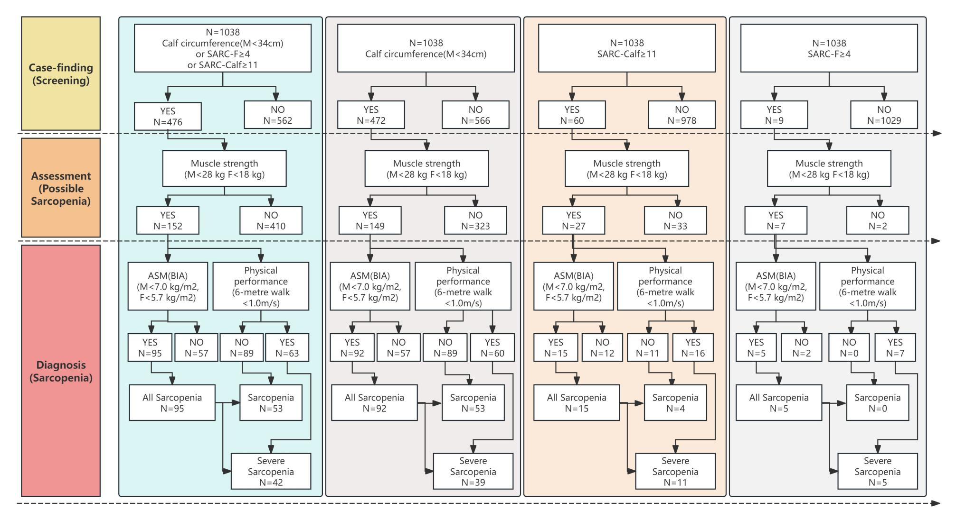
eFig 1. Simulation scenarios from case-finding to diagnosis of sarcopenia in community setting with different screening tools(male)
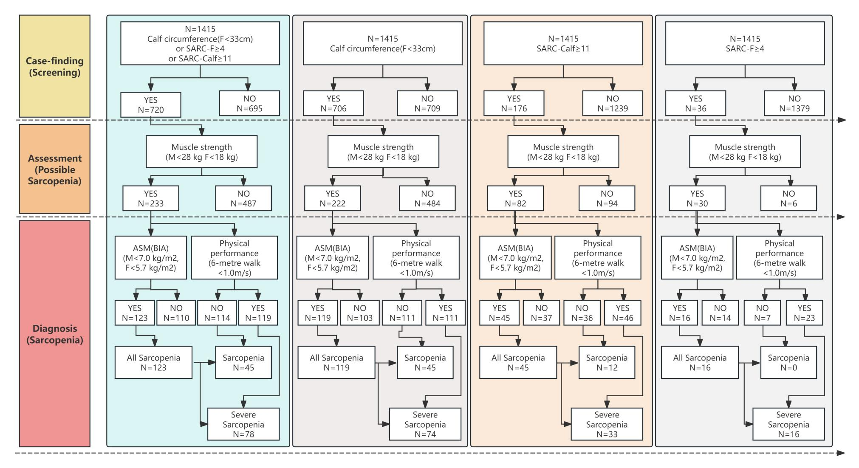
eFig 2. Simulation scenarios from case-finding to diagnosis of sarcopenia in community setting with different screening tools(female)

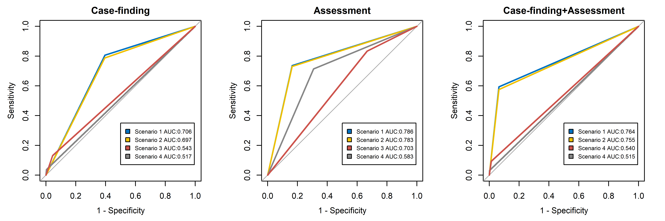
eFig3. ROC and AUC of different steps for 4 simulation scenarios(male)
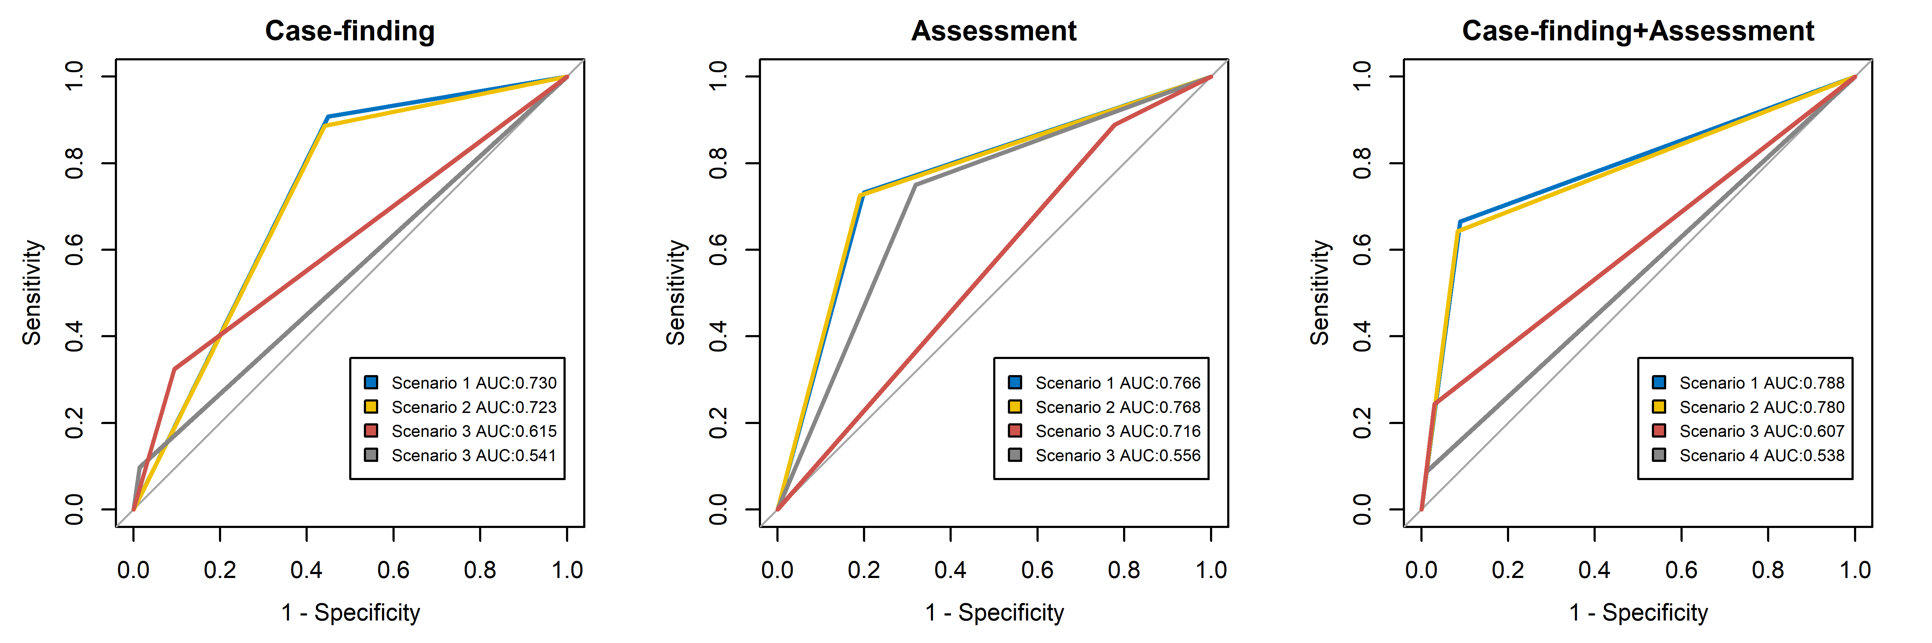
eFig4. ROC and AUC of different steps for 4 simulation scenarios(female)

