Table S1. Missing data prior to multiple imputation
Variables | Number of  missing data | Percentage of  missing data (%) | Imputed
Social participation | 204 | 4.25
Outpatient expenses | 198 | 4.13
Inpatient expenses | 378 | 7.88
Medical services accessibility | 227 | 4.73
Years of schooling | 737 | 15.35
Age(years) | 0 | 0.00 | *
Gender | 0 | 0.00 | *
Marital status | 72 | 1.50
Race | 769 | 16.02
Occupation | 890 | 18.54
Living arrangement | 110 | 2.29
Distance from hospital | 265 | 5.52
Medical insurance | 201 | 4.19
Subjective economic status | 62 | 1.29
Economic status in childhood | 920 | 19.17
ADL | 271 | 5.65
CESD-10 | 230 | 4.79
Chronic disease | 233 | 4.85
Self-rated health | 0 | 0.00 | *
Participants with missing values were deleted in the main statistical analyses, and we performed multiple imputation for missing values as a sensitivity analysis.
Abbreviations: ADL=activities of daily living.CESD-10=depression situation.

Table S2.Odds ratios for covariates predicting transitions in social participation from T1 (2011) to T2 (2014) among Chinese rural older adults
Predictor | T1 latent class | T2 latent class
Predictor | T1 latent class | low | moderate | high
Age (years) | low | ref | 1.03(0.92,1.14) | 1.02(0.93,1.14)
Age (years) | moderate | 1.01(0.94,1.29) | ref | 0.81(0.58,1.12)
Age (years) | high | 0.96(0.90,1.03) | 0.94(0.88,1.01) | ref
Gender (ref=female) | low | ref | 1.58(0.25,9.85) | 1.20(0.23,6.35)
Gender (ref=female) | moderate | 18.26(0.51,648.27) | ref | 1.82(0.21,6.86)
Gender (ref=female) | high | 1.02(0.37,2.82) | 1.99(0.37,2.65) | ref
Marital status (ref=not in marriage) | low | ref | 0.87(0.11,7.23) | 1.38(0.18,10.24)
Marital status (ref=not in marriage) | moderate | 0.18(0.01,3.73) | ref | 0.98(0.14,6.72)
Marital status (ref=not in marriage) | high | 0.34(0.10,1.20) | 2.15(0.61,7.60) | ref
Occupation (ref=minority) | low | ref | 6.25(0.72,54.22) | 1.98(0.27,14.04)
Occupation (ref=minority) | moderate | 1.95(0.17,21.54) | ref | 1.96(0.18.21.55)
Occupation (ref=minority) | high | 0.96(0.11,8.11) | 6.85(2.20,21.31) | ref
Living arrangement (ref=alone) | low | ref | 0.85(0.09,7.94) | 0.97(0.13,6.89)
Living arrangement (ref=alone) | moderate | 2.12(0.97,8.98) | ref | 0.67(0.11,4.16)
Living arrangement (ref=alone) | high | 0.87(0.30,2.54) | 0.57(0.13,2.35) | ref
Distance from hospital | low | ref | 1.08(0.88,1.33) | 0.89(0.55,1.43)
Distance from hospital | moderate | 1.64(0.85,3.18) | ref | 1.33(0.64,2.75)
Distance from hospital | high | 0.87(0.63,1.21) | 0.73(0.48,1.12) | ref
Medical insurance (ref=no) | low | ref | 0.84(0.15,4.51) | 0.93(0.19,4.47)
Medical insurance (ref=no) | moderate | 0.38(0.06,2.45) | ref | 0.13*(0.02,0.82)
Medical insurance (ref=no) | high | 3.69(0.47,28.75) | 0.31**(0.12,0.82) | ref
Subjective economic status (ref=poor) | low | ref | 0.19(0.02,2.57) | 1.70(0.38,7.64)
Subjective economic status (ref=poor) | moderate | 3.55*(0.26,9.14) | ref | 2.09*(1.00,8.20)
Subjective economic status (ref=poor) | high | 3.71(1.43,9.58) | 0.27(0.06,1.05) | ref
Economic status in childhood (ref=poor) | low | ref | 3.57(0.85,15.09) | 0.85(0.20,3.67)
Economic status in childhood (ref=poor) | moderate | 0.23(0.01,6.89) | ref | 0.97(0.01,17.94)
Economic status in childhood (ref=poor) | high | 0.99*(0.34,2.88) | 2.51(1.00,6.29) | ref
CESD-10 | low | ref | 1.06(0.78,1.46) | 1.06(0.79,1.43)
CESD-10 | moderate | 1.09(0.60,2.00) | ref | 1.69(0.67,4.27)
CESD-10 | high | 0.96(0.81,1.13) | 0.93(0.78,1.11) | ref
Chronic disease (ref=no) | low | ref | 1.67(0.79,1.46) | 1.43(0.72,2.85)
Chronic disease (ref=no) | moderate | 1.61(0.52,5.01) | ref | 2.52(0.42,15.05)
Chronic disease (ref=no) | high | 1.54(0.95,2.50) | 1.89*(1.13,3.17) | ref
Self-rated health (ref=bad) | low | ref | 1.57(0.65,3.57) | 1.10(0.47,2.59)
Self-rated health (ref=bad) | moderate | 6.03(0.62,59.59) | ref | 1.71(0.13,21.65)
Self-rated health (ref=bad) | high | 1.37(0.811,2.32) | 2.50**(1.41,4.42) | ref
Abbreviations: CESD-10=depression situation.
Table S3.Odds ratios for covariates predicting transitions in social participation from T2 (2014) to T3 (2018) among Chinese rural older adults
Predictor | T 2 latent class | T3 latent class
Predictor | T 2 latent class | low | moderate | high
Age (years) | low | ref | 0.92(0.80,1.06) | 1.01(0.89,1.15)
Age (years) | moderate | 1.08(0.91,1.30) | ref | 1.00(0.87,1.15)
Age (years) | high | 0.98(0.94,1.04) | 0.96(0.91,1.01) | ref
Gender  (ref=female) | low | ref | 2.30(0.40,13.17) | 0.97(1.88,4.94)
Gender  (ref=female) | moderate | 14.64*(2.23,102.87) | ref | 16.09**(3.75,164.57)
Gender  (ref=female) | high | 1.15(0.51,2.60) | 1.01(0.45,2.27) | ref
Marital status (ref=not in marriage) | low | ref | 0.47(0.06,3.45) | 0.75(0.08,6.72)
Marital status (ref=not in marriage) | moderate | 1.05(0.03,40.01) | ref | 1.091(0.112,30.90)
Marital status (ref=not in marriage) | high | 0.28*(0.09,0.83) | 1.40(0.56,3.52) | ref
Occupation (ref=minority) | low | ref | 0.33(0.02,5.27) | 3.15(0.55,18.08)
Occupation (ref=minority) | moderate | 0.00(0.00,0.00) | ref | 0.87(0.05,14.84)
Occupation (ref=minority) | high | 3.91(0.12,6.87) | 1.05(0.33,3.31) | ref
Living arrangement (ref=alone) | low | ref | 5.98(0.56,63.76) | 0.74(0.10,5.62)
Living arrangement (ref=alone) | moderate | 44.56(0.19,10.61) | ref | 6.58(0.34,127.80)
Living arrangement (ref=alone) | high | 1.77(0.63,5.00) | 0.80(0.29,2.20) | ref
Distance from hospital | low | ref | 0.60(0.31,1.18) | 0.95(0.74,1.20)
Distance from hospital | moderate | 0.70(0.34,1.43) | ref | 0.66(0.37,1.17)
Distance from hospital | high | 1.03*(1.02,1.05) | 1.01(0.97,1.04) | ref
Medical insurance (ref=no) | low | ref | 0.69(0.09,5.26) | 0.28(0.06,1.27)
Medical insurance (ref=no) | moderate | 0.00(0.00,0.00) | ref | 3.43(0.59,20.01)
Medical insurance (ref=no) | high | 2.57(0.56,11.98) | 1.10(0.37,3.03) | ref
Subjective economic status  (ref=poor) | low | ref | 0.08(0.01,1.04) | 0.44(0.07,2.90)
Subjective economic status  (ref=poor) | moderate | 0.33(0.02,9.29) | ref | 2.51*(1.11,5.69)
Subjective economic status  (ref=poor) | high | 0.03*(0.01,0.54) | 2.79(1.26,6.17) | ref
Economic status in childhood (ref=poor) | low | ref | 6.83*(1.47,31.65) | 2.26(0.46,10.92)
Economic status in childhood (ref=poor) | moderate | 0.45(0.02,12.37) | ref | 0.52(0.06,4.70)
Economic status in childhood (ref=poor) | high | 0.92(0.38,2.24) | 1.42(0.65,3.11) | ref
CESD-10 | low | ref | 0.99(0.71,1.38) | 1.08(0.81,1.45)
CESD-10 | moderate | 1.57(0.72,3.41) | ref | 1.69(0.95,3.01)
CESD-10 | high | 1.01(0.87,1.17) | 0.97(0.84,1.11) | ref
Chronic disease (ref=no) | low | ref | 0.46*(0.21,1.04) | 0.83(0.39,1.79)
Chronic disease (ref=no) | moderate | 0.48(0.10,2.31) | ref | 0.63(0.21,1.84)
Chronic disease (ref=no) | high | 1.46(0.95,2.23) | 0.65*(0.44,0.96) | ref
Self-rated health (ref=bad) | low | ref | 1.07(0.39,2.93) | 0.74(0.28,1.95)
Self-rated health (ref=bad) | moderate | 9.75*(1.02,92.54) | ref | 7.80*(1.32,45.99)
Self-rated health (ref=bad) | high | 1.23(0.80,1.91) | 1.18(0.77,1.79) | ref
Abbreviations: CESD-10=depression situation.

Table S4. Baseline characteristics between study sample and excluded individuals.
Variables | Study sample  (N=1600 ) | Excluded (N=8165 )
Independent variable
Social participation, mean±SD ª | 36.28±6.02 | 39.14±7.10
Dependent variables
Outpatient expenses (logarithmized), mean±SD | 5.17±3.03 | 3.48±4.10
Inpatient expenses (logarithmized), mean±SD | 2.70±4.06 | 3.60±4.18
Control variables
Medical services accessibility, n (%)
No | 1502(93.9) | 8102(99.2)
Yes | 98(6.1) | 63(0.8)
Years of schooling, mean±SD | 2.62±5.12 | 2.41±5.04
Age(years), mean±SD | 83.30±8.32 | 87.2±11.38
Gender, n (%)
Female | 870(54.4) | 4497(55.1)
Male | 730(45.6) | 3368(44.9)
Marital status, n (%)
Not in marriage | 730(45.6) | 5303(64.9)
In marriage | 870(54.4) | 2862(35.1)
Race, n (%)
Not minority | 75(4.7) | 489(6.0)
Minority | 1525(95.3) | 7676(94.0)
Occupation, n (%)
Manual labor | 1503(93.9) | 2100（25.7）
Mental work | 97(6.1) | 6065(74.3)
Living arrangement, n (%)
Alone | 327(20.4) | 1324(16.2)
Not living alone | 1273(79.6) | 6841(83.8)
Distance from hospital, mean±SD | 2.74±8.04 | 2.75±8.04
Medical insurance, n (%)
No | 256(16.0) | 2073(25.4)
Yes | 1344(84.0) | 6092(74.6)
Subjective economic status, n (%)
Poor | 1357(84.8) | 6731(82.4)
Rich | 243(15.2) | 1434(17.6)
Economic status in childhood, n (%)
Poor | 1197(74.8) | 6179(75.7)
Rich | 403(25.2) | 1986(24.3)
ADL, mean±SD | 6.21±1.17 | 7.84±2.81
CESD-10, mean±SD | 15.95±2.69 | 17.31±2.62
Chronic disease, n (%)
No | 785(49.1) | 3639(44.6)
Yes | 815(50.9) | 4562(55.4)
Self-rated health, n (%)
Bad | 896(56.0) | 4792(58.7)
Good | 704(44.0) | 3373(41.3)
Notes: Abbreviations: sd, standard deviation.
ª Social participation (including housework, tai chi chuan, square dancing, visiting and interacting with friends, other outdoor activities, reading books and newspapers, playing cards or mahjong, watching TV and listening to the radio, and taking part in organized social activities).

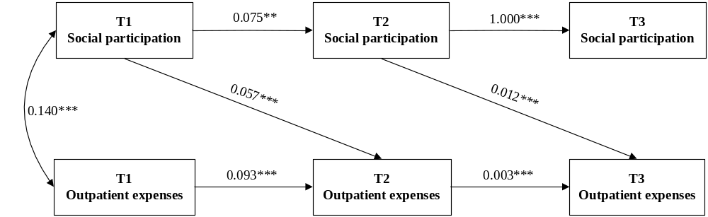
Figure S1. Cross-lagged model with social participation and outpatient expenses among rural older people at three time points. Note: ***P<0.001.
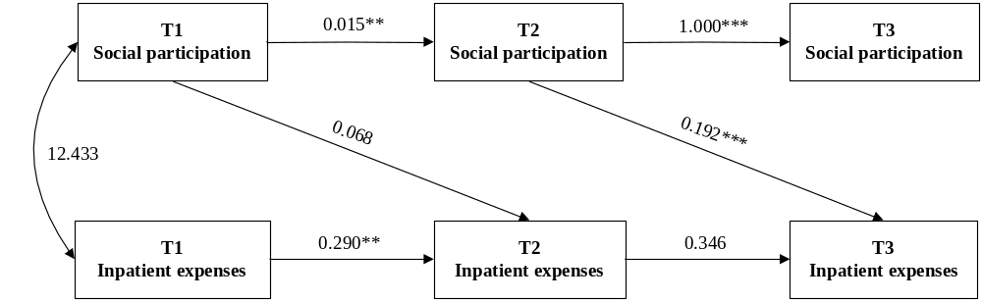
Figure S2. Cross-lagged model with social participation and inpatient expenses among rural older people at three time points. Note: ***P<0.001.
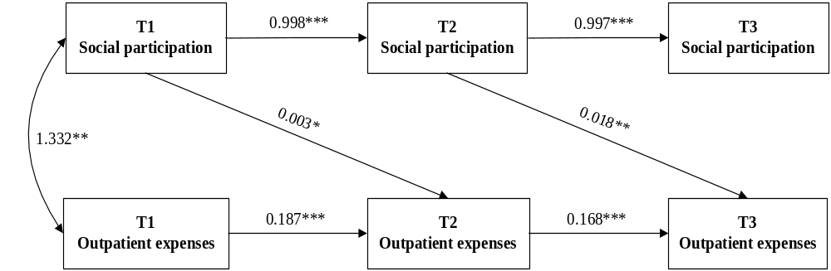Figure S3. Cross-lagged panel model of social participation and outpatient expenses among rural older males across three time points. Note: ***P<0.001.
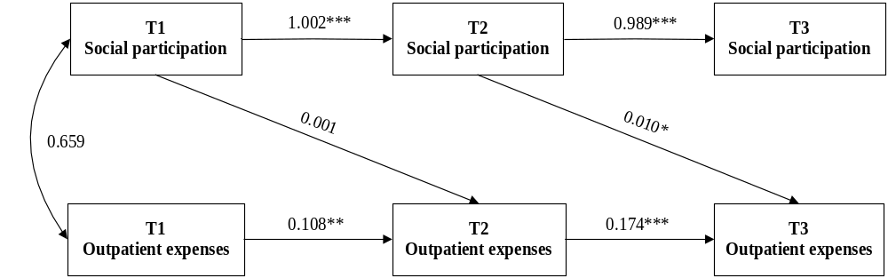
Figure S4. Cross-lagged panel model of social participation and outpatient expenses among rural older females across three time points. Note: ***P<0.001.
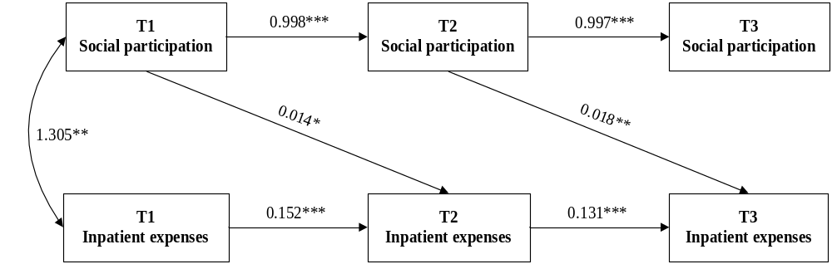
Figure S5. Cross-lagged panel model of social participation and inpatient expenses among rural older males across three time points. Note: ***P<0.001.
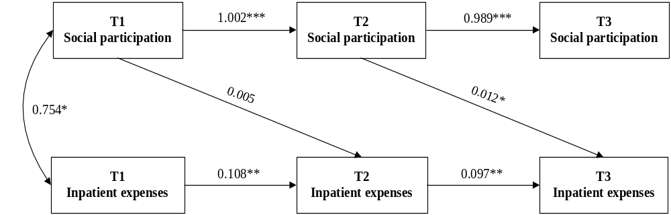
Figure S6. Cross-lagged panel model of social participation and inpatient expenses among rural older females across three time points. Note: ***P<0.001.
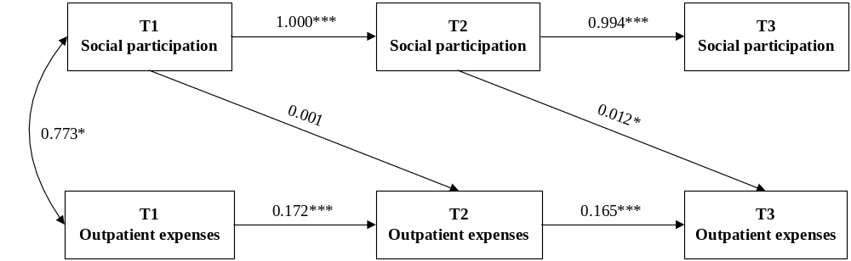
Figure S7. Cross-lagged panel model of social participation and outpatient expenses among unmarried rural older people across three time points. Note: ***P<0.001.
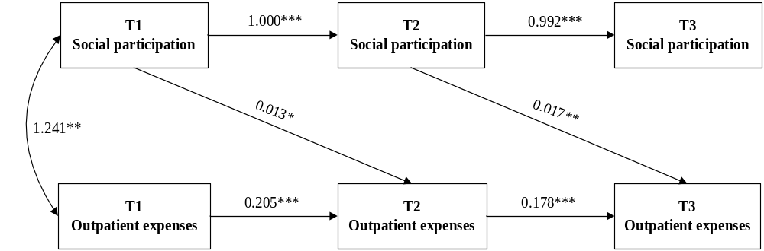
Figure S8. Cross-lagged panel model of social participation and outpatient expenses among married rural older people across three time points. Note: ***P<0.001.
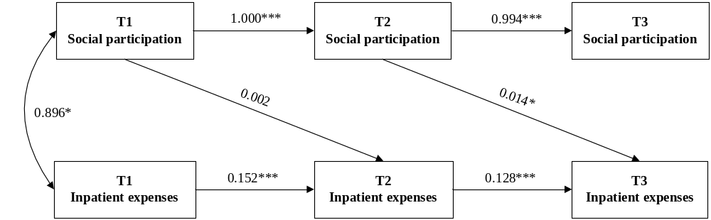
Figure S9. Cross-lagged panel model of social participation and inpatient expenses among unmarried rural older people across three time points. Note: ***P<0.001.
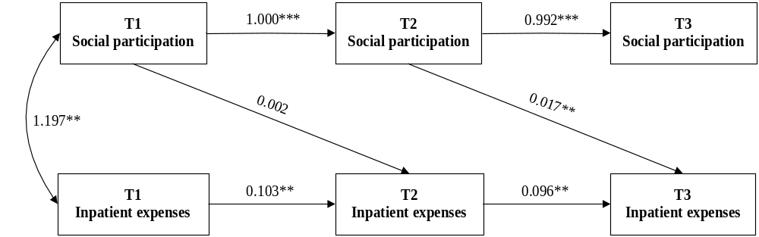
Figure S10. Cross-lagged panel model of social participation and outpatient expenses among married rural older people across three time points. Note: ***P<0.001.
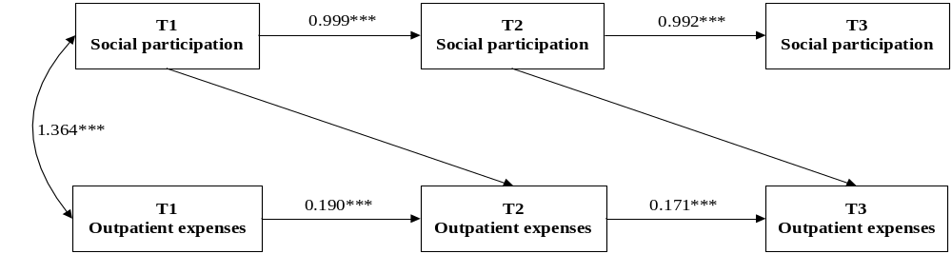
Figure S11. Cross-lagged panel model of social participation and outpatient expenses among rural older adults with poor economic conditions across three time points. Note: ***P<0.001.
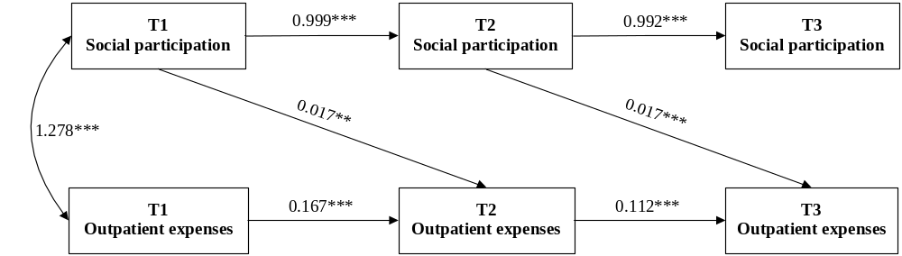
Figure S12. Cross-lagged panel model of social participation and outpatient expenses among rural older adults with good economic conditions across three time points. Note: ***P<0.001.
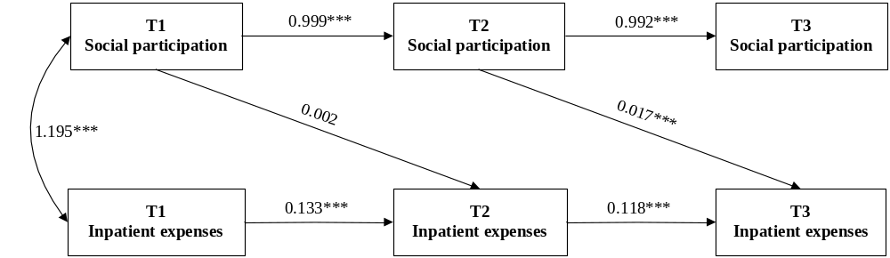
Figure S13. Cross-lagged panel model of social participation and inpatient expenses among rural older adults with poor economic conditions across three time points.
Note: *** P<0.001.
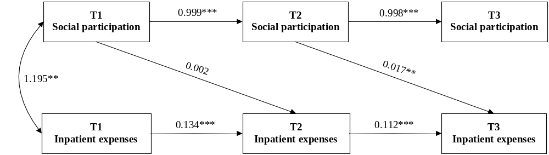
Figure S14. Cross-lagged panel model of social participation and inpatient expenses among rural older adults with good economic conditions across three time points. Note: ***P<0.001.
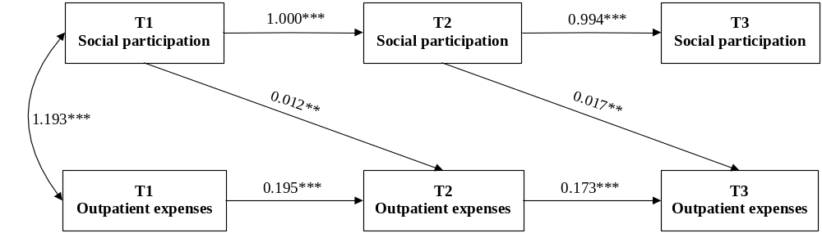
Figure S15. Cross-lagged panel model of social participation and outpatient expenses among rural older adults with access to medical services across three time points. Note: ***P<0.001.
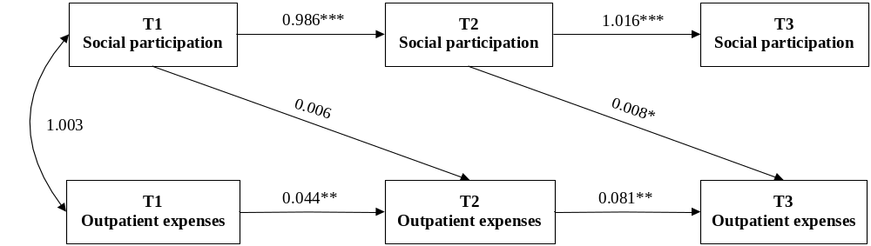
Figure S16. Cross-lagged panel model of social participation and outpatient expenses among rural older adults with no access to medical services across three time points. Note: ***P<0.001.
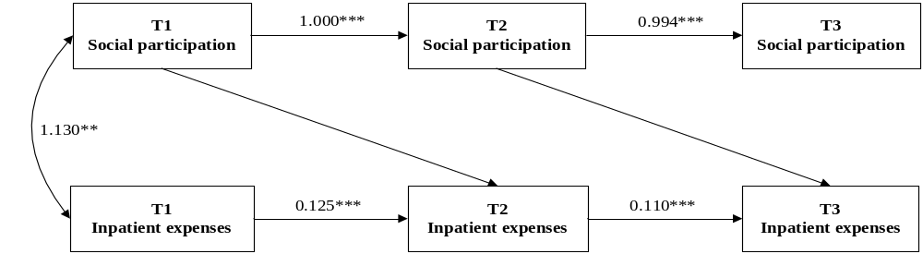
Figure S17. Cross-lagged panel model of social participation and inpatient expenses among rural older adults with access to medical services across three time points. Note: ***P<0.001.
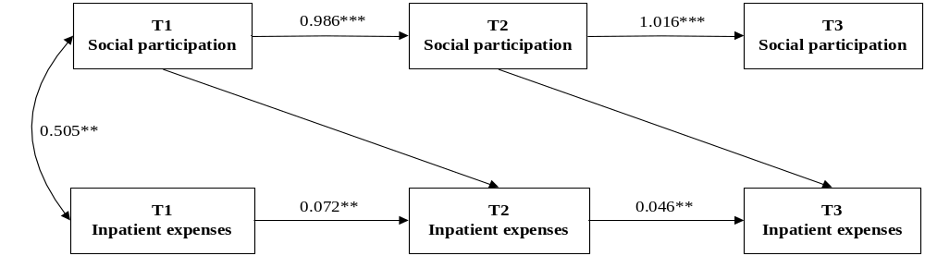
Figure S18. Cross-lagged panel model of social participation and outpatient expenses among rural older adults with no access to medical services across three time points. Note: ***P<0.001.
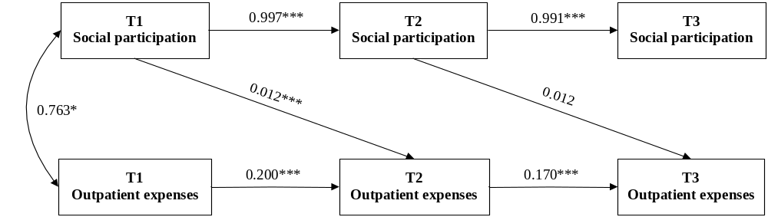
Figure S19. Cross-lagged panel model of social participation and outpatient expenses among self-rated healthy older adults in rural areas across three time points. Note: ***P<0.001.
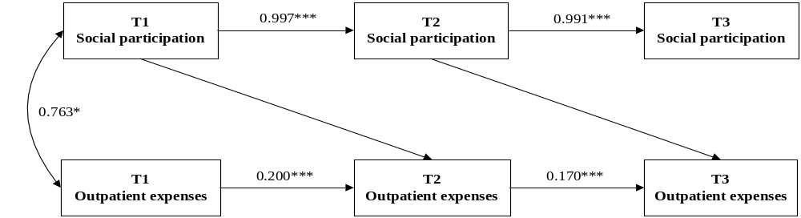
Figure S20. Cross-lagged panel model of social participation and outpatient expenses of the self-rated unhealthy older adults in rural areas at different time points. Note: ***P<0.001.
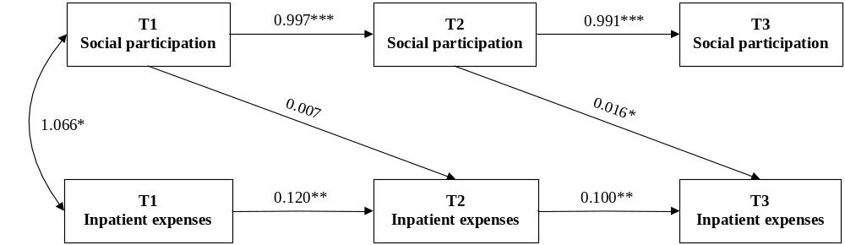
Figure S21. Cross-lagged panel model of social participation and inpatient expenses among self-rated healthy older adults in rural areas across three time points. Note: ***P<0.001.
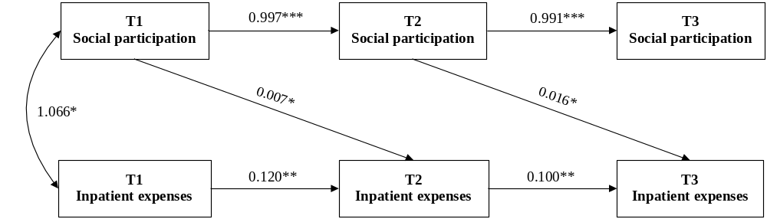
Figure S22. Cross-lagged panel model of social participation and inpatient expenses of the self-rated unhealthy older adults in rural areas at different time points. Note: ***P<0.001.

