Figure S1: Flowchart for the stepped wedge cluster randomised trial by allocated sequence and period
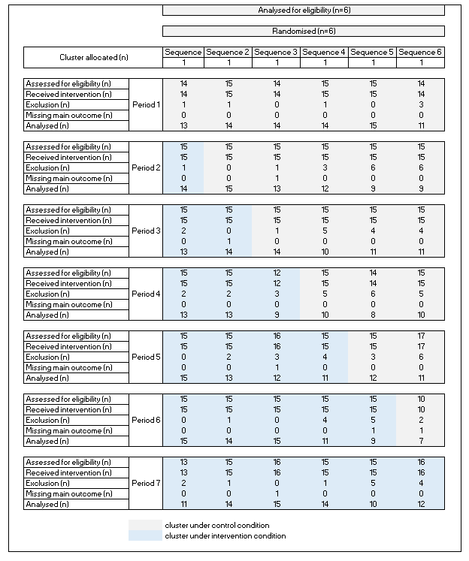

Figure S2: Stepped-wedge schedule of the MEDREV study. Clusters sequentially cross over from the control period (light grey) to the intervention period (dark grey).
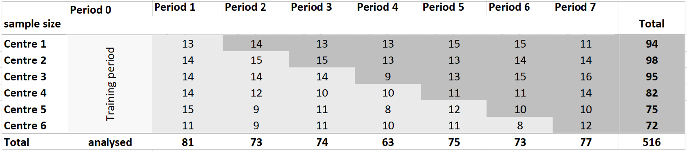

Table S1: Checklist CONSORT SW-RCT recommendations
Section/Topic | Item No | Checklist item | Reported on page No
Title and abstract
 | 1a | Identification as a randomised trial in the title | Page 1
 | 1b | Structured summary of trial design, methods, results, and conclusions (for specific guidance see CONSORT for abstracts) | Pages 5-6
Introduction
Background and objectives | 2a | Scientific background and explanation of rationale | Page 7
Background and objectives | 2b | Specific objectives or hypotheses | Page 8
Methods
Trial design | 3a | Description of trial design (such as parallel, factorial) including allocation ratio | Page 9 + Figure 1
Trial design | 3b | Important changes to methods after trial commencement (such as eligibility criteria), with reasons | NA
Participants | 4a | Eligibility criteria for participants | Page 10
Participants | 4b | Settings and locations where the data were collected | Page 10
Interventions | 5 | The interventions for each group with sufficient details to allow replication, including how and when they were actually administered | Pages 10-11
Outcomes | 6a | Completely defined pre-specified primary and secondary outcome measures, including how and when they were assessed | Page 11
Outcomes | 6b | Any changes to trial outcomes after the trial commenced, with reasons | NA
Sample size | 7a | How sample size was determined | Page 12
Sample size | 7b | When applicable, explanation of any interim analyses and stopping guidelines | NA
Randomisation:
Sequence generation | 8a | Method used to generate the random allocation sequence | Page 9
Sequence generation | 8b | Type of randomisation; details of any restriction (such as blocking and block size) | Page 9
Allocation concealment mechanism | 9 | Mechanism used to implement the random allocation sequence (such as sequentially numbered containers), describing any steps taken to conceal the sequence until interventions were assigned | Page 9
Implementation | 10 | Who generated the random allocation sequence, who enrolled participants, and who assigned participants to interventions | Page 9
Blinding | 11a | If done, who was blinded after assignment to interventions (for example, participants, care providers, those assessing outcomes) and how | NA
Blinding | 11b | If relevant, description of the similarity of interventions | NA
Statistical methods | 12a | Statistical methods used to compare groups for primary and secondary outcomes | Page 13
Statistical methods | 12b | Methods for additional analyses, such as subgroup analyses and adjusted analyses | NA
Results
Participant flow (a diagram is strongly recommended) | 13a | For each group, the numbers of participants who were randomly assigned, received intended treatment, and were analysed for the primary outcome | Page 14
Participant flow (a diagram is strongly recommended) | 13b | For each group, losses and exclusions after randomisation, together with reasons | Page 14
Recruitment | 14a | Dates defining the periods of recruitment and follow-up | Page 14
Recruitment | 14b | Why the trial ended or was stopped | -
Baseline data | 15 | A table showing baseline demographic and clinical characteristics for each group | Table 1
Numbers analysed | 16 | For each group, number of participants (denominator) included in each analysis and whether the analysis was by original assigned groups | Figure S1
Outcomes and estimation | 17a | For each primary and secondary outcome, results for each group, and the estimated effect size and its precision (such as 95% confidence interval) | Tables 2, 3, 4
Outcomes and estimation | 17b | For binary outcomes, presentation of both absolute and relative effect sizes is recommended | NA
Ancillary analyses | 18 | Results of any other analyses performed, including subgroup analyses and adjusted analyses, distinguishing pre-specified from exploratory | NA
Harms | 19 | All important harms or unintended effects in each group (for specific guidance see CONSORT for harms) | Table 2
Discussion
Limitations | 20 | Trial limitations, addressing sources of potential bias, imprecision, and, if relevant, multiplicity of analyses | Page 19
Generalisability | 21 | Generalisability (external validity, applicability) of the trial findings | Page 17
Interpretation | 22 | Interpretation consistent with results, balancing benefits and harms, and considering other relevant evidence | Pages 17-18
Other information
Registration | 23 | Registration number and name of trial registry | Page 4
Protocol | 24 | Where the full trial protocol can be accessed, if available | Page 9
Funding | 25 | Sources of funding and other support (such as supply of drugs), role of funders | Page 21

Table S2: Comparison of analysed and excluded patients

 | Analysed patients  (n=516) | Excluded patients (n=105)
Male, n(%) | 262 (50.8%) | 42 (40%)
Median age, years (IQR) | 78 (71;85) | 82 (77;88)
Median weight, kg (IQR) | 70 (59;82) | 70 (61;80)
Most common causes of hospital admissions (ICD-10):
Disease of the circulatory system, n(%) | 139 (27.1%) | 17 (19.1%)
Endocrine, nutritional and metabolic diseases, n(%) | 68 (13.3%) | 9 (10.1%)
Factors influencing health status and contact with health services, n(%) | 51 (9.9%) | 3 (3.4%)
Diseases of the respiratory system, n(%) | 50 (9.7%) | 12 (13.5%)
Injury, poisoning and certain other consequences of external causes, n(%) | 42 (8.2%) | 25 (28.1%)
Comorbidities:
High blood pressure, n(%) | 377 (79.4%) | 79 (87.8%)
Vascular disease, n(%) | 276 (61.7%) | 51 (61.4%)
Atrial fibrillation | 121 (29.7%) | 25 (33.8%)
Heart failure | 59 (15.6%) | 11 (16.9%)
Venous thromboembolic disease | 47 (12.2%) | 8 (13.3%)
Ischemic heart disease | 153 (38.1%) | 29 (39.7%)
Diabetes 2, n(%) | 201 (49.4%) | 26 (40%)
Dyslipidemia, n(%) | 208 (52.1%) | 42 (59.2%)
Functional constipation, n(%) | 47 (12.1%) | 10 (16.1%)
Peptic ulcer, n(%) | 24 (6.6%) | 5 (8.2%)
Gastroesophageal reflux, n(%) | 57 (15.2%) | 13 (20.3%)
Major depressive syndrome, n(%) | 62 (15.9%) | 16 (24.2%)
Dementia, n(%) | 39 (10.1%) | 12 (19%)
Confusional states, n(%) | 16 (4.3%) | 6 (10.2%)
Chronic renal failure, n(%) | 141 (35.2%) | 27 (38.6%)
Anaemia, n(%) | 115 (28.7%) | 23 (31.1%)
Osteoporosis, n(%) | 37 (10.5%) | 13 (20.6%)
Chronic obstructive pulmonary disease, n(%) | 49 (12.6%) | 9 (14.8%)
Malignancy (previous or current), n(%) | 110 (28.6%) | 23 (37.7%)
Dysphagia, n(%) | 18 (4.9%) | 3 (5.3%)
Recurrent falls, n(%) | 44 (45.4%) | 17 (51.5%)
Living at nursing home, n(%) | 37 (7.2%) | 5 (4.9%)
ICD-10: International statistical classification of diseases and related health problems, version 10
IQR: Interquartile range

