Table S1 Independent associations of IPAQ (three groups) and ABSI with sleep disorders across age and sex subgroups.
Subgroup |  | OR(95%CI) ª | P
Total | Level of IPAQ ^{b}
 | Low vs. High | 6.34(3.17,12.65) | <0.001
 | Middle vs. High | 1.88(1.01,3.51) | 0.046
 | High ABSI ^{c}( vs. Low) | 1.47(1.05,2.06) | 0.024
Age≤70 | Level of IPAQ ^{b}
 | Low vs. High | 6.52(2.27,18.70) | <0.001
 | Middle vs. High | 2.09(0.81,5.38) | 0.129
 | High ABSI ^{c}( vs. Low) | 1.16(0.71,1.88) | 0.558
Age>70 | Level of IPAQ ^{b}
 | Low vs. High | 7.12(2.73,18.61) | <0.001
 | Middle vs. High | 1.85(0.78,4.41) | 0.164
 | High ABSI ^{c}( vs. Low) | 1.97(1.22,3.19) | 0.006
Male | Level of IPAQ ^{b}
 | Low vs. High | 1.94(0.66,5.75) | 0.230
 | Middle vs. High | 0.74(0.27,2.01) | 0.560
 | High ABSI ^{c}( vs. Low) | 1.32(0.76,2.28) | 0.321
Female | Level of IPAQ ^{b}
 | Low vs. High | 13.05(5.13,33.24) | <0.001
 | Middle vs. High | 3.05(1.33,7.01) | 0.009
 | High ABSI ^{c}( vs. Low) | 1.56(1.00,2.41) | 0.048
a. Logistic regression models were adjusted for age, sex (male as reference), alcohol consumption (never consumed alcohol as reference), diastolic blood pressure, fasting plasma glucose, erythrocyte, monocyte and diagnoses of hypertension, ischemia heart disease and stroke.
b. The levels of physical activity of each participant were measured by means of the IPAQ-Short Form. Two IPAQ groups were then formed by amalgamating the under-represented high physical activity group with the middle physical activity group.
c. Utilizing the ROC curve and Jordon's index, the optimal cut-off value of the ABSI for predicting sleep disorders (diagnosed with PSQI scores >7) was determined to be 0.79, thereby leading to two distinct groups of the ABSI.
Abbreviations: PSQI, Pittsburgh sleep quality index; IPAQ, International Physical Activity Questionnaire; ABSI, a body shape index; ROC, receiver operating characteristic.

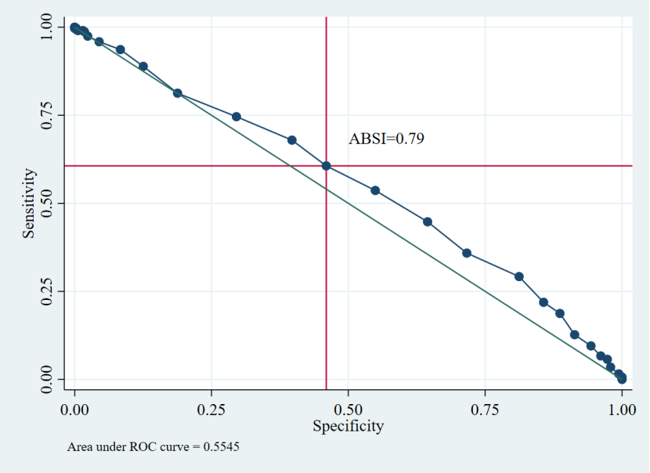
Figure S1 ROC curves for ABSI predicting sleep disorders (diagnosed with PSQI scores >7). Abbreviations: ROC, receiver operating characteristic; ABSI,a body shape index; PSQI, Pittsburgh sleep quality index.

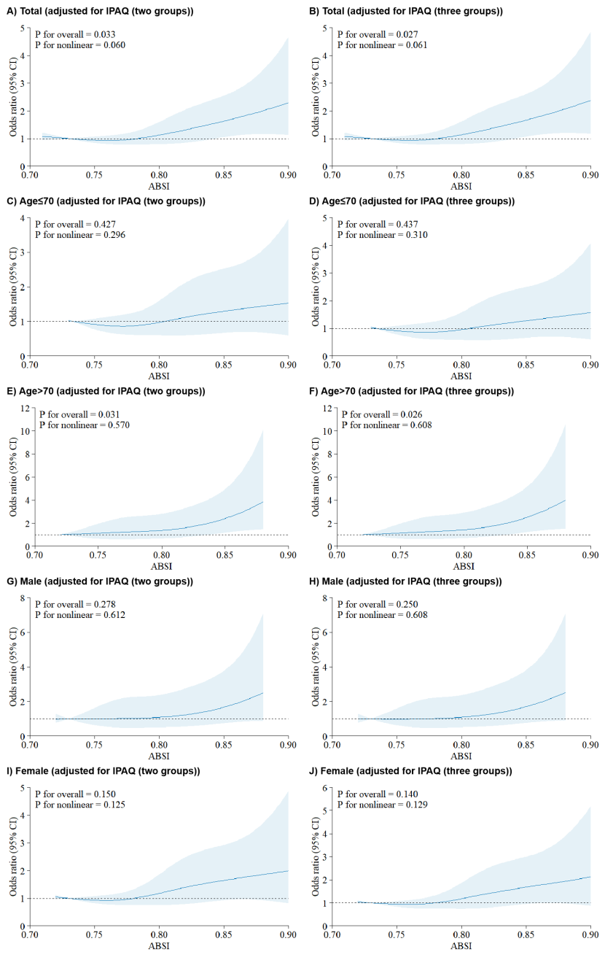
Figure S2 Association between ABSI and sleep disorders (diagnosed with PSQI scores >7) using restricted cubic spline regression models across age and sex subgroups.
- All logistic regression models were adjusted for age, sex (male as reference), alcohol consumption (never consumed alcohol as reference), level of IPAQ (two or three groups), diastolic blood pressure, fasting plasma glucose, erythrocyte, monocyte and diagnoses of hypertension, ischemia heart disease and stroke.
Abbreviations: ABSI, a body shape index; PSQI, Pittsburgh sleep quality index; IPAQ, International Physical Activity Questionnaire.

